Family Letter
5th Grade Addition and Subtraction of Decimals

Dear Family,

During the week of <date> we will begin a new math unit focused on the addition and subtraction of decimals. The purpose of this letter is provide background information about our new unit.

Focus of the Unit
This unit on addition and subtraction of decimals builds on the knowledge of addition and subtraction that students have used with whole numbers in all previous grades. Students also use their understanding of the place value system to help them add and subtract with decimals.

Building off Past Mathematics
In previous grade levels, students learned that the operation of addition is joining together more than one quantity and subtraction is removing or finding the difference between numbers. Students have also learned that numbers can be broken apart by the value of each digit in the number (expanded form):

356 is the same as 300 + 50 + 6

300 + 50 + 6
In fourth grade, students were introduced to decimal numbers and modeled the connections between whole numbers and decimal place value.

ten
tenth
hundredth
hundred
one
In fourth grade, students also modeled the connections between fractions and decimals. They represented tenths and hundredths with models and used the models to make comparisons:
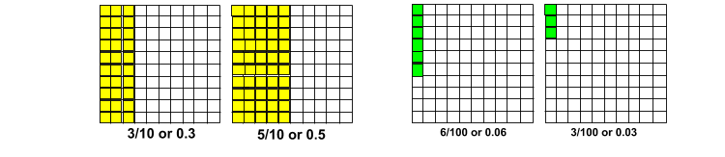
Strategies that Students Will Learn
Students will learn that adding and subtracting decimals is very much like adding and subtracting whole numbers. When adding and subtracting whole numbers, it is often helpful to represent the number in expanded form and then add similar values together. See example:

234 + 321
200 + 300 = 500
30 + 20 = 50
4 + 1 = 5
500 + 50 + 5 = 555

The same is true for adding and subtracting decimals. See the Student #1’s explanation below:

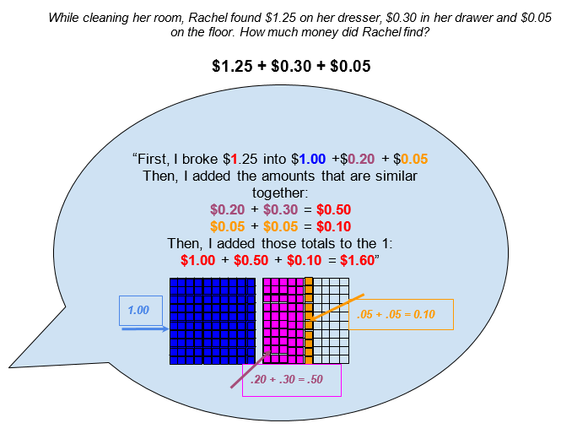
Students often have difficulty remembering the value of the parts of the numbers they break apart. It is very important that students represent and justify their thinking with the use of models, as shown in the student explanation above.

Students may also choose to use a number line to represent their thinking. See Student #2’s explanation:
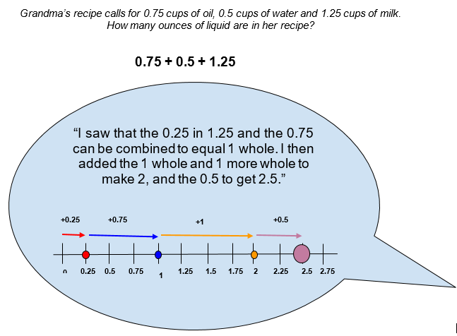
Students use these same ideas dealing with parts of numbers when subtracting decimals:
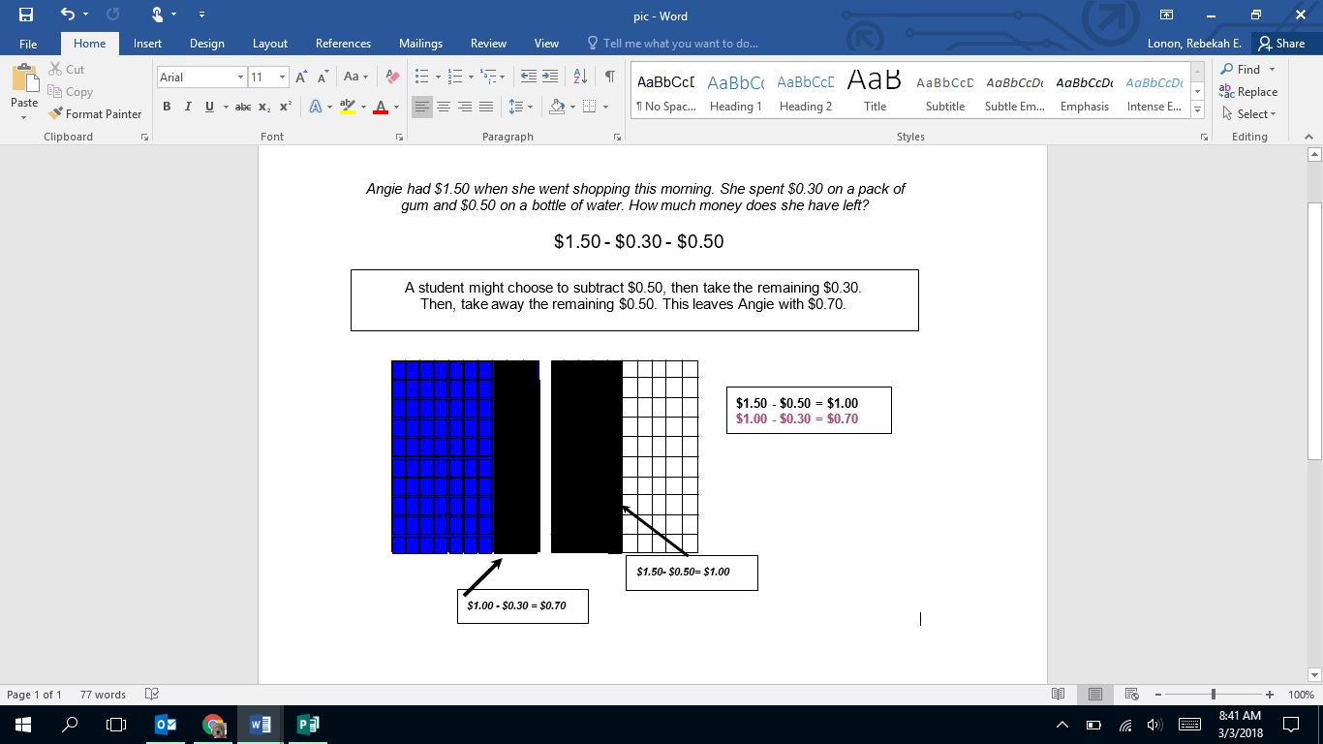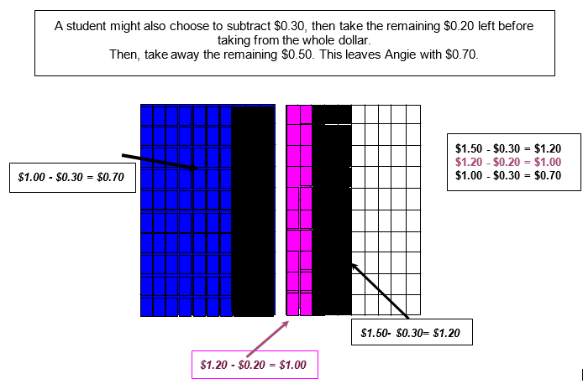
Ideas for Home Support
We see decimals on a daily basis and we add and subtract them regularly. As you spend time with your child, notice decimals in your daily interactions and point them out. Decimals are used in reference to things that are less than 1 (0.5 cup) or in reference to something that is in between two whole things (13.1 miles). Counting money is also a great way to reinforce the idea of breaking apart a quantity to create a new quantity, such as Student #1’s response. Consider having a change jar that you and your child can count regularly to reinforce this idea.

Thank you for serving as partners in your child’s success as a mathematician!
<signature>

