Family Letter
5th Grade
Addition and Subtraction of Fractions
Dear Family,

During the week of <date> we will begin a new math unit focused on fractions. The purpose of this letter is to provide background information about our new unit.

Focus of the Unit
This unit is based on the understanding that fractions are equal parts of a whole. Students will continue to develop fluency with addition and subtraction of fractions and explore making reasonable estimates as well. They will also learn to add and subtract fractions and mixed numbers with unlike denominators.

Building off Past Mathematics
In previous grade levels, students explored the idea that fractions are also numbers, so they can be added, subtracted, multiplied, and divided (later in fifth grade). Students have also learned about comparing fractions using equivalence, benchmarks, doubling, and like denominators. In previous grades, students learned how to place fractions on a number line and explored the idea of mixed numbers and improper fractions.

Strategies that Students Will Learn
In this unit, students will extend their understanding of addition and subtraction with fractions by adding and subtracting fractions with unlike denominators. For example:
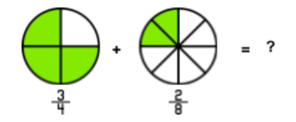
Students use what they know from previous grades about equivalent fractions to add fractions with unlike denominators. They know that one fourth is equivalent to two eighths, so three fourths is equivalent to six eighths
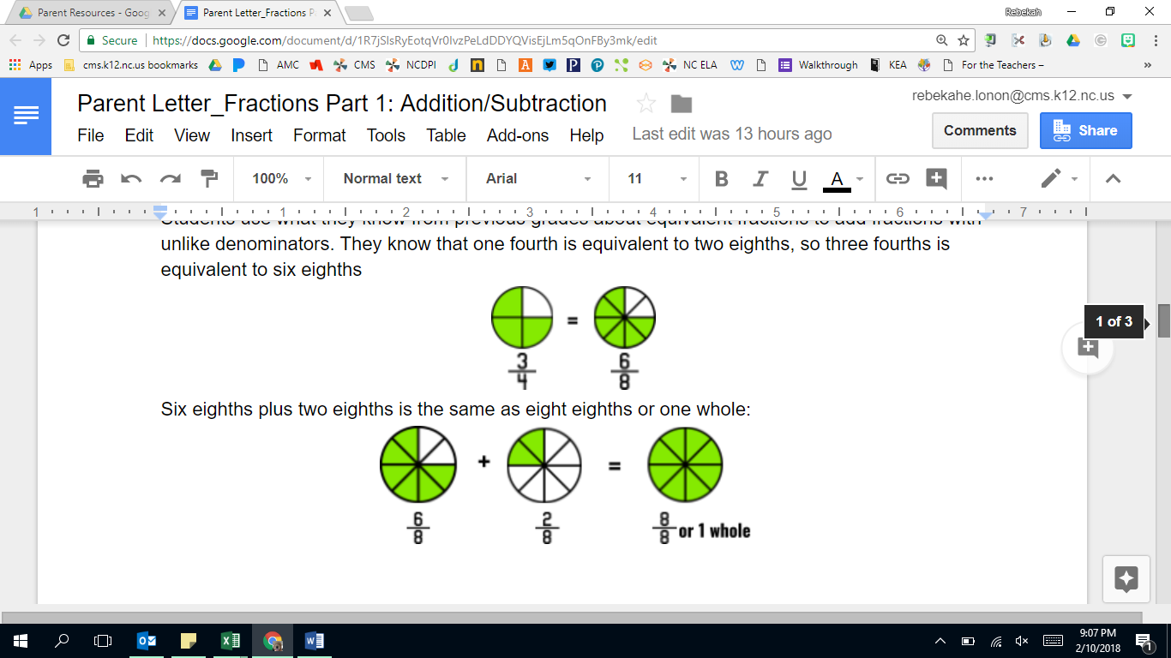
Six eighths plus two eighths is the same as eight eighths or one whole:
Likewise, students use equivalent fractions to help them with subtraction of fractions with unlike denominators:
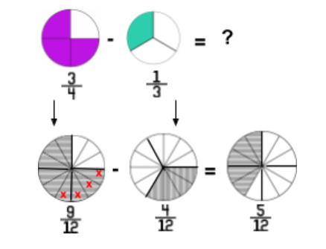

5th grade students also work with mixed numbers (whole numbers and fractions), as they use equivalent fractions to add and subtract:
Addition:
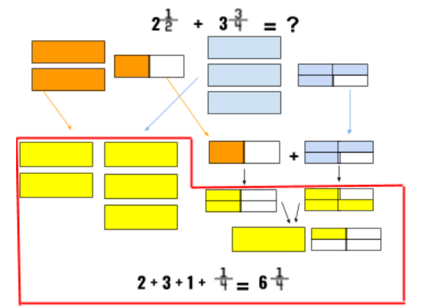
Subtraction:
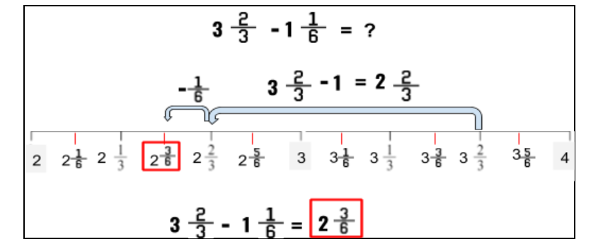
Ideas for Home Support
As students are making sense of fractions, unlike denominators and using equivalence, it is important that they have opportunities to talk about their reasoning. Encourage your child to talk about their thinking and explain the mathematics that supports their reasoning.

A fraction number line (as shown above) is a great tool for visualizing fractional parts and equivalence. A measuring cup is a great example of the use of a fraction number line. While cooking, talk about how the measuring cup shows fractions, whole numbers, and equivalent measurements. Other tools that support this conversation at home are speedometers, rulers, and thermometers. Consider also looking for tools that have marks with no numbers and discuss how to use the information around the marks to determine their value.

When you see opportunities to use fractions in everyday life, have conversations about estimating how much is needed, whether or not you have enough, and how much more you might need. Also discuss how certain fractions are most familiar and become “landmark fractions” that help make estimate easier.

Thank you for serving as partners in your child’s success as a mathematician!
<signature>

