Family Letter
5th Grade Place Value

Dear Family,

During the week of <date> we will begin a new math unit focused on place value. The purpose of this letter is to provide background information about our new unit.

Focus of the Unit
This unit on place value builds on students’ work from previous grades. Students will reason about the magnitude of whole numbers and decimal numbers.

Building off Past Mathematics
In fourth grade, students learned that in multi-digit whole numbers, a digit in one place represents 10 times as much as it represents in the place to its right. In this unit, students will work with decimals numbers as well, and learn that a digit in one place represents 1/10 of what it represents in the place to its left.

Strategies that Students Will Learn
Students will continue to learn how numbers compare and extend this understanding to decimal numbers. They will understand that the relationships between whole numbers also exist between decimal numbers. Specifically, a digit in one place represents 10 times as much as it represents in the place to its right, and 1/10 of what it represents in the place to its left. For example:
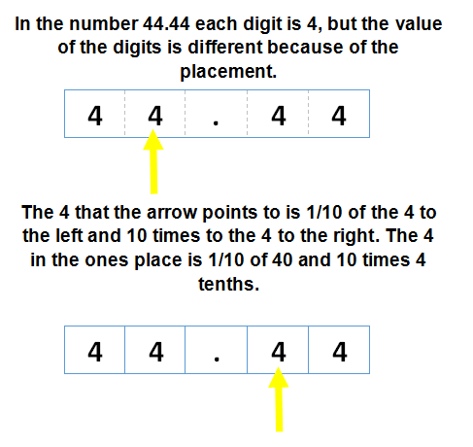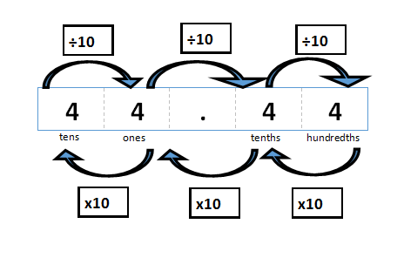

Ideas for Home Support
Be on the look-out for numbers that have the same digit in multiple places. You might see this in grocery store totals, gas totals, mileage, weight and other forms of measurement. Discuss with your child why the values of those digits are different, based on where they are placed in the number. Encourage your child to reason about how much larger or smaller the value of the digit is, based on its place.

Thank you for serving as partners in your child’s success as a mathematician!
<signature>

