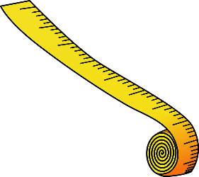
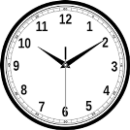
Dear Family,
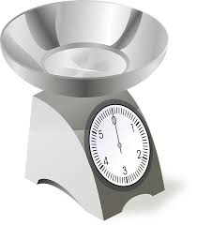
We are beginning a new math unit centered around metric measurement and elapsed time.
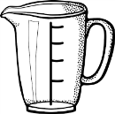
This document is created to help family members better understand the math concepts found in this unit by providing background information and examples of strategies that will be taught.

Connections to previous mathematics:
The learning in this unit builds on previous knowledge of multiplication and place value and will assist students as they learn to convert metric units. All of the operations will again be reviewed as students use addition, subtraction, multiplication, and division to solve word problems involving metric measurements. Students will also use their skills of telling time to figure out elapsed time problems and how much time has passed across an hour.

Important concepts taught in this unit:
1. Developing benchmarks and mental images for measurement units and measuring in the real world
Students will work on developing a mental image of the size of a measurement unit. By doing so, it allows them to focus on the attribute being measured and estimate prior to measuring. Students will also be given opportunities to use measuring tools such as rulers, meter sticks, balance scales, graduated cylinders, etc. during this unit. They will add, subtract, multiply, and divide to solve problems and complete tasks involving metric units (centimeter, meter, milliliter, Liter, gram, and kilogram).

How Can I Help?

- Have your child make estimates about the length, capacity, or weight of objects in the real world. Encourage child to use benchmarks (see examples below).
  - Centimeter = width of pinky finger
  - Meter = half of the height of a door
  - Milliliter = a drop of liquid from an eye dropper
  - Liter = half of a 2-Liter soda
  - Gram = mass of a small paperclip
  - Kilogram = mass of a standard textbook
- Emphasize the use of approximate language. The bench is about 2 meters long. The water bottle is a little less than a Liter.
- Allow your child opportunities to use measuring tools such as rulers, measuring cups, and scales at home for various tasks.
- Involve students in measurement problem solving through real-life tasks. (Example: It takes two meters of wrapping paper to wrap each box. If I have 7 meters of wrapping paper left, how many boxes can I wrap?)

2. Converting metric measurements from larger units to smaller units
Fourth grade students will develop an understanding of the metric system in order to covert metric units from larger units to smaller units using various strategies. For example, meters to centimeters, Liters to milliliters, and kilograms to grams. The metric system is a base 10 system. This means that each successive unit is 10 times larger than the previous one. The names of metric units are formed by adding a prefix to a basic unit of measurement (meter, Liter, gram). Students can use their understanding of place value and multiplication to help build the concept of metric conversions. Both charts are included to highlight the similarities.

Prefixes in the Metric System
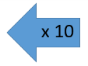  -kilo | -hecto | -deka | Meter  Gram  Liter | 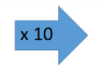  -deci | -centi | -milli
1000 times larger than the base unit | 100 times larger than the base unit | 10 times larger than the base unit | Base units | 10 times smaller than the base unit | 100 times smaller than the base unit | 1000 times smaller than the base unit

(whole numbers) Place Value Chart (decimals)
Thousands | Hundreds | Tens | Ones . | Tenths | Hundredths | Thousandths
1000 times larger than the base unit | 100 times larger than the base unit | 10 times larger than the base unit | Base units of our number system | 10 times smaller than the base unit | 100 times smaller than the base unit | 1000 times smaller than the base unit

How Can I Help?

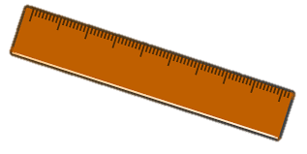
- Talk about place value patterns with your student (e.g. How many 10’s are in 100? How many 100’s are in 1000? How many 10’s are in 230?)
- Encourage your student to measure objects around the house using metric measuring tools. Have your child measure ingredients for a recipe, measure ribbon or fabric for a craft project, or measure wood for building a bird house.
- Review the new metric vocabulary with your student and discuss how the prefixes in the metric system follow the same patterns as the place value system.

3. Solving word problems involving time intervals that cross the hour
Students will use their knowledge of addition and subtraction to solve word problems that involve units of time. These time intervals can cross an hour, which can be tricky for some children because time does not use standard place value (an hour is NOT 100 minutes). Students must learn that there are 60 minutes within an hour and learn to convert between hours and minutes to decide how much time has passed in a situation.

How Can I Help?
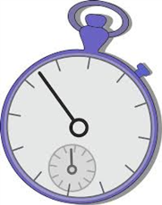
- Designate time amounts for certain chores or activities so students get a sense of how much time has passed. (Ex. Instruct child to clean up for 5 minutes. Set a timer and stop the activity at the end of the time.)
- Share your daily schedule with your child. Have them figure out how long it will be until soccer practice or how long an appointment has lasted. (Ex. The dentist appointment started at 8:15 and ended at 9:10, how much time passed?)

Strategies for Elapsed Time
Number Line Strategy  Math ends at 10:40 and Science begins at 12:10. How much time is there between the two classes?  1 hour 10 min 10 min 10 min  10:40 11:40 11:50 12:00 12:10  1 hour 30 minutes | T-Chart Strategy  Math ends at 10:40 and Science begins at 12:10. How much time is there between the two classes?  Time Hours/Minutes Passed  10:40  10:50 10 minutes  11:00 10 minutes  12:00 1 hour  12:10 10 minutes  TOTAL: 1 hour 30 minutes

