
Dear Family,

During the week of <date> we will be starting a new math unit focused on geometry and measurement. The purpose of this letter is to give you some background information about our new unit.

Focus of the Unit
In this unit, students will build an awareness of their surroundings and the objects in them using symmetry and attributes of two-dimensional shapes. They will use tools to draw and measure lines, angles, and shapes. Students will also make connections between geometry and our number system as they generate and analyze shape patterns and estimate the reasonableness of their measurements.

Building off Past Mathematics
In this unit, students will build on the knowledge gained from their past geometry work when they learned about shapes and their attributes. For example, students previously learned that triangles have three sides and three angles, and quadrilaterals have four sides and four angles. They also learned different types of quadrilaterals including squares, rectangles, parallelograms, rhombuses, and trapezoids.

Strategies Students Will Learn
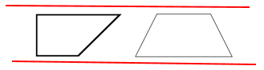
Students will learn to use their understanding of parallel and perpendicular lines to further classify two-dimensional shapes. For example, they will be able to describe a trapezoid as a quadrilateral that has exactly one pair of parallel lines. Both of the following shapes in the image are trapezoids since the top line of each shape is parallel to the bottom line.

They will use their measurement skills to reason about the size of angles, using the right angle (90°) as a benchmark. This benchmark will help students determine whether an angle is acute or obtuse before using the protractor to measure it.

This is an obtuse angle. It is greater than a right angle.

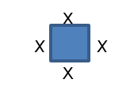
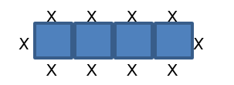
Students will use shape and number patterns to practice using their vocabulary, spatial reasoning, and angle measurement learned in this unit of study. For example, they may explore how the number of seats at square tables increases when any number of square tables is joined together. They realize that 4 people can sit at one table and 10 people can sit when four square tables are pushed together. They can use this exploration to help determine how many people can be seated when 6, 13, or any number of square tables joined together.

Ideas for Home Support
Developing spatial sense is important for future mathematics. Children can do many things at home to help strengthen their spatial reasoning skills.
- Allowing children to build structures with Legos or other blocks is helpful. Parents can build a simple structure and ask the child to replicate it.
- Simple craft supplies, such as toothpicks, popsicle sticks, and play dough can also be used to build structures.
- Creating challenges with blocks or paper folding activities can also enhance spatial reasoning.
- Certain video games, like Tetris, are also helpful in building spatial intelligence.
- Map reading can help children acquire abstract spatial reasoning as they learn to think about large-scale spatial relations among different locations in a concrete way. A fun thing to do at home is to have your child make a map of your backyard or a room in the house and mark where a hidden object is on their map. Give the map to someone in the house to see if they locate the hidden object.
- Allowing children ample opportunities to build, draw, and use spatial vocabulary at home will help strengthen their abilities to further develop their spatial reasoning. An additional sheet is attached to help with the shapes and vocabulary used in fourth grade. The following cards can be cut apart and used as a card sort or flash cards to help learn and/or review geometry vocabulary.

Thank you for serving as our partners in your child’s success becoming a mathematician!

<signature>

Vocabulary Terminology for Fourth Grade Families

Term | Picture | Definition
point |  | An exact location in space that has no length, width, or depth
line |  | An infinite set of points forming a straight path extending in two directions
line segment |  | A part of a line defined by two endpoints
perpendicular lines |  | Two lines that intersect at right angles
parallel lines |  | Two lines that never meet;  Two lines that are always the same distance apart
ray |  | A part of a line that has one endpoint and extends indefinitely (forever) in one direction
angle |  | The figure formed by two rays (sides) that share a common endpoint (vertex)
degree | ˚ | A unit for measuring angles
right angle |  | An angle that measures exactly 90°
acute angle |  | An angle that measures less than 90°
obtuse angle |  | An angle that measures more than 90° but less than 180˚
straight angle |  | An angle that measures exactly 180˚
protractor | 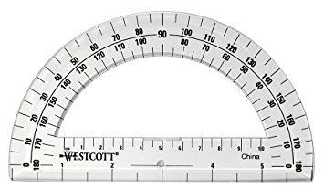 | A tool to measure angles
triangle |  | A polygon with three sides and three angles
right triangle |  | A triangle with one right (90°) angle
acute triangle |  | A triangle with no angle measuring 90˚ or more
obtuse triangle |  | A triangle with one angle measuring 90˚ or greater
equilateral triangle |  | A triangle with all three sides equal in length
isosceles triangle |  | A triangle with two congruent sides (two sides equal in length)
scalene triangle |  | A triangle with no congruent sides (no sides equal in length)
quadrilateral |  | A polygon with four sides and four angles
square |  | A quadrilateral with four congruent sides and four right angles. This shape is always a rhombus and a rectangle, because it has equal sides and equal angles.
rectangle |  | A quadrilateral with four sides and four right angles; opposite sides are parallel and congruent. This shape is sometimes a square.
trapezoid | 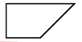 | A quadrilateral with exactly one pair of parallel sides
parallelogram |  | A quadrilateral with two pairs of parallel sides; opposite sides have the same length and opposite angles have the same measure
rhombus |  | A parallelogram with all four sides equal in length
pentagon |  | A five-sided polygon
hexagon |  | A six-sided polygon
octagon |  | An eight-sided polygon
line symmetry | 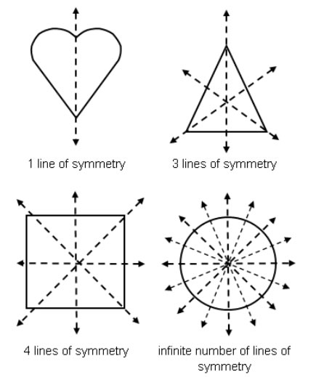 | Line symmetry is a geometric property. If a figure can be folded along a line so the two halves match exactly, then the figure has line symmetry.  The line that divides the figure into two equal parts is called a line of symmetry. Some shapes have multiple lines of symmetry.

