Dear Family,

During this unit, we will be starting new math concepts focusing on multiplication. Often, parents ask
Why isn’t my child learning to multiply like I did?


Let’s start by knowing the standard we are addressing:
NC.4.NBT.5: Multiply a whole number of up to three digits by a one-digit whole number, and multiply up to two two-digit numbers with place value understanding using area models, partial products, and the properties of operations. Use models to make connections and develop the algorithm.

What does this really mean?
This standard calls for students to multiply numbers using a variety of strategies. In order to develop flexibility in their thinking, students will use base ten blocks and models to better understand how place value connects to multiplication. Understanding place value strategies will allow students to develop fluency and efficiency while building a foundation for understanding the traditional algorithm.

Let’s see this in action:
Strategies | Examples
Partial Products-  In this model, students will use place value understanding in order to break apart larger numbers to create simpler problems. | 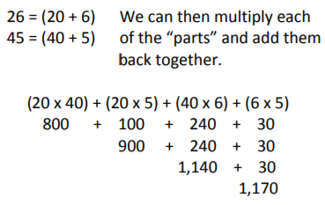
Properties of Operations-  This model also uses strategies to make numbers easier to work with. Students use the Commutative Property (ex: 4 x 2 is the same as 2 x 4) and the Associative Property (ex: (2 x 3) x 4 is the same as 2 X (3 X 4) ) to solve more complex problems. | 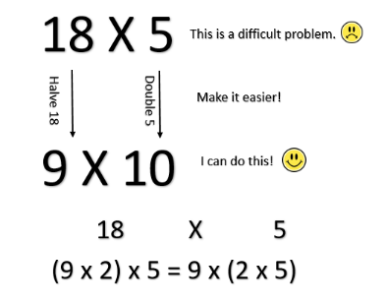
Area Models-  This strategy uses models and the distributive property to solve multiplication problems. | 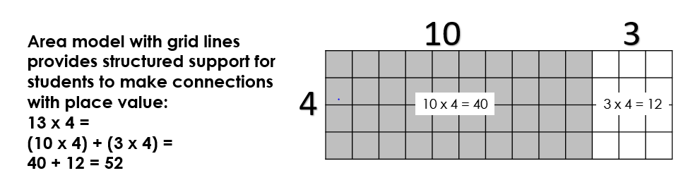  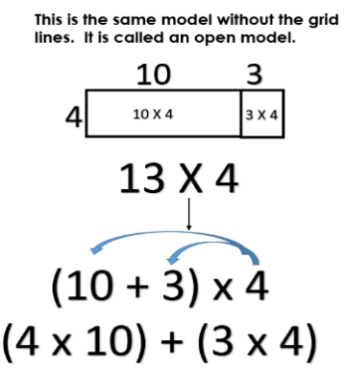  The open model also works well with 2 or 3-digit factors. This supports development of algorithms later as well as mental mathematics.  Consider 29 x 14:  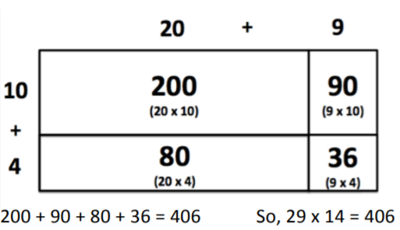
Traditional Algorithm-  In the traditional algorithm, students will multiply 4 X 29 and then 29 X10 and add the two products together for the total. | 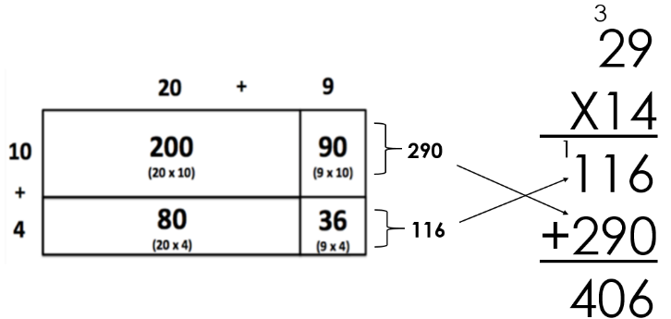


Why are they doing it that way?
Parents often ask why students are not learning how to multiply using the traditional algorithm. The answer to the question is: They will!
But first…Our major emphasis is on developing efficient and flexible methods for solving problems. Students now use “transparent” algorithms in which the operations and the place value concepts are easily seen. This is different from the “shortcut” method that parents learned as youngsters.

Students study a variety of algorithms for a number of reasons:
- One method may be better suited to a particular problem, set of numbers, or scenario. Ex. To solve 99 x 3, it is more efficient to solve 100 x 3 (300) and then subtract a group of 3 (297) rather than using the traditional algorithm.

- By developing a variety of approaches, students learn which ones they are comfortable with and can gradually apply these approaches to harder problems.
- Students understand how these algorithms work and what the numbers represent.
- The skills learned in “transparent” algorithms build foundations for mathematical
concepts used later in Algebra.
- Once students are firmly grounded in understanding the operation and problem solving, they study the traditional multiplication algorithm. They learn how the “shortcut” relates to concrete models. As a result, the “shortcut” makes sense, rather than being a series of mysterious steps. Students are more accurate when multiplying and are less likely to make careless mistakes.

How can I help my child?
- Be positive about math. Your own attitudes can influence your child’s desire to learn math.
- Find out about your child’s math program by attending parent conferences, back-to-school nights, and family math classes at your child’s school.



