Dear Family,

During this unit, your child will be learning strategies for division. The mathematical standard we are addressing is:
NC.4.NBT.6 Find whole-number quotients and remainders with up to three-digit dividends and one-digit divisors with place value understanding using rectangular arrays, area models, repeated subtraction, partial quotients, properties of operations, and/or the relationship between multiplication and division. | 
What does this standard mean?
This standard asks students to find the quotient (the answer when you divide) and the remainder (the number left over) of up to three-digit numbers divided by one-digit numbers. When students understand the size of the number they are dividing, they can make sense of the process of equally grouping using a variety of strategies. This helps students become more flexible, efficient, and accurate over time.

Let’s see this in action:

Strategies | Examples
Area Models and Rectangular Arrays- Students can take out chunks that make sense to them using multiplication facts they know. | 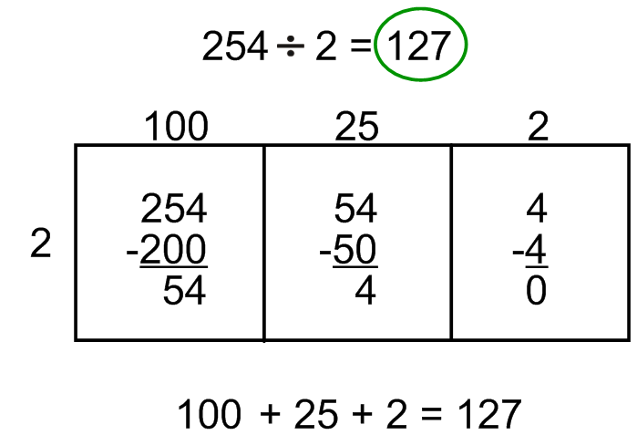
Repeated Subtraction-  Students can repeatedly take out groups of the same size, finding how many groups were taken out and how many are remaining. | 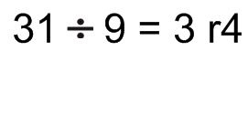  31 – 9 = 22  22 – 9 = 13  13 – 9 = 4
Partial Quotients-  Students take out groups that make sense and relate to multiplication facts they know. They decide how many groups they took out in all to find their answer. | 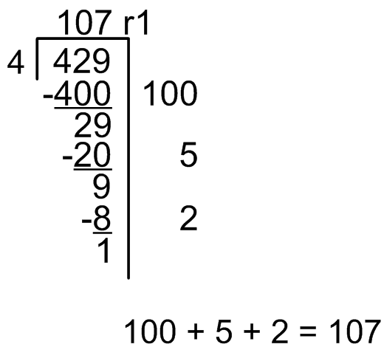
Relationship Between Multiplication and Division-  Students understand that they can use the multiplication facts they know to solve division problems. | 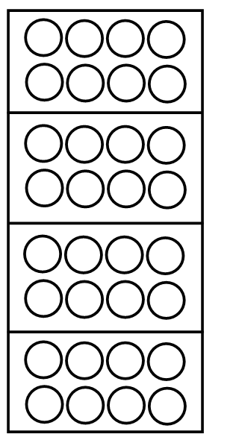  4 groups of 8 is 32  4 x 8 = 32  32 objects divided into 4 groups is 8.  32 ÷ 4 = 8

How can I help at home?
When children are very young, they learn quickly how to get a fair share by making equal groups. However, when learning to divide, they can sometimes forget division is just that—making equal groups. As your child solves problems, encourage a description of the strategies used in terms of the groups that have been taken out and the leftover amount.

Have your child divide real-life items around the house. Examples: 36 pieces of silverware divided among 5 family members, 44 pieces of candy divided among 7 people, 13 toy cars shared with 2 children, or 3 cookies divided among 6 sisters. Discuss how many equal groups would be created and how many items would be leftover. Consider how the amounts would change if one more person was added to the group.

You could also play games with your child. Try these games, found on this website (https://tools4ncteachers.com/resources/district-leaders/documents/4thgrade-GAMES.pdf)!
- Four Quotients
- Race to the Resort
- Mt. Mitchell Rock
- Rockingham Remainders
- The Great Raleigh Road Race

