Kindergarten Family Letter
Cluster 7: Foundations of Place Value – Exploring Numbers 11-19

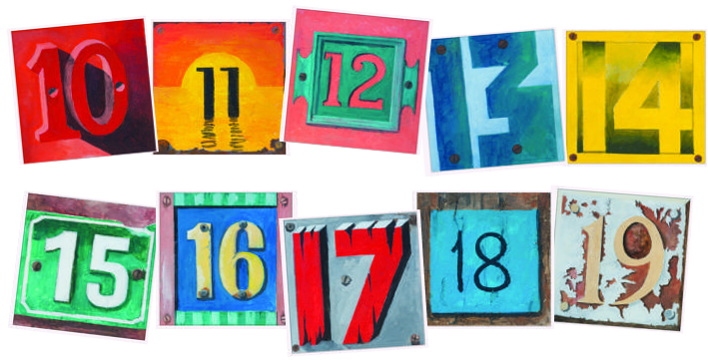

Dear Family,

During the last few weeks of Kindergarten, students continue to build upon their understanding of numbers. They decompose (break apart) and compose (put together) numbers within ten, fluently add and subtract within five, and develop an understanding of place value.

This letter provides resources for helping your child work flexibly with numbers and develop an understanding of teen numbers. By engaging in these fun activities and talking about mathematics in the world around you, your child develops skills, efficiency, and a belief that the study of mathematics is essential!

Your Partner in Learning,
_________________________

Kindergartners Decompose and Compose Numbers within 10

Kindergartners find many ways to decompose (break apart) and compose (put together) numbers within 10. For example, 9 can be broken into 9+0, 8+1, 7+2, and so on. This work helps Kindergartners see patterns within numbers, develop an understanding of relationships among numbers, and begin to fluently add and subtract.

How Can Parents Help?
- Complete the activity Matching Number Pairs for Eight by Dreambox (click, scroll down).

- Complete the activity Matching Number Pairs for Nine by Dreambox (click, scroll down).

- Complete the activity Matching Number Pairs for Ten by Dreambox (click, scroll down).

- Complete the activity Missing Addends to 10 by Mega Math.

- Read Ten Black Dots by Donald Crews.

Kindergartners Fluently Add and Subtract within 5

By the end of the school year, Kindergartners fluently add and subtract within five. When a Kindergartners is fluent, they are accurate, efficient, and flexible. They are accurate when they get the correct answer. A Kindergartner is efficient when they solve a problem easily, within a reasonable amount of time. They are flexible when they know a variety of strategies to solve a problem and choose the most appropriate one. For example, when adding 4+1, a Kindergartners may simply say the next number in the counting sequence…5.


How Can Parents Help?
- Play Hide the Coins: Place a group of coins (e.g., four coins) in your hand, and show your child. Remove part of the group put it behind your back. Your child looks at the coins still in your hand, and determines the amount hiding behind your back.


- Play How Many Do I Need? Show your child a small group of pennies or other objects (e.g., 2 toy cars). Say: I have 2 toy cars. I want 5 toy cars. How many do I need?

Kindergartners Develop an Understanding of Place Value

Kindergartners build an understanding of place value as they build teen numbers. They do this by making a set of ten and some additional ones. For example, when given 14 objects, a child notices they can make a group of ten and have four leftovers.

How Can Parents Help?
- Complete the activity Teen Numbers as Tens and Ones by Mega Math.

- Complete the activity Sums within 20 (with 10 as an addend) by Mega Math.
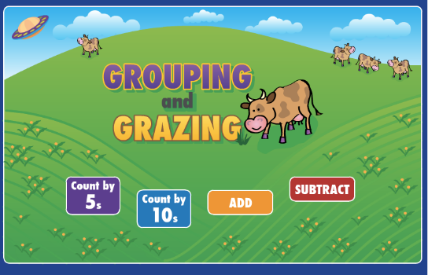
- Play the game Ten Frame Mania by Greg Tang

- Play the game Grouping and Grazing by NCTM.

- Play the game Okta’s Rescue by NCTM.

