First Grade Representing and Interpreting Data Parent Letter

Dear First Grade Family,

During the week of <date> we will be starting a new math unit focused on representing data in simple charts and tables. Students will learn to explain what they notice about the information. The purpose of this letter is to give you some background information about our new unit.

Focus of the Unit
- Representing up to three categories of data in a chart or table
- Asking questions, answering questions, and making statements about the collected data

Your first grader will focus on collecting and categorizing information by asking questions through a survey or activity (such as shoe size, eye color, or favorite ___ ). Once the data is collected, students interpret it by answering a question or making a statement about what they see. They typically describe the total number of responses, which category had the most or least responses, and interesting differences or similarities between the categories. In first grade, the number of categories is limited to three. These practices will help students build a solid foundation for data representations in future grades.

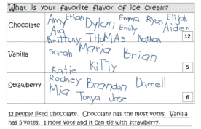

Building Off Past Mathematics
Last year students sorted objects into categories. Then they counted the number of objects in each group and put groups in order by those numbers. These activities and skills helped build a foundation for first grade standards which require students to collect, organize, and analyze information with up to three categories.

Strategies that Students Will Learn
Students will learn how to collect and organize data by using tally marks, sticky notes, or some other way to track the “votes” or pieces of information. It is helpful to record numbers on data charts to represent totals for each category. Students will analyze the data and share what they notice. They will learn to compare categories and explain “how many more” one group has than the other. This directly relates to the types of word problems explored in first grade.

When comparing the categories of data, your child may use counting or matching strategies. Students will also determine when to add and subtract to help analyze the information. Some helpful tools are double number lines, grid paper, cube towers, etc. See the examples below:

There were three people that prefer vanilla ice cream and five people that prefer chocolate ice cream. How many more students like chocolate ice cream than vanilla ice cream?

How many fewer people like vanilla ice cream than chocolate ice cream?

Double Number Lines

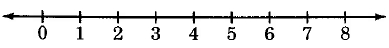

Grid Paper or Bars  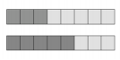  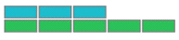 | Cube Towers  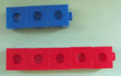
First, I showed the three people that prefer vanilla ice cream. Then I showed the five people that prefer chocolate ice cream. I noticed there were two more people that prefer chocolate ice cream and two fewer people that prefer vanilla.

Ideas for Home Support
Practice the skill of counting tally marks by making them with pretzel sticks or other foods. Remember when you say “5,” place the fifth pretzel across the others. Then you can count those as groups of 5. “I have 5, 6, 7, 8.” Then record the number that is represented by the pretzels.

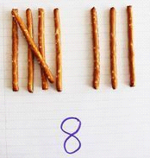
While students are home, ask them to keep track of three different animals they see in the yard (birds, squirrels, butterflies, dogs, or cats) by using tally marks. They may organize the information in a table or chart and write statements and/or questions about the data.

Collect a set of data by asking a question to family members (such as shoe size, eye color, or favorite ___ ). Remember to give three categories. For example, eye color could be blue, brown, or other color. Analyze the information together by using statements and questions such as:
- Tell/Write a statement about the data.
- Use a number to tell/write something about the data.
- Tell/Write a sentence using the word more.
- Tell/Write a sentence using the word fewer.
- Tell/Write a question to compare two categories of data.

Let your child collect and organize up to three types of items in the house. It could be the actual items, or they could just represent the number of objects using tally marks in a chart or table. Give them categories such as boxes, writing utensils, etc. Your child can describe the data or ask and answer questions about the total number of items collected. They may also explain how many items are in each category and compare how many more or less are in one category than in another.

Practice creating data sets with your child. Create a circle spinner with paper and a paper clip. You may hold the paper clip with the eraser of a pencil in order to spin it. Divide the spinner into three sections, deciding what three colors or categories you want to place in each section. Then spin the paperclip 12 times to generate data and record the results. Ask your child to make statements or ask you questions about the data. In turn, you can ask your child questions.

Reading books is a great way to enhance learning! You may check out the following titles at your local library or you may find free online versions to support the learning in this unit.
- Duck! Rabbit! by Amy Krouse Rosenthal
- Tally O’Malley by Stuart J. Murphy
- The Sundae Scoop by Stuart J. Murphy
- Who’s Got Spots? by Linda W. Aber

Thank you for serving as partners in your child’s success as a mathematician!

<signature>

