First Grade Problem Solving Parent Letter

Dear First Grade Family,

During the week of <date> we will be starting a new math unit focused solving addition and subtraction problems within 10. The purpose of this letter is to give you some background information about our new unit.

Focus of the Unit:
During this unit, your child will develop a deep understanding of the meaning of addition and subtraction by solving a variety of story problems. The chart below provides an example of the types of problems will be solve.

Type of Problem | Example
Add To Change Unknown | Justin had six toy cars. His brother gave him some more. Now Justin has nine toy cars. How many toy cars did his brother give him?  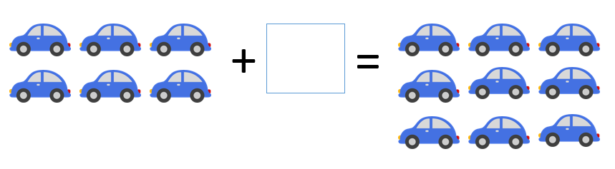
Take From Change Unknown | Ten birds were in a tree. Some of them flew away. Now there are five birds in the tree. How many birds flew away?  
Put Together/Take Apart Addend Unknown | Mackenzie put eight seashells in a bucket. Five are black and the rest are white. How many seashells are white?  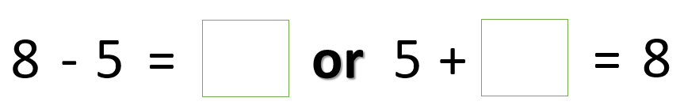
Compare Difference Unknown | Chris has four muffins. Todd has seven muffins. How many more muffins does Todd have than Chris?  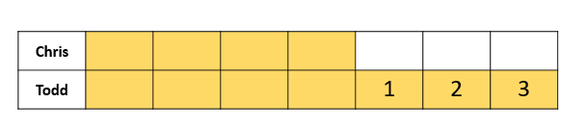
Compare Difference Unknown | Chris has four muffins. Todd has seven muffins. How many fewer muffins does Chris have than Todd?  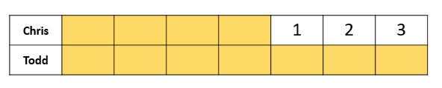

Building off Past Mathematics:
In kindergarten your child used objects, drawings, and equations to develop an understanding of addition and subtraction within 10. The chart below provides an example of the types of problems your child solved last year along with common ways they may have represented solving the problems.

Type of Problem | Example
Add To Result Unknown | Justin had six toy cars. His brother gave him three more. How many toy cars does Justin have now?  
Take From Result Unknown | Ten birds were in a tree. Five flew away. How many are in the tree now?  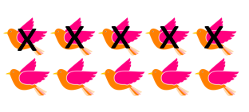
Put Together/Take Apart Total Unknown | Mackenzie put five black seashells and five white seashells in a bucket. How many seashells are in the bucket?  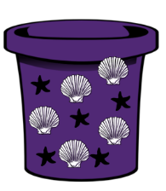
Put Together/Take Apart Both Addends Unknown | 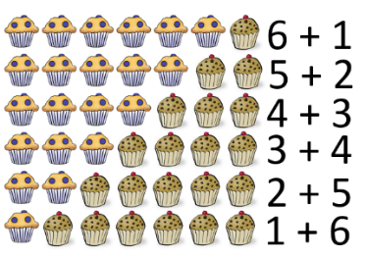  Chris has seven muffins. Some are blueberry and some are chocolate chip. How many of each could he have?

Strategies Students will Learn:
Throughout the unit, your child will use his/her understanding of the actions of addition (putting together/adding to) and subtraction (taking apart/taking from) to choose the operation that makes when solving different types of story problems. Rather than focus on key words to develop this understanding, your child will spend ample time:
- acting out problems with classmates
- using objects or counters to model what is happening in story problems
- retelling stories in his/her own words
- drawing pictures to show what is happening, and
- writing equations that connect to what is happening in story problems.

Your child will also become familiar with the meaning of the equal sign and with showing unknowns in various places in equations using symbols.

Ideas for Home Support:
Skillful problem solvers think about a plan before jumping into a solution and do not give up if they get stuck. Help your child make sense of problems and persevere in solving them by asking the following questions while they are working to extend their thinking:
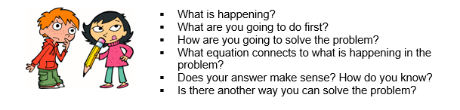
Reading stories that show addition and subtraction is a great way to enhance learning. As you read aloud with your child, have him/her solve or write problems about the story/characters.
- Animals on Board by Stuart J. Murphy
- Jack the Builder by Stuart J. Murphy
- Ready, Set, Hop! by Stuart J. Murphy
- Safari Park by Stuart J. Murphy

Thank you for serving as partners in your child’s success as a mathematician!

<signature>

