Kindergarten Family Letter
Cluster 2: Understanding the Relationship between Numbers and Quantities
PART 1

Dear Family,

During the next several weeks, your child focuses on developing number sense. According to Gersten and Chard number sense “refers to a child's fluency and flexibility with numbers, the sense of what numbers mean and an ability to perform mental mathematics and to look at the world and make comparisons." This is seen when your child connects a number to a group of objects (e.g., “that’s 5”). Students learn to count in the correct sequence, and write and identify numbers. Students also begin to subitize. This means they recognize a quantity in a group or arrangement without counting. An example of this is when your child instantly knows the amount of dots on a die/dice.

A solid foundation with understanding of number sense starts children on a journey to becoming great mathematicians. Below are resources that support your child in achieving success as a math student.

Your Partner in Learning,

_________________________

Kindergartners Count to 20

In Kindergarten students count out loud. In this cluster, we ask students to rote count to 20.
By the end of the school year, Kindergartners will count to 100. Through practice, students
begin counting at different numbers such as 3, or 5, or 8 and then continue counting on to 20.

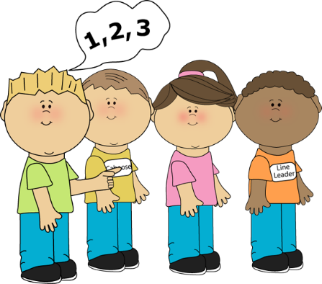
How can parents help?
- Have your child count as they complete home activities including tying shoes, making their bed, brushing their teeth, combing their hair, etc.
- In the car, encourage your child to count out loud until you get to the next stop sign, business, or house.
- In the car, call out a number. Ask your child to count beginning at this, stopping at 20.
- Watch the YouTube videos:
Clipart from My Cute Graphics
- Count to 20
- Number Rock
- Count to 20 and Workout

Kindergartners Write Numerals

A numeral is a symbol used to represent an amount. For instance...1, 2, and 3 are numerals. For the first several week of this unit, your child focuses on writing numerals 0-5. Once this is mastered, they continue on to write numerals 6-10. Your child also works to understand that 0 represents “nothing”, or “a group with nothing in it”.

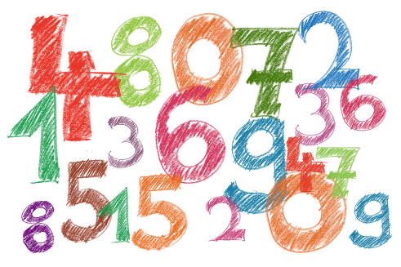
How can parents help?
- Say a number aloud, and have your child write it.
- Show your child a group of cookies or other objects. Have your child write a numeral to represent the group.
- List to Dr. Jean Numeral Song.
- Play the app-123 Numbers Count.
- Use playdough to make numerals.

Kindergartners Understand Number Relationships

Understanding number relationships means your child understands ways numbers are connected to each other. This is a big idea in early mathematics.

As Kindergartners begin to understand number relationships, the say number names in the standard order when counting objects. They match each object with only one number name. They know the last number counted in a group represents the total amount in that group.

Another big idea in this unit is subitizing. This is the ability to instantly know “how many” without counting. For example, a child may instantly know he has one piece of toast, two eggs, and three pieces of bacon.

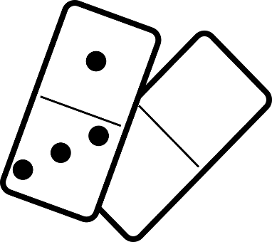

How can parents help?
- Play games with dice and dominoes. Encourage your child to find “how many” without having to count each dot individually.
- Counting everyday items around the house or while shopping.

