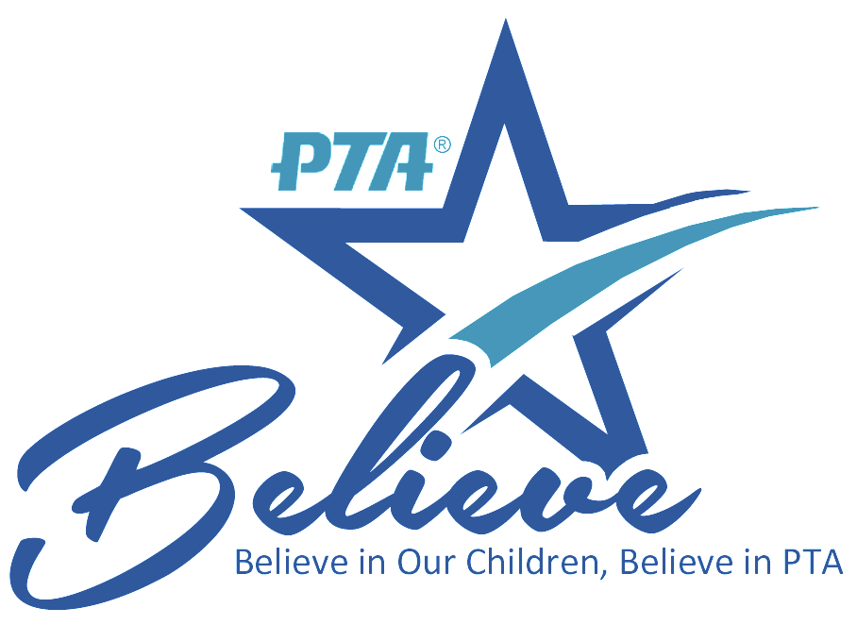

Marshall Fundamental School
is better...with YOU!
With your PTSA membership, all things are possible!
YOUR PTSA EVENTS AND PROGRAMS:  - New Family Meet & Greet  - 6th Grade Potluck  - Campus Beautification  - Four Teacher Appreciation Potlucks  - Two Scholarships Awarded to Eligible Graduating Seniors ($500 each)  - Department Wish List for Teachers ($300 per dept.) |   “We invite every parent, teacher and neighbor to join with PTSA, as we work to make MARSHALL FUNDAMENTAL the best it can be for our students...our most precious resource.”
  PRINCIPAL:  Dr. Anderson | PTA PRESIDENT:  Lena Bayrakdarian
  PRINCIPAL EMAIL:  Anderson.mark@pusd.us | PRESIDENT EMAIL:  Marshallptsa1@yahoo.com
PTA also means exclusive extra perks for YOU!
Google Express ~ Yoobi ~ Aquarium of the Pacific ~ Boxed ~ Comcast Internet Essentials
California Academy of Sciences ~ LEGOLAND ~ Enterprise Car Rental

Learn more online at www.capta.org
Marshall Fundamental PTSA –
Support your child  and your school –  Support PTSA! | 
With your PTSA membership:
- You show your children that school matters, and that you are invested in their success.

- You demonstrate to your child that success in school is the pathway to college, a career and a productive life!

- You partner with the principal, teachers and staff to make your child's school safe, welcoming, a hub of learning, and a fun place to be.

- You share in campus events and experiences that make your child’s school days more memorable!

- You connect with other parents, and become part California State PTA and National PTA, the largest and most powerful children’s advocacy organization in the country.

- You help make sure parents and family members voices are heard when important decisions that affect your school are made.

 | Here’s how to join PTSA:  Fill out membership form and include  - $9 per person dues  For more information:  Email Lena or Denise at Marshallptsa1@yahoo.com
Marshall Fundamental PTSA
990 N Allen Ave., Pasadena, CA 91104 – www.marshallfundamental.org
(626)396-5810

