Joe Rotundo
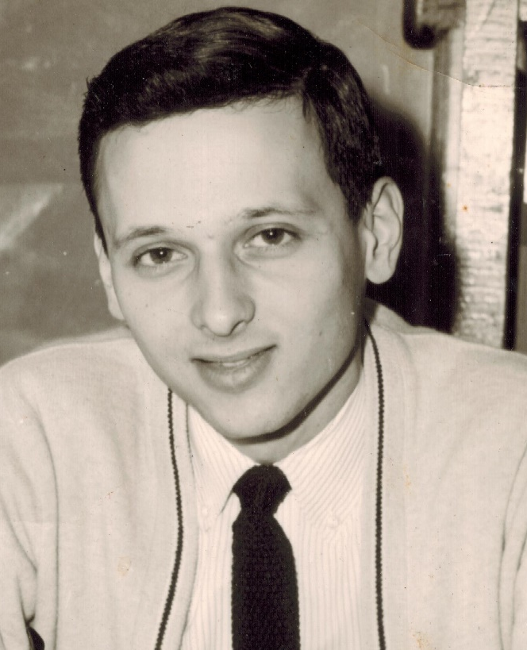
Coach

- Coached Wrestling – 40 years
  - NT, Will. South and Clarence
- 250 Coaching Wins Overall
- Varsity Wrestling – Clarence
  - 43 wins – 5 losses
  - 2 x ECIC Divisional Championships
  - 1 Sectional Championship
- Started Kid’s Club – open to all
- Organized many Kids’ Club Events
- Hosted teams from US and abroad
- Took teams to Germany and Japan
- Dir. US Junior All-Star Games – 4 years
- 2016 HOF Inductee -
WNY Wrestling Coaches Association

