Norm Miosi
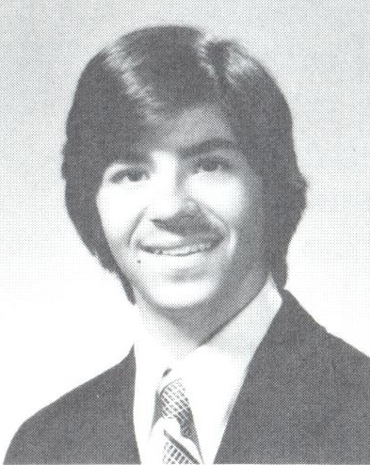
Class of 1977

- Varsity Soccer – 2 years
  - 2 x ECIC 1st Team All-Star
  - 2 x Team Leading Scorer
- Varsity Bowling – 4 years
  - 4 x ECIC 1st Team All-Star
  - 3 x White Letter Winner
- Varsity Baseball – 2 years
  - 2 x ECIC 1st Team All-Star
  - 2 x White Letter Winner
  - 2nd Team All WNY – Shortstop
- Scholarship to Canisius College
  - Baseball

