John Lally
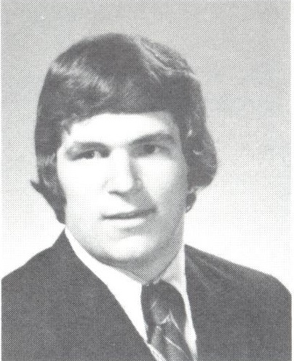
Class of 1977

- 7 Varsity Red Letters
- Varsity Football – 2 years
  - 2 x ECIC 1st Team Division All-Star
  - ALL-WNY in 1976 as a Senior
- Varsity Wrestling – 2 years
  - Heavyweight and Unlimited
  - ALL-WNY
  - Practiced with the
United States Olympic Team
- Varsity Track and Field – 3 years
- Awarded Scholarship at
Syracuse University for Football

