Elizabeth Dunne
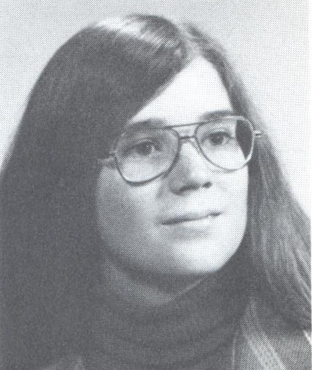
Class of 1973/Coach

- Varsity Volleyball, Captain
- Varsity Basketball, Captain
- Varsity Swimming
- Varsity Softball, Captain
- Varsity Track and Field
- Female Athlete of the Year – 1973
- Pres. – Girl’s Athletic Association
- VP – Pep Club
- Clarence Girls Leader Club
- Forty years Teacher/Coach ’78 – ’18
  - Varsity Girls’ Volleyball
  - Varsity Girls’ Basketball
  - Varsity Girls’ Swimming, Assistant
  - JV Girls’ Basketball
  - Modified Volleyball, Basketball, Swimming,
Track & Field, and Softball

