Kevyn Adams
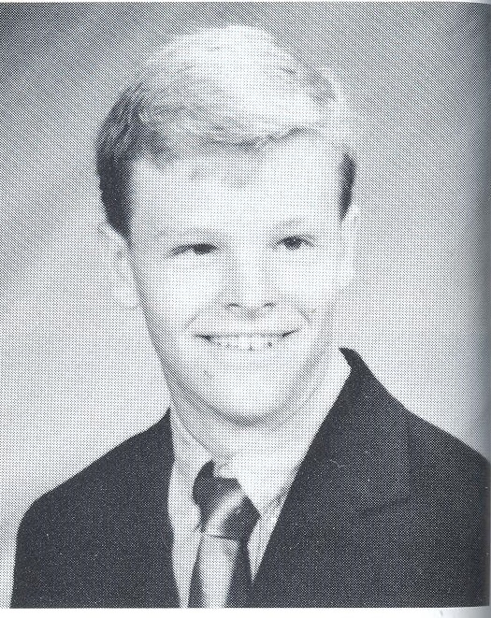
Class of 1992

- Varsity Baseball – 2 years
  - 1st Team ECIC Division All-Star
  - MVP and Best Batter – 1992
- Hockey
  - Wheatfield Blades as a youth
  - NA Junior Hockey League
  - Miami of Ohio University HOF
  - 1st Round Pick – Boston Bruins
  - 11-year NHL Career
  - Stanley Cup Champion – 2006
  - Academy of Hockey Program
  - GM of Buffalo Sabres since 2020

