
Buzz – Search For Success
Integration Manual for Clerks

Created by Aileen Sweeney

Revision History
May 4, 2018 - Aileen Sweeney – This is the initial revision of this document.

Table of Contents
Introduction 4
Subdomains needing new Search For Success Menu Item Customization 4
Master Excel File of data needed for Search For Success Customization 4
Step 1. Login to Buzz using your Admin credentials 5
Step 2. Access the Domain’s Settings Options 6
Step 3. Edit the Menu Entries – Custom section 7
Step 3a. Edit the Menu Entries – Custom section – Add new 8
Step 4. Save your changes 10
Step 5. How to Edit the Menu Entries – Custom section 11

Introduction
The SLS Search for Success logged in user screen can be added to each school district building using the sub-domain’s Settings screen in Buzz. This manual explains how to add that Menu Item link to the applicable sub-domains.

Subdomains needing new Search For Success Menu Item Customization
Oneida-Herkimer-Madison BOCES (oneida - 3139)

Master Excel File of data needed for Search For Success Customization
This excel file contains the URLS, usernames and passwords needed to create the specific Menu Items by sub-domain.
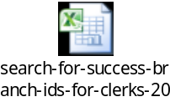

Step 1. Login to Buzz using your Admin credentials
Navigate to the sub-domain listed in the excel file.
These screenshots show the sample for oneida-media which has already been customized for Search For Success.
Click on the Settings icon in the top navigation bar.
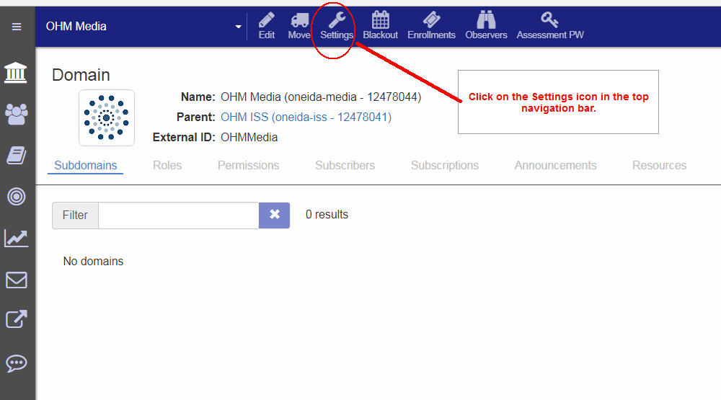

Step 2. Access the Domain’s Settings Options
Scroll Down until you can see the Menu Entries section of the Domain Options Settings.
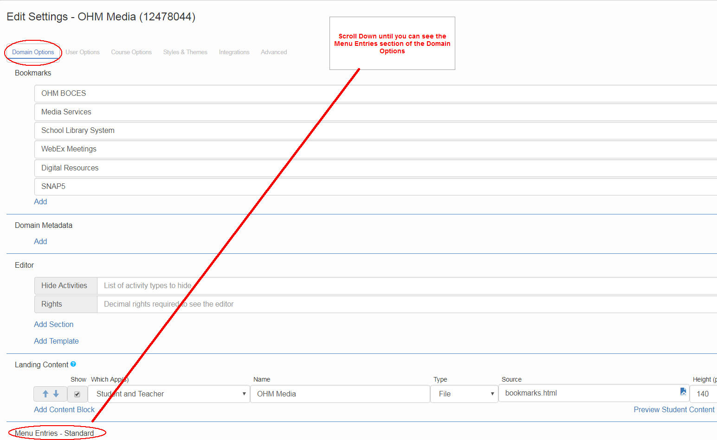

Step 3. Edit the Menu Entries – Custom section
Scroll Down until you can see the Menu Entries - Custom section in the Domain Options screen.
Use the Add link to create a new menu item. Click on the pencil to edit an existing menu item
This screenshot shows that the search menu item has already been added to the Menu Entries-Custom Section.
For each subdomain that you are editing, that does not already have the search menu item, you will need to click on the Add link.
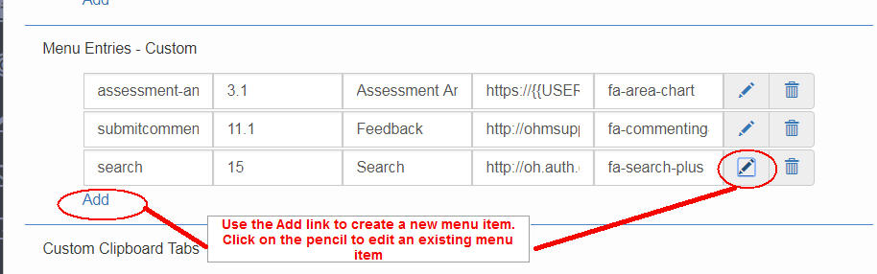

Step 3a. Edit the Menu Entries – Custom section – Add new
This screenshot shows the add menu item result.
You will need to copy and paste the values needed for these fields:
All subdomains will use the same values for ID, Order, Title and Icon.
The only field that is unique for the sub-domain will be the Search for Success Login URL
Field name Value
ID search
Order 15
Title Search
URL Edited URL created for this sub-domain (see spreadsheet)
Icon fa-search-plus
This screenshot provides the values you will need to use and/or change for each particular subdomain.
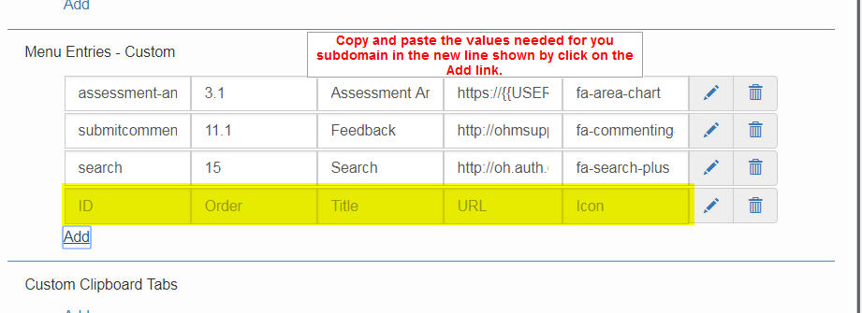
Step 3a1. Create the URL needed using sample URL
The sample URL is:
http://oh.auth.orc.scoolaid.net/bin/dblist?schoolId=226&myUsername=ohsls&myPassword=search&sysId=23
The needed Search for Success URL consists of 4 parameters based on the specific sub-domain’s login id.
The parameters are separated by & character in the sample URL.
Two of the parameters, myPassword and sysId , will contain the same value for all subdomains and do not need to be changed. All sub-domain schools have the same myPassword value and sysid value.
schoolId=226
myUsername=ohsls
myPassword=search
sysId=23
Using the sample URL, edit it so you can copy and paste it into the URL field on the Add row.
Look up your sub-domains’s schoolId and myUsername in the excel file provided above.
Look for your sub-domain prefix in the excel file’s column named Buzz Log-in Prefix.
Find your subdomain’s schoolid value in the column named Opals/Search for Success subscriber ID Number.
Find your subdomain’s myUsername value in the column named User login for Search.
Copy those values into the sample URL replacing the values that are already there.
After editing the sample URL, copy and paste the new URL into the URL field.

Step 4. Save your changes
Make sure to click on the Save button once you have your item all set.
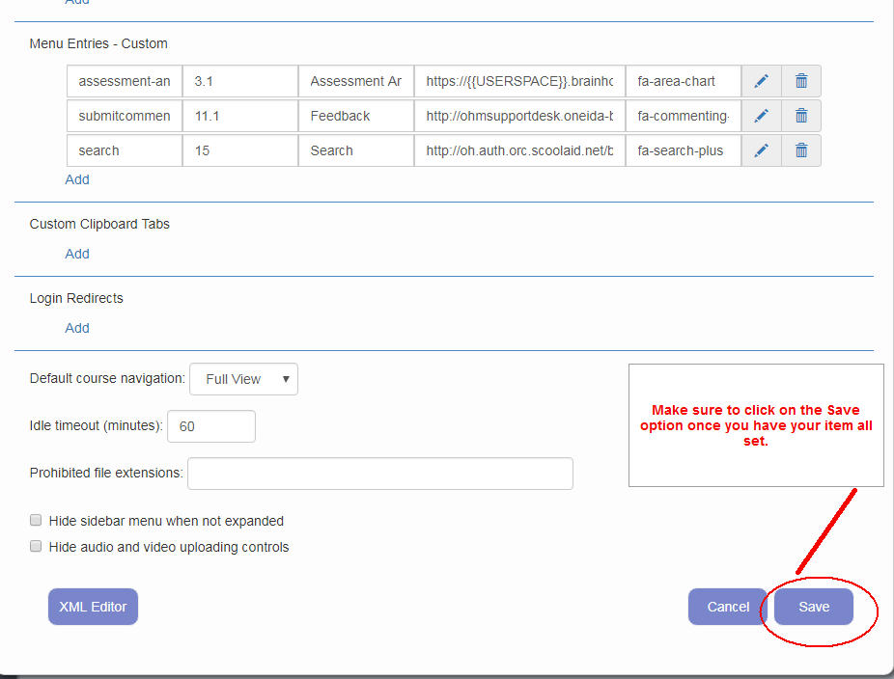

Step 5. How to Edit the Menu Entries – Custom section
You can also edit an existing one if you need to make a change.
This screenshot shows an existing search menu item that was added to the oneida-media subdomain. This screenshot provides the values you will need to use and/or change for each particular subdomain.
It also shows the options you should have selected when you added the menu items. 