
BrainHoney
Customizing Courses Instructions

Created by Aileen Sweeney

Revision History
April 13, 2015 - Aileen Sweeney – This is the intial document.
April 21, 2015 – Aileen Sweeney – Added note that the Styles Pull Down Menu will only work in Internet Explorer.
April 23, 2015 – Aileen Sweeney – Added path on the common BOCES drive where sample templates are stored. Added Preview Problems to the HTML Files for Assessments Section. Added instruction about turning WordWrap off in the Notepad editor prior to copy and paste in the TinyMCE window.

Table of Contents
Introduction 5
Common Customization Files 6
Cascading Style Sheet Files 6
Common Image Files 7
Common BOCES logo image files 7
Common Subject Area Banners: 7
BrainHoney Training Common Banner Images 8
Types of BrainHoney Syllabus Objects 9
Set up the Course CSS in the Course Syllabus 10
Get the Correct css Import File from the Common Share Drive 10
Steps to Upload the css import file to the Course Syllabus 11
Open the Syllabus of the Course you are customizing. 11
Navigate to the HTML folder 12
Navigate to the css folder 13
Use the Add function to upload the css import file. 14
Add File Popup Window 15
Course Settings 17
Course Settings Popup Window 18
Styles Pull Down Menu 19
Managing Course Customization Source Files 20
Source File Backups 20
Subject Area folders 20
Grade Level folders 21
Course Modules/Topics folders 21
Module/Topic Folder and Filename Naming Conventions 22
Sample Backup Names 23
Types of HTML Files 24
Sample files for customization 24
CSS Banner Tags 25
HTML stand-alone files 26
Editable Content Area 27
TinyMCE Editor Icon for HTML 27
Sample Editable Content files are available for each course. 27
TinyMCE Editor HTML Popup Window 28
Editing Existing Content 29
HTML Files for Assessments 40
Assessment Files for Non-Standard Assessments (html content by Questions) 40
Assessment Template Files for Standard Assessments (Video followed by Questions) 43
Assessment Settings 50
Find the ID of your Assessment Object 50
Get the ID of your course 53
DLAP Command for Assessment Associating 54
Email the DLAP file to the BrainHoney Administrators 55
DLAP BrainHoney Administrator Functions 56
Preview after DLAP BrainHoney Administrator Functions 57
Preview Problems 58
Appendix A – Sample HTML Files 59
Appendix B – Editable Content - Html Code 60
Appendix C – Generic Web Page - Html Code 62
Appendix D – Assessment Template 64
Appendix E – DLAP Command Template 67

Introduction

This document is intended to show BrainHoney Clerks the steps to follow when customizing a BrainHoney course.
Sample Continuous Type courses which need customization include those in the following subdomains. This list is not the complete list of courses.
Subdomain | Course Title
Oneida-Herkimer-Madison BOCES | OHM Universal Course Intro – MASTER  - Note – This course appears at the front of all other courses
Oneida-Herkimer-Madison BOCES | BrainHoney Training: Basic Authoring - MASTER
Oneida-Herkimer-Madison BOCES | BrainHoney Training: Interacting with the Platform as a Student
Oneida-Herkimer-Madison BOCES | BrainHoney Training: Digital Library and Test Banks
Oneida-Herkimer-Madison BOCES | BrainHoney Training: Intermediate Authoring
Common Core | Grade P ELA – Master,  Grade P Math Common Core Master
Common Core | Grade K ELA – Master,  Grade 1 Math Common Core Master,  Grade 1 Social Studies Master
Common Core | Grade 2 ELA – Master,  Grade 2 Math Common Core Master,  Grade 2 Social Studies Master
Common Core | Grade 3 ELA – Master,  Grade 3 Math Common Core Master,  Grade 3 Social Studies Master
Common Core | Grade 4 ELA – Master,  Grade 4 Math Common Core Master,  Grade 4 Social Studies Master
Common Core | Grade 5 ELA – Master,  Grade 5 Math Common Core Master,  Grade 5 Social Studies Master
Common Core | Grade 6 ELA – Master,  Grade 6 Math Common Core Master,  Grade 6 Social Studies Master
Common Core | Grade 7 ELA – Master,  Grade 7 Math Common Core Master
Common Core | Grade 8 ELA – Master,  Grade 8 Math Common Core Master
Common Core | Grade 9 ELA – Master,  Grade 9 Math Common Core Master

Common Customization Files

Cascading Style Sheet files and corresponding image files, that are common to a subject area, have already been created and stored at the NYBOCES subdomain.
Backup versions of the css files and the course image files are stored on the common share drive here:
F:\Office\Common\eLearning\Brainhoney administration\nyboces-top-level-css-files

The BrainHoney folder/file structure where they are located is:
NYBOCES
web
css

Cascading Style Sheet Files
Files were or will be created for each subject area. Samples include:
brainhoney_training_courses.css
common_core_math.css

Common Image Files
The images created for customizations reflect the responsive web design. There are 5 different size images for the same subject area image.

Common BOCES logo image files
All style sheet files use a common set of images for the BOCES logo in the footer. The filename for the logo includes the width of that image in the actual filename. The images are identical except for the width and height dimensions. The names are:
boces-logo-89.jpg,
boces-logo-120.jpg,
boces-logo-225.jpg,
boces-logo-259.jpg,
boces-logo-300.jpg

Common Subject Area Banners:
All style sheet files use a common set of images for the Course Subject Area. The filename for the banner includes the width of that image in the actual filename. The images are identical except for the width and height dimensions. Sample names are:
common_core_math_320px.jpg
common_core_math_468px.jpg
common_core_math_768px.jpg
common_core_math_1024px.jpg
common_core_math_1920px.jpg

BrainHoney Training Common Banner Images
In the case of BrainHoney Training courses, specific banner images were created for the following courses. The 5 images created, for each course, were named using the BrainHoney ID of that particular course. Refer to the matching CSS Banner tags.
Course Name | Course ID used in Image filenames
OHM Universal Course Intro – MASTER  Note – This course appears as the common front of all other BrainHoney Training courses | 7137702_320px.jpg  7137702_468px.jpg  7137702_768px.jpg  7137702_1024px.jpg  7137702_1920px.jpg
BrainHoney Training: Basic Authoring – MASTER | 24931478_320px.jpg  24931478_468px.jpg  24931478_768px.jpg  24931478_1024px.jpg  24931478_1920px.jpg
BrainHoney Training: Interacting with the Platform as a Student | 24931465_320px.jpg  24931465_468px.jpg  24931465_768px.jpg  24931465_1024px.jpg  24931465_1920px.jpg
BrainHoney Training: Digital Library and Test Banks | 24968346_320px.jpg  24968346_468px.jpg  24968346_768px.jpg  24968346_1024px.jpg  24968346_1920px.jpg
BrainHoney Training: Intermediate Authoring | 24968353_320px.jpg  24968353_468px.jpg  24968353_768px.jpg  24968353_1024px.jpg  24968353_1920px.jpg
All Common Core Math Courses Grade P, Grade K, Grade 1, Grade 2, Grade 3, Grade 4, Grade 5, Grade 6 | common_core_math_320px.jpg  common_core_math_468px.jpg  common_core_math_768px.jpg  common_core_math_1024px.jpg  common_core_math_1920px.jpg

Types of BrainHoney Syllabus Objects

It documents the steps needed to complete the customization of a particular course. The customization will allow the use of a common course template to apply to all course sections, modules, assessment, assignments, etc. within a course. The goal is to create a common assessment look and feel for courses by subject area: Professional Development, Science, Math and History are examples.
These are the types of objects that can be added to a Course Section and, of these; we are primarily concerned with Assessments.
Assignment
Assessment (shows a ? icon)
Homework
Discussion Board
Custom Activity
Editable Content
File or Web Site
Folder
Lesson
Module
RSS Feed
Wiki
Survey
Blog
Journal
IMS Common Cartridge or SCORM package

For demonstration purposes, we will use the OHM Universal Course Intro – MASTER course.

Set up the Course CSS in the Course Syllabus

Every course that is customized needs to identify where to go within the BrainHoney resource structure to use the common css file. This is done by uploading a file to the Course Syllabus that does nothing more than point to where the actual css file is stored.

Get the Correct css Import File from the Common Share Drive

The file to use can be found on this common share folder:
F:\Office\Common\eLearning\Brainhoney administration\Customizing-Courses-files\Sample-files-for-courses
As of 4/13/15, there are sub-folders in that location, which are organized by the Course Names.
Our example will use this folder - course-customization-BT-OHM-Universal-Course-Intro
Double click on that folder name and drill down through HTML\css until you reach this folder:
F:\Office\Common\eLearning\Brainhoney administration\Customizing-Courses-files\Sample-files-for-courses\course-customization-BT-OHM-Universal-Course-Intro\HTML\css
Copy this file (notice it has the word import as part of its filename) to your desktop or in one of you own folders. Do NOT modify any of the source files stored on the common share.
brainhoney_training_courses_import.css
Below is the content of that file. It contains one actual css command line which is not a comment. That line begins with the @import and it tells the server where to go to get the true path of the css common file.
/* CSS File for BrainHoney Course Override
* The following imports the top level course css stylesheet and uses it across the course
* filename = brainhoney_training_courses_import.css
* modified date 03/23/2015
*/
@import url("https://nyboces.brainhoney.com/resource/7137702/web/css/brainhoney_training_courses.css");

Depending on what type of course is being customized, you will need to copy and save for uploading the appropriate import file. All BrainHoney Training courses use the file above.

Steps to Upload the css import file to the Course Syllabus

Open the Syllabus of the Course you are customizing.
Double Click on the Syllabus icon.
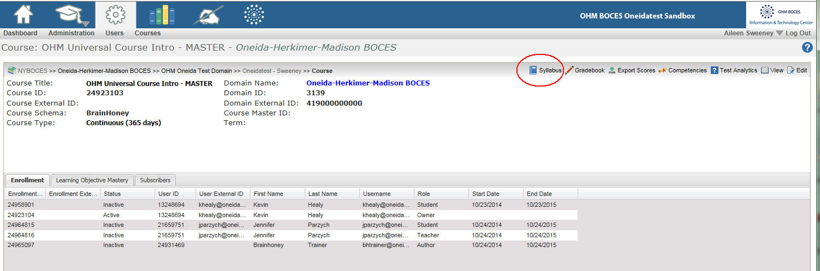

Navigate to the HTML folder
In the Syllabus View, on the right side panel are the Course Files.
If there is no folder named HTML, then you are going to create one when you upload the css import file.
If an HTML folder already exists, click on the arrow next to it to see its content sub-folders and files.

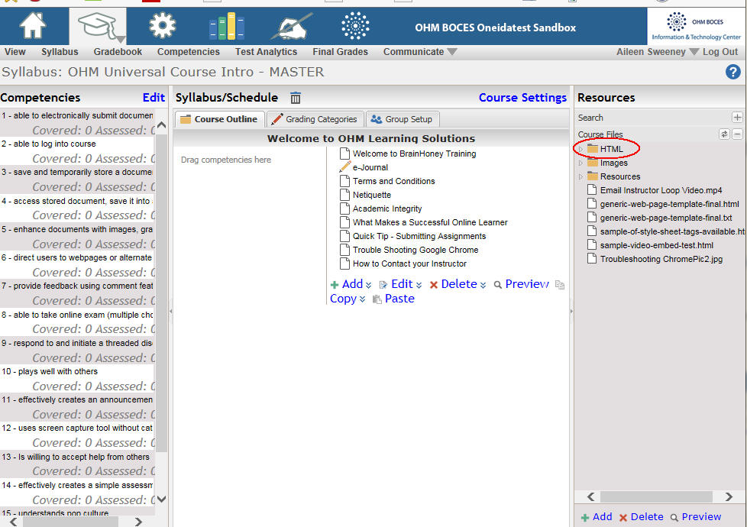

Navigate to the css folder
If there is no folder named css, then you are going to create one when you upload the css import file.
If and css folder already exists, click on the arrow next to it to see its content file.
If you need to overwrite the existing file or if you need to create the new css folder and upload the import.css file, this is where you have to be to do that.
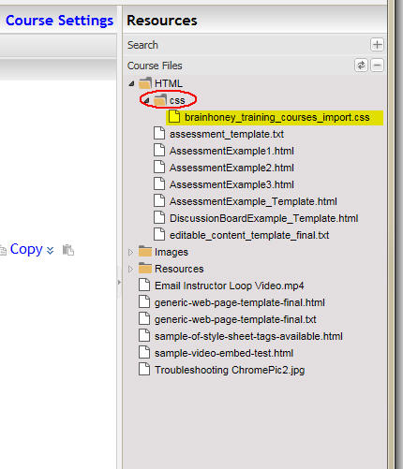

Use the Add function to upload the css import file.
The Add icon is on the bottom of the right panel. Clicking on it will bring you to a popup window where you can upload your file.
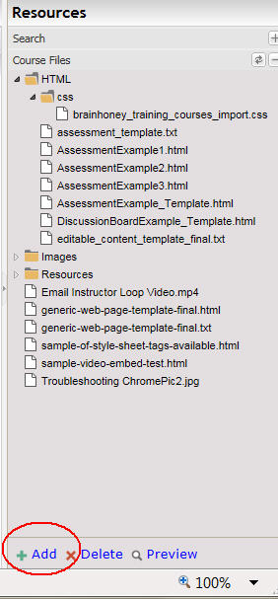

Add File Popup Window
The first time the window opens, the sub-folders will not be opened to show you the contents of them. You can click on them to navigate to the sub-folder where you want to put your file. For the css file, it should always be placed in this path HTML/css. You can click on the arrow next the HTML folder to drill down into the css sub-folder.
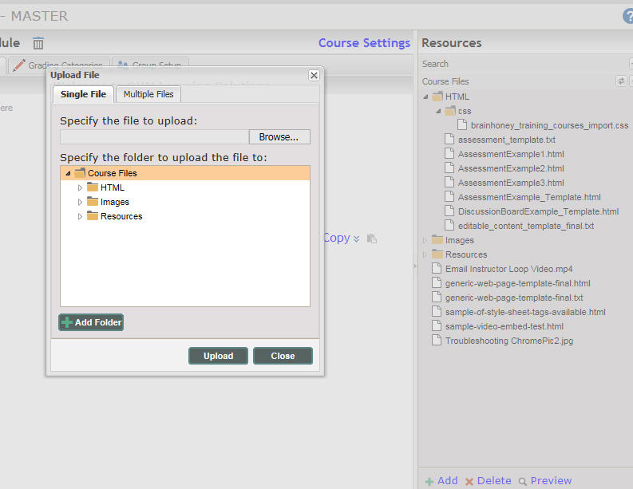

Locate the css sub-folder and open it.
You can click on the arrow next the css folder to drill down into the sub-folder.
If you have to create either the HTML and/or the css folder, make sure you use the exact CASE that is shown in these examples. HTML is all uppercase and css is all lowercase.
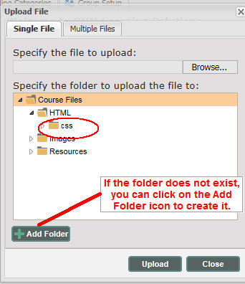
When you are positioned where you need to be, click on the Browse button to navigate to the area of your pc where you copied the brainhoney_training_courses_import.css file and then click the Upload button.
If you get a popup window asking you if you want to overwrite the file, click yes. You will only need to upload this file once per Course.

Course Settings
The Course Settings need to be setup using the following options.
Click on the Course Settings to make those adjustments.
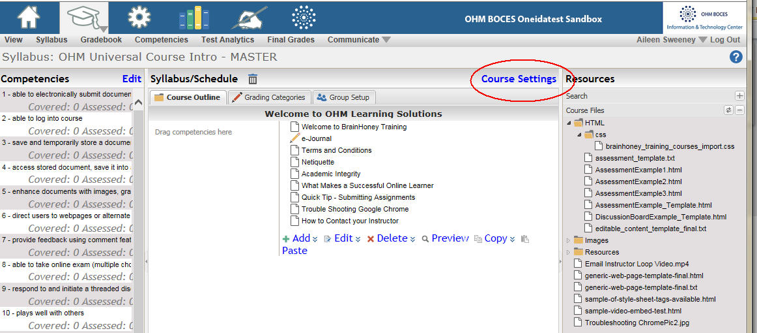

Course Settings Popup Window
A popup window allows you to set the Course Settings. Make sure that the checkbox for Use a course stylesheet is CHECKED. If this is the first time one has been setup for the course, you will need to select the style file. Select the file from the pulldown menu that you uploaded in the previous steps.
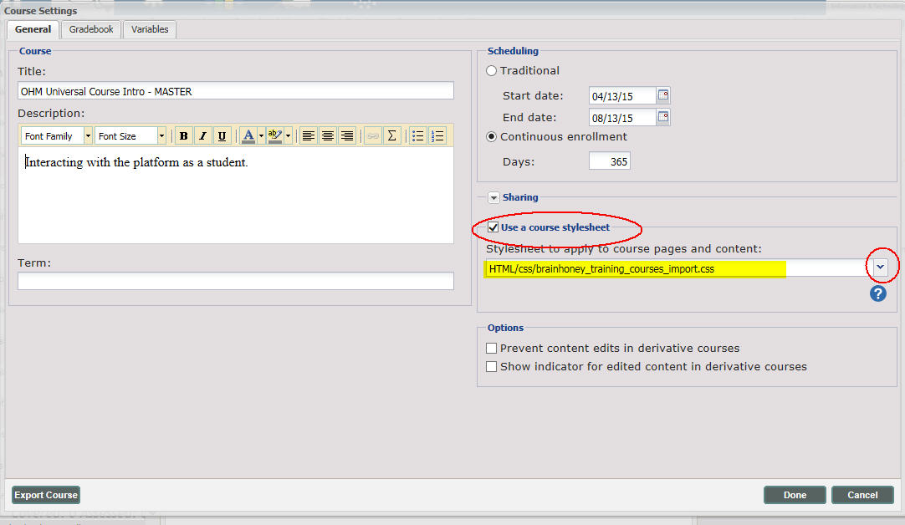

Styles Pull Down Menu
After checking the Course Settings to use a stylesheet, you will now be able to see a Styles pull down menu in the Editable Content windows.
*** Note – The Styles Pull Down menu does NOT work in Chrome or Firefox. It will work in Internet Explorer.
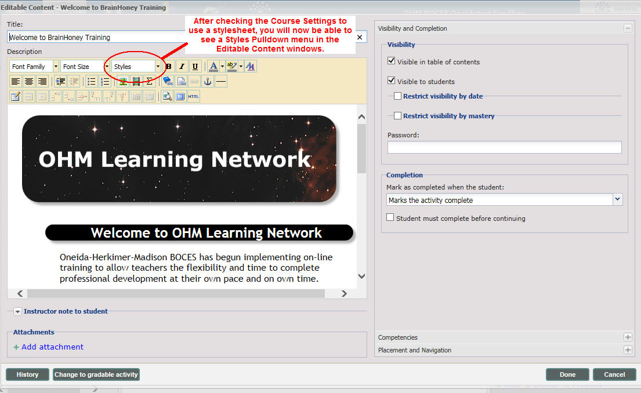

Managing Course Customization Source Files
There are basically three types of customization files that can be uploaded or pasted into a course object and/or html page.
Editable Content
HTML files for Assessments
HTML stand-alone files

The raw html code needed to this is slightly different for each of these types of source files. In addition, once you have created an Editable Content object and pasted in the html, the BrainHoney TinyMCE editor modifies the html and removes all line breaks. This makes it very difficult to go back to edit the HTML again.

Source File Backups
It is highly recommended that all html based content that is used in a course be placed on the common share as .txt files. This will preserve the code layout and make it easier to re-edit the code if needed.
Course content files should be stored on the current BOCES common drive path:
F:\Office\Common\eLearning\Brainhoney administration\Coding\source-code
In the above folder, there are sub-folders by subject, grade level and course name.

Subject Area folders
Subject areas include the following topics. Courses should be stored in the appropriate subject area folder.
ela
math
professional-development (for Jen’s BrainHoney training courses, etc.)
science
social-studies

Grade Level folders
Each course can be further sub-categorized by grade level.
For example, all grade 2 math files would then be located here:
F:\Office\Common\eLearning\Brainhoney administration\Coding\source-code\math\grade2
Sample folder structure and names
math/grade-p
math/grade-k
math/grade-1
math/grade-2
math/grade-3
math/grade-4
math/grade-5
math/grade-6
math/grade-7
math/grade-8
math/grade-9

Course Modules/Topics folders

Each course can be further sub-divided with folders for each course Module/Topic within the course

Module/Topic Folder and Filename Naming Conventions

Naming conventions for the source-code .txt files should be followed so that it is easy to correlate the backup filenames on the common drive with the actual BrainHoney Course Module and Activity.
In the professional development sample course use in these examples, there was only one Module so I did not create a sub-folder for just that module. For other courses, I would recommend creating a sub-folder for each BrainHoney MODULE name.
I used the exact name (including case and spaces in the activity name) that appeared in the Activity title bar for the name of the corresponding customized .txt file.
Before modifying an existing Activity’s content, you need to make a backup of the Activity code. Edit the Activity in BrainHoney and click on the TinyMCE html icon. Copy the source html code to your clipboard and then paste into a blank Notepad file. Save the backup of the file by using the phrase –original appended to the file name. Save the file with a file extension of .txt.
The backup file contains the jumbled html code that was copied from the TinyMCE html editor. Although the files contain html, name them with an extension of .txt. It is easier to open the code in Notepad and copy and paste back into the TinyMCE html editor.
Before you copy your new .txt file content, to paste into the TinyMCE html window, make sure that your Notepad option has Word Wrap turned off.

Sample Backup Names
See sample backup filenames for the Course OHM Universal Course Intro – MASTER
Here are the BrainHoney Activity Titles
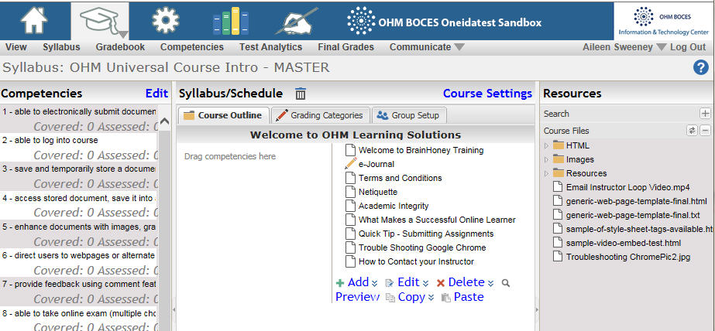

Here are the BrainHoney Activity Title backup filenames on the common drive
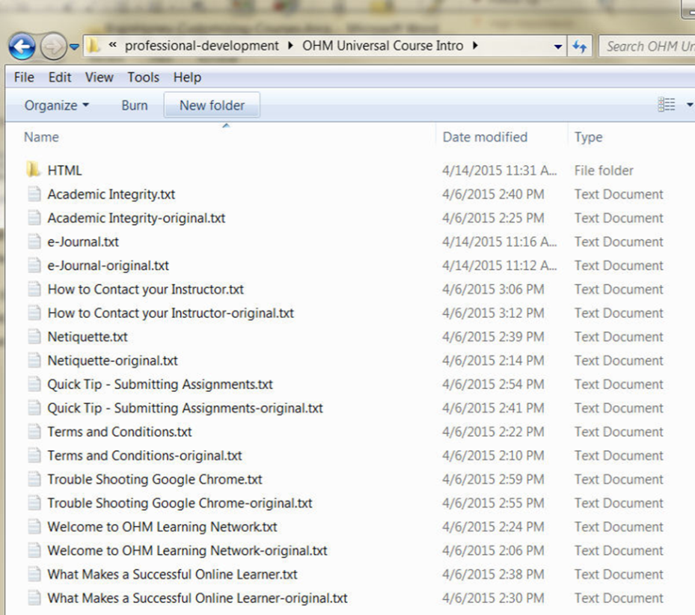

Types of HTML Files

There are different types of html files and Activity related code that can be stored on BrainHoney:
- Editable Content

- HTML files for Assessments which are associated with an Activity using the DLAP putitems command.

- HTML stand-alone files

Sample files for customization
Various sample html files for customization are available here:
F:\Office\Common\eLearning\Brainhoney administration\Customizing-Courses-files\Sample-files-for-courses
Make sure that you use the sample that matches your subject area. The Banners for each subject area are different and are coded into the sample html files. In addition, make sure that the sample you select to use matches the CSS style sheet for that subject area.

CSS Banner Tags
If you are not seeing the expected Course image banner for your course, it could be that you are using the wrong sample html files. Refer to BrainHoney Training Common Banner Images to see the filenames for the various BrainHoney Training courses. You also should verify that you are using the correct banner CSS Class tag for the header. Here are the current available tags:
Course Title | CSS tag | CSS File
OHM Universal Course Intro | banner_for_ohmlearning_network | brainhoney_training_courses.css
BrainHoney Training: Basic Authoring – MASTER | banner_for_course_authoring | brainhoney_training_courses.css
BrainHoney Training: Digital Library and Test Banks | banner_for_course_digital_library | brainhoney_training_courses.css
BrainHoney Training: Intermediate Authoring | banner_for_course_intermediate_authoring | brainhoney_training_courses.css
BrainHoney Training: Interacting with the Platform as a Student (Student View) | banner_for_course_student_view | brainhoney_training_courses.css
 | banner_for_course_math | common_core_math.css

OHM Learning Network Banner banner_for_ohmlearning_network
A sample web page file is available for you to copy, upload and view. This web page shows all the various stylesheet tags applied all on one web page. The name of the file is sample-of-style-sheet-tags-available.html
See
F:\Office\Common\eLearning\Brainhoney administration\Customizing-Courses-files\Sample-files-for-courses\course-customization-BT-OHM-Universal-Course-Intro\sample-of-style-sheet-tags-available.html

HTML stand-alone files

You can create a stand-alone web page and upload it to the Course Files folder.
Then you can create an Activity, in the Syllabus, that LINKS to that html file. This type of file will require the starting <html> tags, the body html and the closing footer tags to the ending </html> tag.
See Appendix C for a sample of the code to use on an Independent Stand-alone Web Page which is also referred to as a generic html web page.

Editable Content Area
The editable content Object allows you to view and edit the raw html of the content.
See Appendix B for a sample of the code to use on an Editable Content - Html Code.
For an existing activity, you can edit the object and then click on the HTML icon in the TinyMCE editor. This will pop up a window that contains the existing html content.

TinyMCE Editor Icon for HTML
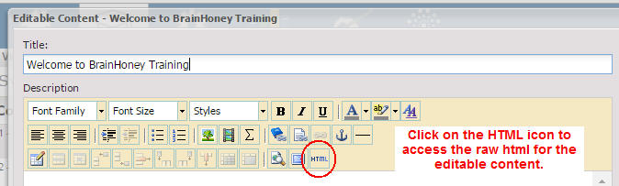

First make a copy of all the content in the Activity to create a backup .txt version of the Activity. Save the backup to the course’s common share Module folder.
It is suggested that you make edits using Notepad and save the .txt version to the common share folder. The Notepad version is easier to edit. If this is a brand new Activity, you can start with the template for editable content.

Sample Editable Content files are available for each course.
The sample for the OHM Universal Course Intro is stored here:
F:\Office\Common\eLearning\Brainhoney administration\Customizing-Courses-files\Sample-files-for-courses\course-customization-BT-OHM-Universal-Course-Intro\HTML\editable_content_template_final.txt
If you make edits in the TinyMCE file, you will not have a file that is easy to modify. The TinyMCE editor removes all the line breaks in the resulting html and that makes it very difficult to read and edit.

TinyMCE Editor HTML Popup Window

In the popup window, scroll to the top and highlight all the text down to the very bottom. Paste in the content from your clipboard. Then click on the Update button.
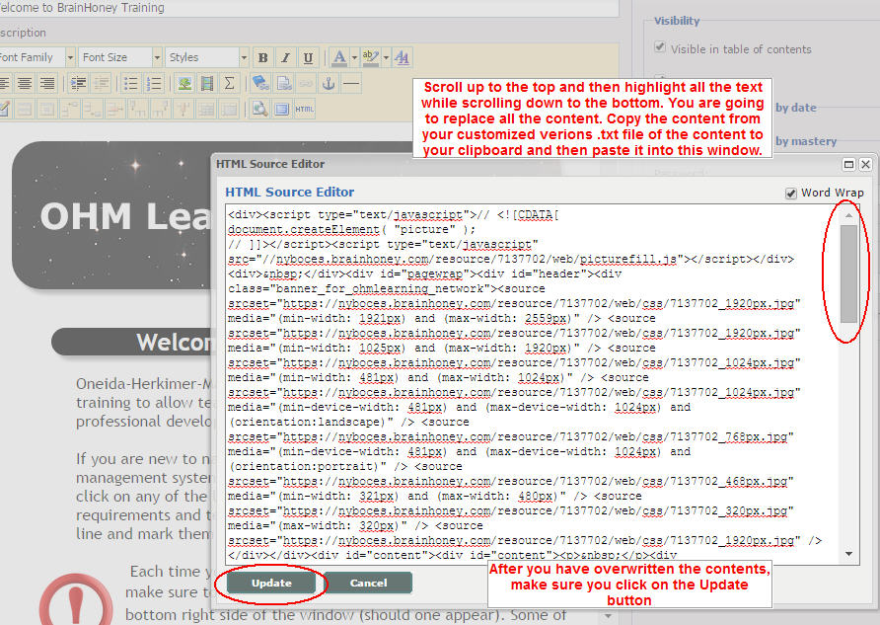
Click on the Done Button to finish with your changes.
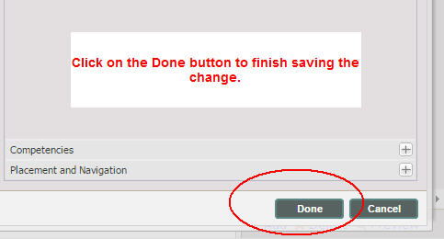

Editing Existing Content
Because most content was created prior to setting up CSS style sheets, the existing html for Editable content will contain text formatting that does not match our style sheet.
You can see this in the html view with tags that might look like this:
<span style="font-family: 'trebuchet ms', geneva; font-size: 12pt;">
See sample existing screenshot that has not been customized yet.
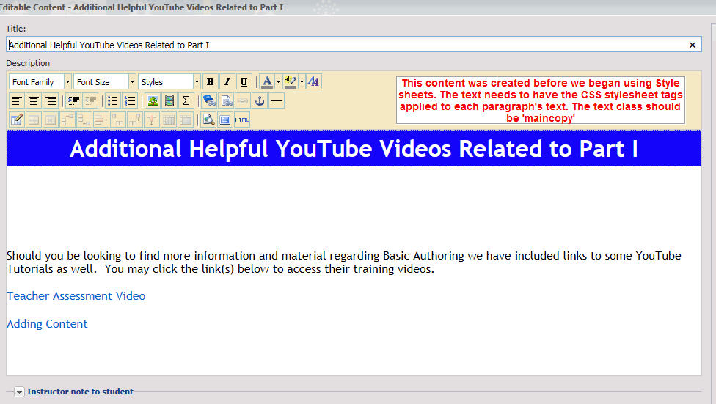
Step 1. It is recommended that you copy the backup .txt file to a new Notepad file to do your edits.
For example, you would save the file with this filename:
Additional Helpful YouTube Videos Related to Part I-original.txt

Step 2. Open a new Notepad file and copy the html to the new file. Save the file with this name
Additional Helpful YouTube Videos Related to Part I.txt
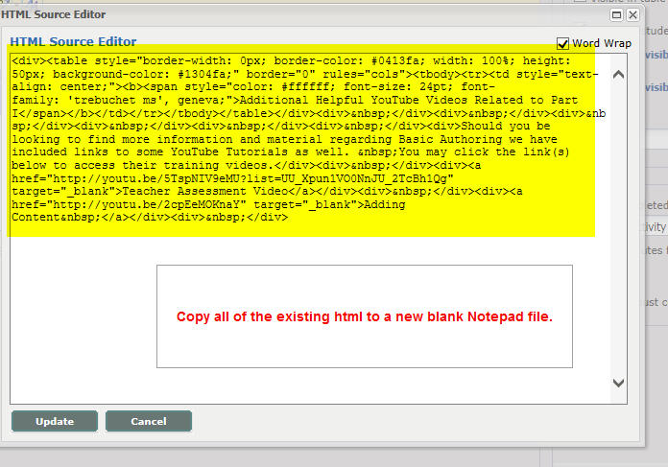

Step 3. In the new file which you saved in Step 2, format the html by entering line breaks on the html tags. That way you will better be able to see the starting and ending tags and remove those that do not apply. See this sample of the html code after line breaks have been added.
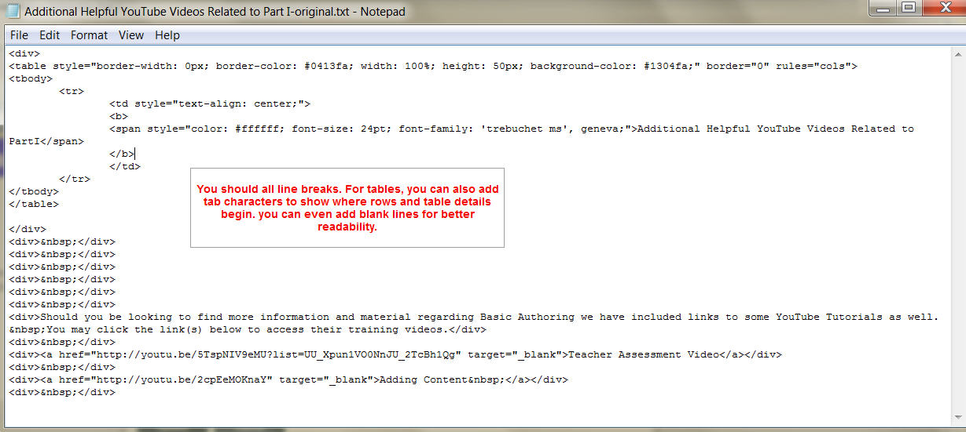

Step 4. Copy the top Customization Code.
Open your copy of the editable content sample file. You will copy code from that into the file you saved above. See filename editable_content_template_final.txt. You will copy up to a specific point in the template file to get the front end code needed for you editable content customization. See sample below:
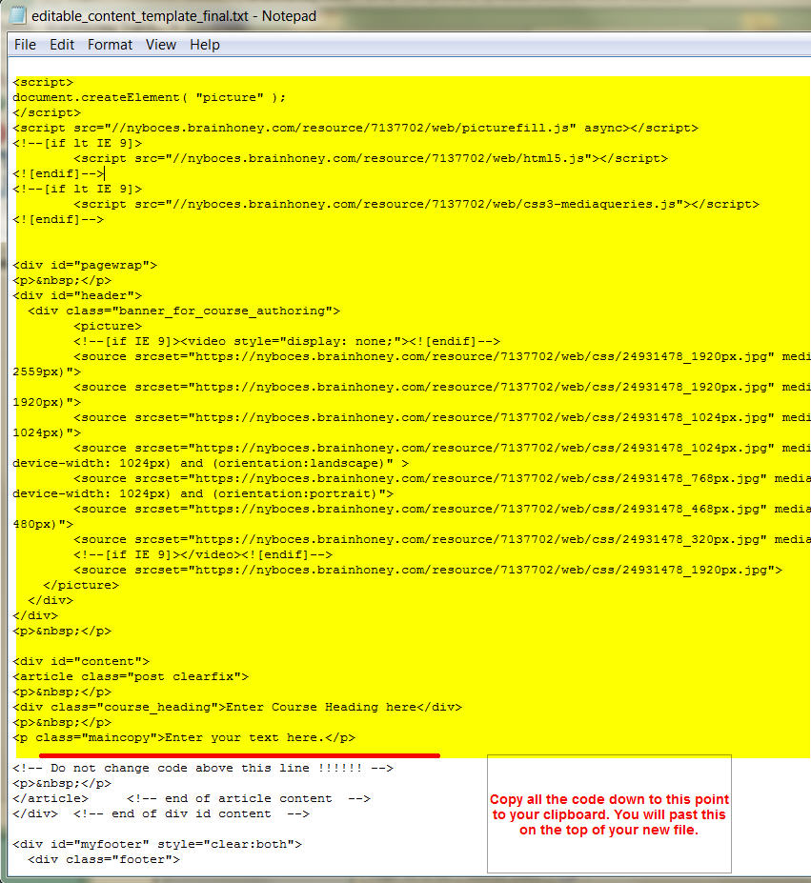

Step 5. Make room for the Top customization code
Using the html on your clipboard, go to the first line of your file. If there is no blank line at the top of the file, add a few. Paste in the content from your clipboard.
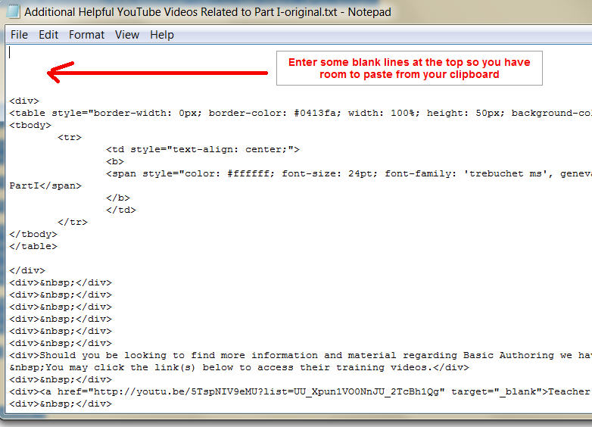

Step 6. Paste the Top customization code into your new file.
Paste the template customization html code from your clipboard html at the top of your new file.
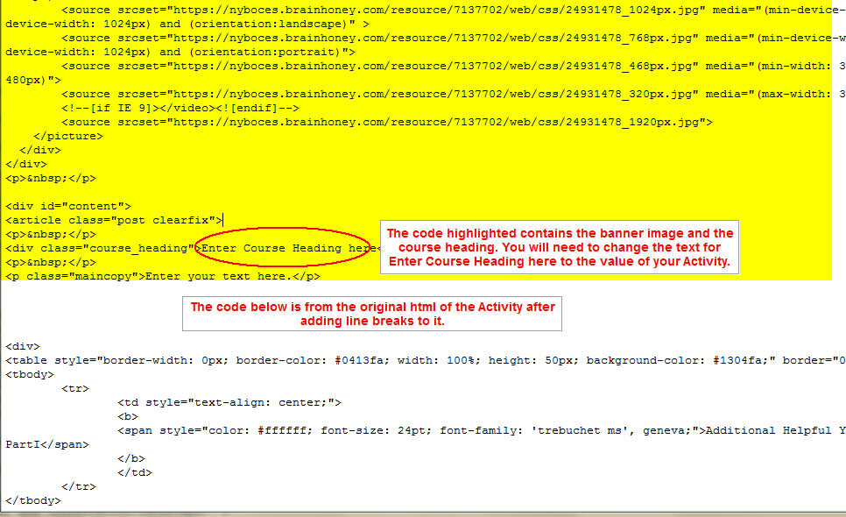

Step 7. Copy the bottom/footer Customization Code.
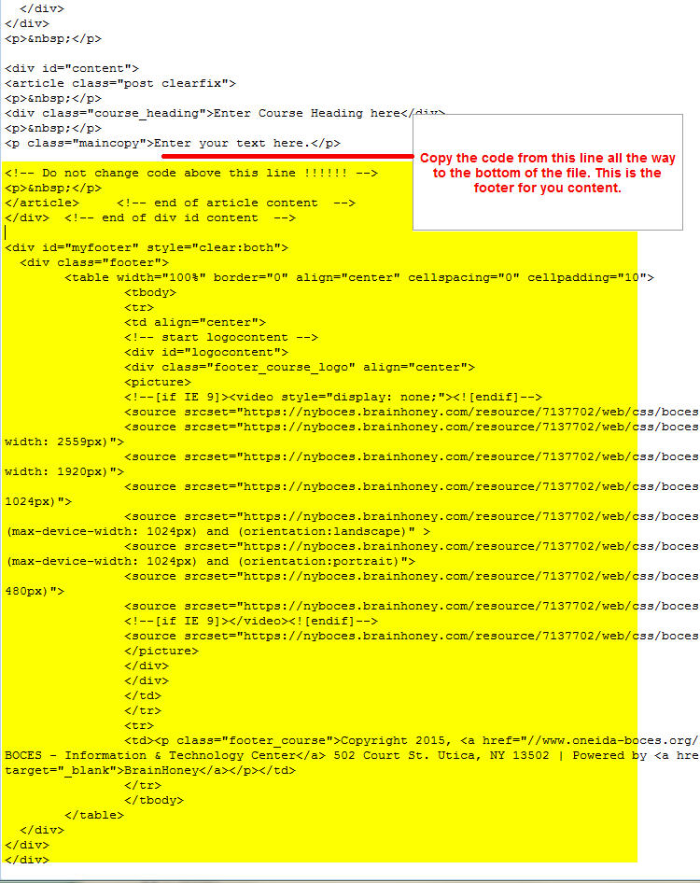

Step 8. Paste the Bottom/footer customization code into your new file.
If there are no blank lines at the bottom of the new file, add a couple so you have room to do the paste. Paste the template customization bottom html code, from your clipboard, to the bottom of your new file.
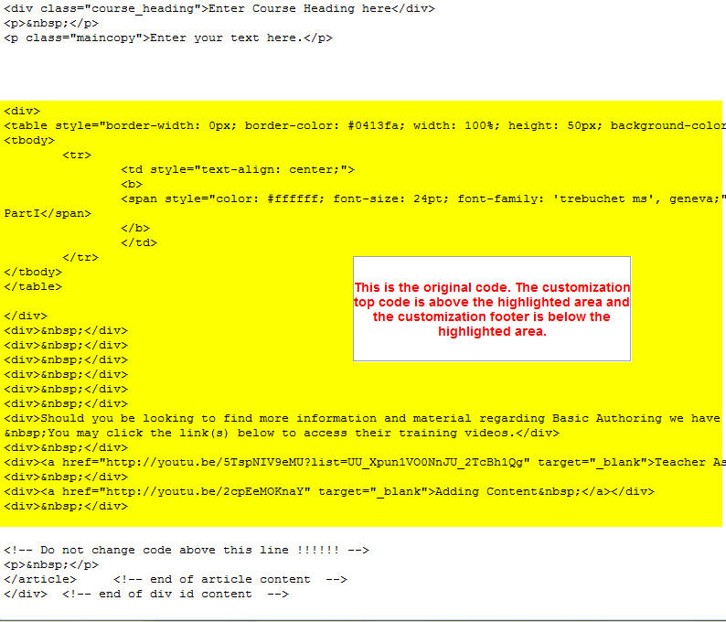
Step 9. Review the existing Activity code for further changes.
In the sample shown, there was a table that contained the Activity title. This entire table can be deleted because it is replaced with the course_heading class. You will need to edit the text for ‘Enter Course Heading here’. You should also remove unnecessary span tags that contain font specification and replace them with the class=”maincopy” tag. When you are removing tags, make sure you removed the code up to and including the matching end tag. End tags begin with </
For example, if you are going to remove the content from a starting <div> tag, you need to remove it down to and including the matching end </div> tag. You can also remove extra div tags that were just used for spacing. They would look like this. <div>&nbsp;</div>
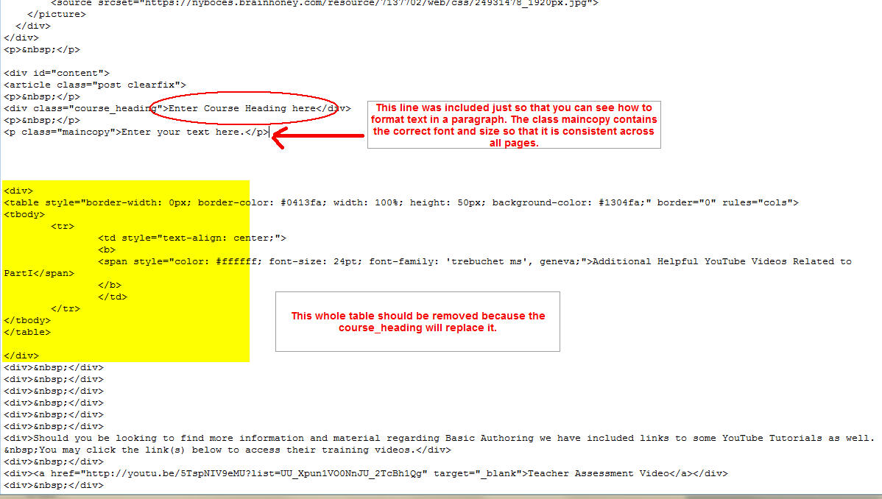

Step 10. Save your code in the .txt file and copy and paste it into the HTML source popup window. Click on the Update button to save the change.
Save your code and then paste it back into the BrainHoney html window to review the results.
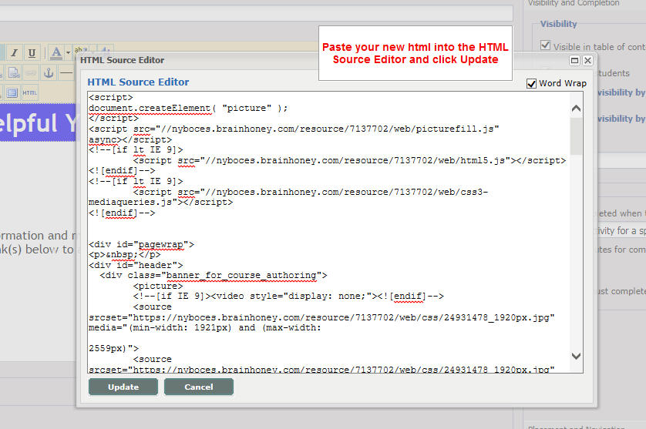

Step 11. Review the result and click Done to save the changes.
If you need to edit more, always edit back in your new Activity .txt file and paste back into the html window. This is how you can refine the html best and keep a copy that is easy to read and edit. Your .txt file becomes the source original master.
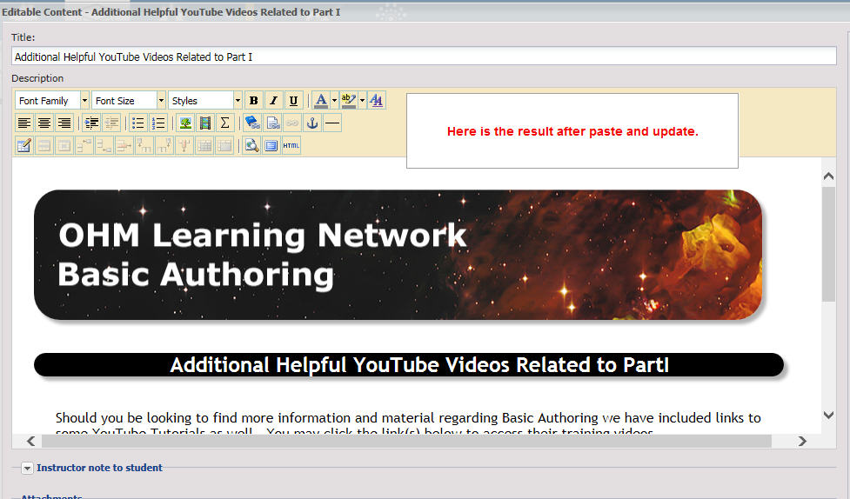

HTML Files for Assessments

The course sample that we have been using for sample code does not contain any Assessment Activities. Therefore, a sample will be shown from BrainHoney Training: Basic Authoring – MASTER course.

Creating a customized Assessment activity uses code that is for a full web page display and they will need the html start and header tags.

Customizing Assessment also requires extra steps to implement it fully.

Assessment Files for Non-Standard Assessments (html content by Questions)

An assessment may already be associated with an existing hmtl file. The html file needs to be modified to include the customization code. Performing this edit would be similar to the process followed for creating an Editable Content file. For existing html pages already associated with an Assessment, you will need to get the original html code. The code could be stored on the common share or it could only exist in BrainHoney. Normally it would be located under the Course Files right panel in the HTML folder.
You can download a copy by using the ftp command. That way you would have the original formatting including line breaks. The other option is to Preview the file and View the Source. You can then copy the source code to a blank .txt file, add line breaks and continue the customization from there.
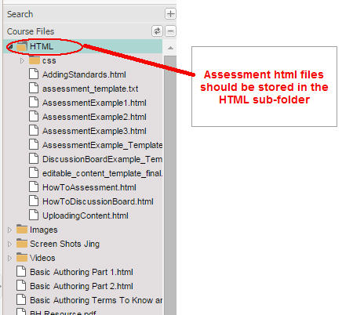

Filenaming Conventions
It is important to name your corresponding .html files with the same Title text as the Assessment that it represents. Below is an example of where the filename does not match the Assessment Title. Because this Assessment was previously associated using a DLAP command, it would be best to modify the Title in the Assessment Edit screen to match the phrase of the actual .html file.
The .html files should match the Title except space characters should be removed from the filename.
In this instance, the Assessment Title should be changed to “Adding Standards”.
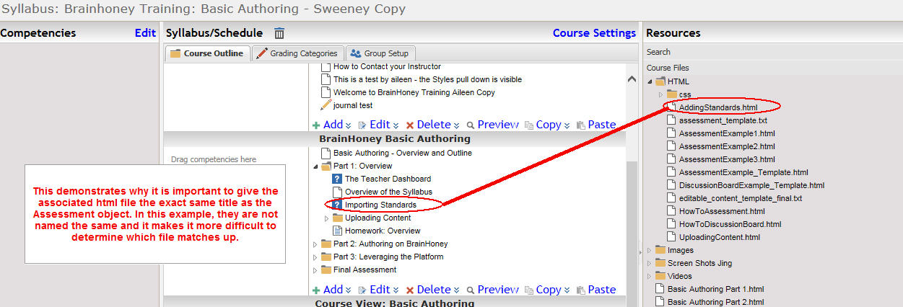

How to Add Questions
On the Questions Tab, click on the Add sign to start adding questions
Select the Question type from the top bar - Multiple Choice is a sample type
Click on the text icon to begin typing in your question and then hit the enter key
Type in the answer(s)
If your question is a multiple choice question, click on one of the radio buttons to pick the correct answer.
Then click Done

You could select your questions from a question bank by....
Click on the phrase 'Question Banks' in the upper right tab
You can click on 'More Banks' to find questions.
In the Find a course popup window, that contains more question banks, enter the text
nys and then check the box to Search all Domains and finally, click on the Find button
Then select the Test Bank that you are looking for on the right side of the screen, in that panel you can select the question you want to use.
Then click Done

Assessment Template Files for Standard Assessments (Video followed by Questions)

Sample files for customization are available here:
F:\Office\Common\eLearning\Brainhoney administration\Customizing-Courses-files\Sample-files-for-courses
See assessment_template.txt for a template that displays a video followed by questions.

Open your copy of the editable content sample file. You will copy code from that into a new file which you will save as both a .txt and .html file.
The assessment_template.txt file contains all the code for full web page including the starting html and header tags.
Refer to Appendix D for a sample Assessment template file

Modify the Title
<title>Enter Your Title Here</title> (replace with the title of your Assessment Activity – this should match the value in the Assessment Title)

Modify the Course Heading Value
<div class="course_heading">Enter your Assessment Title Here</div> (replace with the title of your Assessment Activity – this should match the value in the Assessment Title)

Modify the Video iframe Parameter Values if the assessment uses a video
If your assessment uses a video, you will need to modify the parameters for the iframe. If your assessment does not contain a video, delete the iframe code and replace it with your assessment unique text and images.
Modify the type and DM number.
There are two types of videos that are used in TOMMs.
Make sure that your value matches the correct video type as it appears in the TOMMs Share window.
If you make the wrong designation, for example you use open when the video is really exclusive, it WILL NOT PLAY in BrainHoney.

Private videos contain the following in the src parameter value: /exclusive/
Public videos contain the following in the src parameter value: /open/

<iframe width="710" height="458" src="https://webmax.oneida-boces.org/tomms2/index.php/snap/player/open/DM28027/embed" frameborder="0" allowfullscreen></iframe>
Replace the iframe parameters with the correct values for your video – if the video shows open in the TOMMs Share window, make sure your replacement code matches it – replace the video DM number with your video’s DM number.

Below is the SNAP/TOMMs display for an open public video
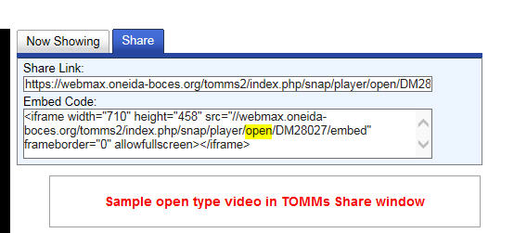
Below is the SNAP/TOMMs display for an exclusive private video
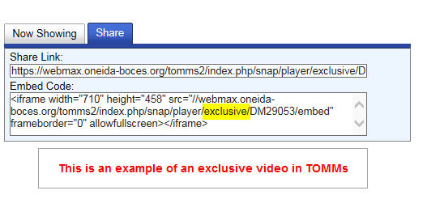

Modify the number of questions to match the number of questions in your Assessment.
Assessment objects can contain all types of html tags.
For most courses, assessments will consist of a TOMMs video, in and iframe, followed by the assessment questions. These can all be customized by creating a web page (.html file) and associating it with the assessment object ID number through a DLAP command.
Each assessment can have from 1 to N questions. Your code should match the number of questions used in the activity. The template was setup to show 4 questions. If your assessment uses less than 4, delete the questions that are not used. If it uses more than 4 questions, copy question 3 and modify the copied 3 to change its number to 4 and increase the index of the last question to 5.
This is the pattern of the existing template. Each question is followed by a course_ruler and a paragraph tag. The last question is NOT followed by a paragraph tag.

<a:question index="1"/>
<div class="course_ruler"></div>
<p>&nbsp;</p>

<a:question index="2"/>
<div class="course_ruler"></div>
<p>&nbsp;</p>

<a:question index="3"/>
<div class="course_ruler"></div>
<p>&nbsp;</p>

<a:question index="4"/>
<div class="course_ruler"></div>

Save your Assessment as both a .txt and html file and upload the html file to the HTML sub-folder
Save your new file and name it to match the assessment. Save 2 versions of the file, one as .txt and the other as .html - Both files should have the exact same name except the file extension will be different for each. Always keeps these files in sync if you make changes in the future. Make changes in the .txt version and save it as both .txt and html every time that you edit it. Upload the .html version to the Course Files.
Below is a screenshot of how to save your file as a .txt file.
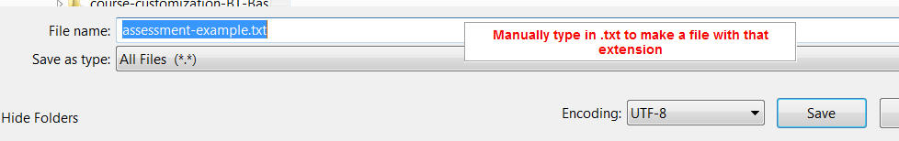
Below is a screenshot of how to save your file as an .html file.
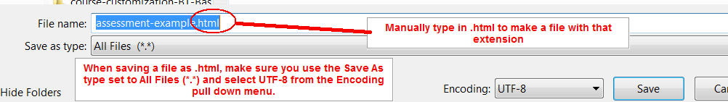

Upload the new html file to the HTML folder
Upload your new file .html version of the file to the Course Files in the HTML sub-folder.
To do this, Click on the Add icon in the lower right of the Course Files panel.
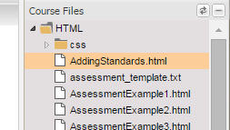

If the file already exists, you will get a popup asking if you are sure. Click Yes.
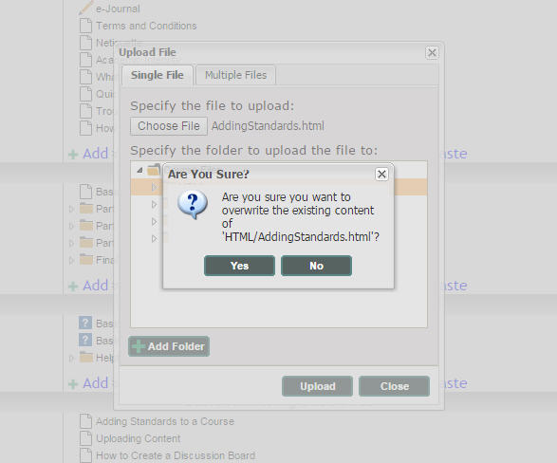

Preview the changes
Preview your change by clicking on the filename and then clicking on the Preview link in the lower right of the Course Files panel. Continue the process until you are satisfied with your results.
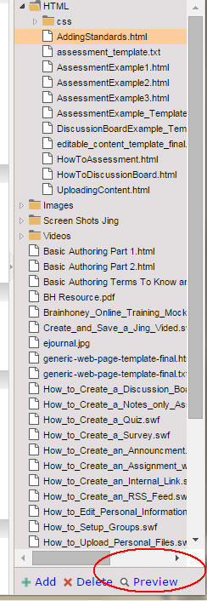
If the Preview popup window does not appear to show your changes, right mouse click in the popup window and select Reload Frame.
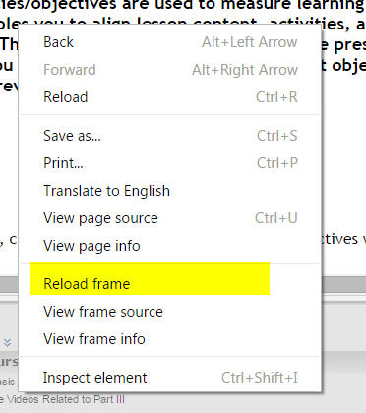
Repeat the process of editing the .txt file, saving the file as .html and uploading to the HTML folder until you are satisfied with the changes.

Assessment Settings
In BrainHoney, you need to use the Assessment Settings in the right panel, on the Assessment’s Properties tab, to do the following:
1. Uncheck Allow Save and Continue
2. Uncheck Randomize Question Order
3. Check Auto start

Find the ID of your Assessment Object
You will need to know the ID of the course item you created. It will need to be associated with the assessment html file you created in the previous section. This association is created by executing a DLAP command. Only BrainHoney Administrators have the permissions needed to access the DLAP commands.
Double Click on the name of your Assessment Title in the Syllabus window.
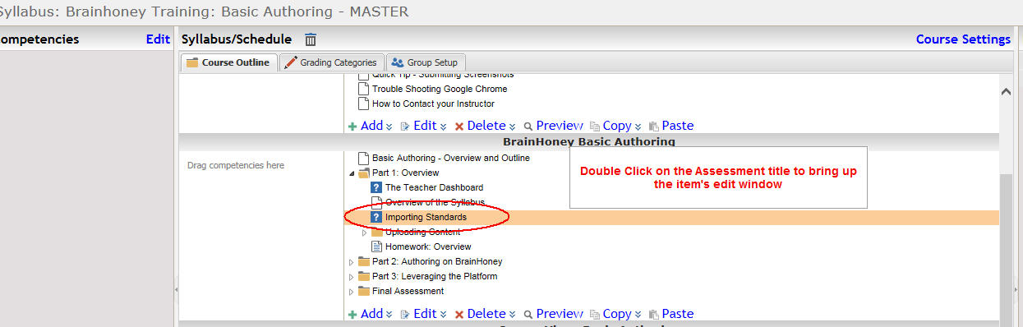

In the lower right panel is a tab named Placement and Navigation. Click on that tab bar.
Click on the Placement and Navigation Menu
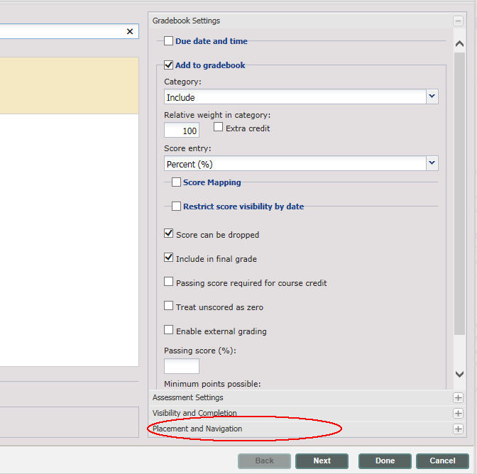

The placement and navigation panel will open and show the Module Pulldown menu with your Module pre-selected in the pulldown.
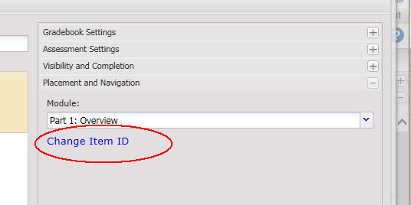
Under that menu are the words Change Item Id. That is a hotlink that will pop up a window with your Item Id prepopulated in the text box. Use control-c to copy the value in the box to your clipboard. This will be needed for the DLAP command. This is the value that will replace the text in the itemid DLAP template.
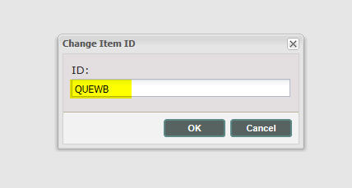
QUEWB

Get the ID of your course
Use the Top Menu Gear to return to your BrainHoney administrative screen.
Click on Find a Course.
In the popup that appears, Click on Find. You do not have to enter any Title or Id if you know the course is in your subdomain.
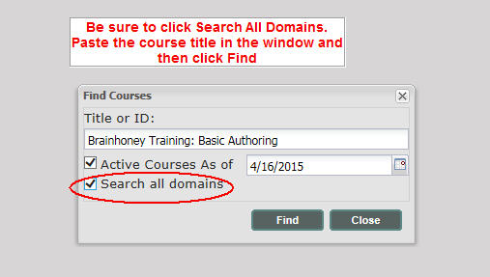
A list of courses in your subdomain will be displayed if you did not check the box to Search all domains. If nothing appears, make sure you are positioned in the correct subdomain hierarchy.
Double click on the Course Title. In the Course Detail Window, put your cursor over the number that appears next to the Course ID:
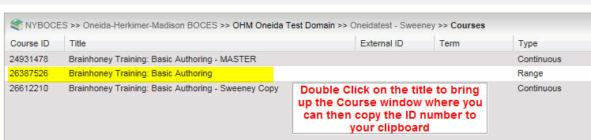

Use control-c to copy that number to your clipboard.
Our example Course ID is 24931478

DLAP Command for Assessment Associating

Modify the Sample DLAP template

Sample file for DLAP are available here:
F:\Office\Common\eLearning\Brainhoney administration\Customizing-Courses-files\Sample-files-for-courses
See assessment_template.txt for a template that displays a video followed by questions.

Refer to Appendix E for DLAP sample file information

Below is the sample DLAP template. You will need to replace the content of three items in the template with the id numbers and names of your course entity id, your html template filename and your Assessment object content id. Modify the name.html to the name of your html file.
The path to the HTML filename will always start with Assets/
Never change the front end before the first /
<requests>
<item entityid="course ID" itemid="assessment item ID" >
<data>
<examtemplate>Assets/HTML/name.html</examtemplate>
</data>
</item>
</requests>

Here is our edited version of the DLAP template using the course ID, Item Id and html template filename samples created.
<requests>
<item entityid=" 24931478" itemid="QUEWB" >
<data>
<examtemplate>Assets/AddingStandards.html</examtemplate>
</data>
</item>
</requests>

Save the file as assessmenttitle_dlap.txt, where you replace ‘assessmenttitle’ with the actual value in your Assessment Title bar. Save the file as a plain txt file. Make sure you add _dlap to the filename. You don’t want to overwrite your .txt version by mistake. The DLAP file has the same name but it has the additional suffix of DLAP appended to the filename. Our sample would be AddingStandards_dlap.txt

Email the DLAP file to the BrainHoney Administrators

Email that DLAP txt file to the BrainHoney email address
ohmbrainhoneyteam@oneida-boces.org

DLAP BrainHoney Administrator Functions

Execute the DLAP command to make the association
The following actions can only be performed by a BrainHoney user who has Administrative privileges.

Step 1. Access the DLAP web site
You must have administrative rights in BrainHoney to enter commands in this site.
Go to this web page.
http://gls.agilix.com/CallMethod.aspx

Step 2. Login to the DLAP web site
Click on the Login Button that on the right side of the DLAP screen.
This will pop a new window where you will login. Keep that window open while you return to the first DLAP screen.
Set the Method pulldown menu to POST
Set the Accepts pulldown menu to XML
Set the Content-Type pulldown menu to text/xml
Query-String text box - Enter the following command in the text box
putitems
POST Data - Paste your edited version of the Request portion of the template into the window in the textbox.
Click on Send Request
Notify the BrainHoney requestor that the DLAP command has been executed so that they can verify the Assessment appears as intended.

Preview after DLAP BrainHoney Administrator Functions

The BrainHoney Administrator should reply to your email to notify you that the DLAP command has been completed. You should then go back into the Syllabus and View the Course to verify that the Assessment is working as expected (including being able to click on the Submit button).
If there are errors in the html, the Submit function may not work correctly and that would require that you go back and re-edit the source code to correct the problem.
If you do not change the assessment filename or the object id, you do not need to resubmit a DLAP request.
You should View the Course to review the Assessment that you added or changed.
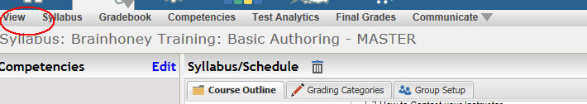
Make sure the Submit button works and if you have a video in your assessment, make sure that the video will play.
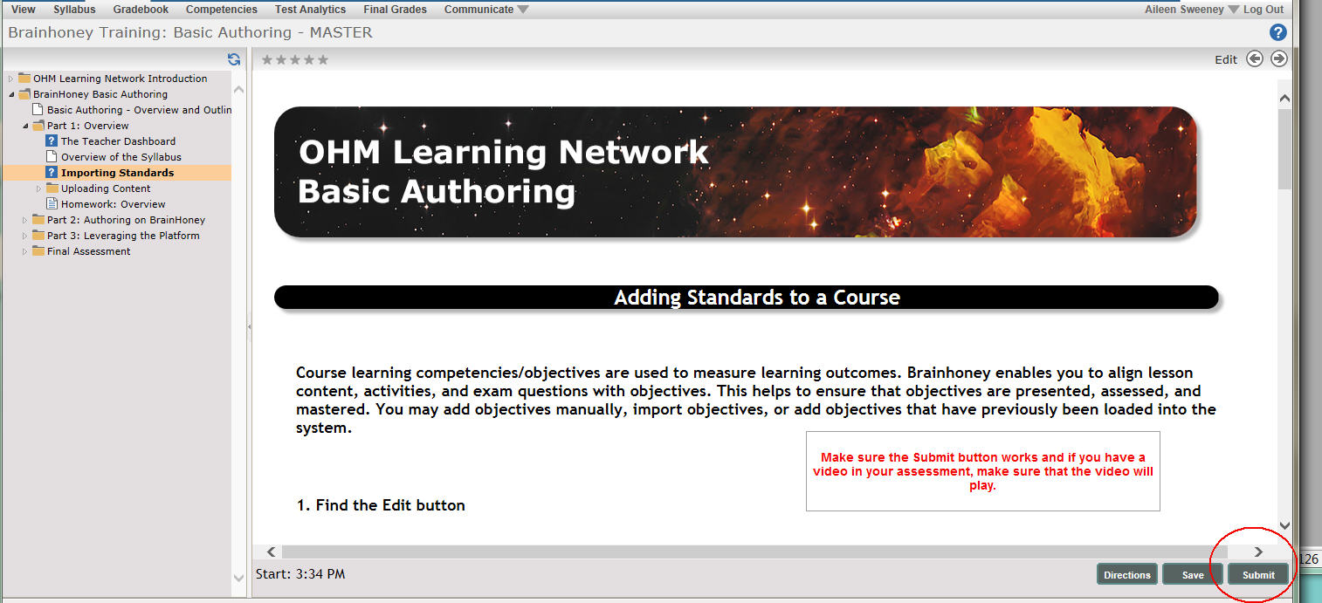

Preview Problems

If for some reason, the display does not work (nothing shows up for the Assessment), go back and review the email you sent to the BrainHoney administrator.
If the path to the file is not exactly the following structure, the display will not work.
Here is our edited version of the DLAP template using the course ID, Item Id and html template filename samples created.
<requests>
<item entityid=" 24931478" itemid="QUEWB" >
<data>
<examtemplate>Assets/HTML/AddingStandards.html</examtemplate>
</data>
</item>
</requests>

For example, if the /HTML/ was left out, in the command submitted by the BrainHoney Administrator, the display will fail.
Make sure that this path sample was followed in the DLAP command that you sent.
Make sure that the filename in the DLAP command matches exactly the filename that you uploaded.
Make sure that you actually uploaded the file to the /HTML folder in the Course Resources structure.
You made need to resend the DLAP command if it needs correcting for resubmission.

Appendix A – Sample HTML Files

Sample files for customization are available here:
F:\Office\Common\eLearning\Brainhoney administration\Customizing-Courses-files\Sample-files-for-courses
Make sure that you use the sample that matches your subject area. The Banners for each subject area are different and are coded into the sample html files. In addition, make sure that the sample you select to use matches the CSS style sheet for that subject area.
A sample file is available for you to upload and view. This file shows all the various stylesheet tags applied in one web page. The name of the file is sample-of-style-sheet-tags-available.html
See
F:\Office\Common\eLearning\Brainhoney administration\Customizing-Courses-files\Sample-files-for-courses\course-customization-BT-OHM-Universal-Course-Intro\sample-of-style-sheet-tags-available.html

Appendix B – Editable Content - Html Code
This sample may be used for editable content. You should save it in the back-ups folder both as .txt versions. Make a copy of the existing content so that you have a backup version. You will copy and paste the .html version to the Editable Content HTML popup window. Make sure that you are in the correct course before you copy the sample. There are different samples for each course.
See F:\Office\Common\eLearning\Brainhoney administration\Customizing-Courses-files\Sample-files-for-courses\course-customization-BT-OHM-Universal-Course-Intro\HTML\editable_content_template_final.txt
<script>
document.createElement( "picture" );
</script>
<script src="//nyboces.brainhoney.com/resource/7137702/web/picturefill.js" async></script>
<!--[if lt IE 9]>
<script src="//nyboces.brainhoney.com/resource/7137702/web/html5.js"></script>
<![endif]-->
<!--[if lt IE 9]>
<script src="//nyboces.brainhoney.com/resource/7137702/web/css3-mediaqueries.js"></script>
<![endif]-->
<div>&nbsp;</div>
<div id="pagewrap">
<div id="header">
<div class="banner_for_ohmlearning_network">
<picture>
<!--[if IE 9]><video style="display: none;"><![endif]-->
<source srcset="https://nyboces.brainhoney.com/resource/7137702/web/css/7137702_1920px.jpg" media="(min-width: 1921px) and (max-width: 2559px)">
<source srcset="https://nyboces.brainhoney.com/resource/7137702/web/css/7137702_1920px.jpg" media="(min-width: 1025px) and (max-width: 1920px)">
<source srcset="https://nyboces.brainhoney.com/resource/7137702/web/css/7137702_1024px.jpg" media="(min-width: 481px) and (max-width: 1024px)">
<source srcset="https://nyboces.brainhoney.com/resource/7137702/web/css/7137702_1024px.jpg" media="(min-device-width: 481px) and (max-device-width: 1024px) and (orientation:landscape)" >
<source srcset="https://nyboces.brainhoney.com/resource/7137702/web/css/7137702_768px.jpg" media="(min-device-width: 481px) and (max-device-width: 1024px) and (orientation:portrait)">
<source srcset="https://nyboces.brainhoney.com/resource/7137702/web/css/7137702_468px.jpg" media="(min-width: 321px) and (max-width: 480px)">
<source srcset="https://nyboces.brainhoney.com/resource/7137702/web/css/7137702_320px.jpg" media="(max-width: 320px)">
<!--[if IE 9]></video><![endif]-->
<source srcset="https://nyboces.brainhoney.com/resource/7137702/web/css/7137702_1920px.jpg">
</picture>
</div>
</div>
<div id="content">
<article class="post clearfix">
<p>&nbsp;</p>
<div class="course_heading">Enter Course Heading here</div>
<p>&nbsp;</p>
<p class="maincopy">Enter your text here.</p>

<!-- Do not change code below this line !!!!! -->
<p>&nbsp;</p>
</article> <!-- end of article content -->
</div> <!-- end of div id content -->

<div id="myfooter" style="clear:both">
<div class="footer">
<table width="100%" border="0" align="center" cellspacing="0" cellpadding="10">
<tbody>
<tr>
<td align="center">
<!-- start logocontent -->
<div id="logocontent">
<div class="footer_course_logo" align="center">
<picture>
<!--[if IE 9]><video style="display: none;"><![endif]-->
<source srcset="https://nyboces.brainhoney.com/resource/7137702/web/css/boces-logo-300.jpg" media="(min-width: 2560px)">
<source srcset="https://nyboces.brainhoney.com/resource/7137702/web/css/boces-logo-259.jpg" media="(min-width: 1921px) and (max-width: 2559px)">
<source srcset="https://nyboces.brainhoney.com/resource/7137702/web/css/boces-logo-259.jpg" media="(min-width: 1025px) and (max-width: 1920px)">
<source srcset="https://nyboces.brainhoney.com/resource/7137702/web/css/boces-logo-120.jpg" media="(min-width: 481px) and (max-width: 1024px)">
<source srcset="https://nyboces.brainhoney.com/resource/7137702/web/css/boces-logo-259.jpg" media="(min-device-width: 481px) and (max-device-width: 1024px) and (orientation:landscape)" >
<source srcset="https://nyboces.brainhoney.com/resource/7137702/web/css/boces-logo-120.jpg" media="(min-device-width: 481px) and (max-device-width: 1024px) and (orientation:portrait)">
<source srcset="https://nyboces.brainhoney.com/resource/7137702/web/css/boces-logo-89.jpg" media="(min-width: 321px) and (max-width: 480px)">
<source srcset="https://nyboces.brainhoney.com/resource/7137702/web/css/boces-logo-89.jpg" media="(max-width: 320px)">
<!--[if IE 9]></video><![endif]-->
<source srcset="https://nyboces.brainhoney.com/resource/7137702/web/css/boces-logo-225.jpg">
</picture>
</div>
</div>
</td>
</tr>
<tr>
<td><p class="footer_course">Copyright 2015, <a href="//www.oneida-boces.org/infotech" target="_blank">Oneida - Herkimer - Madison BOCES - Information & Technology Center</a> 502 Court St. Utica, NY 13502 | Powered by <a href="//brainhoney.com" target="_blank">BrainHoney</a></p></td>
</tr>
</tbody>
</table>
</div>
</div>
</div>

Appendix C – Generic Web Page - Html Code
This sample may be used for a stand-alone web page. You should save it in the back-ups folder both as a .txt and .html version. They should match but the only difference will be in the file extensions. You will upload the .html version to BrainHoney.
<!DOCTYPE html>
<html xmlns="http://www.w3.org/1999/xhtml" lang="en">
<head>
<title>Generic Web Page Template</title>
<meta name="viewport" content="width=device-width, minimum-scale=1.0, maximum-scale=1.0">
<meta name="viewport" content="width=device-width, initial-scale=1">
<meta http-equiv="X-UA-Compatible" content="IE=edge" />
<meta charset="utf-8">
<link rel="stylesheet" type="text/css" href="https://nyboces.brainhoney.com/resource/7137702/web/css/brainhoney_training_courses.css" />
<script>
document.createElement( "picture" );
</script>
<script src="//nyboces.brainhoney.com/resource/7137702/web/picturefill.js" async></script>
<!--[if lt IE 9]>
<script src="//nyboces.brainhoney.com/resource/7137702/web/html5.js"></script>
<![endif]-->
<!--[if lt IE 9]>
<script src="//nyboces.brainhoney.com/resource/7137702/web/css3-mediaqueries.js"></script>
<![endif]-->
</head>
<body>
<div id="pagewrap">
<div id="header">
<div class="banner_for_ohmlearning_network">
<picture>
<!--[if IE 9]><video style="display: none;"><![endif]-->
<source srcset="https://nyboces.brainhoney.com/resource/7137702/web/css/7137702_1920px.jpg" media="(min-width: 1921px) and (max-width: 2559px)">
<source srcset="https://nyboces.brainhoney.com/resource/7137702/web/css/7137702_1920px.jpg" media="(min-width: 1025px) and (max-width: 1920px)">
<source srcset="https://nyboces.brainhoney.com/resource/7137702/web/css/7137702_1024px.jpg" media="(min-width: 481px) and (max-width: 1024px)">
<source srcset="https://nyboces.brainhoney.com/resource/7137702/web/css/7137702_1024px.jpg" media="(min-device-width: 481px) and (max-device-width: 1024px) and (orientation:landscape)" >
<source srcset="https://nyboces.brainhoney.com/resource/7137702/web/css/7137702_768px.jpg" media="(min-device-width: 481px) and (max-device-width: 1024px) and (orientation:portrait)">
<source srcset="https://nyboces.brainhoney.com/resource/7137702/web/css/7137702_468px.jpg" media="(min-width: 321px) and (max-width: 480px)">
<source srcset="https://nyboces.brainhoney.com/resource/7137702/web/css/7137702_320px.jpg" media="(max-width: 320px)">
<!--[if IE 9]></video><![endif]-->
<source srcset="https://nyboces.brainhoney.com/resource/7137702/web/css/7137702_1920px.jpg">
</picture>
</div>
</div>

<div id="content">
<article class="post clearfix">

<!-- Do not change code above this line !!!!!! -->
<p>&nbsp;</p>
<div class="course_heading">Enter Course Heading here</div>
<p>&nbsp;</p>

<p align="left" class="maincopy">
HERE IS WHERE YOU START ENTERING WEB PAGE CONTENT
</p>
<p align="left" class="maincopy">The template can be used for any web page in the course </p>
<p>&nbsp;</p>
<p align="left" class="maincopy">This example hard codes the full url to the css style sheet
<br />
nyboces.brainhoney.com/resource/7137702/web/css/brainhoney_training_courses.css </p>
<p>&nbsp;</p>
<p align="left" class="maincopy">The images and the css style sheet are stored at the top nyboces subdomain content web/css folder
</p>
<p>&nbsp;</p>
<p class="maincopy">Below is the sample of the class course_ruler</p>
<div class="course_ruler"></div>
<p align="left" class="maincopy">
HERE IS WHERE YOU END ENTERING WEB PAGE CONTENT
</p>
<!-- Do not change code below this line !!!!! -->
<p>&nbsp;</p>
</article> <!-- end of article content -->
</div> <!-- end of div id content -->
<div id="myfooter" style="clear:both">
<div class="footer">
<table width="100%" border="0" align="center" cellspacing="0" cellpadding="10">
<tbody>
<tr>
<td align="center">
<!-- start logocontent -->
<div id="logocontent">
<div class="footer_course_logo" align="center">
<picture>
<!--[if IE 9]><video style="display: none;"><![endif]-->
<source srcset="https://nyboces.brainhoney.com/resource/7137702/web/css/boces-logo-300.jpg" media="(min-width: 2560px)">
<source srcset="https://nyboces.brainhoney.com/resource/7137702/web/css/boces-logo-259.jpg" media="(min-width: 1921px) and (max-width: 2559px)">
<source srcset="https://nyboces.brainhoney.com/resource/7137702/web/css/boces-logo-259.jpg" media="(min-width: 1025px) and (max-width: 1920px)">
<source srcset="https://nyboces.brainhoney.com/resource/7137702/web/css/boces-logo-120.jpg" media="(min-width: 481px) and (max-width: 1024px)">
<source srcset="https://nyboces.brainhoney.com/resource/7137702/web/css/boces-logo-259.jpg" media="(min-device-width: 481px) and (max-device-width: 1024px) and (orientation:landscape)" >
<source srcset="https://nyboces.brainhoney.com/resource/7137702/web/css/boces-logo-120.jpg" media="(min-device-width: 481px) and (max-device-width: 1024px) and (orientation:portrait)">
<source srcset="https://nyboces.brainhoney.com/resource/7137702/web/css/boces-logo-89.jpg" media="(min-width: 321px) and (max-width: 480px)">
<source srcset="https://nyboces.brainhoney.com/resource/7137702/web/css/boces-logo-89.jpg" media="(max-width: 320px)">
<!--[if IE 9]></video><![endif]-->
<source srcset="https://nyboces.brainhoney.com/resource/7137702/web/css/boces-logo-225.jpg">
</picture>
</div>
</div>
</td>
</tr>
<tr>
<td><p class="footer_course">Copyright 2015, <a href="//www.oneida-boces.org/infotech" target="_blank">Oneida - Herkimer - Madison BOCES - Information & Technology Center</a> 502 Court St. Utica, NY 13502 | Powered by <a href="//brainhoney.com" target="_blank">BrainHoney</a></p></td>
</tr>
</tbody>
</table>
</div>
</div>
</div> <!-- /#pagewrap -->
</body>
</html>

Appendix D – Assessment Template
This sample may be used for Assessment html web pages. You should save it in the back-ups folder both as a .txt and .html version. They should match but the only difference will be in the file extensions. You will upload the .html version to BrainHoney in the course files HTML folder.
Make sure you are using the current sample that matches your course.
Assessment templates are stored, by course, here:
F:\Office\Common\eLearning\Brainhoney administration\Customizing-Courses-files\Sample-files-for-courses
This sample shows 4 questions following the display of a video. You can add or remove the questions to match the number of questions in your Assessment.
<!DOCTYPE html>
<html xmlns="http://www.w3.org/1999/xhtml" lang="en">
<head>
<title>Enter Your Title Here</title>
<meta name="viewport" content="width=device-width, minimum-scale=1.0, maximum-scale=1.0">
<meta name="viewport" content="width=device-width, initial-scale=1">
<meta http-equiv="X-UA-Compatible" content="IE=edge" />
<meta charset="utf-8">
<link rel="stylesheet" type="text/css" href="https://nyboces.brainhoney.com/resource/7137702/web/css/brainhoney_training_courses.css" />
<script>
// Picture element HTML5 shiv
document.createElement( "picture" );
</script>
<script src="//nyboces.brainhoney.com/resource/7137702/web/picturefill.js" async></script>
<!--[if lt IE 9]>
<script src="//nyboces.brainhoney.com/resource/7137702/web/html5.js"></script>
<![endif]-->
<!--[if lt IE 9]>
<script src="//nyboces.brainhoney.com/resource/7137702/web/css3-mediaqueries.js"></script>
<![endif]-->
</head>
<body>
<div id="pagewrap">
<p>&nbsp;</p>
<div id="header">
<div class="banner_for_course_authoring">
<picture>
<!--[if IE 9]><video style="display: none;"><![endif]-->
<source srcset="https://nyboces.brainhoney.com/resource/7137702/web/css/24931478_1920px.jpg" media="(min-width: 1921px) and (max-width: 2559px)">
<source srcset="https://nyboces.brainhoney.com/resource/7137702/web/css/24931478_1920px.jpg" media="(min-width: 1025px) and (max-width: 1920px)">
<source srcset="https://nyboces.brainhoney.com/resource/7137702/web/css/24931478_1024px.jpg" media="(min-width: 481px) and (max-width: 1024px)">
<source srcset="https://nyboces.brainhoney.com/resource/7137702/web/css/24931478_1024px.jpg" media="(min-device-width: 481px) and (max-device-width: 1024px) and (orientation:landscape)" >
<source srcset="https://nyboces.brainhoney.com/resource/7137702/web/css/24931478_768px.jpg" media="(min-device-width: 481px) and (max-device-width: 1024px) and (orientation:portrait)">
<source srcset="https://nyboces.brainhoney.com/resource/7137702/web/css/24931478_468px.jpg" media="(min-width: 321px) and (max-width: 480px)">
<source srcset="https://nyboces.brainhoney.com/resource/7137702/web/css/24931478_320px.jpg" media="(max-width: 320px)">
<!--[if IE 9]></video><![endif]-->
<source srcset="https://nyboces.brainhoney.com/resource/7137702/web/css/24931478_1920px.jpg">
</picture>
</div>
</div>
<p>&nbsp;</p>
<div id="content">
<article class="post clearfix">
<!-- Do not change code above this line !!!!!! -->

<div class="course_heading">Enter your Assessment Title Here</div>

<p>&nbsp;</p>

<div align="center">
<iframe width="710" height="458" src="https://webmax.oneida-boces.org/tomms2/index.php/snap/player/open/DM28027/embed" frameborder="0" allowfullscreen></iframe>
</div>

<div class="course_ruler"></div>

<a:question index="1"/>
<div class="course_ruler"></div>

<p>&nbsp;</p>

<a:question index="2"/>
<div class="course_ruler"></div>

<p>&nbsp;</p>

<a:question index="3"/>
<div class="course_ruler"></div>

<p>&nbsp;</p>

<a:question index="4"/>
<div class="course_ruler"></div>

<!-- Do not change code below this line !!!!! -->
<p>&nbsp;</p>
</article> <!-- end of article content -->
</div> <!-- end of div id content -->

<div id="myfooter" style="clear:both">
<div class="footer">
<table width="100%" border="0" align="center" cellspacing="0" cellpadding="10">
<tbody>
<tr>
<td align="center">
<!-- start logocontent -->
<div id="logocontent">
<div class="footer_course_logo" align="center">
<picture>
<!--[if IE 9]><video style="display: none;"><![endif]-->
<source srcset="https://nyboces.brainhoney.com/resource/7137702/web/css/boces-logo-300.jpg" media="(min-width: 2560px)">
<source srcset="https://nyboces.brainhoney.com/resource/7137702/web/css/boces-logo-259.jpg" media="(min-width: 1921px) and (max-width: 2559px)">
<source srcset="https://nyboces.brainhoney.com/resource/7137702/web/css/boces-logo-259.jpg" media="(min-width: 1025px) and (max-width: 1920px)">
<source srcset="https://nyboces.brainhoney.com/resource/7137702/web/css/boces-logo-120.jpg" media="(min-width: 481px) and (max-width: 1024px)">
<source srcset="https://nyboces.brainhoney.com/resource/7137702/web/css/boces-logo-259.jpg" media="(min-device-width: 481px) and (max-device-width: 1024px) and (orientation:landscape)" >
<source srcset="https://nyboces.brainhoney.com/resource/7137702/web/css/boces-logo-120.jpg" media="(min-device-width: 481px) and (max-device-width: 1024px) and (orientation:portrait)">
<source srcset="https://nyboces.brainhoney.com/resource/7137702/web/css/boces-logo-89.jpg" media="(min-width: 321px) and (max-width: 480px)">
<source srcset="https://nyboces.brainhoney.com/resource/7137702/web/css/boces-logo-89.jpg" media="(max-width: 320px)">
<!--[if IE 9]></video><![endif]-->
<source srcset="https://nyboces.brainhoney.com/resource/7137702/web/css/boces-logo-225.jpg">
</picture>
</div>
</div>
</td>
</tr>
<tr>
<td><p class="footer_course">Copyright 2015, <a href="//www.oneida-boces.org/infotech" target="_blank">Oneida - Herkimer - Madison BOCES - Information & Technology Center</a> 502 Court St. Utica, NY 13502 | Powered by <a href="//brainhoney.com" target="_blank">BrainHoney</a></p></td>
</tr>
</tbody>
</table>
</div>
</div>
</div> <!-- /#pagewrap -->
</body>
</html>

Appendix E – DLAP Command Template

This sample may be used to create the DLAP Assessment file to create the association for the DLAP commands.
You should save it in the back-ups folder with the Assessment Title as the filename appended with _dlap.txt.
Example: AddingStandards_dlap.txt
You will email the .txt version to BrainHoney administrator for DLAP command execution
Include the Assessment Title in your Subject line in the email message.
\\Ohm-fs\brodock\Office\Common\eLearning\Brainhoney administration\Customizing-Courses-files\Sample-files-for-courses\course-customization-BT-Basic Authoring\HTML\DLAPtemplate.txt
<requests>
<item entityid="24931478" itemid="QUEWB" >
<data>
<examtemplate>Assets/HTML/AddingStandards.html</examtemplate>
</data>
</item>
</requests>

