Hamilton Elementary School

Parent Handbook
2022-2023



2089 Rose Villa Street
Pasadena, CA 91107
Ph: (626) 396-5730
www.bobcatbuzz.com
Erika Cooper
Principal
cooper.erika@pusd.us

School Hours:
Monday: 8:45am – 1:30pm
Tuesday-Friday: 8:45am – 3:10pm

Office Hours:
8:30 am – 3:30pm
Hamilton Elementary School’s Mission Statement
Hamilton Elementary nurtures, inspires, and challenges our students to become
confident, creative, and successful leaders of tomorrow.

Welcome & Principal’s Message
Dear Parent/Guardian,
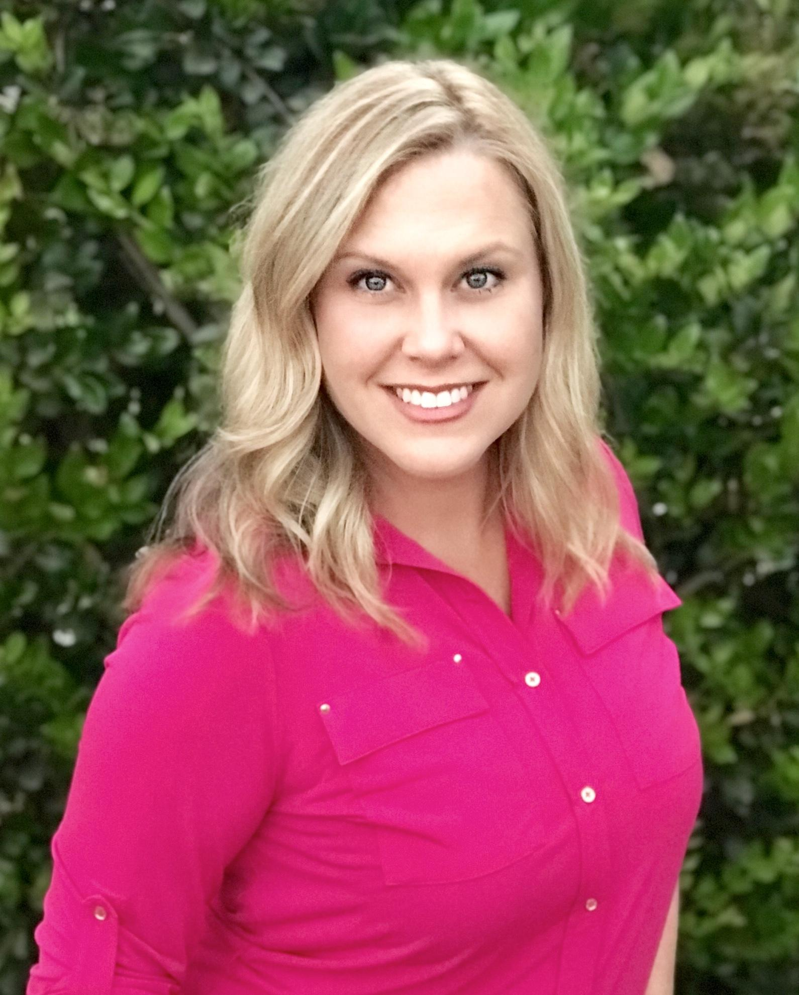
Welcome to the 2022-23 school year! This Parent Handbook is designed to provide valuable details regarding Hamilton Elementary School’s procedures and the rights and responsibilities of elementary students registered at Hamilton. I hope it serves as a resource for you and your children during the school year.

Our goal of promoting student excellence in a safe, positive environment is shared between school and home. The success of our school depends on positive collaboration between home and school so I invite you to take part in your child’s learning, here on campus and at home and show an interest in your child's progress.

It is my sincere wish that we all work together in fostering positive learning experiences for students. I
wish you and your family an outstanding school year! As always, we believe in the power of families and the vested interest of our community. To that end we welcome parents and the community to our school as we continue our educational journey. We look forward to working with you as partners as we develop young leaders. Our elementary staff has spent time this summer training and renewing their commitment to helping our students grow academically and as Leaders. Please join us in our educational efforts and partner with us to instill greatness in your child each day.

Sincerely,

Erika Cooper

Erika Cooper, Principal
Alexander Hamilton Elementary School

Since protocols are constantly changing: We continue to work hard to update this handbook annually, but please note that school board policy supersedes any errors or changes made during the school year and Hamilton reserves the right to make changes as needed for the safety of our students.



PUSD PARENT/STUDENT HANDBOOKS : The district is switching to paperless: The Parent/Student Handbook is an annual publication containing updated information for the families of Pasadena Unified including rights and responsibilities, and district, local, state, and federal policies that impact all students. You'll find information on student and parent rights, expectations for behavior and attendance, parent involvement, calendar information and more.

Download/view the 2022-23 Parent Student/Handbook:
  - English
  - Spanish
2022-23 Annual Parent Notification Forms
Parents/guardians can also complete these forms via their Parent Portal accounts.
- Universal Acknowledgement & Authorization Form English Spanish
- Attendance & Truancy Policy English Spanish
- Acceptable Use Policy English Spanish
- Student Directory Information Release English Spanish
- Annual Pesticide Notification English Spanish
- Report Card Paper Copy Request (Eng/Sp)
- Medication During School Hours(Eng/Sp)
- Military Parent/Guardian Affiliation (Eng/Sp)
- District Student Image Release (Eng/Sp)
- News Media Access (Eng/Sp)

School Safety Updates
- PUSD has multiple layers of safety measures already in place and will comply with the State’s public health requirements for schools. We continue to work closely with the Pasadena Public Health Department (PPHD).

COVID-19 VACCINATION INFORMATION: COVID-19 vaccines are now available for everyone 12 years and older. Get your vaccine today! Please visit myturn.ca.gov or contact PUSD Health Programs at healthprograms@pusd.us.
To learn more about PUSD and vaccinations, please visit, pusd.us/covidvaccine

COVID-19 SAFETY PLANS
- COVID-19 Safe Return to In-Person Learning & Continuity Plan
COVID-19 Dashboard

COVID-19 SAFETY PLAN
- In preparation for a safe return for students and employees, we have updated our Covid-19 Safety Plan, now in its fifth edition and revised to meet the changing Center for Disease Control and Prevention (CDC), California Public Health Department (CDPH), and City of Pasadena Public Health Department (PPHD) guidelines. The Pasadena Unified School District's plan was also submitted to the State. Haga clic aquí para español (abajo)
- Click Here

Hamilton Elementary

2022-23 Handbook Table of Contents
Welcome/Principal’s Message | 2 | Food Services: Breakfast/Lunch | 20
After School Program Options | 6 | Food Allergies | 24
Annual Fund | 7 | Gifted and Talented Education (GATE) | 21
Attendance/ Absences | 8 | Getting Involved | 21
Awards | 9 | Health Office: Medications/Allergies/Diseases | 24
Bell Schedule | 10 | Hamilton Homework Policy | 25
Before & After School Programs, Clubs, and  Enrichment Programs | 6 | Leader In Me Program | 26
Bicycles/Skateboards/Scooters | 11 | Library | 26
Bus Expectations | 11 | Meals | 21
Calendar | 14 | Medications | 4
Cell Phones | 13 | Parties | 31
Classroom Placement | 13 | Parent and Teacher Association (PTA) | 27
Communications | 13 | Parent Councils and Committees | 28
Directory: Faculty/Staff | 15 | Room Parents | 14
Discipline Philosophy | 16 | School Safety Plan | 30
Drop Off and Pick Up Procedures | 17 | Special Education | 30
Dogs and other Furry Friends | 17 | School Supplies | 31
English Language Learners (ELL) | 20 | Transportation (See Bus/Bicycle) | 11
Emergency Cards/information | 20 | Uniform/Dress Code | 31
Events (Social and School) | 24 | Visitors on Campus | 32
 |  | Volunteer Coordination | 22
All information included in this parent handbook is subject to change.

After School Programs
Hamilton offers two after school care programs that operate with the following hours:
Monday: 1:30pm. – 6:00pm.
Tuesday – Friday: 3:10 pm. – 6:00pm.

Pasadena LEARNs : Marie Novelo: novelo.marie@pusd.us
Pasadena LEARNs offers a balanced program consisting of homework help, leadership
development, visual and performing arts classes, structured recreation, and other academic
enrichment activities. Participating students are required to attend daily. Pasadena LEARNs is
offered on a sliding scale fee basis. For more information, please contact our LEARNS
Coordinator Marie Novelo at (626) 396-5730 ext. 26044.

After School Adventures Program and Early Care Adventures Program (City of Pasadena)
Citywide Recreation provides a variety of activities including arts and crafts, games, and various
recreational and organized sports, as well as time for students to work on their homework. This
program is operated by the City of Pasadena’s Human Services and Recreation Department at
Hamilton Elementary School. Students must be registered and attend regularly to participate, but
do not need to attend daily.
Online registration is available starting in August at the following website: ww5.cityofpasadena.net/humanservices
- website to register for the programs click here
- offices are located at Central Park Center, 37 E. Del Mar Blvd. Pasadena, 91105
- phone number is (626) 744-6500. For general info and payments, customers can then press 1. Crystal Amaya, Recreation Specialist will be the contact person for your site. She can be reached at (626) 744-6500, and then press 3.


After School Clubs and Enrichment Programs
After school programs are available to Hamilton students. Classes are held usually three sessions per year, which last approximately 6-8 weeks, with classes occurring weekly. Classes change based on parent/student input and interest. Classes offered in the past include: Spanish, Karate, Chess, Lego, Musical Minds, Mad Science, Kids Art, and Dance. Information will be sent home prior to registration or can be found at www.bobcatbuzz.com or contacting our after school enrichment chairperson.

There are no current classes to register for at this time - We will be sending more information to come on this for the 2022-23 school year.

After School Team Sports
A variety of team sports—including flag football, basketball, soccer, and cheerleading— are offered
through both the Citywide and LEARNs programs. If your child is interested in participating, please
contact the after school care programs for more details.

Scout Troops
There are several Daisy/Brownie/ and Scout troops that meet at or near Hamilton once a month. If
your child wishes to participate, please contact:


Scout Center Office  https://www.glaacbsa.org/rose_bowl  Cub Scouts Pack 48  joinpack48@gmail.com  albertcarojr@gmail.com  and  hamiltonpack48@gmail.com | Girl Scouts  Crown Poppy Area  Lisette Gutierrez: 626-677-2080  lgutierrez@girlscoutsla.org  (must be at least 5 years old)

Other Potential Clubs
If you are a parent interested in starting a club at the school, please contact the principal, Mrs. Erika
Cooper at cooper.erika@pusd.us or (626) 396-5730.

Annual Fund at Hamilton
Co-Chairs: Yesenia Gonzalez and Suzy Alfaro
hamiltonannualfund@gmail.com

The Hamilton Annual Fund was established in the Spring of 2010 to provide funding for critical programs at Hamilton that do not receive district funding and may fall outside the allowable uses for PTA monies (such as salaries). Hamilton is an award winning school that has made tremendous strides in academic achievement. Parents and community members are encouraged to contribute to our Annual Fund so we can maintain positive momentum and continue to provide an environment where all students can excel.
Donations are directed toward the following needs:
- Technology:
Provide state of the art technology to enhance learning, as well as replace and upgrade equipment as needed. The major cost is a full time computer lab teacher that teaches every class each week.
- Staffing:
Potentially including librarian, computer lab teacher, instructional aides, playground supervision, and professional development for our teachers.
- Unrestricted:
To be used as needed - for example, art and music education.
All donations, big or small, make a difference and are welcome! Checks should be made payable to “PEF”
with “Hamilton Annual Fund” clearly noted in the memo section. Mail checks to PEF at 351 S. Hudson Ave.,
Rm 214, Pasadena, CA 91109. Donations may also be made online at www.bobcatbuzz.com. Money
donated will be held by the Pasadena Educational Foundation (PEF) specifically for Hamilton.

Wishlist Donations
All Hamilton teachers provide wish lists of items that are in excess of the budgeted allotments for teachers supplies but that are important for helping them run an effective classroom. All parents and guardians are encouraged to view teacher wish lists throughout the year and to donate items for teachers. Wish Lists are coming soon.

ATTENDANCE & ABSENCES
Attendance
Regular attendance is important for your child’s education. Children are not only required to attend school
regularly, but the school loses money if a child is absent from school for any reason. According to the
California Education Code, any student who is absent from school without a valid excuse, for three full days, is truant; any student who is tardy or absent for any 30-minute period of the school day, without a valid excuse on three occasions during one school year, is classified as truant. Letters go out from the district notifying parents of truancy after the 3rd absence & additional absences will require a meeting with the school principal and/or district personnel.

Notification of Absence
If your child will be absent, please call the school at (626) 396-5730 option 3 before 9:00 am. on the first day of
the absence. If you know your child will be absent in advance, please inform the school. Please submit a
signed note to your child’s teacher or the office with the child’s name, date(s) of, and reason for absence or fill out an attendance form (available in the office or at www.bobcatbuzz.com) within three (3) days of your child’s return to school.

Extended Absence
If you know your child will be absent for five (5) or more consecutive school days, please complete an
Independent Study Plan with your child’s teacher. Completing this form will ensure that your child will not fall
behind while she/he is out of school and also enables the school district to receive funding for the days your
child is absent. An Independent Study Plan form can be obtained from your child’s teacher or the office. (Subject to change)

Early Release Procedure
In the event that you need to pick up your child before the end of the school day, please notify your child’s
teacher in advance. When you arrive at the school, please report to the office to sign your child out.

Grades K-5: Office staff will call your child’s teacher to have him/her sent to the office to meet you. Children will only be released to parents, legal guardians, or persons listed on the Emergency Card. For other arrangements, written permission must be sent to the office by the parent/guardian. Please do your best to arrange for appointments outside of the school day. Students’ leaving school early interrupts learning for all students.

Awards: Our School in the News!
School Awards:

California Pivotal Practice Award 2022
Top LA County Public School, 2020
California Gold Ribbon Award 2016, 2018
National Blue Ribbon Award 2009
California Business for Education Excellence Honor Roll School for 2011-2018
STEM Honor Roll 2012 & 2014
Title 1 Academic Achievement Award (2010-2012)
Leader In Me School 2017-2018
Educational Results Partnership/CBEE Honor Roll School: 2018
California Exemplary Arts Education, 2018

Friday Morning Assemblies:
Typically, weekly school assemblies for grades 1-5 are held every Friday at 8:45am. on the North
Playground. These assemblies include school-wide announcements, student awards, class performances and Library Birthday Book Club dedications (see school library section). These assemblies are a great way to stay informed about what is happening at the school. Designated classes will also take the opportunity to perform at various assemblies. Visitors are not allowed on campus at this time, however, parents are always welcome to attend once Pasadena Health Protocols allow for parents and visitors on campus.

Monthly Awards Assembly:
The Monthly Awards Assembly is generally held on the morning of the first Friday of the month (please see school calendar for dates). Awards earned during the previous month are presented at this assembly.


Bell Schedule
All All grades have a consistent Tuesday- Friday with a shortened schedule on Mondays as follows:
Monday (8:45–1:30)
Tuesday – Friday (8:45–3:10)
6:45am | Adventure Club Morning Supervision (you have to register with the City of Pasadena)
8:00am FREE | Early Morning Drop-Off in the Auditorium (K- 5th Grade)
8:25 | Gates to Campus Open for Students only
8:40am | First bell rings - Your child should be in school by this time to avoid being tardy.
8:45am | SCHOOL BEGINS (second bell rings)
Recess - Morning Break
10:00am-10:15am | Kindergarten Recess
10:30 am-10:45 am | Grades 1-3 Recess: East Playground  Grades 4-5 Recess: West Playground
Lunch Break
10:45am-11:05am | Pre-K AM Lunch (subject to change)
12:10 pm.-12:30 pm | Pre-K PM Lunch (subject to change)
11:15 am-12:00 pm | Kindergarten Lunch
11:30am-12:15pm | Grade 1 Lunch
12:15 pm-1:00 pm | Grades 2 & 3 Lunch
12:45 pm.-1:30 pm | Grades 4 & 5 Lunch
1:30pm | DISMISSAL (Monday) No after school supervision is available for students not enrolled in afterschool programs.
3:10pm | DISMISSAL (Tuesday – Friday)
After School Programs begin directly after school ends.
**NOTE: Times subject to change. Check www.bobcatbuzz.com and school notices for updates.**

ARRIVAL AT SCHOOL

Drop Off and Pick Up Procedures

Hamilton uses a car drop off line. The line extends down Craig All parents are encouraged to use the car line for drop off and pick up times. The Gates will open at 8:25. All students can either enter campus through the Green Gate in front of the school on the left hand side, or the Kindergarten playground gate.

Drop Off: Morning Drop Off
- Please stay within the cones and pull as far forward as possible within the line.
- Please continue westbound on Rose Villa Avenue and make a left turn on Oak Street.
- Once students are on campus, they will walk directly to their designated teacher/classroom lines on the playground or the cafeteria for breakfast

We strongly encourage students to arrive at school on time. If a student is late to school, they must be brought to the front office. At this time, parents will not be able to enter the front office. The student will receive a late pass and be escorted/sent to class. For the safety of our children, please follow the procedures and rules below when dropping off and picking up your child(ren) from school.Students are expected to be in their classrooms and ready to learn by the time school starts at 8:45a.m. Parents should plan to have their children at school no later than 8:35 a.m.

Early Morning Drop Off: early morning drop off is available for all K-5th students starting at 8:00am in the auditorium each morning. (6:45 am through the city of Pasadena Adventure Club Program)

How it works:

Between 8:00 - 8:25am, students will enter the side door to the Auditorium (off the front lawn area) at the front of the school.

Drop Off Line Procedures:
Please enter the drop off line only from Craig Street onto Rose Villa as shown on the map. A teacher will be
available for passenger unloading in this half-block area from approximately 8:25a.m. until 8:45am. Enter the
designated drop-off lane and proceed forward slowly. Continue forward slowly until reaching the safety “Cone
Zone” before stopping to let students out. Please pull all the way to the front of the “Cone Zone”, even if there is
no one behind you. Make sure the passenger door is unlocked and, if needed, give the aides or volunteers who
are working as valets a sign that it is okay for them to open your vehicle door. Follow the hand signals and
instructions of those working the Drop Off Line.

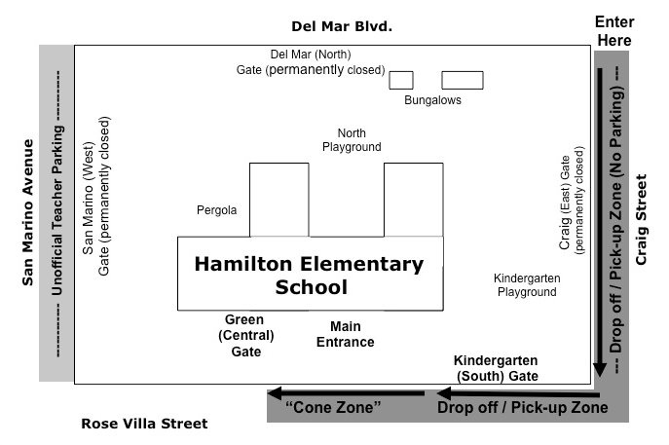

Pick Up:
Students are released from school at 3:10pm. (1:30pm. on Mondays) through the Kindergarten (South) Gate on Rose Villa only (see map). This gate is teacher monitored to ensure safety. For the safety of your children, it is important to pick them up at the pick-up gate.

Grades 1-5: Parents may either:
- Meet their child on foot outside the Kindergarten Gate; or
- Remain in their vehicles and participate in the vehicle Pick-Up Line.

Students Walking or Ubering Home
No student will be released without a parent or designated guardian present. However, for children wishing to walk/ride bike/scooter home, parents must make arrangements with their child’s teacher, and the student must be of an appropriate age and maturity to walk home independently. Please send a note to the teacher letting them know your child has permission to walk home.
Also, please send a note if someone other than those family members designated on your registration form will be picking up your child (after school programs, karate, uber, a friend etc).

Pick-Up Line Procedures:
- Pull into the Pick-Up Line zone which starts at the Kindergarten Gate on Rose Villa and winds around the corner along the west side of Craig (see map)
- Remain in your vehicle and follow the line as it moves forward.
- As you approach the Kindergarten Gate on Rose Villa, a Hamilton staff member will ask for your child’s name. They will call your child’s name and release him/her from the Kindergarten Gate to your vehicle.
- Once your child is safely in your vehicle with his/her seatbelt fastened, please exit the Pick-Up Line to make room for other cars.
- If the Pick-Up Line is full, please drive around the block rather than blocking street traffic. Vehicles that double park or stop in the middle of the street will be ticketed. Also, if you do not see your child in the pickup area, please drive around the block to make way for people waiting behind you.

Important Safety Rules & Reminders:
It is important to be safe and courteous when driving or parking near the school and to obey all
traffic and parking laws. Please be aware that the Sheriff’s Department tickets frequently for moving and parking violations around the school.

- Do not park in the drop off/pick up line (on Craig or Rose Villa) as shown on the map.
- Do not double-park in order to drop off or pick up your child.
- Do not allow your child to exit through the door on the side of oncoming traffic.
- Do not perform U-turns in front of the school.
- Use crosswalks to keep yourself and your child safe as you cross the street. Entry to the school in the morning will only be through the main entrance and the ramp by the auditorium (Green Gate), both on Rose Villa.
- Do not use a cell phone with hands as per California state law. Drop offs are not allowed in red zones.
- Please avoid parking along the east side of San Marino Avenue between Del Mar and Rose Villa as this area is unofficially designated as teacher parking.
- Be aware there is no parking on Oakdale (one block south of the school) between San Marino and Oak on Thursday mornings 7-11am for street cleaning.
- If you are sending someone to pick up your child, please explain the pickup procedure to them and the appropriate parking locations.
Note that these procedures may be modified as needed in our ongoing efforts to ensure student safety.

Adventure Club (City of Pasadena) offers a before school program that allows for 7:00 drop-off. There is a charge for this service. More information available at the City of Pasadena website. Space is limited. ww5.cityofpasadena.net/humanservices

BICYCLES,SKATEBOARDS & ROLLER BLADES
Students are encouraged to ride bicycles to school.The rules for bicycles are explained to students at the beginning of the year. These include walking bikes on and off the school grounds, wearing helmets, and locking bikes. Students are not permitted to ride bikes, skateboards, rollerblades, or wear "wheelies" (shoes with wheels) on the school campus at any time.

BUS EXPECTATIONS
The following school bus rules are issued by the Pasadena Unified School District. These rules apply to both home-to-school-to-home transportation and to bus field trips.
Any action that provides a distraction to the bus driver is considered a safety hazard.
- Remain in seat while the bus is in motion
- Be respectful to the bus driver
- No scuffling, horseplay, or leaving your seat on the bus.
- Keep head and limbs inside the bus (not out the windows).
- Do not throw objects in or out of the bus.
- No unnecessary noise, abusive language or gestures
- Do not litter or damage the school bus
- Never walk behind the bus. Cross the street in front of the bus with an adult chaperone.

2022-23 School Year Calendar
Below is the General Master Calendar for the 2022-2023 school year. Please note that some dates are not listed. Please check our school website at www.bobcatbuzz.com for up-to-date information. Dates are subject to change.
- Friday Morning Assemblies 8:45-9:00 (student/staff only event per PPH protocols)
- Student of the Month Assemblies-1st Friday of each month
- School Site Council Meetings-2nd Tuesday of the month at 8:00am (check website for possible changes)
- English Language Advisory Council Meetings-4th Friday of the month-9:00 (check website for possible changes)
- Coffee with Principal Cooper-4th Friday of the month-9:00 or following morning assembly
The Parent-Teacher Association (PTA), School Site Council (SSC), and English Learner Advisory Council (ELAC) each meet on a monthly basis. These meetings will be scheduled at the beginning of the school year. Please check www.bobcatbuzz.com for specific dates.

CELL PHONES
Although students are not encouraged to bring cellphones to school due to the possibility of loss, theft, or damage, we understand that many families want their children to have a cell phone to contact parents before or after school hours.
Therefore, if a student chooses to bring a cell phone to school, it must be turned "OFF" during the school day and placed where it will not be accessed during the instructional day -- in a backpack, jacket, etc. It should not be visible to other students or staff during the day. If a student does not follow these rules and 1) uses the cell phone, or 2) the cell phone rings, or 3) the cell phone is visible to other staff or students during the instructional day, it will be confiscated and turned in to the office. Parents will be contacted to come to school and pick up the phone at their convenience.
We believe that this policy allows families the flexibility to use cell phones as needed, but will also protect the school day for teaching and learning. Thank you for your cooperation and understanding in this matter.

Classroom Placement
The process of making up classes begins in May. Our goals are to achieve academic, behavior, and boy/girl
balance of classes, to make up satisfactory combination classes and to provide for individual student needs.
Class placements are posted via Parent Portal before school begins.

Home/School Communications
Communication between parents and school is vital. Any time you have questions or concerns, please don't hesitate to contact your child's teacher or the principal. The school number is (626) 396-5730. If you prefer, the school secretary can forward your call to the voicemail of any staff member. Also, voice mail numbers of all teachers are published in the PTA phone directory, and e-mail addresses for individual staff members are also available on the school's website.
The school uses these methods to communicate with Hamilton families:
- Weekly e-blasts/SMOREs regarding school activities
- Report cards and parent conferences
- Newsletters and/or e-communications from teachers to parents
- Sending home samples of student work
- Back-to-School Night and Open House (virtual this year)
- Monthly PTA meetings (virtual)
- "School Messenger" phone system
- Social Media (Facebook, Twitter, instagram)
Teachers conference with all parents during October conference days. Conferences can be arranged at any other time during the year when/if they are necessary.

Hamilton strives to keep its families informed about school events and activities through several

different means: IT IS EXTREMELY IMPORTANT WE HAVE UPDATED CONTACT INFORMATION, including address, phone numbers and email addresses. You can update all family information using PUSD Parent Portal.

Hamilton has gone 98% Green
School, District and community flyers will be sent home
through Peachjar, email and may also be accessed on our school website (They will also be posted in front of the office.) While an attempt is made to send home information electronically, there will be times that actual flyers are sent home. Be sure to check with your child regularly and remind them of the importance to give you any flyers from their school or teacher. If you do not have access to email, please notify the office and we will create a weekly folder to be sent home with applicable home/school communications.

www.bobcatbuzz.com
Our volunteer-maintained website contains a variety of information about the school and its policies as well as a calendar of events that is updated on a regular basis. Electronic versions of flyers to which we have access are also posted on Peachjar which can be accessed by our school website.

Hamilton Happenings Weekly Email
A weekly email is sent out each Thursday evening listing the events for
the upcoming week along with updates on school issues. To subscribe
to this email, please visit www.bobcatbuzz.com.

Phone Messages

The Principal, Mrs. Cooper, sends out a recorded phone call (followed by an email) to
all Hamilton families each Sunday night during the school year highlighting events and important announcements for the upcoming week at Hamilton. Additional recorded phone calls from the school, PTA, or district go out to all families as needed throughout the year.

Room Parents:
Each classroom has a room parent who plays an important communication and coordination role between
parents and the teacher. If you would like to serve as a room parent, please contact the PTA’s Volunteer
Coordinator, at roomparents@bobcatbuzz.com

Curriculum
Hamilton uses a curriculum that will lend itself to the teaching of the National Common Core Standards as specified by the Pasadena Unified School District (PUSD) for use at all of its elementary schools in language arts, math, science, social studies, music, and art. Hamilton provides additional arts instruction in conjunction with the Armory Center for the Arts, and the My Masterpieces art program, which, through projects and field trips, connects the rich arts resources in Pasadena to student learning. Math, science, and technology are given additional emphasis through our Math/Science/Technology Academy. Our goal is to create critical thinkers who will be ready to enter the digital world of the 21st century.

Computer Lab
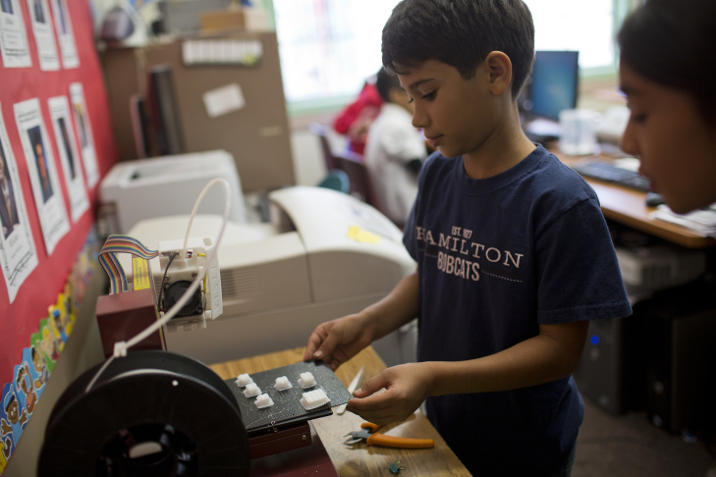
Hamilton’s fully-equipped, state-of-the-art Computer Lab is staffed by a full-time, credentialed teacher, Ms. Anderson, and funded through the combined support of the Hamilton PTA, the Hamilton Annual Fund, personal donations,and PEF grants. Instruction integrates technology with grade level curriculum and standards.
In the Computer lab, students learn:

- Technical skills—such as how to operate a computer and use various software packages for report, analysis, and presentation purposes;
- Research skills; and Computer programming (for grades 4-5)
- Students also have the opportunity to apply these skills toward the projects they are working on in their
homeroom classes.
- 3D Printing
Grades K-2: All students participate in a weekly, 45-minute computer lab session
Grades 3-5: All students participate in one hour computer lab session per week
*If you have questions about computer Lab, please contact Ms. Anderson:anderson.nichole@pusd.us



Hamilton Staff Directory

2022-2023

GRADE | TEACHER | Email
Pre-Kindergarten | Tonie Smith | murillosmith.antonie@pusd.us
Kindergarten | Marion Yamada/Ms. Merina Myklak | yamada.marion@pusd.us
Kindergarten | Jennifer Mably | mably.jennifer@pusd.us
Kindergarten | Lucia Garcia | garcia.lucia@pusd.us
Kindergarten
First Grade | Maria Barajas | barajas.maria@pusd.us
First Grade | Kim Enriquez | enriquez.kimberly@pusd.u
First Grade | Katarina Loury | loury.kathi@pusd.us
SDC (K-3) | Valentin Sanchez | sanchez.valentin@pusd.us
Second Grade | David Berk | berk.david@pusd.us
Second Grade | Sandra Serrano | serrano.sandra@pusd.us
Second Grade | Ana Negrete | negrete.ana@pusd.us
Third Grade | Andre Prosperi | prosperi.andre@pusd.us
Third Grade | Robert Marrufo | marrufo.robert@pusd.us
Third Grade | Julie Ysassi | ysassi.julie@pusd.us
Fourth Grade | Felicia Gomez-Barden | gomez.felicia@pusd.us
Fourth Grade | Kristyn Shiohama | webster.kristyn@pusd.us
Fourth Grade | Melissa McClintock | McClintock.melissa@pusd.us
Fifth Grade | Kristen Aviles | aviles.kristen@pusd.us
First Grade | Carmen Cid | cid.carmen@pusd.us
Fifth Grade | Victoria Hughes | hughes.victoria@pusd.us
SDC (4-5) | Claudia Gonzalez | gonzalez.claudia@pusd.us
Intervention Teacher | Anna Cacioppo
Principal | Erika Cooper | cooper.erika@pusd.us
RSP | Stephanie Elliott | elliott.stephanie@pusd.us
Psychologist | Jin Ok
Speech | Melanie L. Monacelli | monacellim@pusd.us
Occupational Therapist | Narine Khechumyan | muirhead.kristin@pusd.us
Computer Lab | Nichole Anderson | anderson.nichole@pusd.us
Library | Phoebe Phillips
Office Manager | Janet Kitani | kitani.janet@pusd.us
Clerk Typist | Amy Munoz
Nurse
Health Clerk | Jenee Chau | chau.jenee@pusd.us
Foothill Therapist | Marilyn Meyers
LEARNs | Marie Novelo | novelo.marie@pusd.us
Custodians | Art Zaragoza | zaragoza.arthur@pusd.us

School Discipline Philosophy
Fundamental to Hamilton Elementary School’s mission is developing children who are thoughtful, caring, and responsible members of our community. We treat our students as individuals, worthy of respect and capable of making good choices. Further, the school utilizes positive incentives and provides instruction on specific Leadership Habits to promote and reinforce good behavior while simultaneously enforcing specific consequences for inappropriate behavior.

Incentives include special monthly awards and recognitions, achievement privileges, and prizes.
Consequences include campus beautification,reflections sheets, meeting with the RTI Teacher for conference and, in rare instances, school or home suspension or expulsion. We believe this balanced approach promotes a safe school and a warm and friendly classroom environment, and demonstrates that good discipline is a solid foundation on which to build an effective school.

Students at Hamilton are guided by specific rules and classroom expectations that promote respect,
cooperation, courtesy, and acceptance of others. Character Traits are focused on each month with the goal to teach our students to be Safe, Respectful and Responsible. Staff and students will follow the seven rules:
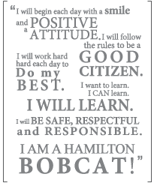
1. We respect each other’s rights, property, opinions, and differences.
2. We think before we act and speak.
3. We take pride in everything we do: our work, our appearance, and our school.
4. We always tell the truth.
5. We solve our problems without fighting.
6. We use appropriate language.
7. We are responsible for our actions.

Our School Motto

"I will begin each day with a smile and a positive attitude. I will follow the rules to be a good citizen. I will work hard each day to do my best. I want to learn. I can learn. I will learn. I will be safe, respectful, and responsible. I am a Hamilton Bobcat!"

Blue Slips
The Blue Slips program encourages positive behavior on campus by rewarding students who are “caught being good.” Hamilton has instituted a school-wide campaign to promote positive character building behaviors. Teachers, administrators, and staff hand out blue slips to students in grades K-5 for positive behavior they see around campus and/or in the classroom. Teachers collect slips acquired during the week. On Friday afternoons, slips for all classes are combined into one box, approximately 10 slips are drawn, names are called over the school intercom and those students receive a special prize.

Other Student Awards
Hamilton also recognizes student excellence through a variety of other means including “Leader of the Month”and Leadership Award recipients. Please see www.bobcatbuzz.com for more details.

Perfect Attendance Award:
To motivate students to attend school regularly and punctually, the school rewards students with the Perfect Attendance Award. In order to get this award students not only need to be in school every day but they also must have no tardies! Perfect attendance field days are offered with treats, music and games (This is a huge incentive for children and we recommend you discuss the great opportunity with your child).

DOGS AND OTHER FURRY FRIENDS

As a general rule, dogs and other animals are not welcome at school. Specifically, according to the state’s education code, dogs are prohibited from school campuses, whether or not the dogs are leashed. Therefore, if families are including a dog walk at the same time they are picking up or dropping off their child, we request that you meet or say goodbye to your child at the sidewalk on Rose Villa, thereby not bringing the dog on campus. This precaution will help keep your pet from being overrun by well-meaning children and assure that our children are safe during the busy arrival and dismissal times. We have several students who are either afraid or allergic to certain types of pets, so this policy keeps our school environment safe and friendly.

If you notice a dog on campus, leashed or not, please inform the school office. It is our intention to keep our campus safe. Again, many thanks for your understanding of this school rule.

English Language Learners (ELL)
Students who are identified as English Language Learners are provided with additional educational
resources to assist them in their acquisition and mastery of the English language. Parents or guardians
should contact their child’s teacher for more information on services available for English Language Learners and their families.

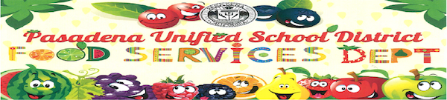
Food Services
2022-23 Meal Prices: (Prices subject to change)
Breakfast: FREE for all students
Lunch: FREE for all students
Breakfast may be picked up in the cafeteria between the hours of 8:10 a.m. and 8:40 a.m.
Menu: an up-to-date menu can be found at http://pasadenausd.yumyummi.com
Food Delivery/GrubHub/Uber Eats etc: Please do not utilize food delivery services for student lunches each day. We always prefer a packed lunch or utilization of the cafeteria ( free this year). Food deliveries may not get to your child during their scheduled lunch break and cause a disruption in your child's instructional time.

Food Services Information
Contact Grace Aguilar at 626-396-5852 x89371

Lunch
Students may either bring their lunch to school or pick up one in the cafeteria. This year, there is no need for parents/ guardians to deposit money in an account tied to their child’s identification number to be used for purchasing cafeteria food at the school (All meals are free this year).
Snacks
Students are encouraged to bring their own healthy snack from home to eat during recess. Snacks are not
organized or provided by the school. Only healthy snacks are allowed for parties and are to be cleared by
the teacher/principal.
Food Restrictions
Food brought to school by students should be healthy and nutritious. The following items are NOT allowed
on campus and will be confiscated: gum, candy, soda. PUSD instituted a Healthy Wellness program as part of the nationwide Wellness Initiative. A list of approved items can be found on PUSD’s website.
School Parties
Birthday party healthy snacks may be brought to school during your child’s lunch time or dropped off for
classroom use at the end of the day. Arrangements must be made in advance with the teacher. Per district-no birthday parties are to be held during students’ instructional time.

Gifted and Talented Program (GATE)
Coordinator: Mr. Alden Denila: denila.alden@pusd.us
GATE is a program for students determined to be academically talented. At Hamilton, these students are
clustered together at each grade level with a GATE-certified teacher to provide them with instruction that is challenging, engaging, and allows them to academically excel. Currently, students are tested for the GATE program at the end of second or fifth grade, or by teacher or parent request. GATE-identified 3rd - 5th graders may have the option to participate in the extra-curricular GATE club (please see After School Clubs section for more information.)

Getting Involved in Our School Community
Hamilton recognizes that parent/guardian involvement is essential to student success. The school
encourages families to get involved in a variety of ways:

Parent and Teacher Association (PTA)
Statutory Councils (SSC and ELAC)
Hamilton Room Parent
Hamilton Annual Fund
Wish list donations to classroom teachers

Volunteer Requirements:
As of January 2014 Megan’s Law must be adhered to for the safety of our students. The requirements to
volunteer at a school site include: TB test, Megan's law database check , attending a district or school volunteer training and the completion of a volunteer application. If your volunteerism will require you to be supervising children without the teacher present (Principal permission is required), in addition to the previous requirements you will also need to be fingerprinted by the district, even if you have been fingerprinted somewhere other than PUSD. Applications are available at our front office. A PTA led parent volunteer training must be attended if you plan on volunteering in your child’s classroom this school year. Please check our website for data and time.

Parent and Teacher Association (PTA)
The Hamilton PTA is a volunteer group of parents and teachers, led by an elected board. Our mission as
parents and teachers are to PARTNER together to PROVIDE a thriving academic environment and enrichment programs for all kids, and to PROMOTE a strong Hamilton community.

Through the PTA, parents and teachers give their time and resources to foster a community that ensures
that every child has a fun learning experience while reinforcing the Math, Science and Technology
Academy and supporting liberal arts, cultural appreciation, general health and well-being, and enrichment
programs.

Our general goals are as follows:
Teacher Support:
Provide each teacher with discretionary funds for their classroom and a trained and
equipped Room Parent who can help facilitate communication between the teacher and the parents,
volunteer in the classroom and at school, coordinate social events, and provide academic support to any
child who needs it.

Communication: Provide accurate and current school and PTA information on a
weekly basis via email and the PTA bulletin board to the Hamilton community including opportunities for
involvement.

Enrichment: To facilitate field trips that support the curriculum, provide quality
assemblies and work with off campus vendors to provide during/after school programs that benefit all kids.

Community: Build strong school support within our Pasadena & Hamilton communities by continuing to
increase our membership and by hosting social events that give opportunities to highlight the quality,
achievements and value of Hamilton.

Volunteer Coordination
The PTA coordinates volunteers, in the classroom, around school, and at various fundraising and social events. Volunteer tasks can be big or small, and can be completed at school or (in some cases) home. Examples include, but are not limited to:
- Being a room parent (see below)
- Staffing a booth for a shift at the carnival
- Bringing food or drinks to a school social event
- Being an event or field trip chaperone cutting/assembling/stapling
- papers for teachers Reading to children in class
- Helping supervise children at lunch
- Set-up or clean-up for a school event
- Many others on bobcatbuzz.com—your ideas are welcome and encouraged!

Room Parents
Room parents help teachers communicate and coordinate with parents and guardians. Typical
responsibilities of room parents include:

- Developing a classroom parent/guardian contact list
- Publicizing teachers’ wish lists to parents
- Supporting and promoting Teacher Appreciation Week
- Helping the teacher find volunteers for the classroom, for field trips, and/or for special projects
- Recruiting parents to volunteer at events throughout the year

Parents/guardians are welcome to volunteer in the classroom! If you wish to volunteer please make note of the following before you sign up:

The PTA sponsors a Volunteer Training for parents, which covers protocol in the classroom, safety, and acquaints volunteers with available tools and resources such as the copy room and various school supplies. We highly recommend that all parents interested in volunteering at Hamilton attend the training! (This usually occurs in late August or early September).
Please coordinate with your room parent or with your child’s teacher in advance to find the best time for you to be in the classroom. This gives your child’s teacher a chance to determine how best to use your time and skills. It also helps minimize classroom disruption.
For safety reasons, all classroom volunteers are required by the district to submit a completed “PUSD Volunteer Application” form, along with proof of a negative tuberculosis (TB) test within the last four years prior to the first day of volunteering in the classroom. Forms are available in the Hamilton main office, on our website (www.bobcatbuzz.com), or on the district website (www.pusd.us). TB tests are offered free of charge at the PUSD Health Care Clinic.
While the PTA encourages your membership, you do not have to be a member of the PTA to volunteer at Hamilton.

To volunteer, please contact your child’s teacher or the PTA Volunteer at volunteers@bobcatbuzz.com.

Social/Community Building Events: Hamilton:
The PTA organizes a number of fun social events during the school year for students and their families.
Anticipated events for this year include:
- Summer play dates and new family orientation
- Back to School Meet and Greet (Canceled this year)
- Boo-Hoo/Woo-Hoo Breakfast on the first day of school
- SMArt Night (an evening of Science, Math, and Art for families)
- A Family Dance
- Talent Show
- End of the Year Carnival
- Cultural Fair
- Field Trips
- Assemblies
- Teacher and Staff Appreciation events

Promoting Communication within the Hamilton Community
The PTA created and continues to maintain our school website, www.bobcatbuzz.com. The PTA also puts out a weekly “Hamilton Happenings” email to keep subscribers aware of on-going events and opportunities at school.

Pasadena Educational Network (PEN)
PEN is a unique organization that was founded by parents, for parents, in 2006. The founding parents’ mission was, and still is, to promote family involvement in public education in the Pasadena Unified School District (PUSD) so all children benefit. Now, we’re a network of more than 2,000 parents who support and send our children to Pasadena Unified School District Schools. Join us!
Hamilton Elementary
Jennifer Goldman
John Lynch
Sean Murray

Health Office: Medications/Allergies
FOOD ALLERGIES

Hamilton takes the safety of students very seriously. If your student has an allergy, it is critical that the school is notified in the SchoolAdmin system during enrollment and re-enrollment. Hamilton cannot guarantee that the campus is peanut, gluten, or any other allergen-free. A handful of Hamilton students are allergic, and in some cases, seriously allergic to peanuts, tree nuts, dairy products, wheat, and eggs. While we have plans in place to address the needs of these students, it’s important that our entire school community be aware of what causes allergies and what we can do to prevent allergic reactions, which for some children, can be a life-threatening incident. We encourage parent support by asking you to join us in communicating the following messages to your children:

1) Students at Hamilton have been told not to share food that their parents have packed with anyone.

2) Wash hands after eating. Touching certain foods can cause an allergic reaction in some students. Therefore, it’s a good practice to clean off any food that is on your hands after eating.

3) If someone becomes ill, get help from an adult immediately! Some symptoms of food allergies are vomiting, swelling of the face and lips, difficulty breathing, coughing, sneezing, watery eyes and skin that is bumpy, red or itchy.

Please let us know if you have any questions about our school’s policies and practices regarding food and
food allergies. Our goal is for all students to feel safe and protected in all situations at school. We do have
non-peanut table available, for students that choose to eat separately. They are allowed to bring a friend with them to eat.

Medication

The administration of the Pasadena Unified School District shall practice the following procedures relative to student medication use on school property or whenever the student is under the jurisdiction of the District.
- No internal medication is to be administered by school personnel except as prescribed by a doctor.
- Dangerous and narcotic drugs which a student has on prescription and carries onto school property for ingestion as prescribed by a doctor must be in their original containers and kept in the principal's office.

Homework
Hamilton School’s homework policy and practices align with the PUSD Board Homework Policy which
“recognizes that homework contributes toward building responsibility, self-discipline and lifelong learning
habits, and that time spent on homework directly influences students’ ability to meet state and district
subject area content standards.” Homework is defined as any required schoolwork completed outside of the instructional day. The goal and purpose of homework is to provide practice in skills that have been taught and/or to deepen understanding of concepts presented in class. As we move into Common Core Standards aligned instruction, students will be responsible for more group projects and homework assignments may be connected to real life experiences.

- Homework serves many important purposes -it reinforces academic skills, teaches research skills, and helps students learn to develop ideas and become lifelong learners.
- Homework is the responsibility of the student; students need to develop regular study habits and do most of the work independently. At times, long-term assignments may require the assistance of the parent.
- Hamilton’s homework plan for our students has been developed after extensive research: Home projects which allows for application of common core standards may be conducted throughout the year at all grade levels.

Suggested Guidelines for Parents to Support Student Success:
- Provide a quiet, well-lighted study area with a desk or table and chair.
- Keep a supply of “study tools” available: pencils, pen, paper, ruler, and dictionary.
- Establish a regular time for homework during which the child can work with a minimum of interruptions.
- Provide a healthy balance between homework, extra and co-curricular activities, and family commitments
- Encourage student responsibility and independence
- Contact the teacher if your child is not consistently able to do the homework within a reasonable amount of time.

Homework During Illness
If you wish to request homework for a child who is ill, please contact the school office by 9:00 am on the day you wish homework to be ready. This will give the teacher sufficient time to prepare your child’s assignments, which may be picked up in the office after 3:10 pm on the day that you phone and every day thereafter throughout the duration of the illness.

Leadership
Each month Hamilton Elementary acknowledges leaders on the month. This is usually the first Friday of the Month. Parents/Guardians and family members are welcome to come join us to celebrate these leaders as soon as health protocols allow). Students are taking on Leadership Roles and helping to make Hamilton Elementary the best that it can be.

Library Services
School Library
The Hamilton library is dedicated to fostering a love of learning and teaching research skills. Hamilton's school library is run by a Library Coordinator. All classes have scheduled library visits during which stories are read, library reference and research skills are taught, and time is made for browsing and book checkout. Over 21,000 books are checked out by students annually. It is open six hours a day, three days a week. K-2 grades visit weekly for 30 minutes and 3rd - 5th grades visit every other week. Opportunities for additional library time for research projects are available to students.

Checking Out Books
Kindergarteners may check out books during their weekly visit. Books remain in the classroom.Students in grades 1-5 may check out books to take home, provided a parent or guardian has completed the required permission slip (which will be sent home at the beginning of the year and is also available at www.bobcatbuzz.com). Some teachers of grades 1-2 may opt to have library books remain in the classroom. Parents may also register to check out books.

Birthday Book Club
To honor your child’s birthday, you can choose to purchase one of a selection of specially bound, library-quality books to be donated to the Hamilton Library. The month before your child’s birthday, the librarian will send home a letter with details about the Birthday Book Club; if you choose to participate, simply fill out the paperwork provided by the librarian and send cash or a check made out to the “Hamilton PTA” for $10, $15, or $20. A label at the front of the book will note that it was purchased in honor of your child’s birthday, and your child can be the first one to check it out of the library. Birthday Book presentations are made every week at our Friday morning assembly or over the intercom during morning announcements. If your child’s birthday falls in the summer, you can participate in May, June, or September.

Parent information and Placement
Parents frequently have information concerning their children that they wish to have considered during the
placement process. Parents with such information are asked to write to the school principal by May 1st,
explaining their child's special needs. Teacher requests are not accepted. It is our philosophy that if we
cannot honor all requests, we will not take any. As Hamilton has amazing teachers, we are confident you will be happy with the highly qualified teacher your child is placed with.

Parent Groups
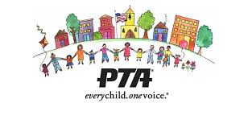
Parent Teacher Association (PTA)

Fundraising
The PTA is the only parent organization whose goal it is to benefit every child in the school, which makes every dollar donated a worthy investment. While the PTA is not a fundraising organization; we raise only the funds needed to implement the programs and activities that have been selected for each calendar year. The PTA focuses on enrichment and community building activities that enhance and support Hamilton. We try to make fundraising painless and fun and strengthen our community through the process. In recent years, PTA fundraising has made possible new tables and seating in the cafeteria, a new laminator and binding machine, new library books, field trips, assemblies, emergency supplies, and the installation of a large donated play structure.

To continue this level of support for our children and the entire Hamilton community, we anticipate the following fundraisers:

- Family Dine Out Nights at local restaurants.
- Book Fairs at school
- eScrip: Participating businesses donate money to the Hamilton PTA in exchange for our support of their establishments. Register your grocery club cards, credit cards, and debit cards at www.escrip.com, and a portion of your purchase at select locations will be donated to the Hamilton PTA. eScrip is not only for parents and teachers—we encourage you to invite your friends and family members to register their grocery club cards, credit cards, and debit cards to support our school.

PTA Logistics
Why Should I join the PTA?
- The PTA is the only parent organization whose efforts benefit every child in the school.
- Last year Hamilton parents logged over 18,000 hours of volunteer service! Helping on campus, from home, regularly or for a single event—Hamilton parents are committed to stepping up to insure that our students receive the highest quality educational experience possible!
- PTA membership and volunteerism are among the factors considered when faced with school consolidations, as occurred last year.
- If we all do a little, no one does a lot!
How do I join the PTA?
It’s easy! Simply fill out a PTA membership form, include the family membership dues (only $8.00 per family!) (cash or check made payable to Hamilton PTA), and return it to the main office or to your child’s teacher. Make sure to include the first and last names of the two adults for the membership cards. PTA membership forms are available at PTA meetings and events, in the front office, in classrooms, and at www.bobcatbuzz.com.

Meetings:
PTA meetings afford a chance for parents to get to know each other, give their valuable input, be informed on upcoming events as well as benefit from resources. They are held monthly alternating between 9:15 a.m. or 6:00 p.m. All dates will be posted soon on the www.bobcatbuzz.com website.

HAMILTON 2022-2023 PTA BOARD
PTA Board members for the 2022-2023 school year are listed on our www.bobcatbuzz.com website. We
represent you, so please feel free to contact us with questions, comments, concerns, or suggestions. A
mailbox is located in the office for all PTA correspondence.
Please refer questions to ptahamilton@bobcatbuzz.com.

HAMILTON BOARD 2022-2023
President: Maythee Rojas  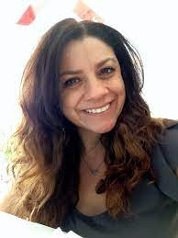 | pta@bobcatbuzz.com
Secretary: Bridget Loera Powers  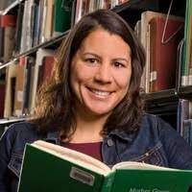 | bridgetloera@gmail.com
Treasurer: Ana Acevedo | ​​aacevedo1515@gmail.com
VP Membership: Susan Alfaro | susan.alfaro2014@gmail.com
Historian: Aleynè Eatman   | aleynei@gmail.com
Auditor: Jason Tirona  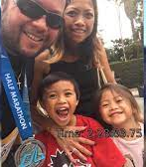 | jtirona730@gmail.com
Parliamentarian: Robyn Ellis | robynellis03@yahoo.com
Room Parent Coordinator: Gabriela Barron   | roomparents@bobcatbuzz.com
Outreach Coordinator: JuLian Blake   | blake.julian@gmail.com
Hospitality: Yesenia Gonzalez | ygonzalez1128@gmail.com
Communications: Roselle Nolasco   | roselle.nolasco@icloud.com
Fundraising Coordinator: Arsineh Hebert   | arsineh.hebert@gmail.com
Volunteer Coordinator: Rubi Rodriguez | rubi.rodriguez@gmail.com

After School Enrichment: Susan Hunter | huntersusanm@gmail.com
Field Trip Chair: Imogene Campbell | imogene.rocco@yahoo.com
Uniform Chair: Karie Goldberg | karie.goldberg@gmail.com
SMART Night / Science Fair Chair: unfilled

Family Dance Chair: Luisa Rengifo | luisarengifo@icloud.com
Cultural Fair Chair: Veronica Jones | vcw1983@gmail.com
Scholastic Book Fair Chair: Ashlee Clark | ashleepclark@gmail.com
Kindergarten Playdate Chair: Sakura Godber | sakuraota@hotmail.com
Reflections Art Chair: Zabrina Carroll | zabrinavc@gmail.com
Advocacy Chair: Una Jost | advocacy@bobcatbuzz.com
Yearbook: Sharon Lo | slo_bruin@yahoo.com

School Site Council (SSC)
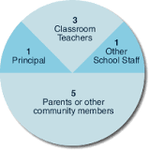
The School Site Council (SSC) is a state-mandated, elected group of parents, teachers, and school employees that works with the principal to develop, review, and evaluate school improvement programs at Hamilton. In carrying out its goals, SSC members are asked to consider:

- What are the goals and priorities of the school, and what data do we have that shows how well we are achieving these goals?
- What new programs should be implemented to reach our goals, and how will we know if they are effective?
- Are there groups of students who are not doing as well as others? What supports could we put in place to help these students, and how will we fund them?
- Can we eliminate programs that are ineffective or unrelated to our goals?

The duties and responsibilities of the SSC include:
- Developing and approving the School Plan and budgeting related expenditures in accordance with all state and federal laws and regulations. A key part of this is to obtain recommendations from all school advisory committees.
- Recommending the approved Plan and expenditures to the PUSD Board of Education for approval.
- Providing ongoing review of the implementation of the Plan with the principal, teachers, and other school staff members; periodically (at least annually) evaluating the progress being made toward school goals.
- At Hamilton, the SSC also works with the Principal to oversee Measure TT construction projects and to make decisions regarding the Hamilton Annual Fund.

All parents are welcome to attend SSC meetings, held monthly in the school library. The SSC members
represent YOU, so feel free to contact them with questions, comments, and ideas. Your attendance is
welcome at SSC meetings. Please check school flyers, emails, and www.bobcatbuzz.com for specific dates and times. For a current list of our SSC Board Members, please go to www.bobcatbuzz.com.

English Learners Advisory Council (ELAC)

English Learners Advisory Council (ELAC) meets regularly to advise the principal, school staff, and School Site Council on programs and services for English learners.

All parents are welcome to attend ELAC meetings, held monthly in the cafeteria. Please check school
flyers, emails, and www.bobcatbuzz.com for specific dates and times.

The African American Parent Council (AAPC)

The mission of PUSD's African American Parent Council (AAPC) is to embrace the identity and experiences of
PUSD's African American families, advocate for the cultural acceptance of all, and mobilize and engage all
stakeholders to transform the system to ensure a high quality education for every student. All parents are
invited and encouraged to join the Hamilton AAPC. Meetings are held bimonthly; please check school flyers, emails, and www.bobcatbuzz.com for specific dates and times.

Parent Education and Communication with families of Hamilton school is accomplished through: Peachjar, emails, Principal Newsletter, Weekly home phone calls (Sunday at 6:00 pm), Twitter, Facebook and our Hamilton website at www.bobcatbuzz.com.

Parent Volunteers and Visitors are welcomed on campus and we are grateful for your cooperation. Below is our Hamilton School Policy regarding welcoming our parents/visitors on campus:

Parents may volunteer to work in classrooms: (as needed)
- Prearrange with classroom teacher
- TB screening complete (Provided by school nurse in September or at PUSD Health Clinic
- Megan’s Law check
- Fingerprinting
- Sign-In at the main office (Volunteer tags are provided to all volunteers for safety and security reasons

Parents may visit and/or observe in classrooms: (Not at this time)
- Prearrange with classroom teacher
- Sign-in at the main office.
- Drop in limit of 20 minutes, as determined by teacher/administration

Parents may conference with teachers: (Virtually for now)
- Prearrange with teacher
- Before or after school, as mutually agreed upon with parent and teacher (not within the instructional minutes of the school day.)

Parents with concerns may:
- Conference with the teacher
- Conference with administration
- Follow District Uniform Complaint Procedure

School Safety Plan

In addition to conducting fire, shelter-in-place, and earthquake drills, all schools in the Pasadena Unified School District have prepared plans for dealing with a major community emergency. At Hamilton we have developed a plan which will insure your children are cared for in the event of a disaster.

The plan involves constant teacher supervision of children. The school is in a safe location, and it has a high priority for receiving emergency services. This means that the children will be in the best situation possible. We request that in an emergency parents not come to school to pick up students until asked to do so by emergency authorities. In any case, the school will release children only to parents or others whom the parents have authorized on the emergency card.

Science & Innovation Fair
Annual Hamilton Innovation & Science Fair
The Academy culminates each spring with the Hamilton Science & Innovation Fair, where students put into practice the skills and knowledge they have acquired throughout the school year. Students participate in the scientific process, asking questions and testing hypotheses.
- Students in grades 4-5 are required to prepare their own project for participation, outside of class time and with parental guidance. Display boards will be provided to each 4-5th grade student.
- Students in grades K-3 prepare a class science project; interested students may also submit their own individual project. If desired, project display boards can be purchased for $3.00 (price subject to change).

Special Education
The Pasadena Unified School District provides Special Education services to children identified as having special needs as young as two years old. The extent of participation in services is dependent on individual needs and may range from weekly speech therapy sessions to on-going Resources Specialist Program (RSP) services to placement in a Special Education classroom. Parents or guardians who feel that their child might need Special Education services should talk first to their child’s teacher or with our school administrator.

Student School Supplies
- Students do not need to bring any school supplies with them on the first day of school unless otherwise informed by their teacher.
- At the beginning of the school year, each teacher will distribute a list of supplies that students should have at school and at home (if any).
- School Supply donations are welcomed – Please see the electronic Wish List at www.bobcatbuzz.com, or contact your teacher for more specifics on what is needed.

Uniform/Dress Code
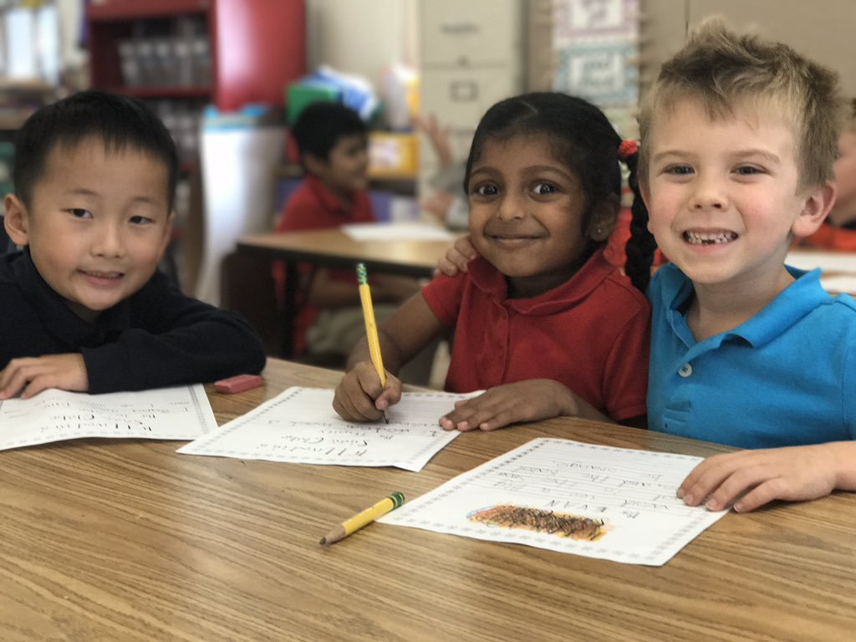
Hamilton has adopted a uniform policy in order to avoid distraction, minimize competition, eliminate undue expense, and call forth from students a serious attitude toward education. Students in uniform may receive Blue Slips for showing they are responsible “Hamilton Bobcats”.

HAMILTON SCHOOL UNIFORM
PANTS & SKIRTS:  long pants, walking shorts,  skirts, skorts, & jumpers | Navy blue, khaki, or plain blue denim Waistband must be fitted – otherwise a belt must be worn  Baggy or low riding pants not allowed Bicycle shorts only permitted under skirts or jumpers
SWEATPANTS | Navy blue, grey
SHIRTS – long & short sleeve polos,  turtlenecks and Hamilton school t-shirts | Navy blue, light blue, white or red polos–  with or without the Hamilton logo  red, blue or white t-shirts with or without  the Hamilton logo (in solid school colors  only)
BUTTON-DOWN SHIRTS; BLOUSES | White, Navy
SWEATERS, SWEATSHIRTS, & JACKETS | Solid school colors (blue, red, or white) only! Please write your child’s name on inside label of sweaters/jackets
WINTER HATS OR SCARVES | permitted during cold weather
SHOES | Must be closed-toed – no sandals allowed
GIRL OR BOY SCOUT UNIFORMS | May be worn on scheduled meeting dates
JEWELRY | If worn, must not get in the way of play or  cause classroom distractions.

Free dress day is the first Friday of each month. Please note that the following are examples of
inappropriate attire and are NOT PERMITTED on free dress days: sandals, short shorts, blouses
or shirts exposing midriff, spaghetti straps, tank tops, and low riding or baggy pants shorts/
skirts.

Please notify the school in writing at the beginning of the year if your child has a medical condition
or religious reasons that require a modification of the dress code.

Uniforms can be purchased at a variety of retailers including, but not limited to, Old Navy,
Target, and most department stores.

Hamilton Logo Uniform Shirts and Sweatshirts are sold by the PTA; For more information,
please see www.bobcatbuzz.com.

**All clothing left on campus will be placed in the Lost and Found. Clothing/items not retrieved from the Lost and Found will be donated to a charity on the last day of each month. Please check the lost and found regularly for any missing clothing items.

Visitors on Campus
All visitors (including parents) on campus (regardless of the purpose of their visit) must check in at the main office when they arrive and sign out when they leave. This is for the safety of visitors, students, and staff: the school needs to know who is on campus at all times, especially in the event of an emergency. All visitors must wear a visitor badge while on school grounds.

