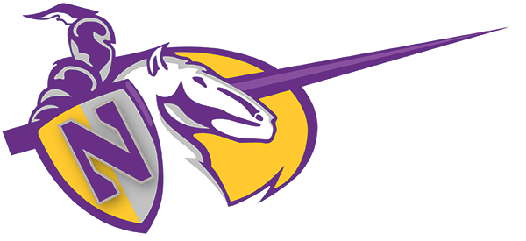Updated 6/6/23

Norwalk High School Athletics

VARSITY Girls Soccer

2023-24

DAY | DATE | OPPONENT | LOCATION | TIME | NHS | OPP.
Thursday | 11/9/23 | Compton (Scrimmage) | Norwalk HS | 5:00
Tuesday | 11/14/23 | Pioneer | Norwalk HS | 5:00
Thursday | 11/16/23 | Bell Gardens | Bell Gardens HS | 5:00
Tuesday | 11/21/23 | Montebello | Montebello HS | 5:15
Tuesday | 11/28/23 | Lakewood | Norwalk HS | 5:00
Friday | 11/30/23 | S. El Monte | S. El Monte HS | 3:30
Tuesday | 12/5/23 | Edgewood | Edgewood HS | 5:00
Friday | 12/8/23 | John Glenn | Norwalk HS | 5:15
Tuesday | 12/12/23 | Gahr | Gahr HS | 5:00
Thursday | 12/14/23 | San Gabriel | Norwalk HS | 5:00
Wednesday | 12/20/23 | Artesia | Norwalk HS | 5:00
Wednesday | 1/3/24 | Lynwood | Norwalk HS | 4:45
Friday | 1/5/24 | Bellflower | Bellflower HS | 4:45
Tuesday | 1/9/24 | Paramount | Norwalk HS | 4:45
Thursday | 1/11/24 | Dominguez | Norwalk HS | 4:45
Tuesday | 1/16/24 | Firebaugh | Firebaugh HS | 4:45
Thursday | 1/18/24 | Lynwood | Lynwood HS | 4:45
Tuesday | 1/23/24 | Bellflower | Norwalk HS | 4:45
Thursday | 1/25/24 | Paramount | Paramount HS | 4:45
Tuesday | 1/30/24 | Dominguez | Dominguez HS | 4:45
Thursday | 2/1/24 | Firebaugh | Norwalk HS | 4:45
COACHING STAFF | SCHOOL INFO | DIVISION/LEAGUE | 2022-23 FINISH
Head Coach:  Augustin Ojeda-Figueroa  Assistants: | Mascots: Lancers  Colors: Purple, Gold, and White | Suburban Valley League

Updated 6/6/23

Norwalk High School Athletics

JV Girls Soccer
2023-24

DAY | DATE | OPPONENT | LOCATION | TIME | NHS | OPP.
Thursday | 11/9/23 | Compton (Scrimmage) | Norwalk HS | 3:00
Tuesday | 11/14/23 | Pioneer | Norwalk HS | 3:00
Thursday | 11/16/23 | Bell Gardens | Bell Gardens HS | 3:30
Tuesday | 11/21/23 | Montebello | Montebello HS | 3:15
Tuesday | 11/28/23 | Lakewood | Norwalk HS | 3:00
Friday | 11/30/23 | S. El Monte | S. El Monte HS | 3:30
Tuesday | 12/5/23 | Edgewood? | Edgewood HS | 3:30
Friday | 12/8/23 | John Glenn | Norwalk HS | 3:15
Tuesday | 12/12/23 | Gahr | Gahr HS | 3:15
Thursday | 12/14/23 | San Gabriel | Norwalk HS | 3:15
Wednesday | 12/20/23 | Artesia | Norwalk HS | 3:15
Wednesday | 1/3/24 | Lynwood | Norwalk HS | 3:00
Friday | 1/5/24 | Bellflower | Bellflower HS | 3:00
Tuesday | 1/9/24 | Paramount | Norwalk HS | 3:00
Thursday | 1/11/24 | Dominguez | Norwalk HS | 3:00
Tuesday | 1/16/24 | Firebaugh | Firebaugh HS | 3:00
Thursday | 1/18/24 | Lynwood | Lynwood HS | 3:00
Tuesday | 1/23/24 | Bellflower | Norwalk HS | 3:00
Thursday | 1/25/24 | Paramount | Paramount HS | 3:00
Tuesday | 1/30/24 | Dominguez | Dominguez HS | 3:00
Thursday | 2/1/24 | Firebaugh | Norwalk HS | 3:00
COACHING STAFF | SCHOOL INFO | DIVISION/LEAGUE | 2022-2023 FINISH
Head Coach:  Edgar Salazar  Assistants: | Mascots: Lancers  Colors: Purple, Gold, and White | Suburban Valley League

