Norwalk-La Mirada Unified School District
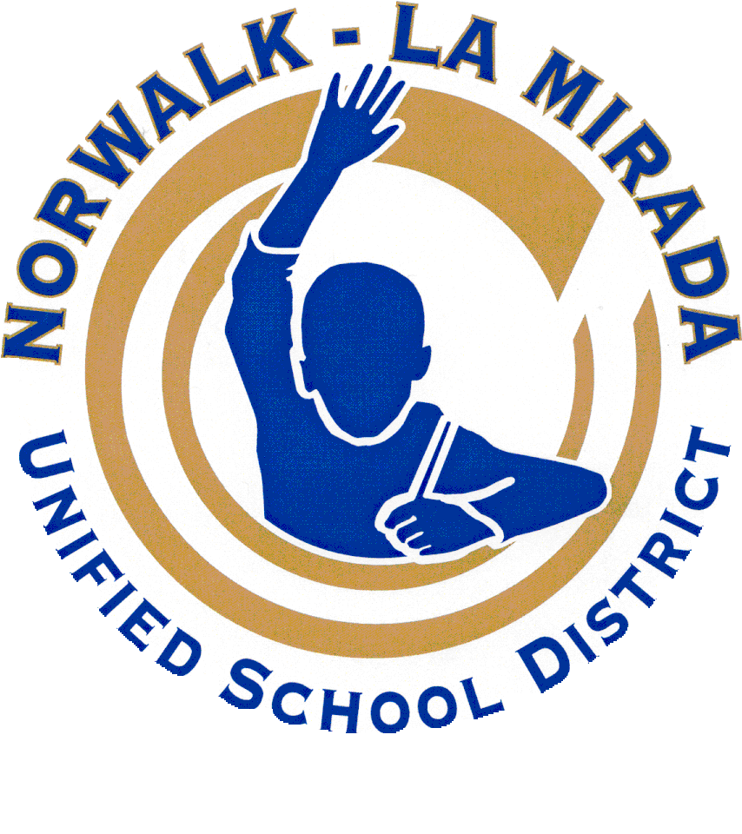
Los Alisos Middle School
School Site Council (SSC)
Title I School-Wide Program (SWP)
SSC Meeting Minutes
Date: February 21, 2019

- Call the Meeting to Order by Rosemary @ 3:16pm

- Welcome & Introductions: Present: Carolyn Nord, Paula Mayes, Majid Salehi, Enrique Gonzales, Ron Carroll, Rosemary Rodriguez, Kenny Zavala, Laura Valenzuela, Delayna Perez, Elizabeth Gonzalez

- Changes/Additions to the Agenda

- Secretary’s Report:
- Review and approval of minutes- Moved- Mr. Carroll Second- Carolyn Nord
- Review and approval of agenda- Moved Carolyn Nord Second- Ron Carroll

- Public Comment/Input- none

- Old Business- none

- New Business: Legal Requirements:

  - 2018-19 and 2019-20 School Plan for Student Achievement (SPSA) completion timeline-
Dr. Salehi shared the timeline for the current year and also 2019-20 school year. We will have our final title I allocation for 2018-19 by next SSC meeting in March. We will review and revise SPSA goals/actions/expenditures for 2019-20 school year in May meeting.

  - Review expenditures and budget- Dr. Salehi shared that we have some funds left in Title 1 to pay for AVID Summer Institute and to ensure we have money to cover any other activities or necessities that may come up. We are also awaiting data information to see if we need more support in intervention, AVID, etc. We can adjust and revise next year based on data we receive over the summer months to meet our goals. Dr. Salehi shared that LAMS will get base, supplemental and concentration funds based on our school needs.

  - Engaging Stakeholders in LCAP Development- We are sending letters to parents and also working with ELAC and our other parent groups to give parents an opportunity to fill out the survey and give their feedback. We also sent home a dialer to remind parents to complete the survey online. The teachers did the survey yesterday at the staff meeting. Classified staff will do it as soon as the district provides the link. Students will complete it next Thursday in their homerooms.

- Reports:
  - ELAC/DELAC- Our DELAC representative shared that they would be interested in drug education/ paraphernalia. Ms. Valenzuela shared that she has requested for Norwalk Public Safety to come and hold a class with parents and so far 40 parents have signed up for the class.
  - AVID- We held an AVID Rally especially for our incoming 6th graders for 2019-20. Teachers are looking for ways to improve the event for next year along with how to get more parents to attend. We have 6 staff who are registered to attend the AVID Summer Institute in July.
  - Magnet- Mr. Gonzales shared in Green Architecture, students are working on design. Dr. Salehi shared that next year PLTW classes will be designated by their titles. We also opened up the STEM room, room 110 and have set it up for teachers to take students there to do labs and projects.

- Adjournment @ 3:41PM by Dr. Salehi

Next Meeting: March 14, 2019 (changed from 3/21)

For further information, please contact Majid Salehi (LAMS Principal) by phone (562-210-3495) or email (msalehi@nlmusd.k12.ca.us)

