NOTICE

The Bell County Board of Education’s special called meeting on Tuesday December 21, 2021 at 2:00 pm will be held via video teleconference. The primary location where all members can be seen and heard and the public may attend in accordance with KRS 61.840 is the Bell County Board of Education Administration Office, 211 W Virginia Avenue, Pineville, Kentucky with the anticipation that four board members will be present and one board member will participate via video teleconference as authorized under KRS 61.826.

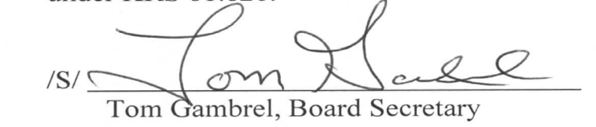

Bell County Board of Education
Special Called Meeting
Tuesday December 21, 2021
2:00 p.m.

AGENDA

1. Call meeting to order, establish quorum, moment of silence, Pledge of Allegiance
2. Accept and possibly award bids for Yellow Creek & Page Paving & Interior Lighting Renovation project
3. Adjourn

