NOTICE

The Bell County Board of Education’s special called meeting on Wednesday April 14, 2021 at 4:30pm will be held via video teleconference. The primary location where all members can be seen and heard and the public may attend in accordance with KRS 61.840 is the Bell County Board of Education Administration Office, 211 W Virginia Avenue, Pineville, Kentucky with the anticipation that four board members will be present and one board member will participate via video teleconference as authorized under KRS 61.826.

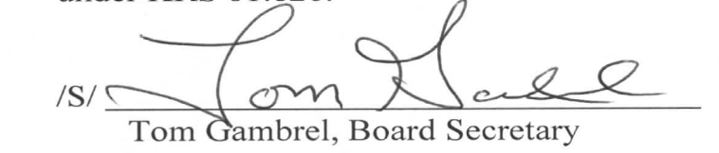

Bell County Board of Education
Special Called Meeting
Wednesday, April 14, 2021
4:30 p.m.

AGENDA

1. Call meeting to order, establish quorum, moment of silence, Pledge of Allegiance
2. Accept and possibly award bids for surplus school busses
3. Conduct a budget work session to review the FY22 budget
4. Set date and time of Bell County High School Graduation
5. Approve Construction Documents-Relocation of Central Office
6. Approve BG-1-Page Parking Lot Paving
7. Approve BG-1-Lone Jack Parking Lot Paving
8. Approve BG-1-Yellow Creek Parking Lot Paving
9 Approve Capital Funds Request
10. Adjourn

