NOTICE

The Bell County Board of Education will meet in a Special Called Meeting, Tuesday, December 8, 2020at 1:00 p.m. at the Bell County Administration Building, Pineville, KY.

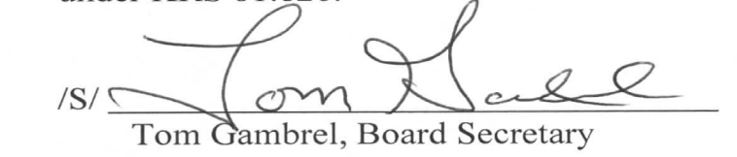

Bell County Board of Education
Special Called Meeting
Tuesday, December 8, 2020
1:00 p.m.

AGENDA

1. Call meeting to order, establish quorum, moment of silence, Pledge of Allegiance

2. Consider a motion to enter into Executive Session as allowed under KRS 61.810 under
subsection (1):(b) Future acquisition or sale of property, only if it will impact the value of
the property-Old Bell County High School Property

3. Consider a Motion to Reconvene into Regular Session

4. Adjourn

