NOTICE

The Bell County Board of Education will meet in a Special Called Meeting, Tuesday, April 7, 2020 at 5:00 p.m. at the Bell County Administration Building, Pineville, KY. The special called meeting will be held via video teleconference. The primary location where all members can be seen and heard and the public may attend in accordance with KRS 61.840 is the Bell County Administrative Office, 211 W Virginia Avenue, Pineville, Kentucky with the anticipation that three board members will be present and two board members will participate via video teleconference as authorized under KRS 61.826.

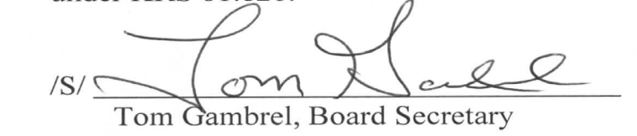

Bell County Board of Education
Special Called Meeting
Tuesday, April 7, 2020
5:00 p.m.

AGENDA

1. Call meeting to order, establish quorum, moment of silence, Pledge of Allegiance

*2. Discuss Superintendent’s Contract

*3. Consider a motion to enter into Executive Session as allowed under KRS 61.810
under subsection (1): f. Discussions or hearings which might lead to the appointment,
discipline or dismissal of an individual employee, member or student. 1) Conduct
Interviews for the Superintendent Vacancy
- Consider a Motion to Reconvene into Regular Session

4. Approve No Kid Hungry Grant Application

*5. Approve Use of Emergency Leave Days

6. Adjourn

*No Packet Contents

