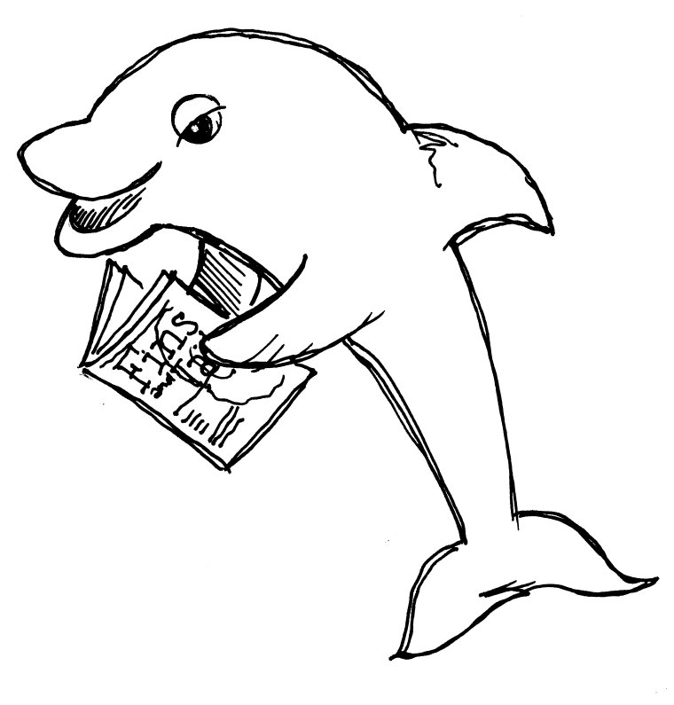
Lampton Elementary School

Code of Conduct

The Golden Rule
Common courtesy and common sense are sufficient rules for most situations. However, when the safety and social growth of our students are considered, it is necessary to develop additional rules. All school rules and items listed in the Lampton Code of Conduct are in effect while students are at school, at school-sponsored events, and while coming to and from school. The following procedures and expectations are adopted to assure the safety of children and maintenance do the school campus.

School Wide Behavior Expectations - “The 3 B’s for Success”
Our behavioral expectations based on PBIS—Positive Behavior Interventions and Supports. Our staff introduces these expectations at the beginning of each school year and again mid year with directed lessons.

At Lampton Elementary School, we have three school-wide behavioral expectations, known as the 3 B’s for success:

• Be Respectful • Be Responsible • Be Safe

We have defined what these expectations look like in various areas of the school such as the playground, hallways, restrooms, cafeteria, etc. These are stated clearly and positively on the matrix on the next page.

Students who noticed exhibiting positive behavior will earn Dolphin Success Tickets. Each month a drawing will be held to select students for an award certificate and special reinforcement, such as a play party, special treat, etc.

Classroom Expectations
Classroom procedures and behavioral expectations are developed by each teacher and/or by grade level teams. Each teacher will instruct his/her students on their classroom rules and procedures at the beginning of the school year. It is the student’s responsibility to understand these standards and follow them. Teachers will keep parents informed of good behavior, and may ask for support from the parent or principal to correct inappropriate behavior.
Incentives for Appropriate Behavior
- Classroom incentives (stickers, stars, table points, etc)
- Positive call or note home
- Dolphin Success Tickets
- Monthly Dolphin Success Drawings for certificates & events
- Trimester awards

Coming To and From School
- All students should arrive on campus between 7:30 to 7:45 AM.
- Students should line up for class when the warning bell rings at 7:55 AM, so that they can be in class by the start of school at 8:00 AM.
- Only students in grades 4-5 may ride bicycles to school. Bicycles must be walked onto and off of the school grounds and riders must wear a helmet.
- Students are to leave the school grounds immediately when dismissed, unless participating in a supervised after-school program, intervention or event.
- Students are to enter and exit through identified gates: Main gate, Excelsior Gate (at dismissal only), or Kindergarten gates (TK & Kdg students only).
- Remember - All school rules are in effect on the way to AND from school!

Appropriate School Dress & Grooming
- All clothing should be modest and respectful.
- Safe footwear should be worn at all times. (i.e.- closed toes, sturdy soles, flat or minimal heel) Tennis shoes are encouraged.
- Hair should not be groomed in the classroom.
- For health reasons, brushes/combs are not to be shared.
- Students are NOT to bring make-up, cologne, or hair sprays/colorants to school.
- See appropriate clothing and grooming guidelines.

Visiting the Office
- Students should have a written note from an adult or classroom pass when visiting the office, except for obvious emergencies.

Absence Verifications
- Written verification of the reason for student absences is necessary . Students should bring a note from their parent or doctor when they return to school.
- Unverified absences automatically become truancies after 10 days.
- In cases of excessive absence, a doctor’s note may be required for ALL absences. Individual parents will be notified if this is required.

Medication
- A signed physician’s authorization is required to be on file in the school office in order for a student to take ANY medication (prescription or non-prescription) while at school. These medically authorized medications MUST be kept in the office.
- Students may NOT be in possession of any medications while on campus (i.e. Tylenol, Asperin, cough drops, inhalers, antibiotics, etc.) except in life threatening circumstances, as written by the student’s physician. In such cases, an emergency health plan should be pre-established with the District Nurse, school principal and necessary staff.

Bus Conduct
- All school rules apply while on the bus.
- Students should remain seated and follow directions from bus drivers & school staff.

Recess and Lunch Play Times - Playworks Program
- Lampton is fortunate to have a Playworks Coach to organize and instruct students on positive play. They will attend recess with students throughout the day.
- Each classroom will have monthly game time to learn the rules for new games that will be introduced on the playground. This helps to ensure that everyone knows and follows the same rules for each game.
- Junior coaches selected from grades 4-5 will help to support and encourage positive play and to resolve conflicts. These student leaders play an important role in keeping students involved and happy.
- Playworks uses an inclusive philosophy. Our intent is to have all students engaged in positive play each recess break. ALL games are open to ALL students, ALL the time. “Locking games” or excluding others is not allowed.
- Students are taught to use “Rock-Paper-Scissors” or “Ro-Sham-Bo” to make decisions or solve minor disagreements in games.

Toys/Equipment/Electronics From Home
- Lampton provides ample play equipment and classroom supplies for our students to use during school. It is not necessary for students to bring balls, toys or sports equipment from home.
- Articles of value and electronic devices such as i-pods, i-pads, and electronic games may NOT be brought to school.
- Lampton will not be responsible for lost, stolen or damaged items from home.

Cell phones
- Students may NOT use cell phones during school hours. Cell phones may not be used to take or post pictures, record the actions or voices of students or staff without permission of their teacher or principal. Parents or students who need to contact one another during school hours should direct their calls to or from the school office at (562) 462-9273.
- Lampton will not be responsible for lost, stolen or damaged cell phones.

Skateboards/ Roller Blades/ Skates/ Scooters
- Skateboards, roller blades/skates, and scooters are not allowed at school.
- Damage to school or school district property from the unauthorized use of these items will be prosecuted.

Bicycles (Grades 4-5 ONLY)
- Bikes may be ridden to/from school by students in 4th & 5th grade only.
- Students must walk bikes onto and off the campus to protect everyone’s safety.
- All bikes must be parked and locked in the bike racks.
- Bikes are not allowed on the playground or in the hallways.
- HELMETS MUST BE WORN, OR BIKES WILL BE LOCKED UP UNTIL A PARENT CAN RETRIEVE IT OR THE STUDENT RETURNS WITH A HELMET.

Disposition of Articles Not Allowed At School
- Candy, gum, etc. are not allowed and will be thrown away.
- Other items that are not allowed at school will be confiscated and returned to the child after school to take home. (ie toys, trading cards, etc.)
- In some, more significant cases, parents may be required to pick up items from the office, principal or teacher.
Bullying
- BULLYING IS NOT ALLOWED!
- Bullying is unwanted, aggressive behavior that involves a real or perceived power imbalance. The behavior is repeated over time.
- In order to be considered bullying, the behavior must be aggressive and include:
  - Imbalance of Power: Kids who bully use their power—such as physical strength, number in the group, access to embarrassing information, or popularity—to control or harm others. AND
  - Repetition: Bullying behaviors happen more than once or have the potential to happen more than once.
- Incidents of bullying will be handled with formal disciplinary consequences, up to and including suspension and referral to the NLMUSD District Guidance Panel for further action.
Harassment
- All students should feel comfortable at school.
- Students are to refrain from “pantsing,” kissing, or inappropriate touching or hugging of others.
- Students are to avoid making negative comments or telling jokes about anyone’s gender, body, race, ethnicity, religion or family.

Appropriate Technology Use
- Students must abide by district regulations for acceptable use of technology
- Unauthorized uses of technology include such things as: accessing or communicating inappropriate language/images, threatening/embarrassing others, sharing personal information of self or others, destroying/deleting data or documents of others, damaging hardware or software, accessing unauthorized software, recording images/voices of self or others without permission, etc.
- See NLMUSD acceptable use agreement for full details.

Alcohol, Tobacco & Drugs
- All NLMUSD schools have a zero tolerance policy for possession, use, sale or furnishing of alcohol, tobacco or drugs. Suspension is the minimal consequence that may be assigned. Selling drugs carries a mandatory recommendation for expulsion from a school district (Ed Code 48915)
Weapons on Campus
- Weapons or dangerous objects of any kind are not allowed at any school. California Education Code requires that a principal or superintendent “recommend a pupil’s expulsion for possession of any firearm, knife, explosive or other dangerous object of no reasonable use to the pupil at school, at a school activity off school grounds, and while going to or coming from school” (Ed Code 48915)
- Dangerous items will be held until a parent conference and/or District Guidance meeting has been held, or may be given to the Sheriff’s Department for evidence in cases of criminal action.
- Imitation firearms (including toy guns of any kind) are not allowed and bringing the to school may lead to suspension. They will be confiscated and kept until a parent conference is held.

Consequences for Inappropriate Conduct
When a student chooses not to follow the rules he /she understands that they have chosen to accept the consequences of their actions. Students who exhibit inappropriate behavior may have their behavior documented in the following ways, all requiring parent signature:
• Playground conduct slip • Daily behavior contract • Office Referral
Minor Consequences | More Serious Consequences
Warning | Parent conference
Note or call home | Referral to principal
Change of seating in class | Daily behavior contract
Reduction of daily classroom behavior rating (no star for the day, change card color, etc) | Full day time out.
Loss of privilege (recess, event, activity, etc) | Referral to SST for behavior intervention
After school detention (15 minutes or less) | Parent required to sit in class with student
Short term time out | Suspensions from class or school *(Due to Ed Code violation)*
Written Behavior Reflection | Change of classroom
Parent conference | Referral to District Guidance which could result in a reassignment to another school or expulsion from the school district *(Due to Ed Code violation)*

If you have any questions regarding above expectations and code of conduct, please contact your child’s teacher or the office.

Please review the Lampton Code of Conduct with your child
Sign and return bottom portion of this page to your child’s teacher

----------------------------------------------------------------------------------------------------------------------------------------------------------------------
My child and I have read and discussed the Lampton Code of Conduct and Procedures. I am willing to support the Code of Conduct and work as partners with the staff to help my child make positive behavioral choices.

Child’s Name: _______________________________________________________ Grade___________ Room #__________

Parent Signature: ____________________________________________________ Date ____________________________

Child Signature: ______________________________________________________ Date: ___________________________

Signatures will be kept on file.

