Utilities and Housing

Salvation Army Utility Assistance
Puget Sound Energy
All assistance is limited up to $600.00 maximum per household. To receive this annual assistance from PSE you must live in Pierce County and provide:
- A copy of the shut-off notice (Urgent, Final, Disconnect) or an "Assistance Provider" notice. If one of these documents is not provided, we will not be able to assist you.
- Current and valid photo ID (or photocopies of the IDs) for all adults in the household age 17 and older.
- Separate proof of address for anyone 17 years or older in the household.
- Proof of all income coming into the home (pay stub, award letter, unemployment, etc.)
Please note: Prior to applying for Warm Home Fund assistance, contact your local federal energy assistance provider LIHEAP (www.liheap.org) and/or PSE HELP at (855) 798-4328 in order to apply for assistance and maximize the financial assistance you are able to receive.
https://puyallup.salvationarmy.org/puyallup_valley/utility-assistance/
St. Vincent DePaul
https://www.svdptacoma.org/get-help/
Eviction Prevention Resources https://www.svdptacoma.org/news/eviction-prevention-resources

PIERCE COUNTY ENERGY ASSISTANCE PROGRAM (EAP)

To apply please call 253-798-4328.
For questions or other translations, please call 253-798-4400 (Option 0)
https://www.piercecountywa.gov/1280/Energy-Assistance

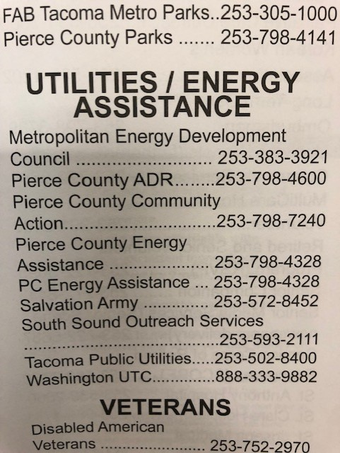
Metropolitan Energy Development Council
https://mdc-hope.org/energy-assistance/

