Enrollment of EL Students

- All ELs must be allowed to attend school, regardless of their ability to present a birth certificate, social security number, or immigration documentation.
- The district may require proof of required vaccinations.
- The Home Language Survey (HLS) is a part of CPSD’s registration process. The parent or guardian of all students must complete the HLS at the time of initial enrollment into CPSD, and the HLS should remain in the student’s permanent record through the student’s graduation.
- If the student does not have a social security card/number, contact the building level MSIS clerk. The MSIS clerk will request a nine-digit number for MSIS identification.
- Immunization records- if parents do not have immunization records available, contact previous school system; if necessary, students can begin the immunization series at the local public health department; appropriate immunization documentation must be obtained within 90 days.

Remember

- LAS Links Placement Test must be given within thirty (30) days of enrollment at the beginning of the school year and within two weeks of enrollment for students who register after the beginning of the school year.
- ELs should be placed at the age-appropriate grade level.
- Each EL student MUST have an English Language Service Plan – updated annually.
- ELs are NOT exempt from the State assessment program.
- Grading guidelines for ELs may be found in the MS Toolkit.
- Specific guidelines for exiting and monitoring the EL program are followed according to MDE guidelines found at http://www.mde.k12.ms.us/docs/federal-programs/english-learner-guidelines-regulations---funding-guidance-and-instructional-supports_20180518.pdf?sfvrsn=2

For more information contact:
Teresa Duke
District EL Coordinator
601-924-7533
tduke@clintonpublicschools.com

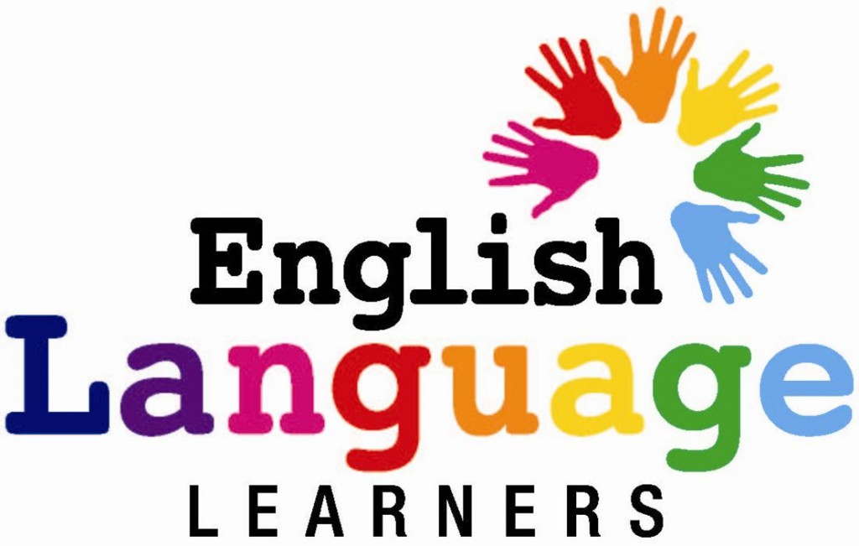



CPSD

Procedures

Definitions

A. The term “English Learner “ (EL) or “Limited English Proficient” (LEP), which is defined in Section 9101 of Title IX when used with respect to an individual, means an individual –
- who is aged 3 through 21;
- who is enrolled or preparing to enroll in an elementary or secondary school;
- who was not born in the U.S. or whose native language is a language other than English;
  - who is a Native American or Alaska Native, or a native resident of the outlying areas; and
  - who comes from an environment where a language other than English has had a significant impact on the individual’s level of English language proficiency; or
  - who is migratory, whose native language is a language other than English, and who comes from an environment where a language other than English is dominant; and
- whose difficulties in speaking, reading, writing, or understanding the English language may be sufficient to deny the individual –
- the ability to meet the State’s proficient level of achievement on

State assessments described in Section 1111(b) (3);
a) the ability to successfully achieve in classrooms where the language of instruction is English; or
b) the opportunity to participate fully in society.

B. The “immigrant child” as described in Section 3301 of NCLB is an individual
- who is age 3 through 21,
- were not born in any State in the U.S. the District of Columbia, or the Commonwealth of Puerto Rico.
- has not been attending one or more schools in any one or more States for more than 3 full academic years.

Children born to U.S. citizens abroad may be considered immigrants if they meet all the criteria in the definition of immigrant.

C. “No person in the United States shall, on the grounds of race, color or national origin, be excluded from participation in, be denied the benefits of, or be subjected to discrimination under any program or activity receiving federal financial assistance.” 42 U. S. C. § 2000d.
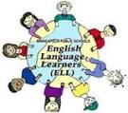

Guidelines
- A Home Language Survey is completed during enrollment

2. Identified as potential EL through home language survey

3. Administered LAS Links placement test to determine English language proficiency level and need for Language Instruction Educational Program

4. Placed in an English as a Second Language program of services

5. Transitions out of Language Instruction Educational Program

6. Monitored for four years student’s academic progress

