Clinton Public School District 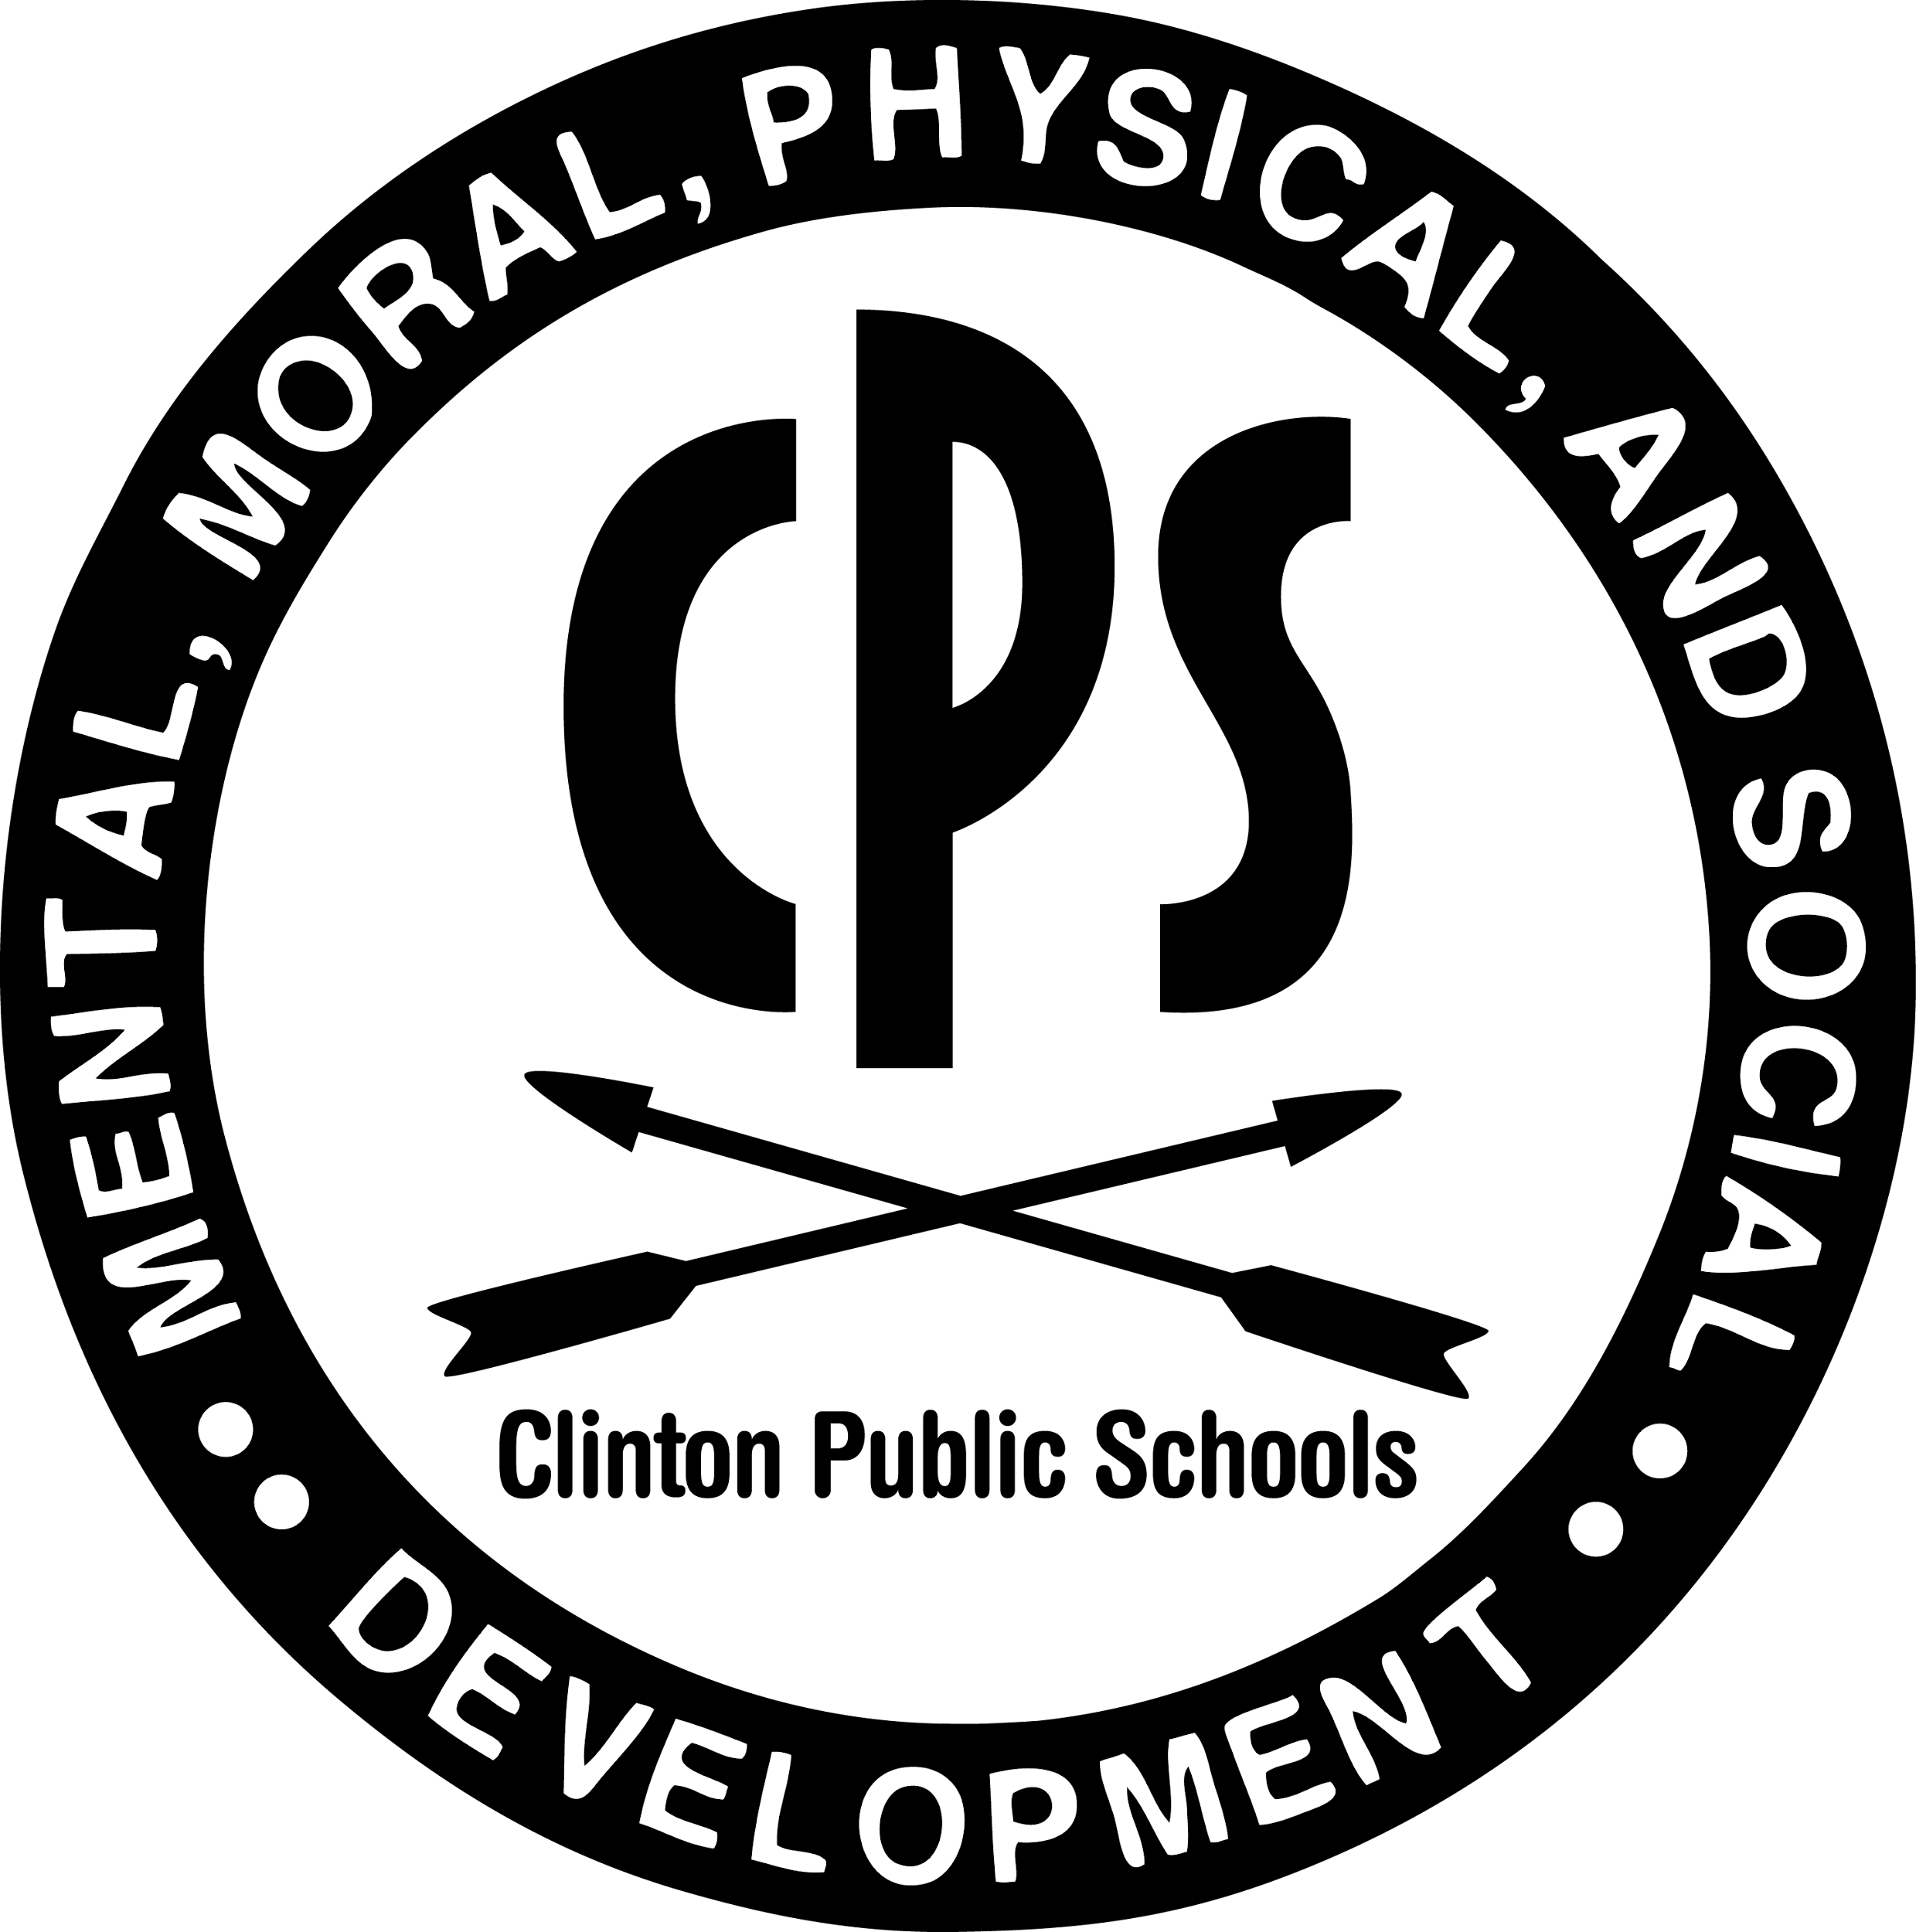
Office of Special Education
Chaffie Gibbs, Director
___________________________________________________________________________________________________________________
Transition Services

Transition Services are a coordinated set of activities for students with disabilities as part of the IEP, designed to promote movement from school to post-school activities. At Clinton Public School District, our Transition Program is dedicated to developing and coordinating services that align with transition skills being taught in the classroom by teachers at each high school. Below, we have outlined the CPS Transition Services offered through the Office of Special Services. The IEP team of each student determines appropriate programming for students.

Student Services

Transition Skills Lab – The transition skills lab provides independent living skills development activities, pre-vocational activities with simulated work samples. This is provided to Middle and High School students in coordination between the teacher and Transition Coordinator. Activities are tailored to student’s skill levels based on Life Skills Assessment and observation.

Work Based Internships – Local businesses & Project Search (through MDRS) partner with CPS to provide opportunities for work experience. CPS tries to partner with a variety of industries to give range experiences for the students to explore various jobs. CPS teachers/job coaches are with the students at these experiences.

Job Shadowing – Students are introduced to various work environments by learning directly from local business employees about their jobs. This is accomplished in individual and group outings to industries in the surrounding metropolitan area.

Job Readiness Skills – Students are provided learning opportunities through classes and activities provided by Transition Staff, including: Self-Advocacy, Career exploration, Dress for success, Application and Interviewing skills practice, and Online Job Search skills.

Drivers Permit Services – Transportation is vital to employment ad independent living after high school. CPS students who need extra help preparing for the driver’s permit test will be offered tutorial help. In addition, we transport groups to the DMV to take their permit test or get their State ID during the school year.

Post-Secondary Training tours – Tours of local colleges, job corps centers, and other training programs helps students explore training opportunities available after they exit high school.
Transition Services

Student workshops & conferences – These conferences include financial literacy, motivational speakers, employer interviews and job seeking strategies.

Self-Advocacy Training – Self-advocacy is a process of identifying personal needs and advocating for them, versus having parents or caregivers advocate them. We try to encourage self-advocacy in all of the transition activities. In addition, we design specific activities to develop these skills needed in life.

Parent and Family Services

Agency Linkages – We connect students and families to service providers that assist them outside the educational setting while the student is still a student of CPS. Also, we connect students and families to programs and services that may assist with Post-secondary services, training or employment.

Parent Night – CPS invites services providers on-site with their information about their services for families to learn about programs available to them.

Consultations – Consultations with the Transition Coordinator may be scheduled at any time to assist with understanding how to access programs outside of CPS, i.e. Medicaid Waiver, Social Security, Vocational Rehabilitation, etc.

