LCHS Class of 2026 Senior Contract

Dear Class of 2026 Parents and Students: (KEEP THIS PAGE)

Senior year will be here before you know it, and we all know how expensive senior class activities can be. Because of this, the Class of 2026 would like to make senior activities available & affordable to every student. We do this through a Senior Contract.

The Senior Contract allows senior activities to be paid in full or through installments. Once the student opts into the Senior Contract, dues are payable according to the payment schedule you choose. The Class of 2026 will send reminders & updates to every individual who signs a Senior Contract of their required payment deadlines and other information.

Every student must have a contract on-file in order to participate in senior activities!

SENIOR CONTRACT ACTIVITIES
Pricing varies based on the purchase date (earlier is cheaper), and here’s what’s included:
- Prom: Prom is an elegant, memorable event and a rite of passage, not just a dance. We are so excited to plan an unforgettable evening for the Class of 2026! The prom ticket price includes: the dance, light food, entertainment, and possible door prizes. The location & date of prom is still to be determined.
  - Prom Guest: One additional prom ticket may be purchased at the lowest possible price, based on the deposit and contract timing you select (see table). All attendees must be approved by LCHS Administration. Prom guest tickets and guest forms may be submitted and purchased three weeks prior to the event.
- Senior Field Trip: The senior field trip is an all-day casual gathering on a school day where the senior class will enjoy sharing time together. This activity is only for LCHS Class of 2026 students. The location & date of the senior field trip is still to be determined.
- Senior T-shirt & Yard Sign: The senior t-shirt & yard sign will be designed and voted on by the Class of 2026.
More details will be announced later for a fun, eventful senior year - don’t miss out!

ELIGIBILITY
In order to participate in senior events, students must be in good standing with LCHS Administration. Meeting the requirements below will ensure eligibility to participate, even if the event is during school hours. Stay eligible – there are no refunds due to ineligibility:
- Student cannot be on Loss of Privilege List;
- Student cannot be on the Loss of Credit List; and
- No suspension (in school or out of school) during the semester in which the event occurs.

PAYMENT GUIDELINES
Payments can be made in the following ways:

All contracts must be PAID IN FULL no later than December 5, 2025!
Zelle (preferred)  Send Zelle payment to:  classof2026lchs@gmail.com  Be sure to include student’s name and ID# in the memo field. | Cash  Please drop off in Room 2222B to Mrs. Alaniz before or after school with your signed contract. Cash must be in a sealed envelope and include the student’s name and ID#.
Checks/Money Orders  Please drop off in Room 2222B to Mrs. Alaniz before or after school with your signed contract. Checks/money orders should be made payable to:  “LCHS Parent Boosters Inc. - Class of 2026”  Be sure to include student’s name and ID# in the memo line. A returned check fee of $40 will be charged on all NSF/bounced checks. | Credit & Debit Card  Please make payment using the QR code below. Payments using this method incur a fee and are not preferred.  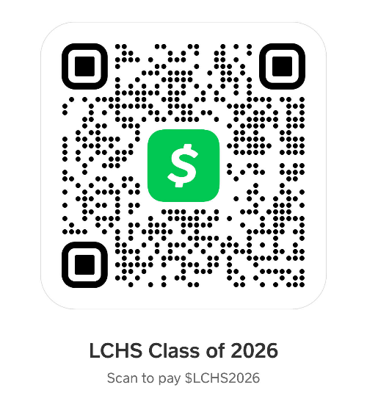

PARENT BOOSTERS & VOLUNTEERS
If a parent wishes to join the Booster Club for the Class of 2026, please email us at classof2026lchs@gmail.com. Please note that the school must have a volunteer form on file for parents wishing to participate in any of school-related activities. The form can be found on the GISD website at: https://garlandisd.net/connect/volunteer/volunteer-application-process

Thank you for your time and effort for the Class of 2026.

Sincerely,

LCHS Class of 2026 Booster & Sponsors

Questions? Email us! classof2026lchs@gmail.com
Facebook: Lakeview Centennial Class of 2026

 | Senior Contract  Class of 2026 | LAKEVIEW CENTENNIAL HIGH SCHOOL  3505 Hayman, Garland, Texas 75043  Sponsor: Lisa Chapman - lchapman@garlandisd.net  Sponsor: April Alaniz - amalaniz@garlandisd.net  Sponsor: Cristina Wilson- ciwilson@garlandisd.net

Instructions: Print, complete form, sign, and return to Mrs. Alaniz in room 2222B, at the booster meetings, or email to classof2026lchs@gmail.com.

Student Information: | Please print clearly
GISD ID#
First & Last Name
GISD Email
Phone #
Parent/Guardian Information:
First & Last Name
Email
Phone #

These prices are per person/per ticket. A completed contract is required to participate in these events. By participating in this contract, you are guaranteed the lowest price of each of the items listed, based on date of receipt of contract and payment. Additional tickets may be obtained, price based on date of first installment [See table].

Full payment is preferred, however, a deposit locks in the lowest price if paid by respective due date. Payments should then be made until the contract is paid in full, which must be completed no later than December 5, 2025. Cash, Check/Money Order, Credit Card, Debit Card, and Zelle payments will all be accepted.

Receipts will be provided via email, so be sure to include an accurate email address on the contract. Once you have submitted a signed contract and deposit, items and event tickets quantities cannot not be decreased, and deposits will not be refunded regardless of attendance/participation.

Mark each event you wish to purchase on the next page, then calculate the deposit amount, sign and date this contract, and return with payment. Be sure to include Student’s first and last name and I.D. number on all payments.

Contract & Minimum Deposit Due Date |  | Deposit | Senior Field Trip  (1 Ticket) | Prom Ticket  (1 Ticket)
Due by May 3, 2024 | Sophomore Year | $50.00 | $45 | $160
Due by December 6, 2024 | Junior Year | 50% of total | $50 | $170
Due by March 7, 2025 | Junior Year | 50% of total | $55 | $180
Due by September 5, 2025 | Senior Year | 50% of total | $60 | $190
Balance of payment due December 5, 2025.
LAST CHANCE - Due by April 3, 2026 |  | 100% of total | $65 | $200
Senior T-Shirt (note - $2 upcharge for sizes 2XL and larger)  *Must be ordered by the March 7, 2025 deadline |  |  | Quantity: _________ x $20 = ___________
Senior Yard Sign  *Must be ordered by the March 7, 2025 deadline |  |  | Quantity: _________ x $15 = ___________

Senior Shirt Size(s) |  |  | Date Senior Contract turned-in:
Small: |  |  | Senior Field Trip price: | $
Medium: |  |  | Prom Ticket price: | $
Large: |  |  | Senior T-Shirt total: | $
X-Large: |  |  | Senior Yard Sign total: | $
2X-Large: |  |  | SENIOR CONTRACT TOTAL: | $
3X-Large: |  |  | Deposit: | $
Other (specify): |  |  | Balance Due: | $

By signing this contract and submitting the required deposit, I understand that I am responsible for complete payment of the balance no later than Friday, December 5, 2025. I understand that payments received after that date but no later than January 9, 2026, are subject to a $15 late fee. Contracts not paid in full by January 9, 2026, are subject to forfeiture. No refunds will be made regardless of attendance, participation, or ineligibility due to being on the Loss of Privilege list, Loss of Credit list or suspension in the semester during which the event occurs. If an event is canceled, refunds may occur, depending on vendor return of funds/deposits.
Student Signature: | _____________________________________ | Date: | _____________
Parent/Guardian  Signature: | _____________________________________ | Date: | _____________
PLEASE MAKE A COPY FOR YOUR RECORDS

