

ARP ESSER Health and Safety Plan
Guidance & Template
Section 2001(i)(1) of the American Rescue Plan (ARP) Act requires each local education agency (LEA) that receives funding under the ARP Elementary and Secondary School Emergency Relief (ESSER) Fund to develop and make publicly available on the LEA’s website a Safe Return to In-Person Instruction and Continuity of Services Plan, hereinafter referred to as a Health and Safety Plan.
Based on ARP requirements, 90 percent of ARP ESSER funds will be distributed to school districts and charter schools based on their relative share of Title I-A funding in FY 2020-2021. Given Federally required timelines, LEAs eligible to apply for and receive this portion of the ARP ESSER funding must submit a Health and Safety Plan that meets ARP Act requirements to the Pennsylvania Department of Education (PDE) by Friday, July 30, 2021, regardless of when the LEA submits its ARP ESSER application.
Each LEA must create a Health and Safety Plan that addresses how it will maintain the health and safety of students, educators, and other staff, and which will serve as local guidelines for all instructional and non-instructional school activities during the period of the LEA’s ARP ESSER grant. The Health and Safety Plan should be tailored to the unique needs of each LEA and its schools and must take into account public comment related to the development of, and subsequent revisions to, the Health and Safety Plan.
The ARP Act and U.S. Department of Education rules require Health and Safety plans include the following components:
- How the LEA will, to the greatest extent practicable, implement prevention and mitigation policies in line with the most up-to-date guidance from the Centers for Disease Control and Prevention (CDC) for the reopening and operation of school facilities in order to continuously and safely open and operate schools for in-person learning;

- How the LEA will ensure continuity of services, including but not limited to services to address the students’ academic needs, and students’ and staff members’ social, emotional, mental health, and other needs, which may include student health and food services;

- How the LEA will maintain the health and safety of students, educators, and other staff and the extent to which it has adopted policies, and a description of any such policy on each of the following safety recommendations established by the CDC:

  - Universal and correct wearing of masks;

  - Modifying facilities to allow for physical distancing (e.g., use of cohorts/podding);

  - Handwashing and respiratory etiquette;

  - Cleaning and maintaining healthy facilities, including improving ventilation;

  - Contact tracing in combination with isolation and quarantine, in collaboration with State and local health departments;

  - Diagnostic and screening testing;

  - Efforts to provide COVID-19 vaccinations to school communities;

  - Appropriate accommodations for children with disabilities with respect to health and safety policies; and

  - Coordination with state and local health officials.
The LEA’s Health and Safety Plan must be approved by its governing body and posted on the LEA’s publicly available website by July 30, 2021.* The ARP Act requires LEAs to post their Health and Safety Plans online in a language that parents/caregivers can understand, or, if it is not practicable to provide written translations to an individual with limited English proficiency, be orally translated. The plan also must be provided in an alternative format accessible, upon request, by a parent who is an individual with a disability as defined by the Americans with Disabilities Act.
Each LEA will upload in the eGrants system its updated Health and Safety Plan and webpage URL where the plan is located on the LEA’s publicly available website.
The ARP Act requires LEAs to review their Health and Safety Plans at least every six months during the period of the LEA’s ARP ESSER grant. LEAs also must review and update their plans whenever there are significant changes to the CDC recommendations for K-12 schools. Like the development of the plan, all revisions must be informed by community input and reviewed and approved by the governing body prior to posting on the LEA’s publicly available website.
LEAs may use the template to revise their current Health and Safety Plans to meet ARP requirements and ensure all stakeholders are fully informed of the LEA’s plan to safely resume instructional and non-instructional school activities, including in-person learning, for the current school year. An LEA may use a different plan template or format provided it includes all the elements required by the ARP Act, as listed above.
* The July 30 deadline applies only to school districts and charter schools that received federal Title I-A funds in FY 2020-2021 and intend to apply for and receive ARP ESSER funding.

Additional Resources
LEAs are advised to review the following resources when developing their Health and Safety Plans:
- CDC K-12 School Operational Strategy
- PDE Resources for School Communities During COVID-19
- PDE Roadmap for Education Leaders
- PDE Accelerated Learning Thorough an Integrated System of Support
- PA Department of Health - COVID-19 in Pennsylvania

Health and Safety Plan Summary: Central Dauphin School District
Initial Effective Date: June 22, 2021
Date of Last Review: January 22, 2024
Date of Last Revision: January 16, 2024
- How will the LEA, to the greatest extent practicable, support prevention and mitigation policies in line with the most up-to-date guidance from the CDC for the reopening and operation of school facilities in order to continuously and safely open and operate schools for in-person learning?
The district will continually monitor this plan to include federal and state mandates and consider significant new guidance. The plan will be reviewed and revised as necessary. The revisions will be recommended to the Board for approval and changes will be communicated to students and families, staff, and the greater District community.
- How will the LEA ensure continuity of services, including but not limited to services to address the students’ academic needs, and students’ and staff members’ social, emotional, mental health, and other needs, which may include student health and food services?
To address academic needs, our methods for educational delivery for the 2021-2022 school year will be:
  - Instruction will resume on August 30, 2021, on a normal day, Monday through Friday schedule.
  - CDSD students will have the following delivery option:
    - In-person classroom instruction (remote learning may be occasionally necessary depending on positive cases and governmental guidance and mandates).
    - Full remote instruction through the CDSD Cyber Academy, the District’s newly established cyber academy taught by District teachers.
Student medical issues which require a temporary leave from the classroom will be addressed on a case-by-case basis to determine appropriate instructional alternatives to continue the student’s education in consideration of information provided by the student’s health care provider, parent/guardians, principal and counselor and the IEP team, if applicable.
To address the social, emotional, mental health and other needs of students and staff members, the District will have measures in place for 2021-2022. These measures include, but are not limited to the following:
    - Additional Mental Health Staff Members
      - Elementary School Counselor
      - CDSD Cyber Academy School Counselor
      - School Social Worker (Check and Connect Coordinator)
    - Professional Development
      - Focus on Suicide Awareness and Prevention
      - Social Emotion Learning
      - Equity and Inclusion
    - Partnerships with Dauphin County and community organizations
    - Expanded Student Assistance Teams
- Use the table below to explain how the LEA will maintain the health and safety of students, educators, and other staff and the extent to which it has adopted policies, and a description of any such policy on each of the following safety recommendations established by the CDC.
ARP ESSER Requirement | Strategies, Policies, and Procedures
- Universal and correct wearing of masks; | Effective February 22, 2022:  Masks are encouraged but not required in all Central Dauphin School District buildings.  The District administration will monitor and review local transmission data monthly, at minimum. As local/county transmission level and guidance from the CDC and PDE change, the District administration will recommend changes for masking to the school board as appropriate. It is possible that the mask  optional approach set forth above may  change in the future as circumstances in  a building, classroom or district change or  when the legal requirements regarding  masking require a different approach.
- Modifying facilities to allow for physical distancing (e.g., use of cohorts/podding); | Students should be socially distanced pursuant to CDC and PDE guidelines.  Students should be spaced to the maximum extent possible.
- Handwashing and respiratory etiquette; | Highlight importance of proper handwashing strategies include washing with soap and water for at least 20 seconds, especially after going to the bathroom; before eating; and after blowing your nose, coughing, or sneezing. If soap and water are not available and hands are not visibly dirty, use an alcohol-based hand sanitizer that contains at least 60% alcohol.  Make available to students and staff CDC handwashing resources that include health promotion materials, information on proper handwashing technique, and tips for families to help children develop good handwashing habits.  Ensure adequate supplies (e.g., soap, paper towels, hand sanitizer, tissue) to support healthy hygiene practices.  CDC Germs Are Everywhere and Wash Your Hands Posters will be posted in all District Cafeterias, Restrooms, and other high traffic areas.
- Cleaning and maintaining healthy facilities, including improving ventilation; | The district will follow the CDC’s Guidance for Cleaning & Disinfecting Schools.  Frequently touched surfaces and objects within the school and on buses will be cleaned and disinfected at least daily. This includes, but is not limited to, door handles, sink handles, and drinking fountains.  The Daily and Weekly COVID-19 Cleaning Activities as specified on the Daily and Weekly COVID-19 Job Cards will be implemented and supervised.  Ventilation rates will be increased  during occupied times to maximize ventilation without causing other IAQ issues.  Classrooms and common areas will be ventilated with additional circulation of outdoor air when possible, using windows, doors, and/or fans.
- Contact tracing in combination with isolation and quarantine, in collaboration with the State and local health departments; | Provide regular information on CDSD website and in parent flyers/letters.  Prepare parents and families for remote learning if a class or school is temporarily dismissed.  Effective February 22, 2022:  Students, staff, and educators who are in close contact with a positive case and are not experiencing symptoms of COVID-19 will not be subject to restriction from school or school activities, regardless of vaccination status.  Students, staff, and educators who test positive for COVID-19 or are in close contact with a positive case and are experiencing symptoms of COVID-19 will be required to isolate or quarantine as required under Commonwealth and CDC directives and per the direction of their health care provider.  Contact tracing will not occur during any  period of optional masking.
- Diagnostic and screening testing; | All students and parents/guardians are required to perform a symptom screening prior to arriving at school or at the bus stop each day.  No student with symptoms will be sent on a bus or brought to school.  All district staff will perform a symptom screen on themselves prior to leaving for work and will stay home if ill.  Students and staff will consistently be made aware of the signs and symptoms of COVID-19.  Students and staff will go to the nurse immediately if feeling symptomatic.  The District will share resources with the school community to help families understand when to keep children home.
- Efforts to provide vaccinations to school communities; | The District will continue to work with local health agencies to offer opportunities for vaccinations.  The District will help to publicize vaccination opportunities within the local community.
- Appropriate accommodations for students with disabilities with respect to health and safety policies; and | The Director of Special Education, IEP case managers, school nurses and counselors will work with families to develop student specific education plan for low incidence students.  If a sink is available in the classroom, staff should thoroughly wash hands immediately before and after working with a student.  Avoid the use of communal objects for student reinforcement. If such objects are used with multiple students, each object should be disinfected immediately before and after student use.  Personal student iPads/AAC devices should be disinfected each time a student enters or exits the classroom.  Bathrooms and changing tables should be disinfected before and after student use. Limit students to one at a time.  Students should be assisted with handwashing.
- Coordination with state and local health officials. | Local DOH staff will notify the district upon learning that someone who tested positive for COVID-19 was present at the school while infectious. The District will work with DOH on risk assessment, isolation and quarantine recommendations, and other infection control recommendations.  The District will work cooperatively with DOH staff on contact tracing and other mitigation measures.

Health and Safety Plan Governing Body Affirmation Statement
The Board of Directors/Trustees for Central Dauphin School District reviewed and approved the Health and Safety Plan on January 22, 2024.

The plan was approved by a vote of:
8 Yes
0 No
1 Absent
Affirmed on:
By: 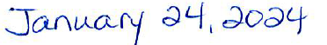

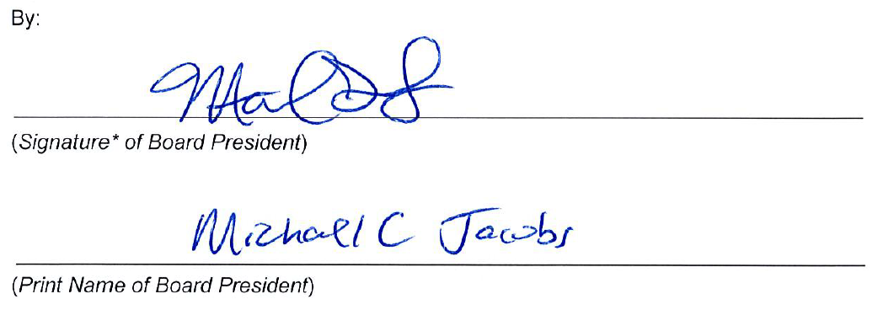
*Electronic signatures on this document are acceptable using one of the two methods detailed below.
Option A: The use of actual signatures is encouraged whenever possible. This method requires that the document be printed, signed, scanned, and then submitted.
Option B: If printing and scanning are not possible, add an electronic signature using the resident Microsoft Office product signature option, which is free to everyone, no installation or purchase needed.

