Activating Firefly Parent Portal

- Go to: https://campbell.fireflycloud.net to access the Campbell Firefly site.
- You will arrive at this page:
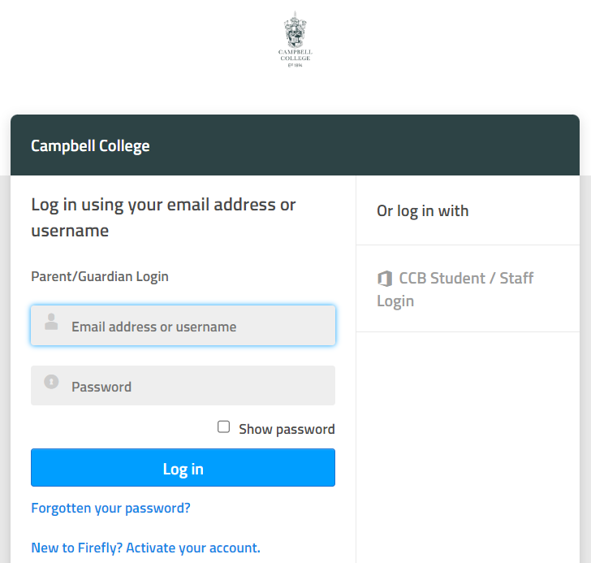
To activate your account, click on the option at the bottom of the page –
“New to Firefly? Activate your account.”

- Enter the email you have provided to the school and click ‘Activate account’.
(The e-mail must be the same one that you provided to the school via the admission application and will be the same as the one you receive Parentmail on unless you have subsequently changed the latter. An e-mail will be sent to this e-mail account.)
(It is possible for each parent to create their own individual Parent Portal account as long as you use separate e-mail addresses, both of which have been provided to school.)

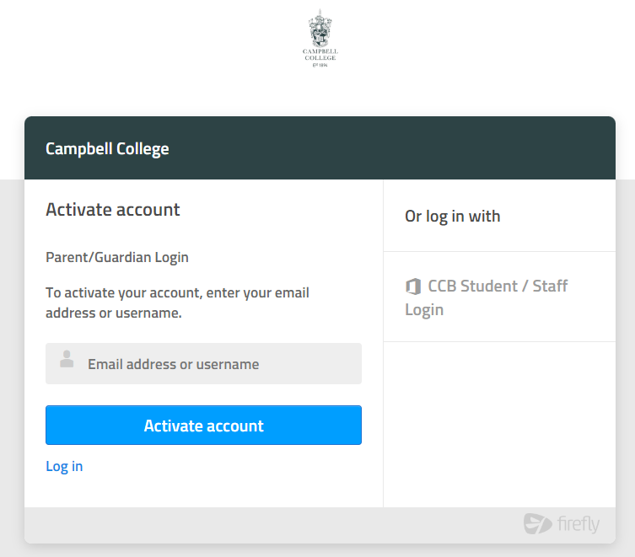

- Go to your e-mail account and click on the Activate account email that you should have received.

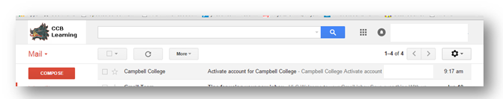

- Make a Firefly password. Your account should then load as shown below and you will see the ‘Parent Dashboard’.
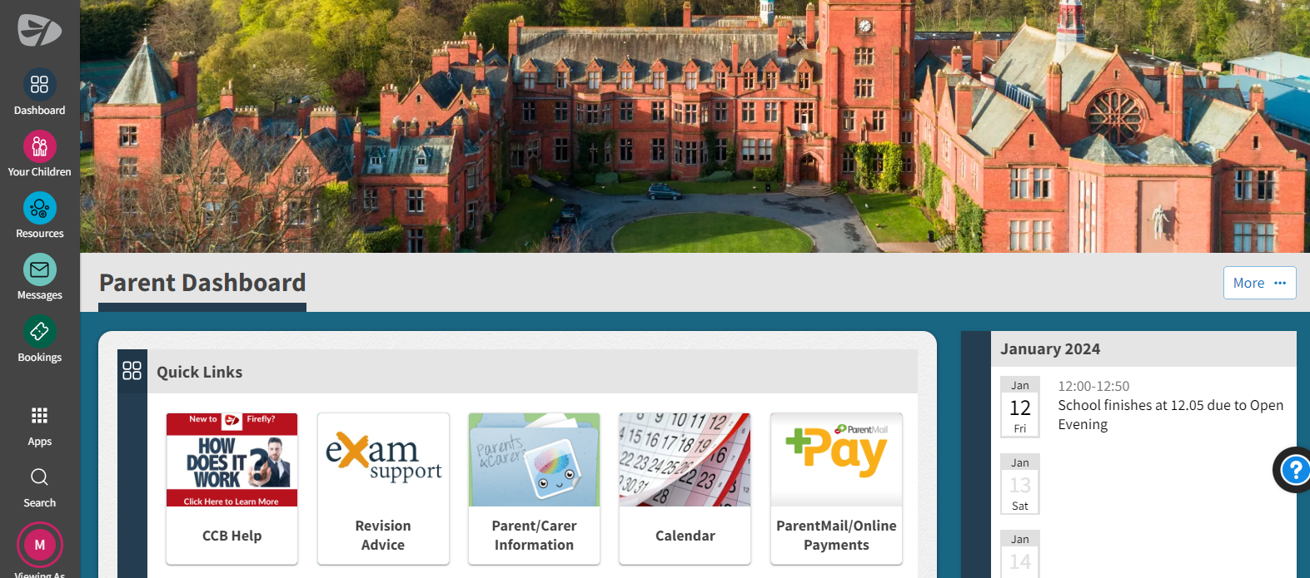
- To see your son’s tasks, feedback, and information about his attendance and punctuality, click on ‘Your Child’ or ‘Your Children’ on the left-hand menu.
If you require further information or assistance, click on the ‘CCB Help’ button on the Dashboard. This will provide further information and links, including information on how to install the ’Firefly for Parents’ App on either Apple or Android. When you install the app for the first time, the school code you will need is ‘campbell’.)
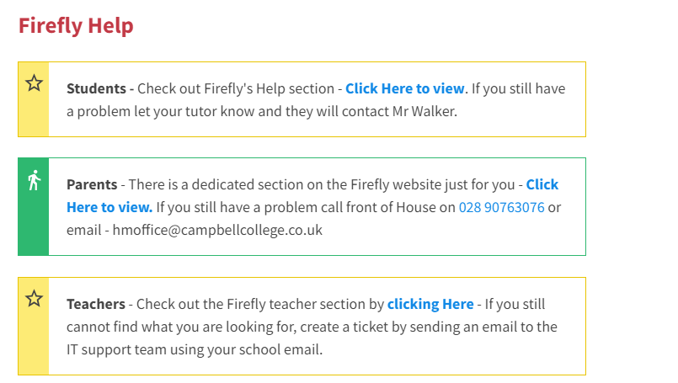

- That’s it . If you encounter technical difficulties with this process, please contact the College via hmoffice@campbellcollege.co.uk and we will endeavour to provide support.

