Battle Creek Middle School
Parent Pick-Up and Drop-Off Procedures

In an effort to ensure student safety, students are not allowed to walk or cross in between busses that are loading and/or unloading on North Park Drive.

Please reference the procedures below for the safe drop-off and pick-up of students.

Morning Drop-Off:
Students that are being transported to school in the morning by a parent/guardian must be dropped off in the parent pick-up/drop-off zone in the parking lot (see below). The map illustrates where your child should be dropped off and where they enter the building. Classes begin promptly at 7:30 AM. Please do not drop your child off at school before 7:15 AM, as there is no staff to monitor students before that time. A staff member will be in the parking lot each day from 7:15 – 7:25 AM.

Afternoon Pick-Up:
School is dismissed at 2:00 PM. Students who are being picked up will be directed to the parent pick-up/drop-off zone in the parking lot (see below). The map illustrates where your child will exit the building and where they should be picked up. A staff member will be in the parking lot each day from 2:00 - 2:10 PM helping students load safely into their vehicles.

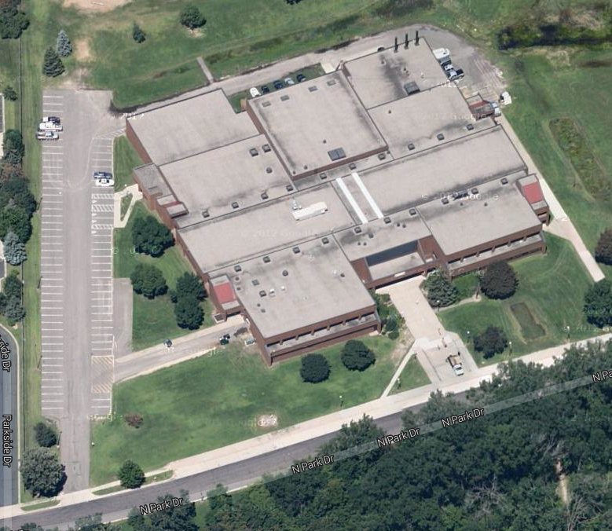
Students Entering/Exiting Building
Bus ONLY Loading Zone
(North Park Drive)
Parent
Pick-Up/Drop-Off
Zone

