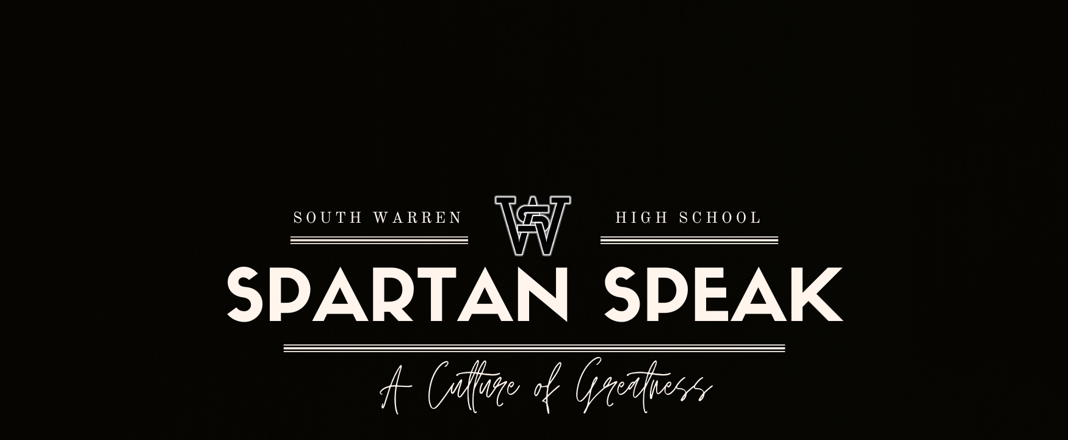

October 8, 2023

Important Dates
10/10 Trunk or Treat
10/14 Calendar Girl Pageant
10/17 Optional ACT for 9th, 10th & 12th
10/20 Seniors with Seniors
10/24 Optional PSAT for 10th & 11th grade
11/1 No School (PLC Day)
11/7 No School (Election Day)

Seniors with Seniors
On Friday, October 20, 2023 we are excited for our school to host the 10th annual grandparents/significant senior luncheon. Senior students may invite guest(s) to join them for lunch on this day. Click here to download the RSVP form and bring to the front office by Monday, October 16.

Urgent PTSO Need
PTSO is seeking to fill Co-President and Co-Vice President positions for the 2023-24 school year. If interested, please complete the Nomination Form and return form to the SWHS office by October 6, 2023 or email to southwarrenhighptso@gmail.com.

Governor's Scholar Program
We will have a Governor's Scholars Program informational session for students on Monday, October 16 during SWORD in the library.
The Governor's School for the Arts (GSA) 2024 APPLICATION IS NOW OPEN!
DEADLINE: Sunday, January 14th, 2024 @ 10:59 p.m. CT. Please visit the GSA website at KentuckyGSA.org for more information.
GSA 2024 Applicant Guides
See the link for the Applicant Guides for GSA 2024.
These important documents describe the application/audition process and criteria, enabling applicants to start honing their materials.
GSA Application Walkthrough Video
See the link to view the Application Walkthrough Video for GSA 2024.
This resource teaches students how to submit their materials through GSA's application portal website, Acceptd.
GSA 2024 Application Portal
See the link to access Acceptd, GSA's application portal website.
Here, students will be able to start uploading their application materials. Applications are due Sunday, January 14th, 2024 at 11:59 p.m. ET/10:59pm CT.
DID YOU KNOW: GSA HAS A FALL WEBINAR SERIES?
From now until December 6th, the GSA admin team will be hosting several Zoom webinars about the 2024 summer program. These are free to attend, however registration is required. For the full webinar schedule, as well as Zoom registration links, please visit this webpage.
Our first webinar, "GSA 101," was held on September 21st. If you missed it, no worries! You can watch a recording of this session here.

School Pictures and Yearbooks
Picture Makeup Days: For underclassmen, picture retakes will be on October 27th. For seniors, the final retake day will be November 10th. If you are wanting to purchase your pictures, you should receive a link in your email that will direct you to mylifetouch.com. You will still get proofs in person this week.

Yearbook Sales: All yearbook sales are conducted online at jostens.com. Direct any questions to Miss Gray @ kathryn.gray@warren.kyschools.us

SWHS ESS Information
SWHS ESS : Free Tutoring & Make Up Testing on Thursdays
STUDENTS SIGN UP AT THE FOLLOWING LINK: bit.ly/SWHSESSsignup23-24
*This form is due no later than 11AM every Thursday.
*Tutoring is 2:30-3:30 every Thursday
*Make up testing will begin at 2:30 and end at 4 every Thursday.
*All tutoring is provided by teachers at SWHS in small group format and is free. Typically there will be 1 to 5 students in a tutoring group.
*Check your SCHOOL GMAIL ACCOUNT at 1:45pm on THURSDAY to see where you are to report to for ESS if you sign up.
*NO TRANSPORTATION IS PROVIDED FOR ANY AFTER SCHOOL ESS SERVICES
*The student must report to their assigned location at 2:30 on Thursdays.

Boys' Lacrosse
Boy’s lacrosse open field starts Wednesday 10/11 5-7 pm at Buchanon field. If you have any questions please contact dale.bird@warren.kyschools.us. Open fields will be Wednesdays 5-6:30pm.

Congratulations!
Congratulations on another great performance by the Marching Spartans on Saturday, September 30th at the Warren Central Dragon Classic!!
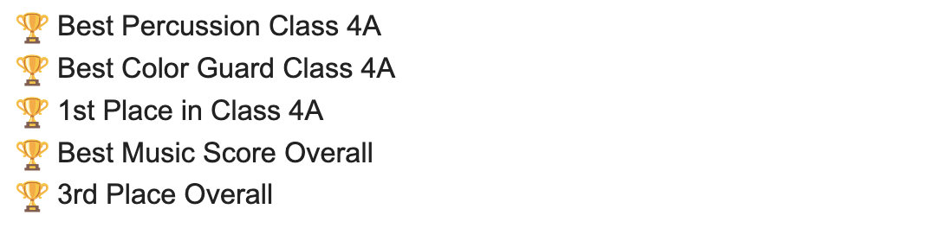


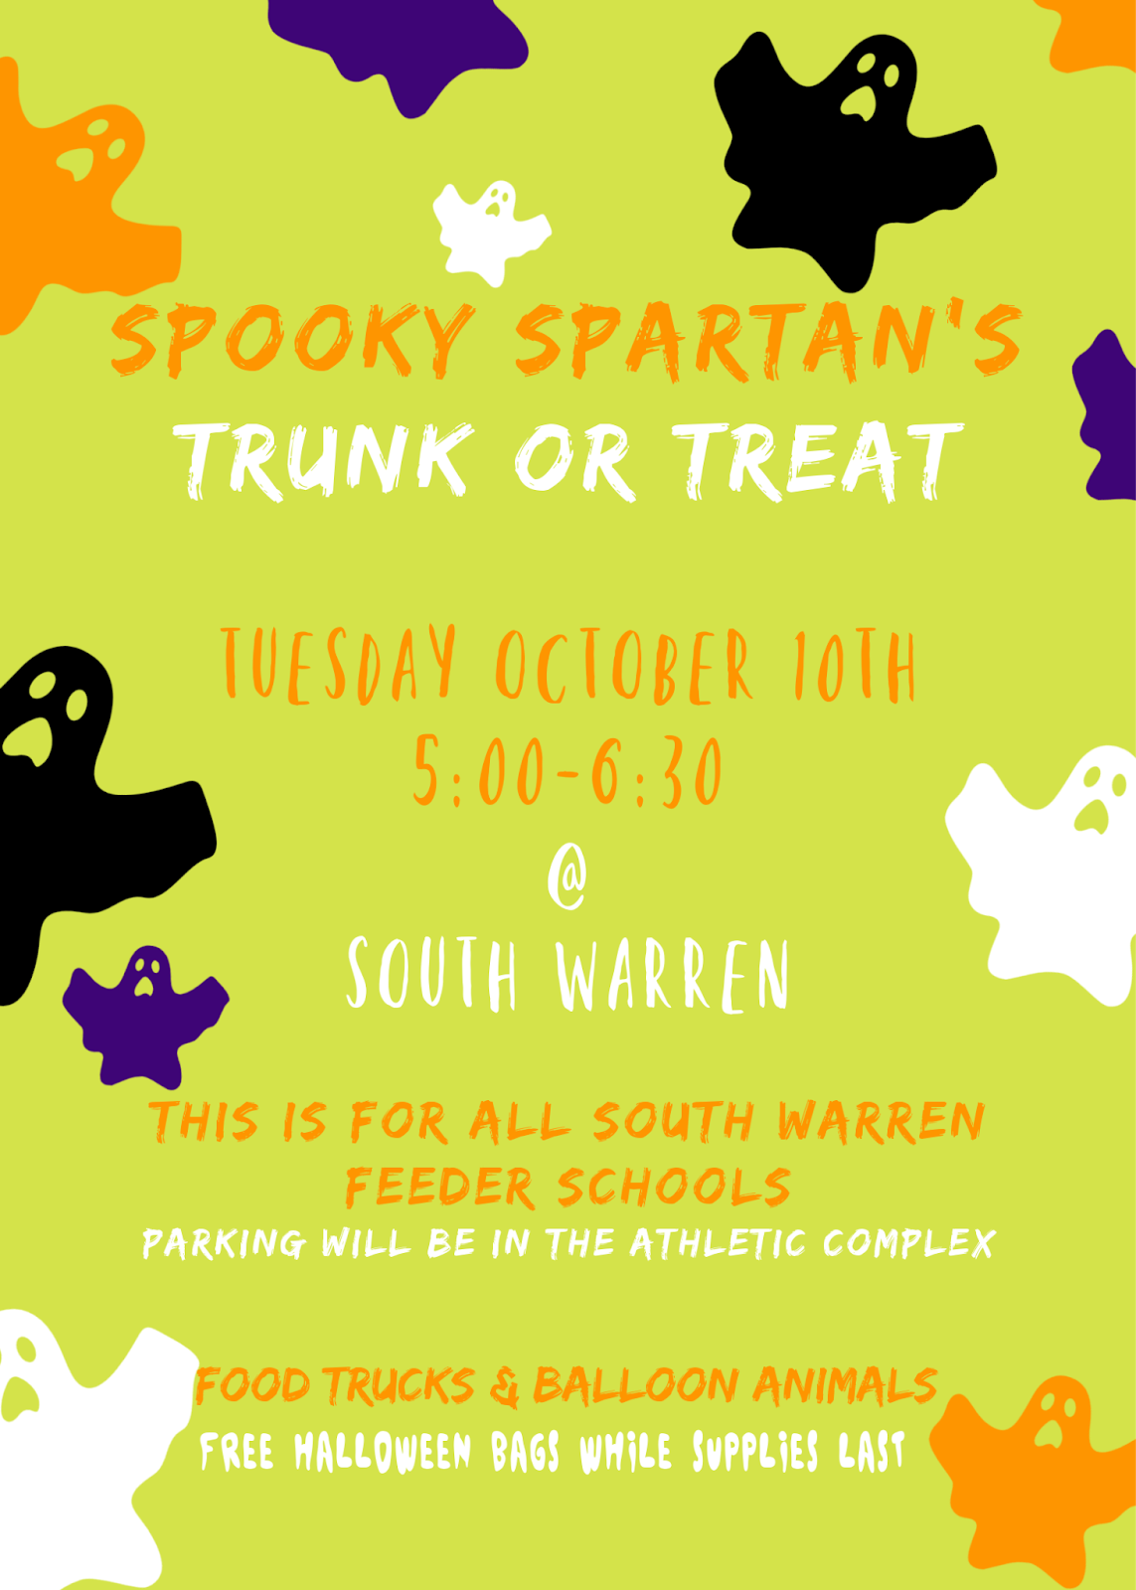









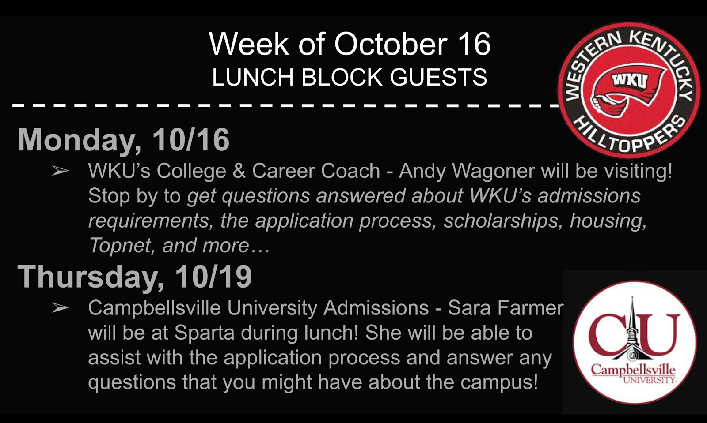

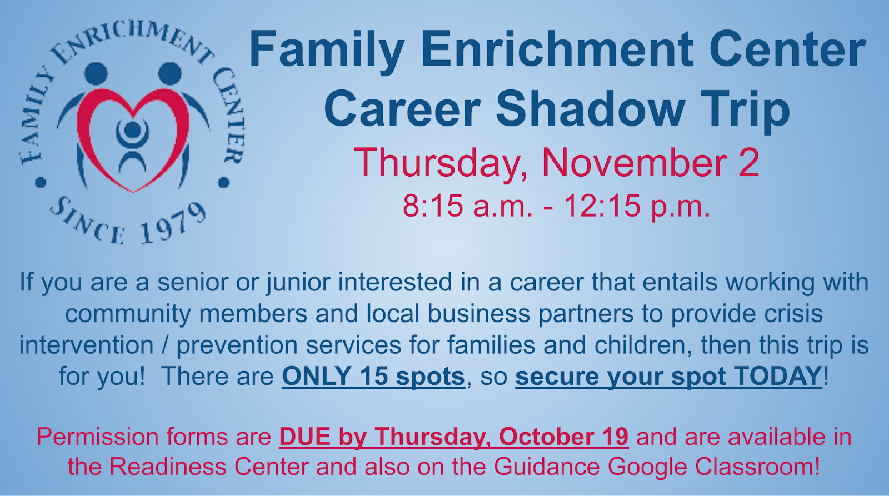

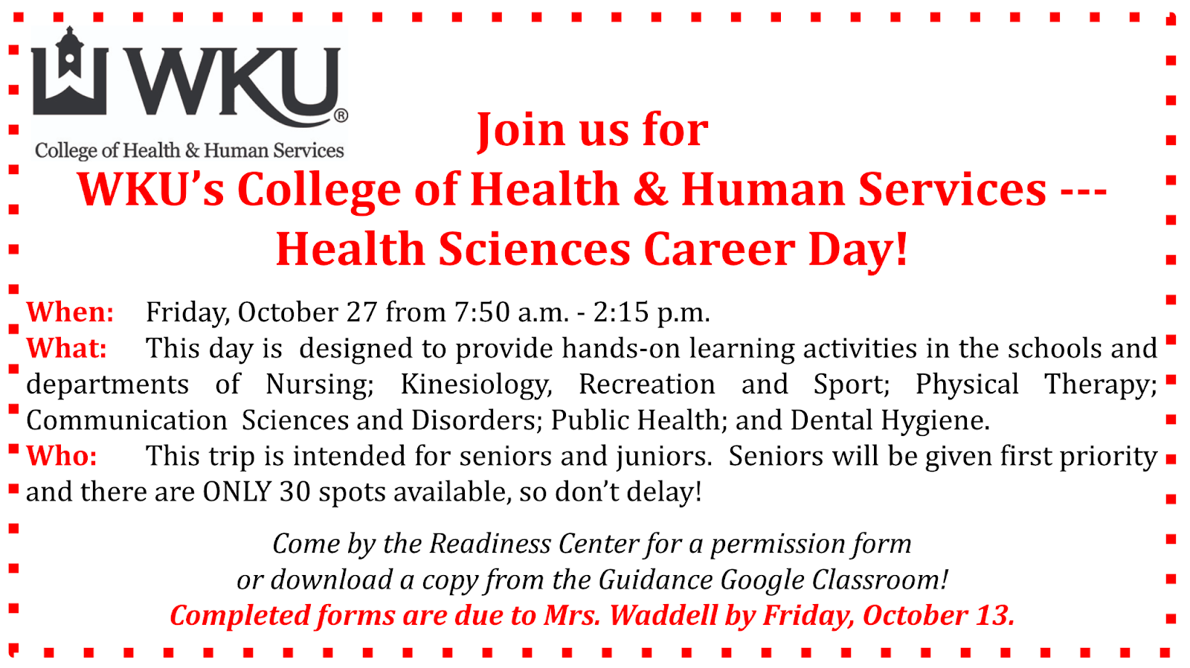

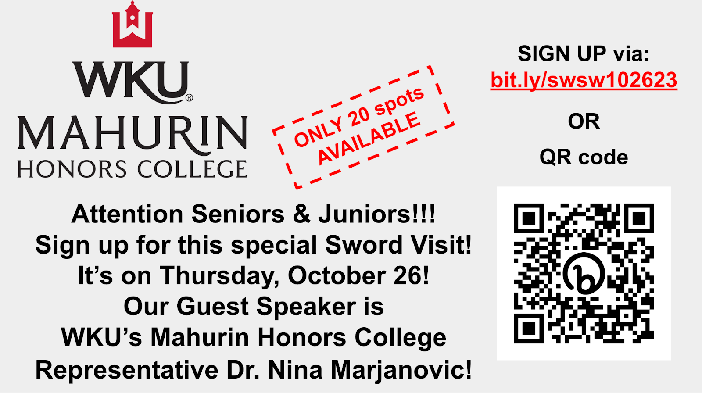





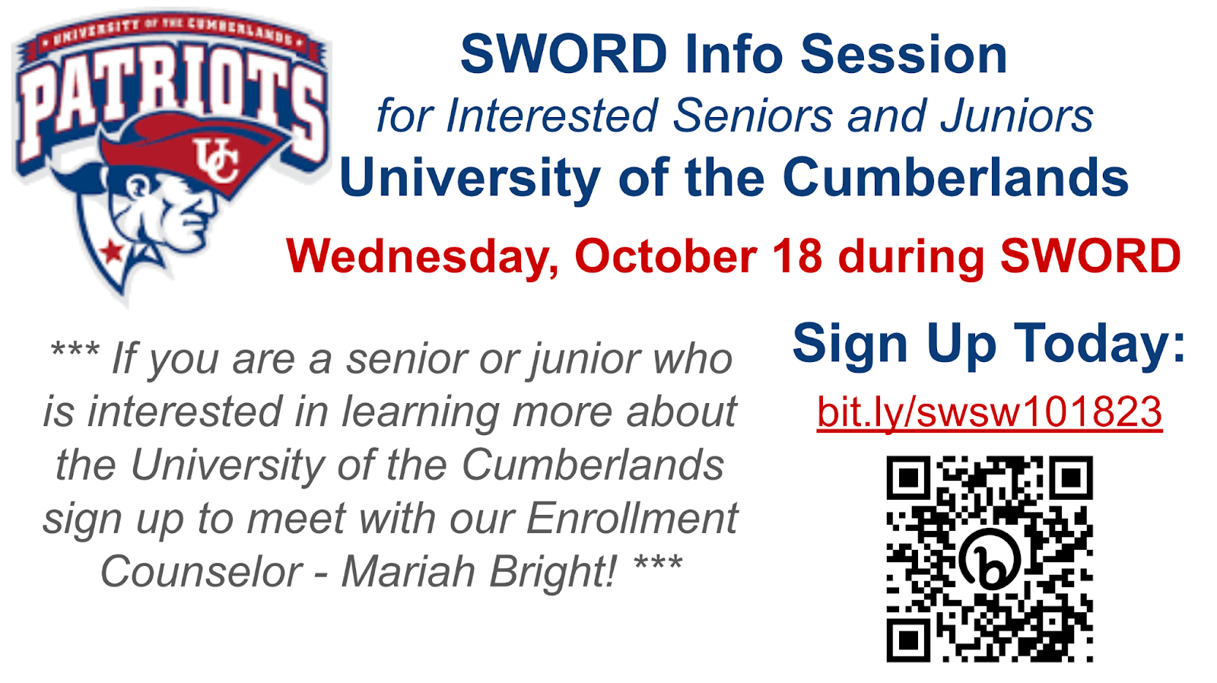

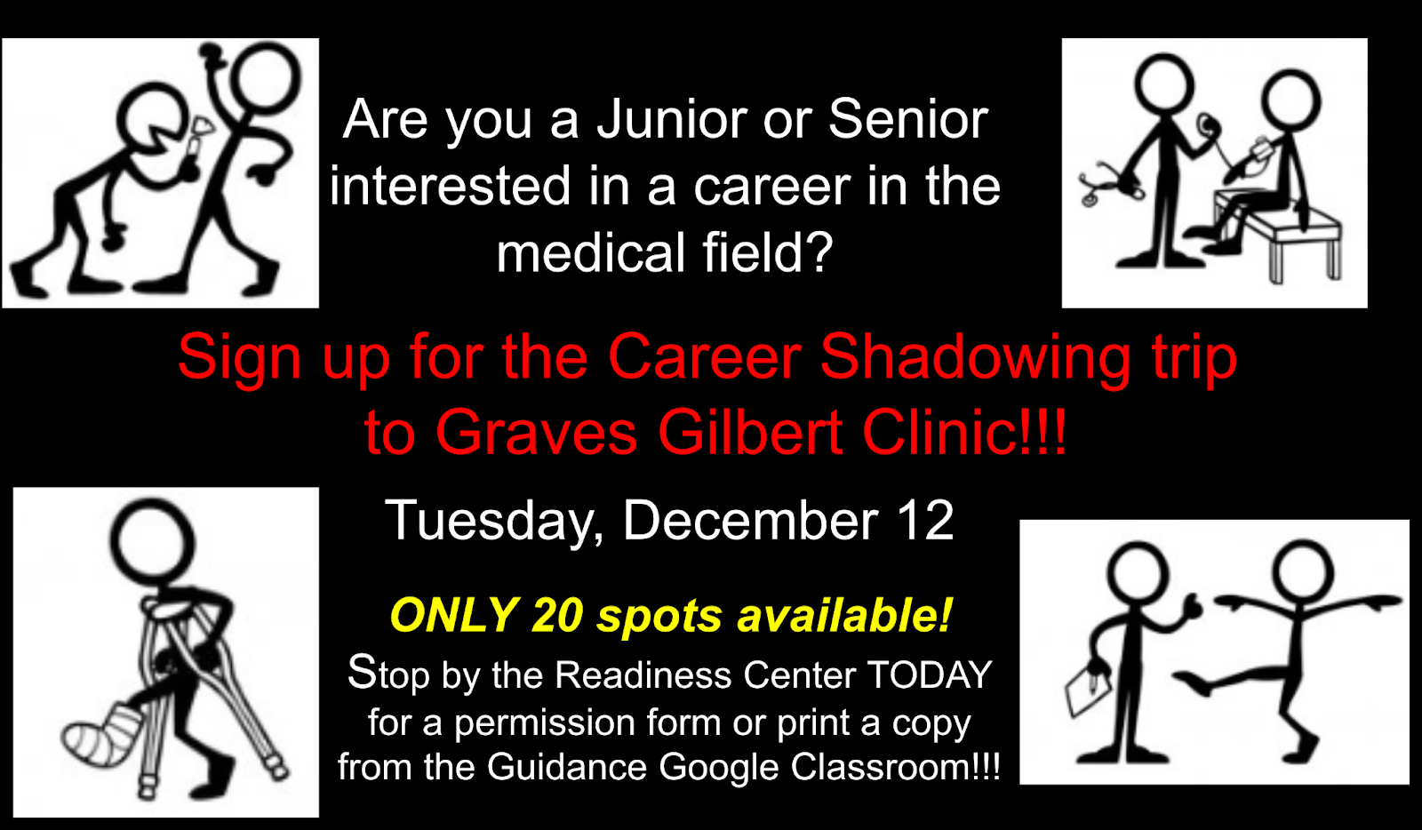









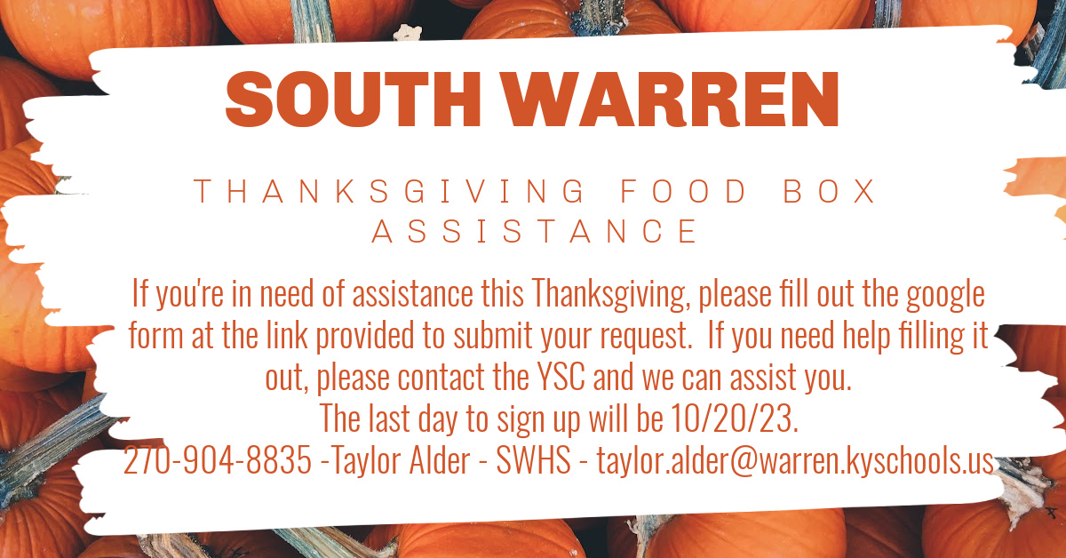

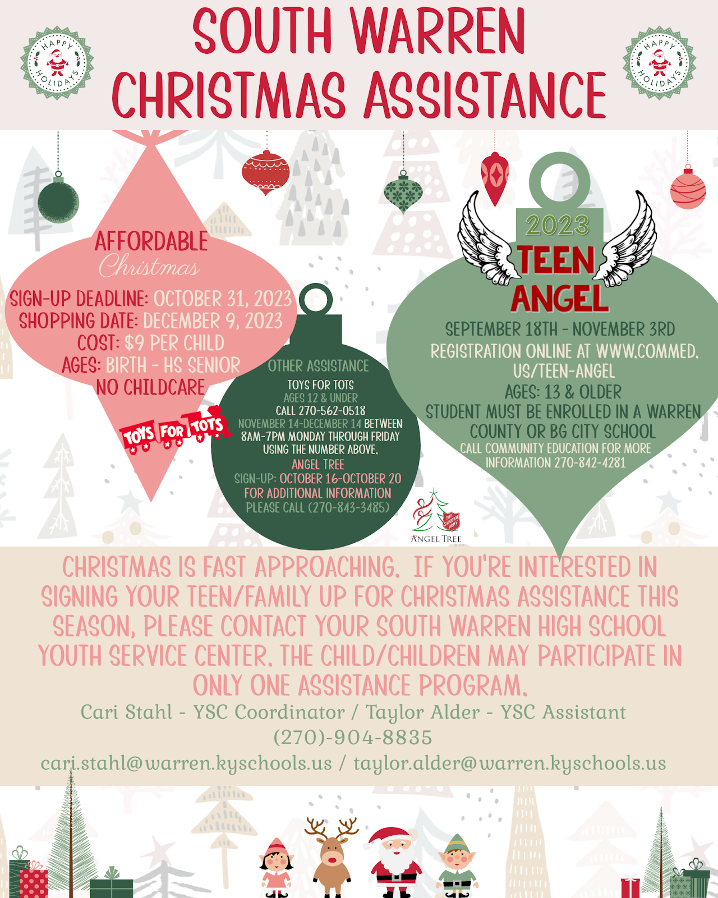




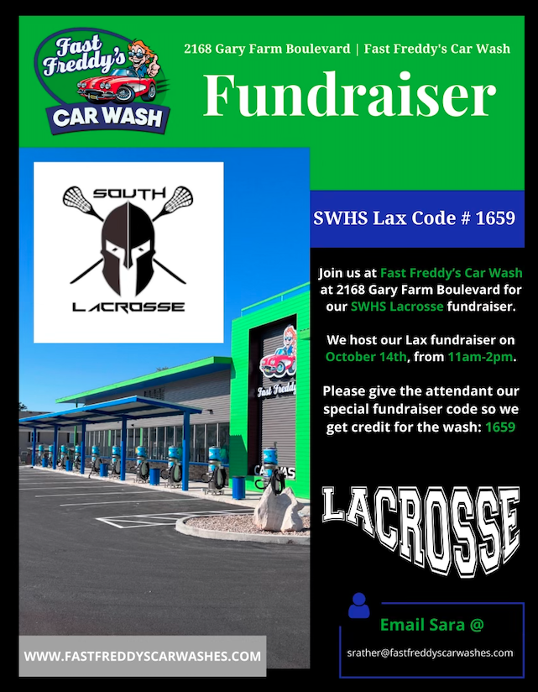





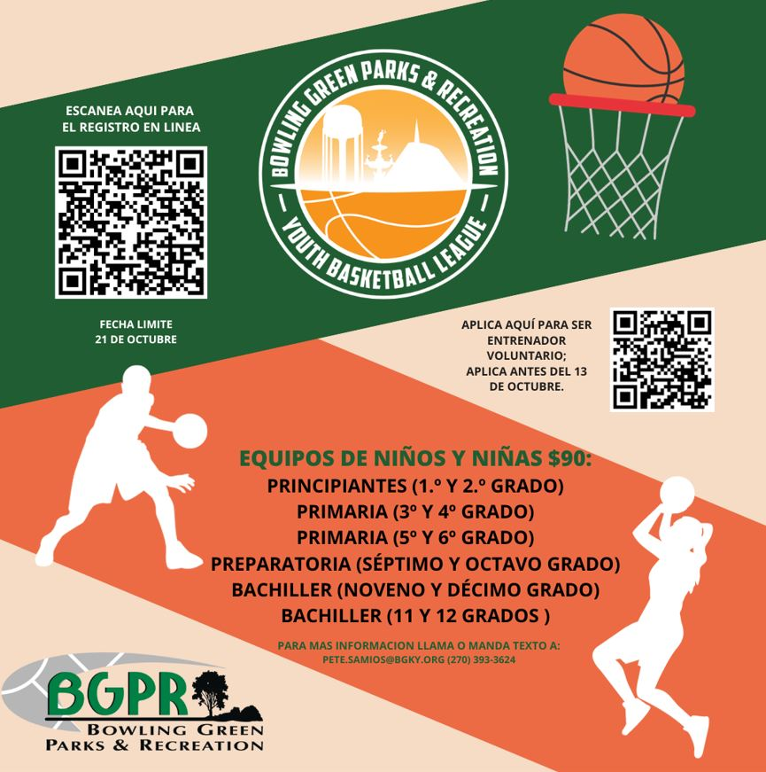

Soap Pads/Brillo Pads
- Black Sharpies
- Dish Soap
- Clear Packing Tape
- Painter's/Masking Tape
- Sandpaper
- Shoe Box Size Storage Containers with Lids
- Plastic/Cling Wrap
- Brooms/Dustpans/Mop A

