
Doctorate of Education in Educational Leadership
Master’s & Add-on Licensure in Educational Leadership

Cohort Information Sessions:

Cohort Information Sessions (choose 1) Thursday, December 15, 2016
New Hanover County Schools 3:15 p.m. – 4:00 p.m.
Daniel K. Spencer Building Board Room 4:15 p.m. – 5:00 p.m.
M.Ed. & Add-on Licensure  Educational Leadership  - M.Ed./Add-on leads to licensure in K-12 School Administration and leadership opportunities at the school and/or district level  - Executive Cohort Model: Classes meet face-to-face one weekend per month with the remainder of class occurring online.  - Competitive cohort tuition  - Financial Aid available for qualified candidates seeking the master’s degree. | Ed.D. Educational Leadership  - Two Leadership Tracks: Educational Leadership and Instructional Leadership  - Executive Cohort Model: Classes meet face-to-face one weekend per month with the remainder of class time occurring online.  - Practitioner-based, professional experience that focuses on the practices of transformational leaders.  - Members of the Carnegie Project of the Educational Doctorate (CPED) which includes 86 other universities across the nation that are creating a new “dissertation in professional practice” that focuses on addressing a real problem in the setting where the doctoral student works.  - Educational Leadership Track: Eligible for NC superintendent’s license upon completion  - Competitive cohort tuition  - Financial Aid available for qualified candidates.
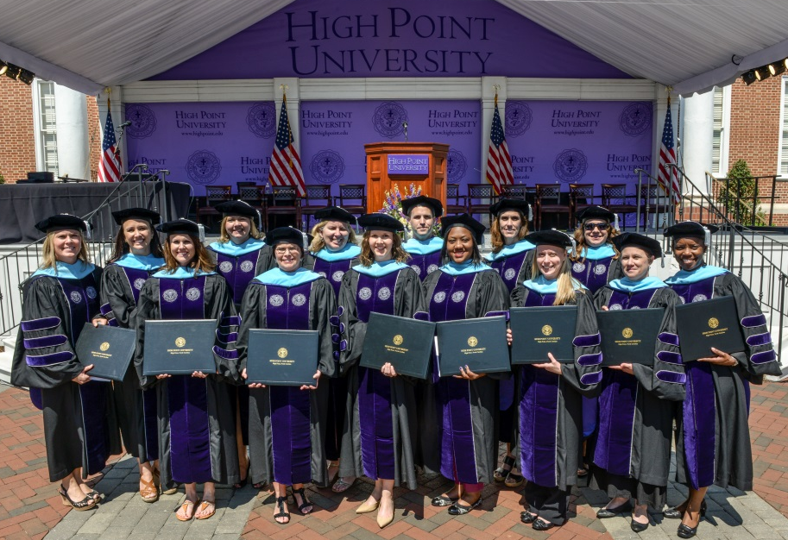
Please RSVP to Dr. James Davis at jdavis@highpoint.edu
Visit our website for additional information: http://www.highpoint.edu/education/
At High Point University, every student receives an extraordinary education in an inspiring environment with caring people.SM

