





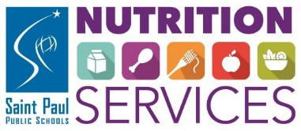

DID YOU KNOW?
WEEKLY MEAL BOXES ARE AVAILABLE FOR
PICK UP AT OVER 50 SCHOOLS!

TO REGISTER: SPPS.ORG/2021MEALS









FREE MEALS! To pre-order meal boxes, and to see a list of pick-up days, times and locations, visit spps.org/2021meals.

CUNTO BILAASH AH! Si aad mar hore u sii dalbatid cuntada baakadeysan, iyo si aad u aragtid liiska maalmaha iyo saacadaha la qaadanayo cuntada iyo weliba meelaha laga qaadanayo, booqo spps.org/2021meals.

ZAUB MOV DAWB! Yog xav hais los sis xaaj ua ntej kom tsev kawm ntawv npaj cov thawv zaub mov rau nej mus nqa, thiab yog xav paub txog cov hnub, sij hawm thiab chaw mus nqa zaub mov, mus saib hauv spps.org/2021meals.

spps.org/2021meals

COMIDAS GRATIS! Para reservar cajas de comidas y para ver una lista de los dias, horarios y lugares para pasar a recoger, visite spps.org/2021meals.

