MOORPARK UNIFIED SCHOOL DISTRICT
5297 MAUREEN LANE
MOORPARK, CA 93021

REQUEST FOR PROPOSAL

DISTRICT CABLING UPGRADE: INTERNAL CONNECTIONS

E-RATE YEAR 2024 RFP# TECH-2024-0108

Page1

LEGAL NOTICE
NOTICE TO VENDOR’S – REQUEST FOR PROPOSALS
Notice is hereby given that the Board of Education of the MOORPARK UNIFIED SCHOOL DISTRICT
(herein after referred to as the “District”) of Ventura County, California, will receive proposals for:

E-RATE FUNDING YEAR 2024 NINE SITES
DISTRICT CABLING UPGRADE: INTERNAL CONNECTIONS, RFP NO. TECH-2024-0108
Each proposal is to be in accordance with the format specified by the Technology Department, copies of which may be examined and obtained, by written request, to the District Technology Department - Technology Services, 5297 Maureen Lane, Moorpark, CA 93021; or may be viewed in the Purchasing website located at: https://www.mrpk.org/technology
Each proposal must be filed with the Technology Department on or before 4:00 p.m., on the 15th Day of February, 2024. All proposals shall be submitted separately and sealed in a package plainly marked with the appropriate title for each proposal. The Board reserves the right to reject any or all proposals and to waive informality in any proposals received. No vendor may withdraw his proposal for a period of Ninety (90) calendar days after the date set for the receipt of proposals.

Vendor must participate in the E-Rate Program and must provide a Service Provider Identification Number (SPIN) and Federal Registration Number (FCC-FRN) with the proposal.

A mandatory Pre-Bid Conference/Job Walk, at which time interested vendors may acquaint themselves with the District’s requirements/sites in the RFP’s, is scheduled for 11:00 A.M., on January 24th, 2024; at Campus Canyon College Preparatory Academy, 15300 Monroe Ave. Moorpark, California 93021.

Published: January 15th, 2024 and January 22nd, 2024

Page2

INDEX OF PROPOSAL DOCUMENTS
For

DISTRICT CABLING UPGRADE: INTERNAL CONNECTIONS
E-RATE FUNDNIG YEAR 2024 RFP NO. TECH-2024-0108
Page

- Legal Notice – Notice to Vendor’s 1
- Index of Proposal Documents 2
- Purpose / Objective / E-Rate Requirements 3
- Request for Proposal (RFP) Response 4 – 5
- RFP Response Timeline 5
- Request for Information and/or Clarification 5
- References / Evaluation Process 6
- E-Rate Supplemental Terms And Conditions 7 – 8
- General Terms and Conditions 9 – 24
- Special Conditions 25 – 26
- Technical Specifications (Copper Cabling) 27 – 29
- Proposal Form (*Return with Proposal) 30 – 33
- Bid Bond (*Return with Proposal) 34 – 39
- Non-Collusion Affidavit (*Return with Proposal) 40
- Vendor’s Certificate Regarding Workers’ Compensation (*Return with Proposal) 41

16. | Conduct Rules for Vendors (*Return with Proposal) | 42
17. | References (*Return with Proposal) | 43 – 44
18. | Debarment and Suspension Certification | 45 – 46
19. | Agreements & Performance/Payments Bonds | 47 – 58
20. | Insurance Documents & Endorsement | 59 – 60
21. | Vendors Certification Regarding Background Checks | 61 – 62
21. | W-9 & 590 Form | 63
22. | Appendix A – Site Map | 64-72

Page3

- PURPOSE
The Moorpark Unified School District (“District”) purpose for this Request for Proposal (“RFP”) is to solicit proposals from qualified vendors to provide a solution to meet the objective stated in the RFP. The solution is subject to all terms, conditions, and specifications in this RFP. All proposal(s) submitted will be reviewed and chosen based on the matrix included in the proposal documents.
The District reserves the right to procure these services based on the District’s ability to find their portion of the project.

- OBJECTIVE
The District is seeking to add additional cabling for the purposes of adding wireless network access points to outdoor locations, to expand our WiFi coverage to all corners of the schools sites within the Moorpark Unified School District.

E-RATE REQUIREMENTS
The Telecommunications Act of 1996 established a fund by which Schools and Libraries across the Country could access discounts on eligible telecommunications products and services. The program is commonly known as the E-Rate Program. The eligibility for discounts on internet access, telecommunications products and services, and internal connection products, services and maintenance is determined by the Federal Communications Commission (FCC). Funding is made available upon application approval by the School and Libraries Division (SLD) of the Universal Service Corporation, which was established by the Act. The amount of discount is based on the numbers of children receiving free and reduced-price meals.
Vendors are required to participate and be in full compliance with all current requirements and future requirements issued by the SLD for participation in the E-Rate Program, throughout the contractual period of any contract entered into with the District as a result of this RFP.

Vendor must have a current and valid Service Provider Identification Number (SPIN) and Federal Registration Number (FCC-FRN) and must be provided with the proposal form.
The awarding of any proposal(s) and any ensuing contracts are contingent upon receiving approval for E-Rate discount, and the availability of specifically budgeted District Technology funds. The vendor agrees to honor any proposal and costs submitted through the E-Rate Funding Year of July 1, 2024 through September 30, 2025.
In the event that E-Rate discounts are not approved, or only partially approved, the District reserves the right to cancel any or all of the work awarded as a result of this RFP.

Page4

REQUEST FOR PROPOSAL (RFP) RESPONSE
All times listed in this RFP are stated as the time reference that is appropriate as of the date in question for Moorpark, CA.
To be considered a Vendor, the candidate must submit the complete original proposal), in the format stated below, and provide fully executed copies of any and all addenda[s] required to be returned, in a sealed envelope on or before 4:00 p.m., on the 15th day of February, 2024, to the following address:
Moorpark Unified School District Technology Department

Attn: Director of Technology – David Roberts
5297 Maureen Lane
Moorpark, CA 93021
All proposals shall be sealed in a package plainly marked “DISTRICT CABLING UPGRADE: Internal Connections, RFP NO. TECH-2024-0108.”

The Vendor is required to submit an Original plus two (2) bind copies and one (1) flash drive copy of the proposal and any required addenda(s). All proposals shall be prepared by and at the expense of the Vendor.
Each proposal submission package should be presented so that it can be readily reviewed and labeled in the following tab order:

A | Proposal Form Cover Sheet, Proposal Form and Proposal
B | Bid Bond
C | Non-Collusion Affidavit
D | Vendor’s Certificate Regarding Workers’ Compensation
E | Conduct Rules for Vendor’s
F | Reference’s
G | Policy Regarding Source Code (If Applicable)
H | Addenda[s]
I | Specifications / Miscellaneous Info.  (Indexed by each section – submit a hardcopy with your proposal):

PROPOSAL SUBMITTED IN ANY OTHER FORMAT WILL BE CONSIDERED NON-RESPONSIVE.

It is the sole responsibility of the Vendor to be sure that the proposal is delivered to the Technology Department. Please be advised that if the submittal of the proposal is received in a department other than the Technology Department located at 5297 Maureen Lane, Moorpark, CA 93021, it is not the responsibility of that department to make sure that the proposal is received in the Technology Department before the time indicated in the Notice to Vendor’s.

Page5

Vendor should not assume that their past and/or current experience with the District demonstrates knowledge of the District’s current needs or that the Moorpark Unified School District – DISTRICT CABLING UPGRADE: Internal Connections Selection Committee possesses knowledge of this experience. The evaluation of each proposal will be based upon the evaluation criteria applied to their proposal submission.
The District reserves the right to reject any or all responses. The District also reserves the right to waive any minor irregularities or defects in any response shall a waiver be in its best interest. No Vendor may withdraw his proposal for a period of Ninety (90) calendar days after the date set for the receipt of proposals.

PROPOSAL SUBMITTED BY FAX OR E-MAIL ARE NOT ACCEPTABLE.

- RESPONSE TIMELINE

EVENT | DATE
1. RFP Publications | January 15 and January 22, 2024
2. Post Form 470 | January 15, 2024
3. Post Web/RFP Mailed | January 15 and January 22, 2024
4. Mandatory Pre-Conference | January 24, 2024 at 11:00 AM
5. RFI-Pre-submittal of written questions/clarification  Email to: erate2024@mrpk.org | January 31, 2024 by 5:00 PM
6. Respond to written questions/clarifications, issue Addendum(s) | February 5, 2024 by 5:00 PM
7. 28 Day E-Rate Window Complete | February 12, 2024
8. Request for Proposals due | February 15, 2024 by 4:00 PM
9. RFP’s Review & Selection Process | February 16, 2024

- REQUEST FOR INFORMATION (RFI) AND/OR CLARIFICATION
Request for information, regarding this proposal, must be submitted in writing and faxed to the attention of: Director of Technology – David Roberts or via emailed to erate2024@mrpk.org within the timeframe indicated in the response timeline. Questions received after the deadline will not be responded to.

The Technology Department will not be responsible for RFI’s sent to the wrong department, nor will it be the responsibility of the receiving department to forward your request to Technology Department.

All RFI’s will be responded to in the form of an Addendum within the timeframe indicated in the timeline.

- REFERENCES

Provide at least five (5) references of similar size and scope, preferably school districts, with the following information:

  - Name of Site, address and phone number
  - Director of ITS Contract
  - Brief description of project, including cost and demonstrate how the project met or exceeded all aspects of the Objective in Section B of this RFP.
  - The ERATE SITE Billed Entity Number (“BEN”) that was approved by SLD

- EVALUATION PROCESS
No commitment will be made to select a Vendor’s system solely on the basis of price. Selection will be made on a combination of factors that may include: price; the degree to which the proposed services to meet functional and service level requirements; the quality of the service architecture, particularly in regards to business continuity and achievement of service level objectives; support procedures and service levels; our ability to understand and work with service billing; competence and reputation of the vendor; as well as any other factors that the District deems appropriate and in the best interest of the District. Points will be awarded based on based on certain criteria for a total sum of 100 points. Reference the “Basis Selection” item in the General Terms and Conditions for the breakdown on the points system.

The District may reject any or all proposals and may waive informalities and minor irregularities in any proposal received. Proposals found to be incomplete may be rejected as non-responsive; and proposal not deemed to be competitive will be rejected.

The Moorpark Unified School District may choose to ask clarification questions or request additional information. All responses will be required in writing; incomplete or unclear responses will result in rejection of proposal.

For convenience in designation on the plans or in the specifications, certain articles or materials to be incorporated in the work may be designated under a trade name or in the name of a manufacturer. Whenever in specifications any materials, process, or article is indicated or specified by grade, patent, or proprietary name or by name of manufacturer, such specification shall be deemed to be used for the purpose of facilitating description of material, process or article desired and shall be deemed to be followed by the words "or equal," and service provider may, unless otherwise stated, offer any material, process or article which shall be substantially equal or better in every respect to that so indicated or specified. If material, process or article offered by service provider is not, in opinion of the District, substantially equal or better in every respect to that specified, then service provider shall furnish material, process or article specified. Burden of proof as to equality of any material, process or article shall rest with service provider. Service Provider shall submit request together with substantiating data for substitution of any "or equal" item within the sealed bid packet at the closing of bids. Provision authorizing submission of "or equal" justification data shall not in any way authorize an extension of time for performance of this contract.
Page6

E-RATE SUPPLEMENTAL TERMS AND CONDITIONS
Signed copy to be returned with proposal and/or bid response (“Proposal’) in response to this Solicitation (“RFP/RFB/RFQ”).
The Telecommunications Act of 1996 established a fund by which Schools and Libraries (“Applicant” or “Applicants”) across the Country could access discounts on eligible telecommunications products and services. The program is commonly known as the E-rate Program. The eligibility for discounts on internet access, telecommunications products and services, internal connection products, services and maintenance is determined by the Federal Communications Commission (“FCC”). Funding is made available upon application approval by the Universal Service Administrative Company (“USAC”), which was established by the Act. The amount of discount is based on the numbers of students eligible to receive free and reduced-price meals.

1) E-RATE CONTINGENCY
The project herein [is/may be] contingent upon the approval of funding from the Universal Service Fund’s Schools and Libraries Program, otherwise known as E‐rate. Even after award of Agreement(s) and/or E-rate funding approval is approved, the Applicant may or may not proceed with the project, in whole or in part. Execution of the project, in whole or in part, is solely at the discretion of the Applicant .

2) SERVICE PROVIDER REQUIREMENTS
The Applicant expects Service Providers to make themselves thoroughly familiar with any rules or regulations regarding the E-rate program.

a. Service Providers are required to be in full compliance with all current rules and requirements and future rules and requirements issued by the FCC and USAC throughout the agreement period of any Agreement entered into as a result of this RFP/RFB/RFQ.

b. Service Providers are responsible for providing a valid Service Provider Identification Number (“SPIN”). More information about obtaining a SPIN may be found at this website: https://www.usac.org/e-rate/service-providers/step-1-obtain-a-spin/
c. Service Providers are responsible for providing a valid Federal Communications Commission Registration Number (“FRN”) at the time the Proposal is submitted. More information about obtaining an FRN may be found at this website: https://fjallfoss.fcc.gov/coresWeb/publicHome.do

d. Service Providers are responsible for providing evidence of FCC Green Light Status at the time the proposal is submitted. Any potential Service Provider found to be in Red Light Status must provide an explanation of the steps it is undertaking to be removed to Red Light Status and the expected timeframe for resolution. A Service Provider's sustained Red Light Status may be grounds for termination of the Agreement as it could prohibit the Service Provider from providing E-rate discounts in a timely manner which would cause harm to the Applicant. More information about FCC Red and Green Light Status may be found at this website: http://www.fcc.gov/debt_collection/welcome.html
e. Products and services must be delivered before billing and E-rate discounting can commence. At no time may the Service Provider invoice before July 1, 2024.
f. Prices must be held firm for the duration of the associated E-rate Funding Year(s) or until all work associated with the project is complete (including any Agreement and USAC-approved extensions).
g. Goods and services provided shall be clearly designated as “E-rate Eligible.” Non-eligible goods and services shall be clearly called out as 100% non-eligible or shall be “cost allocated” to show the percentage of eligible costs per USAC guidelines.
h. For Category 2 equipment or services, within one (1) week of notification of award, the awarded Service Provider must provide the Applicant a bill of materials using a completed and most current and appropriate version of USACs “Bulk Upload Template” (formerly known as the Item 21 attachment) located at https://www.usac.org/e-rate/applicant-process/applying-for-discounts/fcc-form-471-filing/. Subsequent schedules of values and invoices must match the Bulk Upload Template and approved Funding Request Line Items or subsequent approved service substitutions. If the service provider’s proposal consisted of pricing per eligible location, a summary sheet and summary Bulk Upload Template must be provided to describe the cumulative amount for all sites.
i. In the event of questions during an E-rate pre-commitment review, post-commitment review, and/or audit inquiry, the awarded Service Provider is expected to reply within 3 days to questions associated with its proposal.
j. The awarded Service Provider is required to send copies of all forms and invoices to the Applicant prior to invoicing USAC for pre-approval. Failure to comply with this requirement may result in the Applicant placing the vendor on an “Invoice Check” with the USAC: https://www.usac.org/e-rate/applicant-process/invoicing/invoice-check/.

k. Service providers must comply with the FCC rules for Lowest Corresponding Price ("LCP"). Further details on LCP may be obtained at USAC's website: https://www.usac.org/e-rate/service-providers/step-2-responding-to-bids/lowest-corresponding-price/.

l. Service providers must not propose any equipment or services produced or provided by companies, their parents, affiliates, and subsidiaries, found to pose a national security threat to the integrity of communications networks or the communications supply chain as required by FCC rules. See https://www.usac.org/about/reports-orders/supply-chain/. Any proposed solution including Covered Equipment or Services as defined by the FCC will be disqualified. If, after award of the project it is found Covered Equipment or Services are included, the award and/or Agreement will be considered to be null and void. See https://www.fcc.gov/supplychain for further information on FCC requirements.

m. SPAM and/or robotic responses will not be considered valid Proposals and will be disqualified from consideration.

n. Any Service Provider proposals identifying contingency fees such as allocations for change orders, tariffs, or other speculative fees not specifically called out for in the scope and/or terms of the RFP/RFB/RFQ will automatically be included in the Proposal price and subject to evaluation unless otherwise specified in the RFP/RFB/RFQ. Contingency fees not pre-approved by the Applicant will not be allowed.

3) SERVICE PROVIDER ACKNOWLEDGEMENTS
a. The Service Provider acknowledges that no change in the products and/or services specified in its proposal will be allowed without prior written approval from the Applicant and a USAC service substitution approval with the exception of a Global Service Substitutions. See https://www.usac.org/e-rate/applicant-process/before-youre-done/service-substitutions/.

b. The Service Provider acknowledges that all pricing and technology infrastructure information in its Proposal shall be considered as public and non-confidential pursuant to §54.504 (2)(i)(ii).

c. The Service Provider acknowledges that its offer is considered to be the lowest corresponding price pursuant to § 54.511(b). Service Providers found not to be providing Lowest Corresponding Price (LCP) may be required to repay any identified overcharges to USAC. The Service Provider acknowledges that LCP is solely the service provider’s responsibility and it will not hold the Applicant liable, or seek reimbursement from any applicant, for any appeals, commitment adjustments or funding recoveries.

d. The Service Provider attests that its offer does not violate the FCC’s Supply Chain certifications included in the FCC Form 473. Supply Chain requirements and certifications can be viewed at USAC’s Website: https://www.usac.org/about/reports-orders/supply-chain/.

e. This offer is in full compliance with USAC’s Free Services Advisory https://www.usac.org/e-rate/applicant-process/competitive-bidding/free-services-advisory/. There are no free services offered that would predicate an artificial discount and preclude the applicant from paying its proportionate non-discounted share of costs. The Service Provider agrees to provide substantiating documentation to support this assertion should the applicant, USAC, or the FCC request it.

4) STARTING SERVICES/ADVANCE INSTALLATION

Category 1 Services

The annual E-rate Funding Year begins on July 1 and expires on June 30 of each calendar year. Regardless of the Agreement’s “effective date,” E-rate eligible goods and/or services requested in this RFP/RFB/RFQ shall be delivered no earlier than the start of the 2024 funding year (July 1, 2024). If Category 1 services (Telecommunication Services and Internet access) will begin on or shortly after July 1 of a funding year, the service provider, in some cases, may need to undertake some construction and installation work prior to the beginning of that funding year. Within the limitations indicated below, the infrastructure costs of a service provider can be deemed to be delivered at the same time that the associated Category 1 services begin. That is, if services begin on July 1, then the delivery of service provider infrastructure necessary for those services can be considered as also delivered on July 1. However, NO INVOICING can take place prior to July 1 of the associated Funding Year.

Early Funding Conditions

Category 1
There are four conditions that must be met in order for USAC to provide support in a funding year for Category 1 infrastructure costs incurred prior to that funding year.

· Initiation of installation cannot take place before selection of the service provider pursuant to a posted Form 470 and in any event no earlier than six months prior to July 1 of the funding year.
· The Category 1 service must depend on the installation of the infrastructure.
· The underlying Category 1 service cannot have a service start date prior to July 1 of the funding year.
· No invoices can be submitted to USAC for reimbursement prior to July 1 of the funding year.

For more information, please refer to the FCC Order involving the Nassau County Board of Cooperative Educational Services (DA 02-3365 , released December 6, 2002). This FCC decision only applies to Priority/ Category 1 services (telecommunications services and Internet access).

The complete text can be found at the following URL:
https://www.usac.org/e-rate/applicant-process/starting-services/advance-installation/

Category 2
There are two conditions that allow USAC to provide support in a funding year for Category 2 Internal Connections (equipment and services) incurred prior to that funding year.

- Applicants may seek support for Category 2 eligible services purchased on or after April 1, three months prior to the start of funding year on July 1. This will provide schools with the flexibility to purchase equipment in preparation for the summer recess and provide the maximum amount of time during the summer to install these critical networks.
- No invoices can be submitted to USAC for reimbursement prior to July 1 of the funding year.

For more information, please refer to the FCC Report and Order and Further Notice of Proposed Rulemaking (FCC 14-99 , released July 23, 2014).

It is important to note NO FCC FORM 474 INVOICING can take place before the Funding Commitment Decision Letter is issued, the FCC Form 486 is approved, and/or prior to July 1 of the funding year.

5) INVOICING

a. The Service Provider agrees to bill and receive a portion of the payment for the provisions of goods and services described herein directly from USAC via the FCC Form 474 Service Provider Invoice (SPI). The Applicant will only be responsible for paying its non‐discounted share of costs and does not intend to use the BEAR process (FCC Form 472). The maximum percentage the Applicant will be liable for is the pre-discount amount minus the funded amount as shown on the FCC Form 471 Funding Request Number (“FRN”) and associated FRN Line Items and any identified ineligible costs. Upon the successful receipt or posting of a Funding Commitment Decision Letter from USAC and submission, certification and USAC approval of FCC Form 486, the Applicant shall pay only the discounted amount beginning with the billing cycle immediately following said approval. Alternatively, should the Applicant decide that it is in the best interest of the Applicant to file an FCC Form 472, the Applicant will inform the Service Provider of its intent.
b. The Service Provider agrees that it will not invoice USAC for equipment or services that have not been delivered to and accepted by the Applicant and installed. If equipment is being drop-shipped to the Applicant and the Applicant is responsible for installing the equipment, the Service Provider may not invoice USAC until equipment is received and accepted by the Applicant.
c. All Service Provider invoicing to USAC must be completed within 120 days from the last day of service. Should the Service Provider fail to invoice USAC in a timely manner, the Applicant will only be responsible for paying its non-discounted share.

6) FCC/USAC AUDITS
The E-rate program requires that all records be retained for at least ten (10) years from the last date of service provided on a particular funding request. The Service Provider hereby agrees to retain all books, records, and other documents relative to any Agreement resulting from this RFP/RFB/RFQ for ten (10) years after final payment. The Applicant, its authorized agents, and/or auditors reserves the right to perform or have performed an audit of the records of the Service Provider and therefore shall have full access to and the right to examine any of said materials within a reasonable period of time during said period.

7) PROCUREMENT OF ADDITIONAL GOODS AND/OR SERVICES AND AGREEMENT TERM
During the term of any Agreement resulting from this RFP/RFB/RFQ, the Applicant may elect to procure additional or like goods and/or services offered by the Service Provider. Such services shall be negotiated and obtained via an official amendment to this Agreement and approval by the Applicant's Governing Board. All terms, conditions, warranties, obligations, maintenance and support of said goods or services shall have a coterminous expiration date with the original date of this Agreement. The Applicant shall not enter into a separate Agreement for said goods or services. Service Providers must state in their proposal that they acknowledge, accept and are in agreement with coterminous expiration conditions.
I, the undersigned, as an authorized agent of ______________________________ (Service Provider Name), hereby certify that I have read the E-rate Supplemental Terms and Conditions, am fully compliant and intend to cooperate with the E-rate process as outlined above.

Signature: ____________________________Title: __________________________

Phone Number: _______________________ Email:___________________________

Service Provider Name:_________________________________________________

Service Provider FCC Registration Number: _______________________________

Service Provider Identification Number: __________________________________

GENERAL TERMS AND CONDITIONS

The following general terms and condition shall govern the submission of proposals and any agreement resulting from this procurement. Vendors, by virtue of submission of a proposal, acknowledge and accept these general terms and conditions. Vendors shall note that the use in the specifications of any term or phrase typically associated with particular commercially available systems is coincidental and not intended to imply preference or bias toward that system.
Proposals, which do not comply with instructions, may be eliminated from further consideration. All proposals must contain all forms furnished in this request and be in printed form. Failure to provide and execute all enclosed forms as required may result in disqualification.

- Preparation of Proposal Form
The Moorpark Unified School District (“District”) invites proposals on the attached forms to be submitted at such time and place as is stated in the Notice to Vendor’s. Proposal shall be submitted on the prescribed proposal forms, completed in full. All proposal items and statements shall be properly filled out. Numbers shall be stated both in words and in figures where so indicated, and where there is a conflict in the words and the figures, the words shall govern.
All proposals shall be submitted in the format stated and in a sealed package bearing on the outside the name of the bidder, his address, and the name of the project for which the proposal is submitted. It is the sole responsibility of the Vendor to see that his proposal is received in proper time. In accordance with Government Code Section 53068 and Public Contract Code Section 4104.5, any proposal received after the scheduled closing time, for receipt of proposals or after any extension due to material changes, shall be returned to the Vendor unopened.
- Bid Security
Each bid must be accompanied by one of the following forms of bidder’s security: (1) a cashier’s check made payable to the District; (2) a certified check made payable to the District; or (3) a bidder’s bond executed by a California Admitted Surety as defined in Code of Civil Procedure Section 995.120, made payable to the District in the form set forth in the proposal documents. Such bidder’s security must be in an amount not less than ten percent (10%) of the maximum amount of such bidder’s bid as a guarantee that the bidder will enter into the proposed contract, if the same is awarded to such bidder, and will provide the required Performance and Payment Bond and insurance certificates. In the event that a bidder is awarded the contract and such bidder fails to enter into said contract or provide the necessary documents within five (5) calendar days after notification of the award of the contract to bidder, said security will be forfeited.
- Contractor’s License
To perform the work required by this notice, the Contractor must possess a Class “C-7” or “C-10” Contractor’s License, and the Vendor/Contractor must maintain the license throughout the duration of the contract. If, at time of award of the contract, bidder is not licensed to perform the project in accordance with Division 3, Chapter 9, of the Business

and Professions Code for the State of California such proposal will not be considered and the Vendor will forfeit its bid security to the District.

- Form and Delivery of Proposal
The proposal shall be made on the proposal form provided, and the complete proposal, together with any and all additional materials as required by the proposal documents, shall be enclosed in a sealed envelope, addressed and delivered or mailed to the attention of Director of Technology - David Roberts, at 5297 Maureen Lane, Moorpark, CA 93021, and must be received on or before the time set forth in the Notice to Vendor’s. The envelope shall be plainly marked with the Vendor mailing address and the Proposal title and RFP No. It is the Vendor’s sole responsibility to ensure that its proposal is received prior to the scheduled closing time for receipt of proposals.
- Signature(s)
Any signature required on the proposal forms must be signed in the name of the Vendor and must bear the signature in longhand of the person or person(s) duly authorized to sign the proposal on behalf of the bidder in permanent ink.
- Modifications
Changes in or additions to the proposal form, recapitulations of the work proposed upon, alternative proposals, or any other modification of the proposed form which is not specifically called for in the contract documents may result in the District’s rejection of the proposal as not being responsive. No oral or telephonic modification of any proposal submitted will be considered.
- Erasures, Inconsistent or Illegible Proposals
The proposal submitted must not contain any erasures, interlineations, or other corrections unless each such correction creates no inconsistency and is suitably authenticated by affixing in the margin immediately opposite the correction the initials of the person(s) signing the proposal. In the event of inconsistency between words and figures in the proposal price, the words shall govern. In the event the District determines that any proposal is unintelligible, inconsistent or ambiguous, the District may reject such proposal as not being responsive.
- Examination of Contract Documents
Bidders shall thoroughly examine and be familiar with the requirements and specifications. The failure or omission of any bidder to receive or examine any contract document, form, instrument, addenda, or the document, and acquaint himself with conditions there existing shall in nowise relieve any bidder from any obligation with respect to his bid or to the proposal.
By submitting a proposal, the prospective Vendor represents that it has thoroughly examined and become familiar with the work required under this RFP and that it is capable of providing the equipment and services to achieve the District’s objective.
- Withdrawal of Proposals

Any proposal may be withdrawn, either personally by written request at any time prior to the scheduled closing time for receipt of proposals. All requests for proposal withdrawal must be accompanied by proof acceptable to the District which authorizes the individual requesting the proposal withdrawal to so act on behalf of the Vendor. No amendment, addendum or modification will be accepted after the proposal has been submitted to the District. If a change to a proposal that has been submitted is desired, the submitted proposal must be withdrawn and the replacement proposal submitted to the District prior to the scheduled closing time for receipt of proposals. No Vendor may submit more than one proposal. No Vendor may withdraw any proposal for a period of ninety (90) calendar days after the date set for the receipt of proposals.
- Agreement and Performance & Payment Bonds

The Agreement form which the successful bidder, as Vendor, will be required to execute, and the form of the bonds and insurance endorsements which such Vendor will be required to furnish, are included in the contract documents and should be carefully examined by the bidder.
The awarded Vendor will be required to furnish a Performance and Payment Bond in the amount of one-hundred percent (100%) of the amount of the contract and in the form included in the proposal documents, all prior to execution of the Contract. Performance and Payment bonds are required for the protection of the District against failure of a successful Vendor to complete a contract. In the event that the successful Vendor fails to perform or abandons the contract, the District shall have the contract completed as expeditiously as necessary and possible and shall bring action against the bond for additional expenses incurred and administrative time expended.
- Penalties for Non-Performance
Judgment of non-performance in regard to the system performance shall rest solely with District management. Failure to provide maintenance services in accordance with the requirements specified shall constitute an essential breach of contract and be subject to all applicable remedies of law.
- Interpretation of Documents
If any prospective Vendor is in doubt as to the true meaning of any part of the proposal documents, or finds discrepancies in, or omissions from the specifications, a written request for interpretation or correction thereof may be submitted to the District.

Note: All questions concerning this proposal must be submitted in writing attention

Director of Technology – David Roberts or emailed to erate2024@mrpk.org
The Vendor submitting the request shall be responsible for its prompt delivery. Any interpretation or correction of the proposal documents will be made solely at District’s discretion and only by written addendum duly issued by the District and a copy of such addendum will be e-mailed, hand-delivered, U.S. Postal Mailed, overnighted, or faxed to each Vendor known to have received a set of the Request for Proposal documents. No person is authorized to make any oral interpretation of any provision in the proposal documents, nor shall any oral interpretation be binding on the District. Vendor shall

become familiar with the specifications. SUBMITTAL OF A PROPOSAL WITHOUT CLARIFICATIONS SHALL BE INCONTROVERTIBLE EVIDENCE THAT THE VENDOR HAS DETERMINED THAT THE SPECIFICATIONS ARE SUFFICIENT FOR BIDDING AND COMPLETING THE JOB; THAT VENDOR IS CAPABLE OF READING, FOLLOWING AND COMPLETING THE JOB IN ACCORDANCE WITH THE SPECIFICATIONS; AND THAT THE SPECIFICATIONS FALL WITH AN ACCEPTABLE STANDARD FOR SPECIFICATIONS.

- Basis of Selection
This RFP is only for Copper installation. No commitment will be made to select a Vendor’s system solely on the basis of price. Selection will be made on a combination of factors, including: price; the degree to which the proposed services to meet functional and service level requirements; the quality of the service architecture, particularly in regards to business continuity and achievement of service level objectives; support procedures and service levels; our ability to understand and work with service billing; competence and reputation of the vendor; as well as any other factors that the District deems appropriate and in the best interest of the District. Points will be awarded based on the following for a total sum of 100 points; the vendor with the highest points total will be awarded the RFP:

E-rate Eligible Price/Charges | 35
District Experience | 15
Ability to meet minimum district specifications | 10
Non-eligible Price/Charges | 10
Vendor qualifications/certifications | 10
Completeness of response | 10
E-rate experience | 5
References | 5
Total | 100
- Exception/Deviations.
Any exceptions to the requirements and terms in this RFP, including the language in the proposed Agreement, must be included in the proposal submitted by the prospective Vendor. Such exceptions must be segregated as a separate element of the proposal response and noted in the Cover Letter of the response. Significant exceptions may remove the prospective Vendor from further consideration.
- Data
The district provides information herein to assist Vendors in formulating their proposals. Although the District is providing this information in good faith, the District makes no warranty or representation about its accuracy, and the District does not intend any Vendor to rely solely on the accuracy of the information in submitting their proposal.

- Award of Contract
The Moorpark Unified School District will be the sole judge of the quality, methodology, and suitability of the service offered by the Vendor in the proposal. Pursuant to State of California Public Contact Code Section 20118.2, the award of the contract, if made by the District, will be by action of the governing board and be made to the Vendor whose proposal meets the evaluation standards set forth in this Request for Proposal and will be the most advantageous to the District with price and all other factors considered. Low bid does not constitute an award.

The District reserves the right to reject any or all proposals without identifying the cause of such rejection(s), or to waive any irregularities or informalities in any proposals or in the proposal process. The District reserves the right to withdraw this RFP at any time without prior notice. Further, the District makes no representations that an agreement will be awarded to any prospective Vendor responding to this Request for Proposal. The District also reserves the right to award its total requirements to one Vendor, or to apportion those requirements among several vendors, as the District may deem to be in its best interests. The District reserves the right to negotiate with other than the selected Vendor should negotiations with the selected Vendor be terminated, to negotiate with more than one Vendor simultaneously, or to cancel all or part of this RFP.

- Vendor References and Information
The District expressly reserves the right to reject the proposal of any Vendor who, upon investigation, has been determined to fail to complete similar contracts in a timely fashion or in a satisfactory manner. Such rejection would, if applicable, be based upon the principle that the Vendor poses a substantial risk of being unable to complete the work in a cost-effective, professional and timely manner. In performing the above-described determination, the District reserves the right to utilize all possible sources of information in making its determination, including, but not limited to: inquiries to regulatory state boards and agencies; Dun and Bradstreet credit reports, inquiries to companies and public entities for which the Vendor has previously performed work, reference checks and examination of all public records.
- Workers’ Compensation
In accordance with the provisions of §3700 of the Labor Code, Vendor shall secure the payment of Compensation to his employees. Vendor shall sign and file with the District the following certificate prior to performing the work under this contract: “I am aware of the provisions of
§3700 of the Labor Code which require every employer to be insured against liability for workers’ compensation or to undertake self-insurance in accordance with the provisions of the code, and I will comply with such provisions before commencing the performance of the work of the contract.” The form of such certificate is included as part of the proposal documents.
- Non-Collusion Affidavit
The Vendor is required to submit an Affidavit of Non-collusion with their proposal. This

form is included with the proposal documents and must be signed under the penalty of perjury, dated and notarized.
- Anti-Discrimination
It is the policy of the District that in connection with all work performed under contracts, there be no discrimination against any prospective or active employee engaged in the work because of race, color, ancestry, national origin, religious creed, sex, age, physical disability, mental disability, medical condition or marital status.

- Hold Harmless
The Vendor shall protect and defend, indemnify and hold harmless, at its own expense, the District, its officers, employees, and agents from all liabilities, claims, actions, liens, judgments, demands, damages, losses, costs or expenses of any kind arises from death, personal injury, property damage or other causes based or asserted upon any act, omission, or breach connected with services called for in this proposal.

  - Liability for damages for (1) death or bodily injury to persons; (2) injury to, loss or theft of property; or (3) any other loss, damage or expense arising under either (1) or
(2) above, sustained by the Vendor or any person, firm or corporation employed by the Vendor upon or in connection with the services called for in the Contract Documents, except for liability resulting from the sole negligence, or willful misconduct of the District, its officers, employees, agents or independent contractors who are directly employed by the District, and except for liability resulting from the active negligence of the District.

  - Any injury to or death of persons or damage to property caused by any act, neglect, default or omission of the Vendor, or any person, firm, or corporation employed by the Vendor, either directly or independent contract, including all damages due to loss or theft, sustained by any person, firm or corporation, including the District, arising out of, or in any way connected with the services covered by the Agreement, whether said injury or damage occurs either on or off school district property, if the liability arose from the negligence or willful misconduct of anyone employed by the Vendor, either directly or by independent contract, and not by the active negligence of the District.

  - The Vendor, at Vendor’s own expense, cost and risk shall defend any and all actions, suits, or other proceedings that may be brought or instituted against the District, its officers, agents or employees, or any such claim or liability, and shall pay or satisfy any judgment that may be rendered against the District, its officers, agents or employees in any action, suit or other proceedings as a result thereof.
- Vendor’s Proposal Costs
The Vendor shall solely bear any costs incurred: to prepare and submit a proposal in response to this RFP; to negotiate with the District regarding any matter related to this proposal; by the Vendor prior to the date of award. Vendor shall not include any such costs as part of the price as proposed in response to this RFP.

- SPIN
The District requires the Vendor to have a valid and current SPIN (Service Provider Identification Number) as issued by USAC (Universal Service Administrative Company), as well as a valid and current FCC Registration Number (FCC-FRN). The SPIN and FCC-FRN must be established at the time of the proposal submittal.
Service Providers are responsible for providing evidence of FCC Green Light Status at the time the bid is submitted. Any potential bidder found to be in Red Light Status must provide an explanation of the steps it is undertaking to be removed to Red Light Status and the expected timeframe for resolution. A Service Provider's sustained Red Light Status may be grounds for contract termination as it could prohibit the Service Provider from providing E-rate discounts in a timely manner which would cause harm to the Applicant. More information about FCC Red and Green Light Status may be found at this website: http://www.fcc.gov/debt_collection/welcome.html
- E-Rate Compliance
Vendor is, and agrees to remain, in compliance with all current E-Rate program guidelines established by the Federal Communications Committee (FCC). This project is entirely contingent upon available funding from the Federal E-Rate Program (Schools and Libraries Division) and the District may or may not undertake the project at its sole discretion.
Information regarding eligibility of goods and services, invoicing requirements, documentation requirements and other program rules are available from the SLD by calling Schools and Libraries Division (“SLD”) of the Universal Service Administrative Company at (1-888) 203- 8100 or see their website at https://www.usac.org/e-rate/.
In all communications, including (but not limited to) invoices, any responses to this RFP, reports, and proposals, goods and services provided shall be clearly designated as “E- Rate Eligible”. Non-Eligible goods and services shall be clearly called out as 100% non- eligible or shall be “cost-allocated” to show the percentage of eligible costs per SLD guidelines.
The annual E-Rate Funding Year begins on July 1st and September 30th of each year (for non- recurring services). Regardless of contract “signing date”, goods and services requested in this RFP shall be delivered no earlier than the start of the 2024 Funding Year (July 1, 2024).

To assure that all charges are eligible for E-Rate funding, contract renewal and expiration dates shall coincide with the start/end dates of the E-Rate funding years.
Vendors agree to conform to all E-Rate guidelines for the billing of discounts to the SLD. A current SPAC (Service Provider Annual Certification) form must be on file with USAC for the funding year July 1, 2024 and for the subsequent years throughout the term of the contract. If the awarded Vendor fails to file the appropriate forms with the SLD or fails to receive an SLD SPIN number, then at the discretion of the District, the contract may be terminated. Billing method will be in SPI form (Service Provider Invoice): The Vendor will only invoice Moorpark Unified School District for the non-discounted portion of the costs after the E-rate discount is applied.
The Vendor will then invoice the SLD for the E-rate discounted portion. The Vendor must also provide the name, title and telephone number for a single point of contact of E- Rate questions.

The E-Rate program requires that all records be retained for at least ten (10) years. The Vendor hereby agrees to retain all books, records, and other documents relative to this contract for ten
(10) years after final payment, or until audited by SLD and/or the District, whichever is sooner. The District, its authorized agents, and/or auditors reserves the right to perform or have performed an audit of the records of the Vendor and therefore shall have full access to and the right to examine any of said materials within a reasonable period of time during said period.
- E-Rate Funding
This RFP is 100% contingent upon the approval of E-Rate funding from the Universal Service Fund Schools and Libraries Program. Even after award of contracts, the Moorpark Unified School District may or may not proceed with the project, in whole or in part, even in the event E- Rate funding is approved. Execution of the project, in part or in whole, is solely as the discretion of Moorpark Unified School District. Vendors wishing to bid are doing so solely at their own risk. Moorpark Unified School District is not liable or responsible for any costs, loss, fees, or expenses, of any kind, associated with this proposal and/or a decision not to proceed with the project, even after award of the contracts. By submitting a proposal, each bidder/Vendor agrees to bear all of its own costs, fees, expenses, and losses, of any and all kind, should the Moorpark Unified School District cancel the project.

- Invoice the Universal Services
Invoicing the E-Rate Administrator, USAC, is required to collect payment of Non- discounted share of Contract cost. It is required that the contractor specifies whether the customer bills will be the total cost of the service or only the Non-Discounted share of the contract cost. Contractor may provide applicants with discounted bills and submit the SPI to request payment from USAC for the amount of USF support to be paid. Contractors agree to sign the BEAR form when the applicant has paid the entire cost of services to the service provider. In all cases, USAC pays support to the contractor after invoicing process is completed and the Service Provider Annual Certification Form (Form 473).
- E-Rate In-eligible Costs
Bidders must include complete bill of materials, including manufacturer make, model, quantity, unit price, extended price, installation and sales tax. Any E-rate ineligible costs must be submitted on a separate bill of materials.
- Right to Source Program
If Vendor, whether directly or through a successor of affiliate, shall cease to be in the hardware/software business, or cease to support the submitted application, or if Vendor should be declared bankrupt or insolvent by a court of competent jurisdiction, Moorpark Unified School District shall have the right to obtain, for its own and sole use only, a single copy of the then current version of the source program of the object programs supplied under this agreement, and single copy of the documentation associated therewith, upon payment to the person in control of the source program the reasonable

cost of making each copy. Each source program supplied to the District shall be subject to each and every restriction on use set forth in the request for proposal. VENDORS’ MUST STIPULATE THEIR POLICY REGARDING SOURCE CODE.
- System Availability
The proposals submitted must describe a system where all elements are currently available and will not include “futures” or “drawing board” elements. “Futures” or “Drawing Board” elements, if included, must be explicitly labeled as such and may serve only for information purposes and not be used to satisfy a requirement stipulated in the RFP.
- Vendor Inquiries
All questions and/or clarifications regarding the submission and/or technical specifications regarding this proposal must be submitted in writing and faxed to the attention of Director of Technology – David Roberts or via e-mail at erate2024@mrpk.org . All requests for information or requests for clarifications must be submitted by the date and time specified in the Response Timeline. All responses will be sent to each Vendor known to have received the Request for Proposal, through an addendum. Questions submitted after the deadline will not be responded to.
- Communications
Vendors who contact any member of the Board of Education, District administrators, or staff without following the above listed protocol will be eliminated from further consideration. Oral communications of District employees concerning this RFP shall not be binding on the District and shall in no way excuse the Vendor of his/her obligations as set forth in the RFP.
- Proposal Confidentiality
All proposals received shall remain confidential, to the extent permitted by law until negotiations between the District and Vendor are complete; thereafter, the proposals shall be deemed public records. In the event that a Vendor desires to have portions of its proposal remain confidential, it is incumbent upon the Vendor to identify those portions in its transmittal letter deposited with the proposal package. The transmittal letter must identify the page, the particular exemption(s) from disclosure and the contended justification of exemption upon which it is making its claim. Each page, or part thereof, claimed to be confidential must be clearly identified by the word “confidential” printed on the lower right-hand corner of the page. The District will consider a Vendor’s request(s) for confidentially; however, the District will not be bound by the assertion that a page contains confidential material. An assertion by a Vendor that an entire volume of its proposal is confidential will not be honored. The District reserves the right to disclose all information in the proposal, even if the Vendor requests that it remain confidential, if the District determines that disclosure is not prohibited by law or court order. It is understood that the District is subject to the California Public Records Act (Gov. Code Section 6550, et seq.). If a public records request is made to view Vendor’s proprietary and confidential information, the District shall notify Vendor of the request and the date that such records will be released to the requester unless Vendor obtains a court order

enjoining that disclosure. If Vendor fails to obtain a court order enjoining that disclosure, the District will release requested information on the date specified. All materials submitted in response to this request will become the property of the District and will be returned only at the District’s option and at the Vendor’s expense.
- Notification
Vendors whose proposals are rejected will be notified in writing at the address given in the proposal.
- Taxes
The District is subject to State of California Sales and Use Tax. Proposal prices shall include allowances for all taxes including but not limited to all Federal, State and Local taxes.
- Subcontracting Procedure
No performance of the contract or any portion thereof shall be assigned or subcontracted by the Vendor without the expressed written consent of the District. Any attempt by the Vendor to assign or subcontract any performance of the terms of this contract without the expressed written consent of the District will constitute a breach of this contract. Whenever the Vendor is authorized by the District to subcontract or assign, he will include all the terms of this contract to each such subcontract or assignment.
Every subcontractor shall be bound by the terms of the contract as far as it is applicable to the performance of the work. Nothing herein shall create any contract between any subcontractor and the District, or any obligation of the part of the District to pay, or see to the payment of any sums to any subcontractor by the Vendor.

- News Releases
News releases pertaining to the award resulting from this RFP shall not be made without prior written approval of the District’s Superintendent.
- Disposition of Proposal
All materials submitted in response to this request for proposal will become the property of the District and will be returned only at the District’s option and at the Vendor’s expense. The master copy shall be retained for official files and will become a public record as subject to the Public Records Act. However, confidential financial information submitted in support of the requirement to show Vendor’s responsibility and proprietary information will not be made public and will be returned upon request. Confidential and proprietary information must be clearly identified as such.
- Insurance
Vendor shall take out, prior to commencing the work, and maintain, during the life of this contract, and shall require all subcontractors, if any, whether primary or secondary, to take out and maintain the following policies issued by insurance companies authorized to transact business in the State of California and which comply with all requirements of the Department of Insurance for the State of California:

Vendor’s Liability Insurance
    - Worker’s Compensation

    - General Liability
      - Injury or accidental death
$1,000,000.00  (2) Bodily  Injury | Each Occurrence | $2,000,000.00 | Aggregate
$1,000,000.0 0 | Each Occurrence | $2,000,000.00 | Aggregate
(3) Property Damage
$1,000,000.0 0 | Each Occurrence | $2,000,000.00 | Aggregate

    - Automobile Liability (Any Auto)
      - Combined Single Limit
$1,000,000.00 Each Occurrence
Such liability insurance policies shall name the District as an additional insured and shall agree to defend and indemnify the District against loss arising from operations performed under the contract.
- System Performance
Not restricted by any other item, condition, disclaimer, warranty or guarantee, the Vendor represents and warrants that the system will perform the functions described in its product specifications and its proposal and the system will operate in the proposed configuration and the cost set forth.

- Software Integrated Performance
Within the definition of the system described by the Vendor’s proposal and resulting agreement, the vendor acknowledges that the nature of this procurement requires that each component function in accordance with its specification and be integrated and operate successfully with all other components of the system.
- Invoicing and Payment Schedule
Once the service is fully “tuned up” and accepted by the District, the Vendor may invoice the District monthly for the agreed upon monthly service charge and for the agreed upon number of months. Vendor shall include with its invoice a line-item account of the costs and materials used during that month. The District may reduce the amount paid for a month when agreed upon service levels are not achieved pursuant to procedures set forth in the contract between the District and the Vendor Any agreed upon, one-time (i.e., non- recurring) charges shall be invoiced within 120 days after the Vendor and District agree that the related work is complete.

- Cancellation for Insufficient or Non-Appropriated Funds
The Vendor hereby agrees and acknowledges that monies utilized by the District to purchase the services listed in this proposal are public money appropriated by the State of California, the Federal Government under the E-Rate Program, or acquired by the District from similar public sources and is subject to variation. The District fully reserves the right to cancel this proposal at any time and/or to limit quantities of items due to non- availability or non-appropriation of sufficient funds.
- Assignment of Contract
The Vendor shall not assign or transfer by operation of law or otherwise any or all of its rights, burdens, duties or obligations without the prior written consent of the surety on the performance bond and the District.
- Binding Effect
This agreement shall inure to the benefit of and shall be binding upon the Vendor and District and their respective successors and assigns.
- Severability
If any provisions of this agreement shall be held invalid or unenforceable by a court of competent jurisdiction, such holding shall not invalidate or render unenforceable any other provision hereof.
- Amendments
The terms of this agreement shall not be waived, altered, modified, supplemented or amended in any manner whatsoever except by written agreement signed by the parties.
- Prevailing Law
In the event of any conflict or ambiguity between these instructions and State and Federal law or regulations, the latter shall prevail. Additionally, all equipment to be supplied or services to be performed under the proposal shall conform to all applicable requirements.

- Governing Law and Venue
The final contract between Vendor and the District shall be assembled and all disputes hereunder shall be settled in accordance with the laws of the State of California. Pending final resolution of a dispute hereunder, Vendor shall proceed diligently with the performance of the final contract. Venue shall only be with the appropriate state or federal court located in Los Angeles County, California.
- Acceptance Testing
Acceptance testing will begin when components are installed, the service has been “tuned up,” and the Vendor informs the District that the service is functioning according to specifications and agreed upon service levels.

- Clarifications and Corrections
The right is reserved, as the interests of the District may require, to revise or amend the RFP Documents prior to the date set for opening proposals. Such revisions and amendments, if any, will be announced by an addendum or addenda to this Request for Proposal. If the revisions and amendments are of a nature which require material changes, the date set for the opening of the proposals may be postponed by such number of days as in the opinion of the District will enable Vendors to revise their proposals to account for such changes. In such cases, the addendum will include an announcement of the new date for opening proposals. Any clarifications or corrections to the RFP Documents will not be considered valid unless it is provided in writing by the District to all Vendors as a numbered Addendum.
- Local Account Team
Local account team support must be available and the District will be provided with an account manager who acts as a single point of contact that is responsible for the entire account. The District shall have the opportunity to review and approve all members of the Vendor’s team and shall have the right to request removal of personnel it considers unsuitable. The Vendor shall not substitute members of its account team without prior written notification to the District. New members assigned to the District’s account team shall have a trail period of three months; during this period, the District may request that the new member be replaced. At the District’s discretion, semi-annual status meetings shall be held with the Vendor’s account team or upon request by the District. These meetings shall include a written problem escalation procedure review as a standard agenda item.
- Coordination
The Vendor shall coordinate installation schedules with the District and their designated agent(s). The Vendor shall be responsible for placing all service orders with local and long-distance telephone companies. The Vendor shall appoint a project manager from the account team. The Project Manager shall be the primary point of contact for the Vendor during the implementation process. The Vendor shall prepare a separate plan for changing the District’s communication services from their vendor(s) as well as establishing new services. If necessary, the Vendor will also coordinate with the District’s support vendor for the PBXs during the installation process. The Vendor’s implementation plan shall be reviewed and approved by the District’s IT team.

- Notice of Labor Dispute
Whenever Vendor has knowledge that any actual or potential labor dispute may delay the implementation of the services contracted from Vendor, Vendor shall immediately notify and submit all relevant information to the District. Vendor shall insert the substance of this entire clause in any subcontract hereunder.
- Guarantee
The District requires that the DISTRICT CABLING UPGRADE: Internal Connections components provided by the Vendor shall be guaranteed for a minimum of one (1) year

after acceptance by the District. All services necessary to repair malfunctions discovered shall be provided at no cost to the District during the guarantee period. Any defects shall be rectified by the successful Vendor(s) promptly to the satisfaction to the District without expense to the District.
- Warranty
All warranties must be clear, concise and in writing. Warranties shall be specific as to what is and is not covered along with the exact term (in calendar days) of each covered item. Warranties shall cover all individual modules, supplies or created interfaces and any ancillary product that is purchased from the awarded Vendor. In addition, the awarded Vendor will warrant and guarantee the seamless integration and interface modules proposed herein.
Vendor(s) must warrant that the specifications, capabilities and performance characteristics are as stated in the proposal and accompanying documentation. Submission of a proposal will represent your agreement to these conditions.
- Vendor Protest
Any Vendor who submitted a proposal to the District may file a protest provided that each and all of the following are compiled with:
- The protest is in writing;

- The protest is filed and received by the District’s Supervisor of Purchasing not more than three (3) calendar days following the date of the District selection of the apparent lowest responsible bidder;

- The written protest sets forth, in detail, all grounds for the protest, including without limitation all facts, supporting documentation, legal authorities and argument in support of the ground for the protest; any matter not set forth in written protest shall be deemed waived. All factual contentions must be supported by competent, admissible and credible evidence. Any protest not conforming to the foregoing shall be rejected by the District as invalid. Provided that a protest is filed in strict conformity with the foregoing, the District’s Supervisor of Purchasing or such individual(s) as may be designated in his/her discretion, shall review and evaluate the basis of the protest, and shall provide a written decision to the bidder submitting the protest concurring with or denying the protest. The District’s written decision shall be final and not subject to reconsideration or appeal. No bidder shall seek judicial relief, in any form, relative to the District’s intent to award the Contract, or the protest thereof, unless the foregoing protest procedure has been strictly and timely complied with by the bidder. The issuance of a written decision by the District shall be an express condition precedent to the institution of any legal proceeding relative to the proposal process, the District’s intent to award the Contract, or the District’s determination to reject all proposals

- Vendor Certification Regarding Background Checks
Pursuant to Education Code Section 45125.1, Vendor has conducted criminal background checks through the California Department of Justice, of all employees providing services to the District.
- Conduct Rules for Vendors
Each Vendor/subcontractors, when performing work/services on Moorpark Unified School District properties shall adhere to the rules of conduct.
- Wage Rates, Travel and Subsistence
- Pursuant to Labor Code Sections 1770 et. Seq., the DISTRICT has obtained from the Director of the Department of Industrial Relations the general prevailing rate of per diem wages and the general prevailing rate for holiday and overtime work in the locality in which this work is to be performed for each craft, classification or type of worker needed to execute the contract. Copies are available from the DISTRICT to any interested party on request, and are also available from the Director of the Department of Industrial Relations website at (www.dir.ca.gov/dlsr/pwd). The CONTRACTOR shall obtain copies of the above-referenced prevailing wage sheets and post and a copy of such wage rates at appropriate, conspicuous, weatherproof points at the Site.
- Any worker employed to perform work on the Project and such work is not covered by any classification listed in the published general prevailing wage rate determinations or per diem wages determined by the Director of the Department of Industrial Relations, shall be paid not less than the minimum rate of wages specified therein for the classification which most nearly corresponds to the employment of such person in such classification.

- Holiday and overtime work, when permitted by law, shall be paid at the rate set forth in the prevailing wage rate determinations issued by the Director of the Department of Industrial Relations or at least one and one-half (1 ½) times the specified basic rate of per diem wages, plus employer payments, unless otherwise specified in the contract documents or authorized by law.

- These per diem rates, including holiday and overtime work, and employer payments for health and welfare, pension, vacation and similar purposes, are on file at the administrative office of the DISTRICT, located as noted above and are also available from the Director of the Department of Industrial Relations. It is the CONTRACTOR’s responsibility to ensure the appropriate prevailing rates of per diem wages are paid for each classification. It shall be mandatory upon the CONTRACTOR to whom the contract is awarded, and upon any subcontractor under such CONTRACTOR, to pay not less than the said specified rates to all workers employed by them in the execution of the contract.

- Job Site Posting (SBX 2-9). On each job site that is subject to compliance monitoring by the Department of Industrial Relations, the Awarding Body shall post or require the prime contractor to post a Notice containing Compliance and Monitoring information.
- Electrician (C-10 License) – Senate Bill 1362.
Pursuant to the requirements of SB 1362 and CA Labor Code Section 3099.2, all employees performing electrical work for a general contractor or subcontractor holding a C-10 license must be certified. If employees working on a project are found to be not certified, they shall be immediately removed. Failure to provide proof of this documentation on all employees will be considered a violation and subject the general contractor/subcontractor to corrective action up to and including being removed from the project

MOORPARK UNIFIED SCHOOL DISTRICT SPECIAL CONDITONS
For

RFP NO. TECH-2024-0108

STARTING AND COMPLETION DATES
All work to be done as specified in RFP NO. TECH-2024-0108, will be specified in the District's "Notice to Proceed" letter to the Vendor.

WORK HOURS
All work to be done shall be performed between the hours of 6:00 a.m. to 4:30 p.m., Monday thru Friday.
Note: Scheduling timeframes will be discussed at the Pre-Construction Meeting with the awarded Vendor.

SUSPENSION AND DEBARMENT CERTIFICATION
The Vendor will be required to complete the Suspension and Debarment Certification U.S. Department of Agriculture form (enclosed) and must be submitted with your proposal. Review the attached Debarment Instruction for Certification and Certification and Disclosure Statement.

PREVAILING WAGES & DAVIS BACON WAGES

The District has obtained from the Director of the Department of Industrial Relations the general prevailing rate of per diem wages and the general prevailing rate for holiday and overtime work in the locality in which the work is to be performed for each craft, classification or type of work needed to execute the contract. These per diem rates, including holidays and overtime work, as well as employer payments for health and welfare, pension, vacation, and similar purposes, are on file at the District, and are also available from the Director of the Department of Industrial Relations. Pursuant to California Labor Code Sections 1720 et seq., it shall be mandatory upon the Contractor to whom the contract is awarded, and upon any subcontractor under such Contractor, to pay not less than the said specified rates to all workers employed by them in the execution of the contract and to comply with the District’s Labor Compliance Program. In accordance with 1773.2 of the California Labor Code, the Contractor shall post a copy of the determination of prevailing rate of wages at each job site.

Davis Bacon Act – The Contractor and/or Subcontractor(s) will be required to pay the higher prevailing wage between the State Prevailing Wage Determination and the Davis Bacon Wage Determination for Federal funded projects. Reference the Wage Determination Online.Gov website: http://www.wdol.gov for more information.

CERTIFIED PAYROLL RECORDS REQUIRED

- The Contractor and each subcontractor shall maintain Certified Payroll and basic records required under the Labor Code and applicable Industrial Welfare Commission and shall preserve them for a period of three (3) years thereafter for all trade workers working on District project for submittal to the District at times designated in the contract or within ten
(10) days upon request. The Contractor shall be responsible for all submittal of payroll records of all its subcontractors. All Certified Payroll Records shall be accompanied by a statement of compliance signed by the Contractor or each subcontractor indicating that the payroll records are correct and complete, that the wage rates contained therein are not less than those determined by the Director of the employee conform with the work performed.

Certified Payroll Records must be submitted with the pay requests.
- In accordance with the California Labor Code Section 1776 (g), if the Contractor fails to comply within the ten (10) day period, he or she shall, as a penalty to the State or Political Subdivision on whose behalf the contract is made or awarded, forfeit twenty-five dollars ($25) for each calendar day, or portion thereof, for each worker until strict compliance is effectuated.

NOTE: Faxed copies of the Proposal Form or any portion of this bid will not be accepted.

TECHNICAL SPECIFICATIONS RFP TECH-2024-0108

COPPER CABLING
Background
In order to meet the growing technology needs of students and teachers in the Moorpark Unified School District and to better accommodate additional mobile devices in educational programs at the sites, the District wishes to install cabling for wireless network access points in outdoor locations to expand coverage of WiFi to wider areas. The Vendor will be responsible for the installation of additional copper cabling (Cat 6a Ethernet) from each building’s IDF to outdoor location (see Appendix A) including materials and labor as described in the specifications below.

Requirements
The proposed installation must meet the following minimum requirements:

- Installation, testing and labeling is to be done in a professional manner and must be in accordance with the current TIA/EIA Telecommunications Building Wiring Standards.
- Upon completion, the entire system must be certified to run from point to point. Paper and electronic copy of test results is to be provided to the District.
- Proposal will include all materials and labor necessary to provide a complete end to end solution as specified.
- All cable, unless otherwise specified, is to be:
- Category 6A,
  - White Jacket 4 pair UTP;
  - UL Plenum rated,
  - Tested and certified data connections to 1000 Mbps. All patch cables are to be factory manufactured.

Scope of Work
- Vendor will install two (2) Category 6A data drops per marked outdoor location.
- Existing copper network cabling outdoors, in the MDF and IDF will remain in place. If the cabling does need to be relocated, the District will be notified prior to relocation of the cables.
- Wherever possible cable will be run above ceiling tiles and managed with J hooks or similar hardware. In specific locations where drop ceilings are not present surface mounted raceway will be used.
- Outdoor cabling will be terminated in a waterproof junction box, with two (2) RJ45 (female) keystone jacks.
- Outdoor penetration conduits will be sealed with adequate fire blocking, and waterproofing.
- Actual Wireless Access Point installation will be handled by the School District, this RFP is for cabling ONLY
- Cabling will be terminated in each IDF on a keystone jack panel with a Cat6a keystone jack. If existing patch panels do not have a sufficient number of free ports Vendor will install additional keystone jack panels as necessary to accommodate the new cabling. If existing patch panels are designated Cat 5e or below Vendor will replace or install keystone patch panels.
- If there is not adequate conduit space, the District will be notified about removing existing cable(s) and replacing it with new cable(s).
- Vendor will install fire sleeves where necessary for cabling to reach each building’s IDF.
- Vendor will test and certify all new cabling.
- Vendor will clearly label all new cabling at both termination points and provide comprehensive documentation of the project at its conclusion.
- Vendor will verify that each marked location (see appendix A) has at least two (2) data drops.

Note: Vendor will be required to include all factory manufactured (white jacket) Cat6a UTP patch cables to connect new cabling from the patch panels to the existing switching components.

The District Office IT Department will test cabling and patch panels for functionality. If it is determined that the installation has not been completed to District specifications, the vendor will be required to make all necessary changes to ensure functionality and performance. No change orders will be accepted.

As part of this RFP, it is required that the VENDOR assigns a project manager as a single point of contact for all District communications including but not limited to technical support for system troubleshooting. The District Office IT Department and the Vendor Project Manager will meet once a week, every week until successful completion of scope of RFP. The project manager will develop a project schedule and timelines for KEY tasks, provide status updates, review the progress and provide a clear plan of implementation for the cut over.

Furthermore, after complete implementation has commenced, the Vendor must provide a phone number as a single point of contact that the District IT staff can contact for any technical support query.
LOCATIONS (School sites included in this project): Arroyo West Active Learning Academy (AWS)
4117 Country Hill Rd. Moorpark,

Flory Academy of Sciences & Technology (FLS)
240 Flory Ave.
Moorpark, CA 93021

Mountain Meadows 21st Century Learning Academy (MMS)
4200 Mountain Meadow Dr. Moorpark, CA 93021

Peach Hill Academy (PHS) 13400 Christian Barrett Dr. Moorpark, CA 93021

Walnut Canyon School (WCS)
280 Casey Rd.
Moorpark, CA 93021

Campus Canyon College Preparatory Academy (CCS)
15300 Monroe Ave.
Moorpark, CA 93021

Chaparral Middle School (CMS)
280 Poindexter Ave.
Moorpark, CA 93021

Mesa Verde Middle School (MVS)
14000 Peach Hill Rd.
Moorpark, CA 93021
Moorpark High School
4500 Tierra Rejada Rd
Moorpark, CA 93021

Cable Installation Locations and Counts:

Site | Number of Dual-Cat6 Drops
AWS | 8
MVS | 6
CCS | 6
PHS | 11
MMS | 9
WCS | 7
FLS | 8
CMS | 12
MHS | 18
Total | 85

See Appendix A – Site Map for more details

End of Copper Technical Specification

FIRM NAME:

ADDRESS:

TELEPHONE: ( ) FAX: ( )

E-M AIL ADDRESS:

PROPOSAL FORM FOR

DISTRICT CABLING UPGRADE: INTERNAL CONNECTIONS E-RATE FUNDING YEAR 2024

RFP NO. TECH-2024-0108

PROPOSAL FORM

TO: Moorpark Unified School District,

Acting by and through its Governing Board, herein call the “District”:
- Pursuant to and in compliance with your Notice to Vendor’s and the other documents relating thereto, the undersigned bidder, having familiarized himself with the terms of the contract, the local conditions affecting the performance of contract and the cost of the work at the place where the services are to be done and with the specifications and other contract documents, hereby proposes and agrees to perform, within the time stipulated, the contract, including all of its component parts, and everything required to be performed, and to provide and furnish any and all of the labor, materials, tools,

expendable equipment, and all applicable taxes, utility and transportation services necessary to perform the contract and complete in a workmanlike manner all of the services required in connection with the following:

DISTRICT CABLING UPGRADE: INTERNAL CONNECTION
E-RATE FUNDING YEAR 2024 RFP NO. TECH- 2024-0105
All in strict conformity with the specifications and other contract documents, the undersigned has thoroughly examined any and all addenda(s) issued during the proposal period and are thoroughly familiar with all contents thereof and acknowledges receipt of the following addenda[s]:

Addendum No.
Addendum No. Addendum No.
Date Received Date Received Date Received

Bidder to list all addenda[s] (if any) on file at the office of the Technology Department of said District.

For the lump sum of:

(in words) ($ )

Schedule of Hardware/Software/Equipment:
Description | Price | Quantity | Total | Eligible Y or N
Add additional lines as needed
 |  |  | Total Hardware/Software  Eligible (including tax and shipping) | $
 |  |  | Total Hardware/Software Ineligible  (including tax and shipping | $
Total Labor |  |  |  | $
*Prices must include applicable taxes, fees and licenses.

Total HARDWARE PRICE (IN WRITTEN FORM) | Total HARDWARE PRICE (IN NUMBERS)  $
Total SOFTWARE PRICE (IN WRITTEN FORM) | Total SOFTWARE PRICE (IN NUMBERS)  $
Total LABOR AND INSTALLATION PRICE (IN WRITTEN FORM) | Total LABOR AND INSTALLATION PRICE  (IN NUMBERS)  $
Total Ineligible Items  (IN WRITTEN FORM) | Total Ineligible Items  (IN NUMBERS)  $

Signature of Bidder further confirms that the bidder is binding specified product with no exceptions.

- It is understood that the District reserves the right to reject this proposal and that this proposal shall remain open and not be withdrawn for the period specified in the Notice to Vendor’s - Request for Proposal.
- Each individual proposal term shall be determined from the specifications, and all other portions of the proposal documents, and shall include all items necessary to complete the services, including the assumption of all obligations, duties, and responsibilities necessary for the successful completion of the contract and the furnishing of all materials and equipment required to be incorporated in and form a permanent part of the service: complete system consisting of software, hardware (Vendor required to supply minimum specifications on hardware), installation, data conversion, software customization, training, maintenance and software support, including standard District, State & Federal reports; and bonds and insurances; all as per the requirements of the proposal documents, whether or nor expressly listed or designated.
- In submitting this proposal, the Vendor acknowledges that the General Terms and Conditions for the DISTRICT CABLING UPGRADE: Internal Connections are an integral part of the contract documents and that the General Terms and Conditions have been read, understood and accepted by bidder. The bidder understands and agrees not to disclaim knowledge of the meaning and effect of any term or provision of the General Conditions and agrees to strictly abide by their meaning and intent.
- The required Bid Bond is hereto attached.

- The required Non-Collusion Affidavit is hereto attached
- The required Vendor’s Certificate Regarding Workers’ Compensation is hereto attached.
- It is understood and agreed that if written notice of intent to award this proposal is mailed, telegraphed, or delivered to the undersigned after the evaluation of proposals within the time this proposal is required to remain open, or at any time thereafter before the proposal is withdrawn, the undersigned will execute and deliver to the District a contract in accordance with the documents as accepted, and that he will also furnish and deliver to the District the Performance and Payment Bond as specified, all within Five (5) days after receipt of notification of award, and that the work under the contract shall be commenced by the undersigned bidder, if awarded the contract, on the date to be stated in the District’s notice to the Vendor to proceed, and shall be completed by the Vendor in the time specified in the contract documents.

- All notices or other correspondence should be addressed to the undersigned at the address stated below.

- The names of all persons interested in the foregoing proposal as principals are as follows:

(IMPORTANT NOTICE: If Vendor or other interested person is a corporation, state legal name of corporation, also names of the president, secretary treasurer, and manager thereof; if a co-partnership, state true name of firm, also names of all individual co- partners composing firm; if Vendor or other interested person is an individual, state first and last names in full).

- If the Vendor is a corporation, the undersigned hereby represents and warrants that the corporation is duly incorporated and is in good standing in the State of
and that whose title is and

whose title is authorized to act for and bind the corporation.
is/are

- The undersigned bidder shall be licensed and shall provide the following information:
Bidder’s California Contractor’s License Number:

License Expiration date:
Name on License:
Type of License:

- It is understood and agreed that if requested by the District, the Vendor shall furnish a notarized financial statement, references, and other information sufficiently comprehensive to permit an appraisal of its current financial condition.

- Service Provider Identification Number (SPIN) Federal Registration Number (FCC-FRN)

I, the below-indicated bidder, declare under penalty of perjury under the laws of the State of California, that the information provided and representations made in the proposal are true and correct.

Name of Bidder Firm– please print

Proper Name of Bidder – please print

Address

By: Signature of Bidder

(Corporate Seal)
Date:

BID BOND

KNOW ALL MEN BY THESE PRESENT that we, the undersigned, (hereafter called “Principal”), and (hereinafter called “Surety”), are hereby held and firmly bound unto the Moorpark Unified School District (hereafter called “Owner”), in the sum of ($ ) which will and truly to be made, we hereby jointly and severally bind ourselves, successors, and assigns.

SIGNED this day of , 20 .

The condition of the above obligation is such that whereas the Principle has submitted to the Owner a certain Bid, attached hereto and herby made a part hereof, to enter into a contract in writing for the construction of DISTRICT CABLING UPGRADE: Internal Connections, RFP NO. TECH-2024-0108.

NOW, THEREFORE,

  - If said Bid is rejected, or

  - If said Bid is accepted and the Principal executes and delivers a contract or the attached Agreement form within five (5) days after acceptance (properly completed in accordance with said Bid), and furnished bonds for his faithful performance of said Contract and for payment of all persons performing labor or furnished materials in connection therewith,

Then this obligation shall be void; otherwise, the same shall remain in force and effect.

Surety, for value received, hereby stipulates and agrees that no change, extension of time, alteration, or addition to the terms of the contract, or the call for bids, or the work to be performed hereunder, or the specifications accompanying the same, shall in anyway affect its obligation under this bond, and it does hereby waive notice of any such change, extension of time, alternation, or addition to the terms of said contract, or the call for bids, or the work, or to the specifications.

In the event suit is brought upon this bond by the OWNER and judgment is recovered, the Surety shall pay all costs incurred by the OWNER in such suit, including without limitation, attorney’s fees to be fixed by the court.

IN WITNESS WHEREOF, Principal and Surety have hereunto set their hands and seals, and such of them as are corporations have caused their corporate seals to be hereto affixed and these presents to be signed by their proper officers, on the day and year first set forth above.

PRINCIPAL:

ATTEST: (if individual, two witnesses are required)

By: By:

Title: Title:

ATTEST: (if corporation)

By:

Title: (Corporate Seal)

SURETY:

ATTEST: (if individual, two witnesses are required)

By: By:

Title: (Corporate Seal)
Title:

IMPORTANT: THIS IS A REQUIRED FORM.

Surety companies executing bonds must possess a certificate of authority from the California Insurance Commissioner authorizing them to write surety insurance defined in California Insurance Code Section 105, and if the work or project is financed, in whole or in part, with federal, grant, or loan funds, it must also appear on the Treasury Department’s most current list (Circular 570 as amended).

Any claims under this bond may be addressed to:

(Name and Address of Surety)

(Name and Address of agent or representative for service of process in California if different from above)

(Telephone Number of Surety and agent/representative for service of process in California).

NON-COLLUSION AFFIDAVIT
STATE OF CALIFORNIA

County of , , being first duly

(Print Name)
sworn, depose and says that he or she is of the party
(Title)
making the foregoing bid that the bid is not made in the interest of, or on behalf of, any undisclosed person, partnership, company, association, organization, or corporation; that the bid is genuine and not collusive or sham; that the bidder has not directly or indirectly induced or solicited any other bidder to put in a false or sham bid, and has not directly or indirectly colluded, conspired, connived, or agreed with any bidder or anyone else to put in a sham bid, or that anyone shall refrain from bidding; that the bidder has not in any manner, directly or indirectly, sought by agreement, communication, or conference with anyone to fix the bid price of the bidder or any other overhead, profit, or cost element of the bid price, or of that any other bidder, or to secure any advantage against the public body awarding the contract of anyone interested in the proposed contract; that all statements contained in the bid are true; and further, that the bidder has not, directly or indirectly, submitted his or her bid price or any breakdown thereof, or the contents thereof, of divulged information or data relative thereto, or paid, and will not pay, any fee to any corporation, partnership, company association, organization, bid depository, or to any member or agent thereof to effectuate a collusive or sham bid.
I certify (or declare) under penalty of perjury under the laws of the State of California that the foregoing is true and correct.

Dated: Print name

Signature
State of California
County of

On , before me, (Notary
Public), personally appeared , who proved to me on the basis of satisfactory evidence) to be the person(s) whose name(s) is/are subscribed to the within instrument and acknowledged to me that he/she/they executed the same in his/her/their authorized capacity(ies), and that by his/her/their signature(s) on the instrument the person(s), or the entity upon behalf of which the person(s) acted, executed the instrument.
I certify under PENALTY OF PERJURY under the laws of the State of California that the foregoing paragraph is true and correct.
WITNESS my hand and official seal,

(Signature of Notary) (Seal of Notary)

VENDOR’S CERTIFICATE REGARDING WORKER’S COMPENSATION

Labor Code Section 3700 in relevant part provides:

“Every employer except the State shall secure the payment of compensation in one or more of the following ways:

- By being insured against liability to pay compensation in one or more insurers duly authorized to write compensation insurance in this State.

- By securing from the Director of Industrial Relations a certificate, consent to self- insure, which may be given upon furnishing proof satisfactory to the Director of Industrial Relations of ability to self-insure and to pay any compensation that may become due to his employees.

I am aware of the provisions of Labor Code Section 3700 which require every employer to be insured against liability for workers’ compensation or to undertake self-insurance in accordance with the provisions of that code, and I will comply with such provisions before commencing the performance of this contract.

Proper Firm Name of Bidder

Proper Name of Bidder – print name

By: Signature of Bidder

In accordance with Article 5 (commencing at Section 1860), Chapter 1, Part 7, Division 2 of the Labor Code, the above certificate must be signed and filed with the awarding body prior to performing any work under this contract.

CONDUCT RULES FOR VENDORS

Each Vendor/subcontractors, when performing work on Moorpark Unified School District properties shall adhere to the following rules of conduct:
- Professional and courteous conduct is expected and will be displayed at all times.
- Interaction with students, staff, and/or other visitors is prohibited with the exception of designated administrators.
- The use of profanity and/or disparaging language will not be tolerated.
- All vendors/subcontractors shall wear a means of identification on site when school is in session which must be approved by the District prior to commencement.
- All vendors/subcontractors shall remain in the vicinity of his/her work and will not stray to other areas of the property not involved in the proposal, including student and staff toilet facilities.
- Pursuant to Government Code Section 8350 etc. seq., the MOORPARK UNIFIED SCHOOL DISTRICT is a drug free workplace. This policy shall be strictly enforced.
- Alcoholic beverages are prohibited from being consumed or brought on any District property.
- The use of any tobacco products on District property is strictly prohibited.
- Any lewd, obscene or otherwise indecent acts, words, or behavior by any vendor/subcontractors shall not be tolerated.
- All vendors/subcontractors shall conform to a dress code whereby:
  - No clothing that contains violent, suggestive, derogatory, obscene or racially biased material may be worn.
  - Garments, accessories or personal grooming artifacts with slogans, graphics, or pictures promoting drugs, alcohol, tobacco, or any other substances which are prohibited to minors will not be allowed.
- No fire arms are allowed on campuses/District property.
Non-compliance with any of the above-stated rules of conduct by any vendor/subcontractors may be sufficient grounds for immediate removal from the job-site and termination of the contract.
I acknowledge that I am aware of the above-stated rules of conduct and hereby certify that all of my Company’s employees, consultants, suppliers, and/or any subcontractors will adhere to these provisions.

Date Print Firm Name

Signature

Print Name Title

REFERENCES
Provide at least five (5) current references, which include comparable work that has been performed as specified in RFP NO. TECH-2024-0108, preferably school districts utilizing the proposed DISTRICT CABLING UPGRADE: Internal Connections, include the following information:

1. Name of Site:
Name of Director of I.T.S. Contract:
Business Address:
Telephone Number:
Brief description of project including cost and demonstrate how the project met or exceeded all aspects of the Objective in Section B of this RFP:

2. Name of Site:
Name of Director of I.T.S. Contract:
Business Address:
Telephone Number:
Brief description of project including cost and demonstrate how the project met or exceeded all aspects of the Objective in Section B of this RFP:

3. Name of Site:
Name of Director of I.T.S. Contract:
Business Address:
Telephone Number:
Brief description of project including cost and demonstrate how the project met or exceeded all aspects of the Objective in Section B of this RFP:

4. Name of Site:
Name of Director of I.T.S. Contract:
Business Address:
Telephone Number:
Brief description of project including cost and demonstrate how the project met or exceeded all aspects of the Objective in Section B of this RFP:

5. Name of Site:
Name of Director of I.T.S. Contract:
Business Address:
Telephone Number:
Brief description of project including cost and demonstrate how the project met or exceeded all aspects of the Objective in Section B of this RFP:

DEBARMENT AND SUSPENSION CERTIFICATION

Certification Regarding Debarment, Suspension, Ineligibility and Voluntary Exclusion Lower Tier Covered Transactions

This certification is required by the U.S. Department of Education regulations implementing Executive Order 12549, Debarment and Suspension, 34 Code of Federal Regulations Part 85, for all lower tier transactions meeting the threshold and tier requirements stated at Section 85.110.

(BEFORE COMPLETING CERTIFICATION, READ INSTRUCTION ON REVERSE)

- The prospective lower tier participant certifies, by submission of this proposal, that neither it nor its principals is presently debarred, suspended, proposed for debarment, declared ineligible, or voluntarily excluded from participation in this transaction by any Federal Department Agency.

- Where the prospective lower tier participant is unable to certify to any of the statements in this certification, such prospective participant shall attach an explanation to this proposal.

Moorpark U.S.D.

Name of School District

Potential Vendor or Existing Contractor (Lower Tier Participant):

Printed Name Title Signature

Name of Company Date

RETAIN WITH THE APPLICABLE CONTRACT OR PROPOSAL RESPONSES

DEBARMENT INSTRUCTION FOR CERTIFICATION
- By signing and submitting this form/proposal, the prospective lower tier participant is providing the certification set out on the reverse side in accordance with these instructions.
- The certification in this clause is a material representation of fact upon which reliance was placed when this transaction was entered into. If it is later determined that the prospective lower tier participant knowingly rendered an erroneous certification, in addition to other remedies available to the Federal Government, the department or agency with which this transaction originated may pursue available remedies, including suspension and/or debarment.
- The prospective lower tier participant shall provide immediate written notice to the person to which this proposal is submitted if at any time the prospective lower tier participant learns that it’s certification was erroneous when submitted or has become erroneous by reason of changed circumstances.
- The terms “covered transaction,” “debarred,” “suspended,” “ineligible,” “lower tier covered transaction,” “participant,” “person,” “primary covered transaction,” “principal,” “proposed,” and “voluntarily excluded,” as used in this clause, have the meanings set out in the Definitions and Coverage sections of rules implementing Executive Order 12549. You may contact the person to which this proposal is submitted for assistance in obtaining a copy of those regulations.
- The prospective lower tier participant agrees by submitting this form that, should the proposed covered transaction be entered into, it shall not knowingly enter into any lower tier covered transaction with a person who is debarred, suspended, declared ineligible, or voluntarily excluded from participation in this covered transaction, unless authorized by the department or agency with which this transaction originated.
- The prospective lower tier participant further agrees by submitting this form/proposal that it will include this clause titled “Certification Regarding Debarment, Suspension, Ineligibility and Voluntary Exclusion Lower Tier Covered Transactions,” without modification, in all lower tier covered transactions and in all solicitations for lower tier transactions.
- A participant in a covered transaction may rely upon a certification of a prospective participant in a lower tier covered transaction that is not debarred, suspended, ineligible, or voluntarily excluded from the covered transaction, unless it knows that the certification is erroneous. A participant may decide the method and frequency by which it determines the eligibility of its principals. Each participant may, but is not required to, check the Non-Procurement List.
- Nothing contained in the foregoing shall be construed to require establishment of a system of records in order to render in good faith the certification required by this clause. The knowledge and information of a participant is not required to exceed that which is normally possessed by a prudent person in the ordinary course of business dealings.
- Except for transactions authorized under paragraph 5 of these instructions, if a participant in a covered transaction knowingly enters into a lower tier covered transaction with a person who is suspended, debarred, ineligible, or voluntarily excluded from participation in this transaction, in addition to other remedies available to the Federal Government, the department or agency with which this transaction originated may pursue available remedies, including suspension and/or debarment.

AFTER AWARD: AGREEMENT & BOND’S

AGREEMENT

THIS AGREEMENT, made the day of 2024, in the County Ventura, State of California, by and between Moorpark Unified School District; hereinafter called the District, and

hereinafter call the Contractor,

WITNESSETH that the District and the Contractor for the considerations stated herein agree as follows:

ARTICLE 1 – SCOPE OF WORK.

The Contractor shall perform within the time stipulated the contract as herein defined, and shall provide all labor, materials, tools, utility services, and transportation to complete in a workmanlike manner all of the work required in connection with the following titled project:

DISTRICT CABLING UPGRADE: INTERNAL CONNECTIONS ERATE YEAR 2024
(E-Rate Funding Year of July 1, 2024 through September 30, 2025)

RFP NO. TECH-2024-0108
IT IS THE DUTY OF THE Contractor to complete the work covered by this contract in exact accordance with the approved plans, specifications and other contract documents as specified in Article 6 below. The Contractor shall be liable to the District for any damages arising as a result of a failure to fully comply with that obligation, and the Contractor shall not be excused with respect to any failure to so comply by any act or omission of the District, Architect, Inspector, the State of California and their officers, employees, agents, and Independent Contractor of any of them, unless such act or omission actually prevents the Contractor from fully complying with the requirements of the documents, and unless the Contractor protests at the time of such alleged prevention that the act or omission is preventing the Contractor from fully complying with the contract documents. Such protest shall not be effective unless reduced to writing and filed with the District office within three (3) working days of the date of occurrence of the act or omission preventing the Contractor from fully complying with the contract documents.

ARTICLE 2 – CONTRACT TERM

Work performed will be for the term of 12 months from July 1, 2024 or from the start date of the project, whatever is later. The start date of the project is predicated upon the receipt of the Funding Commitment Decision Letter (FCDL) from the Universal Services Administrative Company. The District has the option to extend the term annually for an additional 24 month period total, if required.

ARTICLE 3 - TIME FOR COMPLETION.
The work shall be commenced on the date stated in the District’s Notice to Proceed, as specified therein, shall be completed within TBD calendar days from and after the date in such notice.

ARTICLE 4 – CONTRACT PRICE.

The District shall pay to the Contractor as full consideration for the faithful performance of the contract, subject to any additions or deductions as provided in the contract documents, the sum of

Dollars

($ ), said sum being the total amount of the following amounts stipulated in the proposal:

ARTICLE 5 – HOLD HARMLESS AGREEMENT.

Contractor shall defend, indemnify and hold harmless District, Architect, Inspector, the State of California and their officers, employees, agents and independent contractors from all liabilities, claims, actions, liens, judgments, demands, damages, losses, costs or expenses of any kind arising from death, personal injury, property damage or other cause based or asserted upon any act, omission, or breach connected with or arising from the progress of Work or performance of service under this Agreement or the Contract Documents. As part of this indemnity, Contractor shall protect and defend, at its own expense, District, Architect, Inspector, the State of California and their officers, employees, agents and independent contractors from any legal action including attorneys fees or other proceeding based upon such act, omission, or breach

Furthermore, Contractor agrees to and does hereby defend, indemnify and hold harmless District, Architect, Inspector, the State of California and their officers, employees, agents and independent contractors from every claim or demand made, and every liability, loss, damage, expense or attorneys fees of any nature whatsoever, which may be incurred by reason of:

  - Liability for (1) death or bodily injury to persons; (2) damage or injury to, loss (including theft), or loss of use of, any property; (3) any failure or alleged failure to comply with any provision of law or the Contract Documents; or (4) any other loss,

damage or expense, sustained by any person, firm or corporation or in connection with the Work called for in this Agreement or the Contract Documents, except for liability resulting from the sole or active negligence, or the willful misconduct of the District.

  - Any bodily injury to or death of persons or damage to property caused by any act, omission or breach of Contractor or any person, firm or corporation employed by Contractor, either directly or by independent contract, including all damages or injury to, loss (including theft), or loss of use of, any property, sustained by any person, firm or corporation, including the District, arising out of or in any way connected with Work covered by this Agreement or the Contract Documents, whether said injury or damage occurs either on or off District property, but not for any loss, injury, death or damages caused by the sole or active negligence or willful misconduct of the District.

  - Any dispute between Contractor and Contractor’s subcontractors/supplies/sureties, including, but not limited to, any failure or alleged failure of the Contractor (or any person hired or employed directly or indirectly by the Contractor) to pay any Subcontractor or Materialman of any tier or any other person employed in connection with the Work and/or filing of any stop notice or mechanic’s lien claims.

Contractor, at its own expense, cost, and risk, shall defend any and all claims, actions, suits, or other proceedings that may be brought or instituted against the District, its officers, agents or employees, on any such claim or liability, and shall pay or satisfy any judgment that may be rendered against the District, its officers, agents or employees in any action, suit or other proceedings as a result thereof.

ARTICLE 6 – PROVISIONS REQUIRED BY LAW.

Each and every provision of law and clause required to be inserted in this Contract shall be deemed to be inserted herein and this Contract shall be read and enforced as though it were included herein, and if through mistake or otherwise any such provision is not inserted or is not correctly, then upon application of either party the Contract shall forthwith be physically amended to make such insertion or correction.

ARTICLE 7 – COMPONENT PARTS OF THE CONTRACT.

The contract entered into by this Agreement consists of the following contract documents, all of which are component parts of the contract as if herein set out in full or attached hereto:
Notice to Vendor’s – Request For Proposals; E-Rate Requirements;
Information for Bidders; Proposal Form;
Bid Bond;
Noncollusion Affidavit;
Vendor’s Certificate Regarding Workers’ Compensation; Acknowledgment of Bidding Practices Regarding Indemnity; Conduct Rules For Vendor’s
Vendor Inquiry

Agreement; Performance Bond; Payment Bond; Contractor Certification Regarding Background Check General Conditions Specifications; Addendum(s) Drawings.

All of the above-named contract documents are intended to be complementary. Work required by one of the above-named contract documents and not by others shall be done as if required by all.

IN WITNESS WHEREOF, this Agreement has been dully executed by the above-named parties, on the day and year first above written.

DISTRICT: CONTRACTOR:

By Latasha Jamal, Assistant Superintendent
By Title:

Authorized Officers or Agents

(CORPORATE SEAL)

CONTRACT PERFORMANCE BOND

KNOW ALL MEN BY THESE PRESENT:

THAT WHEREAS, Moorpark Unified School District (referred to hereinafter as “Obligee”) has awarded to . (hereinafter designated as the “PRINCIPAL”), an agreement for the work described as follows: DISTRICT CABLING UPGRADE: Internal Connections, RFP NO. TECH-2024-0108; and

WHEREAS, the work to be performed by the PRINCIPAL is more particularly set forth in that certain contract dated _ , (hereinafter referred to as the “Contract”), which Contract is incorporated herein by this reference; and

WHEREAS, the CONTRACTOR is required by said PRINCIPAL to perform the terms thereof and to provide a bond both for the faithful performance and guaranty thereof.

NOW, THEREFORE, we, , the undersigned, as PRINCIPAL, and ,
a corporation organized and existing under the laws of the State of , and duly authorized to transact business under the laws of the State of California, as Surety, are held and firmly bound unto the Moorpark Unified School District in the sum of
Dollars ($ ), said sum being not less than one hundred percent (100%) of the total amount payable by said Obligee under the terms of said Contract, for which amount well and truly to be made, we bind ourselves, our heirs, executors, administrators, successors, and assigns, jointly and severally, firmly by these presents.

THE CONDITION OF THIS OBLIGATION IS SUCH THAT, if the hereby bounded PRINCIPAL, his or her heirs, executors, administrators, successors or assigns, shall in all things stand to and abide by, and well and truly keep and perform the covenants, conditions, and agreements in said Contract and any alteration thereof made as therein provided, on his or her part, to be kept and performed at the time and in the manner therein specified, and in all respects according to their intent and meaning; and shall faithfully fulfill guarantees of all materials and workmanship; and indemnify, defend and save harmless the Obligee, its officers and agents, as stipulated in said Contract, then this obligation shall become null and void; otherwise it shall be and remain in full force and effect.

For value received, the Surety hereby stipulates and agrees that no change, extension of time, alteration, or addition to the terms of the Contract, or to the work to be performed there under, or the Specifications accompanying the same shall in any way affect its obligations on this bond, and it does hereby waive notice of any such change, extension of time, alteration, or addition to the terms of the Contract, or to the work, or to the Specifications.

No final settlement between the Obligee and the PRINCIPAL shall abridge the right of any beneficiary hereunder, whose claim may be unsatisfied. PRINCIPAL and Surety agree that if the Obligee is required to engage the services of an attorney in connection with enforcement of the bond, PRINCIPAL and Surety shall pay Obligee’s reasonable attorneys’ fees incurred, with or without suit, in addition to the above sum.

In the event suit is brought upon this bond by the DISTRICT and judgment is recovered, the Surety shall pay all costs incurred by the DISTRICT in such suit, including reasonable attorneys’ fees to be fixed by the Court.

IN WITNESS WHEREOF, we have hereunto set our hands and seals this day of
, 20 .

PRINCIPAL:

Signature

(Corporate Seal) By: _ Print Name Title

SURETY:

(Corporate Seal)

By: _ Attorney-in-Fact

The rate of premium on this bond is per thousand.

The total amount of premium charged: $ (This must be filled in by a corporate surety).

IMPORTANT: THIS IS A REQUIRED FORM.

Surety companies executing bonds must possess a certificate of authority from the California Insurance Commissioner authorizing them to write surety insurance defined in California Insurance Code Section 105, and if the work or project is financed, in whole or in part, with federal, grant or loan funds, Surety’s name must also appear on the Treasury Department’s most current list (Circular 570 as amended).

Any claims under this bond may be addressed to: (Name and Address of Surety)

Contact Name (please print)

( ) Telephone Number

( ) Fax Number

(Name and Address of agent or representative for service of process in California)

Contact Name (please print)

( ) Telephone Number

( ) Fax Number

STATE OF CALIFORNIA )
) ss.
COUNTY OF )

On this day of , in the year _ , before me,
, a Notary Public in and for said State, personally appeared
, known to me to be the person whose name is subscribed within the instrument as the Attorney-in-Fact of the (Surety) and acknowledged to me that he subscribed the name of the (Surety) thereto and his own name as Attorney-in-Fact.

Notary Public in and for said State (Seal of Notary)

Commission expires:

NOTE: A copy of the power-of-attorney to local representatives of the bonding company must be attached hereto

PAYMENT BOND

(CALIFORNIA PUBLIC WORK – LABOR & MATERIAL)

KNOW ALL MEN BY THESE PRESENT:

THAT WHEREAS, Moorpark Unified School District (sometimes referred to hereinafter as “Obligee”) has awarded to . (hereinafter designated as the “CONTRACTOR”), an agreement for the work described as follows DISTRICT CABLING UPGRADE: Internal Connections, RFP NO. TECH-2024-0108 (hereinafter referred to as the “Public Work”); and

WHEREAS, said CONTRACTOR is required to furnish a bond in connection with said Contract, and pursuant to California Civil Code Section 3247;

NOW, THEREFORE, We, ,
the undersigned CONTRACTOR, as Principal; and , a corporation organized and existing under the laws of the State of , and duly authorized to transact business under the laws of the State of California, as Surety, are held and firmly bound unto the Moorpark Unified School District and to any and all persons, companies, or corporations entitled by law to file stop notices under California Civil Code Section 3181, or any person, company, or corporation entitled to make a claim on this bond, in the sum of
Dollars ($ ), said sum being not less than one hundred percent (100%) of the total amount payable by said Obligee under the terms of said Contract, for which payment will and truly to be made, we bind ourselves, our heirs, executors and administrators, successors and assigns, jointly and severally, firmly by these presents.

THE CONDITION OF THIS OBLIGATION IS SUCH that if said Principal, its heirs, executors, administrators, successors, or assigns, or subcontractor, shall fail to pay any person or persons named in Civil Code Section 3181; or fail to pay for any materials, provisions, or other supplies, used in, upon, for, or about the performance of the work contracted to be done, or for any work or labor thereon of any kind, or for amounts due under the Unemployment Insurance Code, with respect to work or labor thereon of any kind; or shall fail to deduct, withhold, and pay over to the Employment Development Department, any amounts required to be deducted, withheld, and paid over by Unemployment Insurance Code Section 13020 with respect to work and labor thereon of any kind, then said Surety will pay for the same, in an amount not exceeding the amount herein above set forth, and in the event suit is brought upon this bond, also will pay such reasonable attorneys’ fees as shall be fixed by the court, awarded and taxed as provided in California Civil Code Sections 3247 et. seq.

This bond shall inure to the benefit of any person named in Civil Code Section 3181 giving such person or his/her assigns a right of action in any suit brought upon this bond.

It is further stipulated and agreed that the Surety of this bond shall not be exonerated or released from the obligation of the bond by any change, extension of time for performance, addition, alteration or modification in, to, or of any contract, plans, or specifications, or agreement pertaining or relating to any scheme or work of improvement herein above described; or pertaining or relating to the furnishing of labor, materials, or equipment therefore; nor by any change or modification of any terms of payment or extension of time for payment pertaining or relating to any scheme or work of improvement herein above described; nor by any rescission or attempted rescission of the contract, agreement or bond; nor by any conditions precedent or subsequent in the bond attempting to limit the right of recovery of claimants otherwise entitled to recover under any such contract or agreement or under the bond; nor by any fraud practiced by any person other than the claimant seeking to recover on the bond; and that this bond be construed most strongly against the Surety and in favor of all persons for whose benefit such bond is given; and under no circumstances shall the Surety be released from liability to those for whose benefit such bond has been given, by reason of any breach of contract between the DISTRICT and the CONTRACTOR or on the part of any obligee named in such bond; that the sole condition of recovery shall be that the claimant is a person described in California Civil Code Sections 3110 and 3112, and who has not been paid the full amount of his or her claim; and that the Surety does hereby waive notice of any such change, extension of time, addition, alteration or modification herein mentioned.

IN WITNESS WHEREOF, we have hereunto set our hands and seals this day of
, 20 .

PRINCIPAL/CONTRACTOR:

(Corporate Seal) By: _

SURETY:

(Corporate Seal)

By: _ Attorney-in-Fact

IMPORTANT: THIS IS A REQUIRED FORM.

Surety companies executing bonds must possess a certificate of authority from the California Insurance Commissioner authorizing them to write surety insurance defined in California Insurance Code Section 105, and if the work or project is financed, in whole or in part, with federal, grant or loan funds, Surety’s name must also appear on the Treasury Department’s most current list (Circular 570 as amended).

Any claims under this bond may be addressed to: (Name and Address of Surety)

Contact Name (please print)

( ) Telephone Number

( ) Fax Number

(Name and Address of agent or representative for service of process in California)

Contact Name (please print)

( ) Telephone Number

( ) Fax Number

INSURANCE DOCUMENTS & ENDORSEMENTS

The following insurance endorsements and documents must be provided to the District within five (5) calendar days after receipt of notification of award. If the awarded Vendor fails to provide the documents required bellow, the District may award the contract to the next responsible and responsive Vendor. All insurance provided by the bidder shall fully comply with the requirements set forth in Item No. 28 of the General Terms and Conditions of the contract documents.

- General Liability Insurance: Certificate of Insurance with all specific insurance coverage’s set forth in Item No. 28 of the General Terms and Conditions, proper Proposal description, designation of the Moorpark Unified School District as the Certificate Holder, a statement that the insurance provided is primary to any insurance obtained by the District and minimum of 30 days’ cancellation notice. Bidder shall also provide required additional insured endorsement(s) designating all parties required in the General Terms and Conditions. The additional insured endorsement shall be an ISO CG20 10 (11/85) or ISO CG 20 10 (10/93) or their equivalent as determined by the District.

Incidents and claims are to be reported to the insurer at:

Attn: | (Contact Name) (Title)
 | (Company)
 | (Street Address)
 | (City) (State) (Zip Code)
 | ( ) ( ) (Telephone Number) (Fax Number)

- Workers’ Compensation / Employer’s Liability Insurance: Certificate of Workers’ Compensation Insurance meeting the coverage’s and requirements set for in the General Terms and Conditions, minimum of 30 days’ cancellation notice, proper Proposal description, waiver of subrogation and any applicable endorsements.

- Automobile Liability Insurance: Certificate of Automobile Insurance meeting the coverage’s and requirements set forth in the General Terms and Conditions, minimum 30 days’ cancellation notice, any applicable endorsements and a statement that the insurance provided is primary to any insurance obtained by the District.

Incidents and claims are to be reported to the insurer at:

Attn: | (Contact Name) (Title)
 | (Company)
 | (Street Address)
 | (City) (State) (Zip Code)
 | ( ) ( ) (Telephone Number) (Fax Number)

Date Vendor’s Firm Name

By: Signature

Title

VENDOR’S/CONTRACTOR’S CERTIFICATION REGARDING BACKGROUND CHECKS

certifies that it has performed one of the following: [Name of Vendor]
Pursuant to Education Code Section 45125.1, Contractor has conducted criminal background checks, through the California Department of Justice, of all employees providing services to the Moorpark Unified School District, pursuant to the contract/purchase order dated
, and that none have been convicted of serious or violent felonies, as specified in Penal Code Sections 1192.7(c) and 667.5(c), respectively.
As further required by Education Code Section 45125.1, attached hereto as Attachment “A” is a list of the names of the employees of the undersigned who may come in contact with pupils.

OR
 Pursuant to Education Code Section 45125.2, Vendor will ensure the safety of pupils by one or more of the following methods:

1) The installation of a physical barrier at the worksite to limit contact with pupils.

2) Continual supervision and monitoring of all employees of the entity by an employee of the entity whom the Department of Justice has ascertained has not been convicted of a violent or serious felony.

I declare under penalty of perjury under the laws of the United States that the foregoing is true and correct.
Date: , 20
[Name of Vendor]

Signature

By its: Print Name Title

ATTACHMENT “A”

(INSERT NAMES OF EMPLOYEES WHO MAY COME IN CONTACT WITH PUPILS)

MOORPARK UNIFIED SCHOOL DISTRICT CONSTRUCTION CONTRACTOR
FORMS AND AGREEMENT

STEP 1 – Employee Verification
Are you a part-time or full-time employee of the

Moorpark Unified School District? Yes No
- If you responded affirmatively, STOP, you cannot be hired as a Contractor. Contact the Technology Department immediately for further assistance.
- If you responded negatively, please continue to Step II.

STEP II – Form W-9
As instructed by the Internal Revenue Service and the California Franchise Tax Board, the Moorpark Unified School District must obtain Taxpayer Identification Numbers for every person or entity (other than Corporations) that performs services for the District.

Are you incorporated? Yes No
- If you responded affirmatively, please continue to Step III and disregard Form W-9 (attached).
- If you responded negatively, please complete Form W-9 and continue to Step III.

STEP III – Form 590
As directed by California Revenue and Taxation Code, Section 18662, the Moorpark Unified School District is required to withhold income or franchise tax on payment of California source income made to nonresidents of California.

Are you a resident of California, or
Do you have a permanent place of business

In California? Yes No

All nonresidents who respond negatively and who do not complete and return Form 590 will be subject to the seven percent (7%) tax withholding.
- If you responded affirmatively, please disregard Form 590 (attached).
- If you responded negatively, please complete Form 590.

Signature |  |  |  | Date
Print Name | Title |  |  | Phone Number
Name of Company

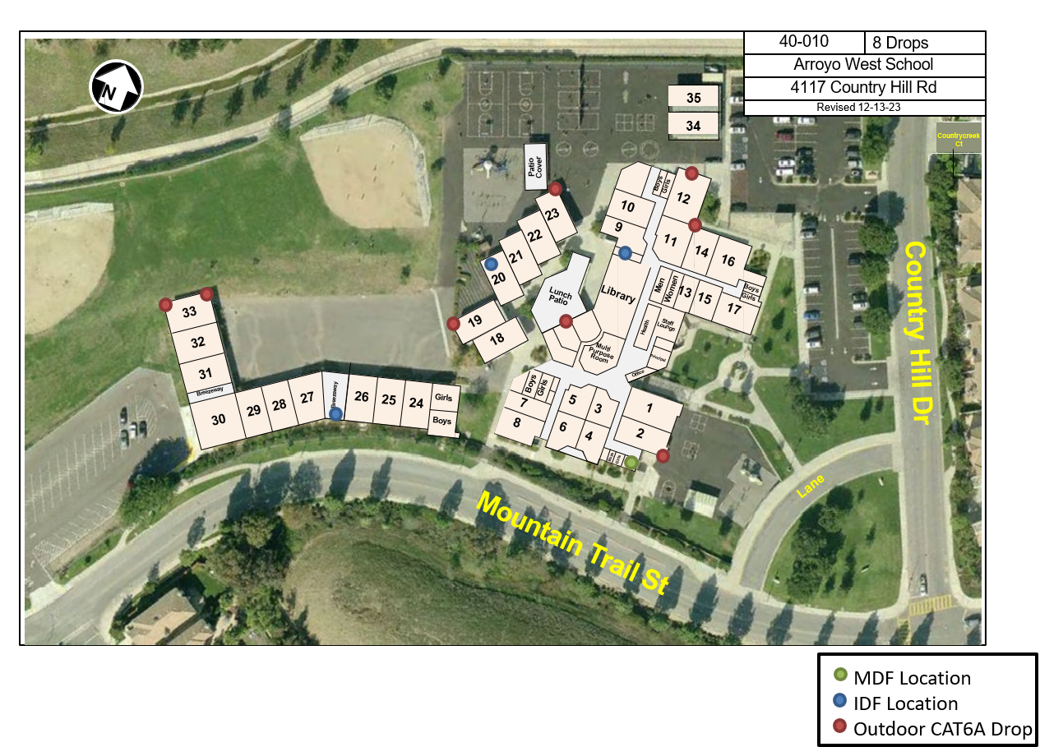

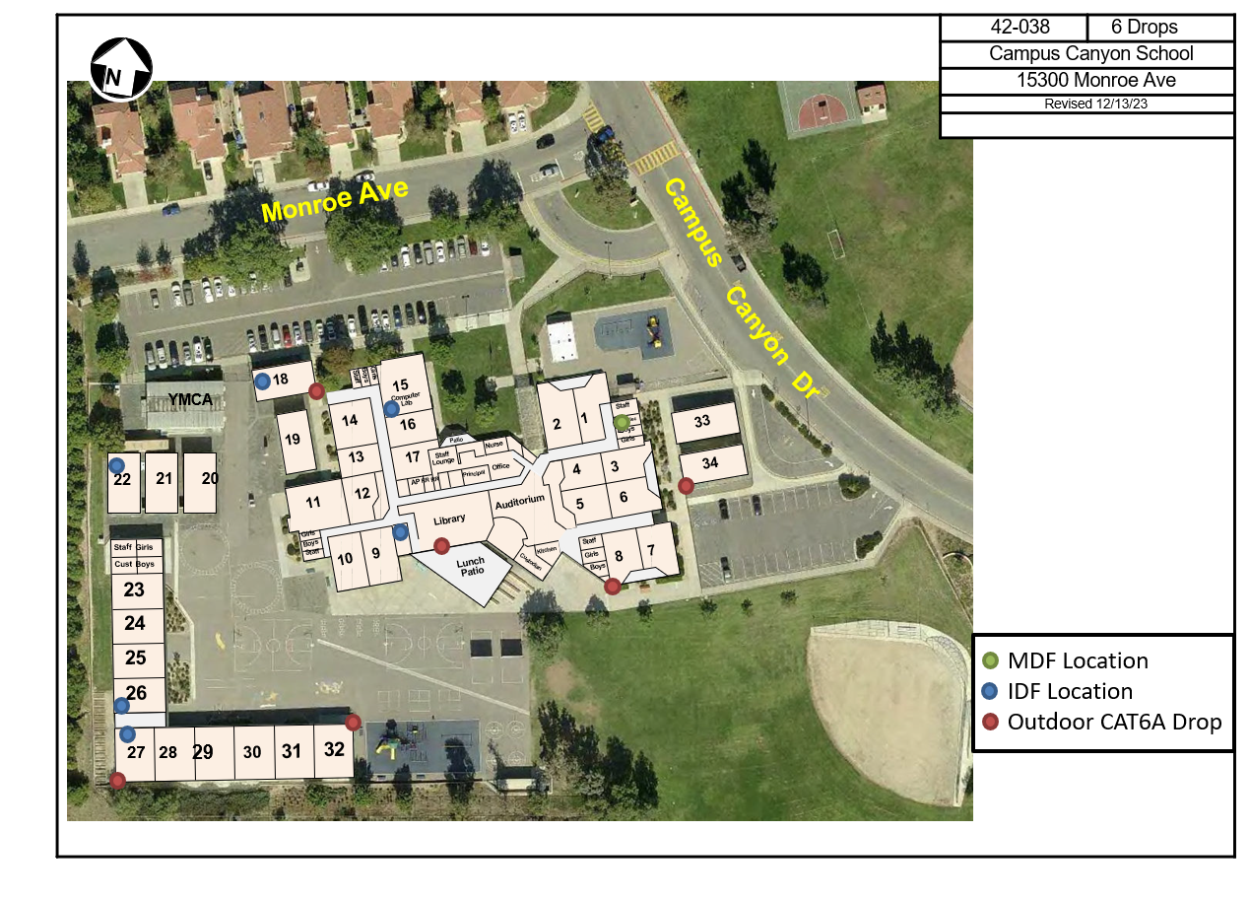

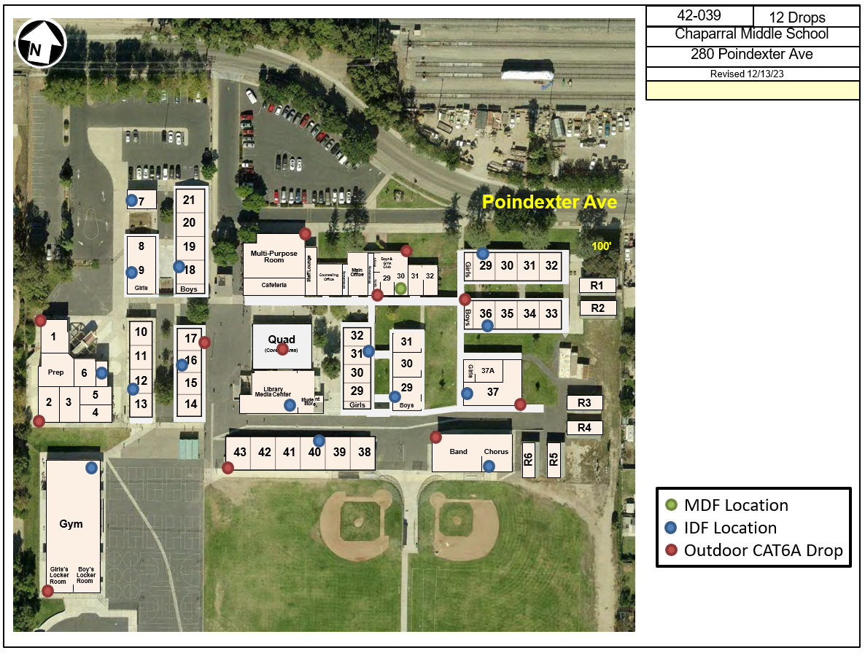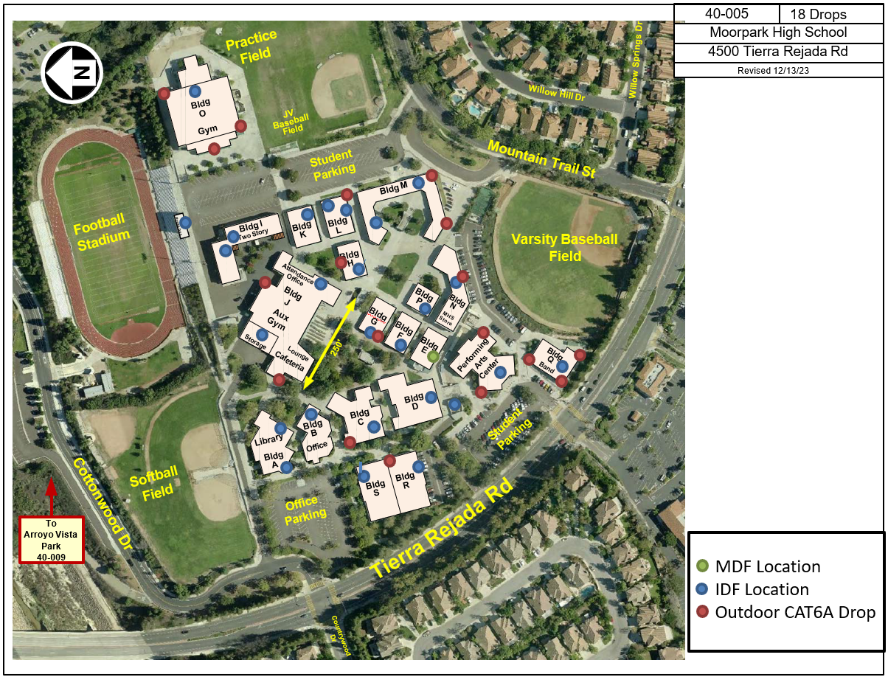

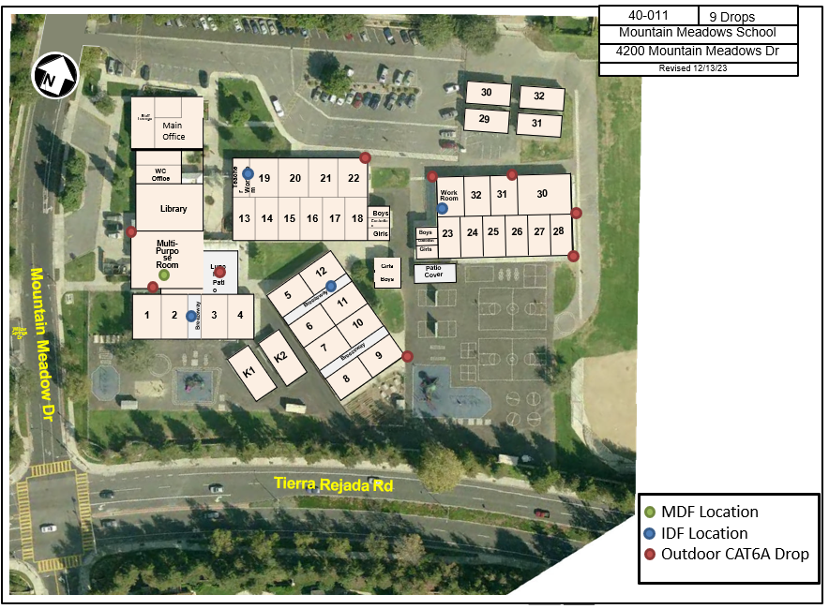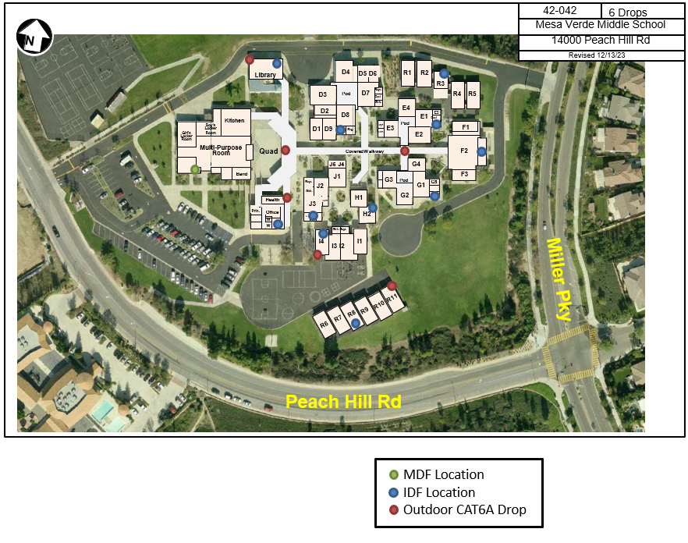
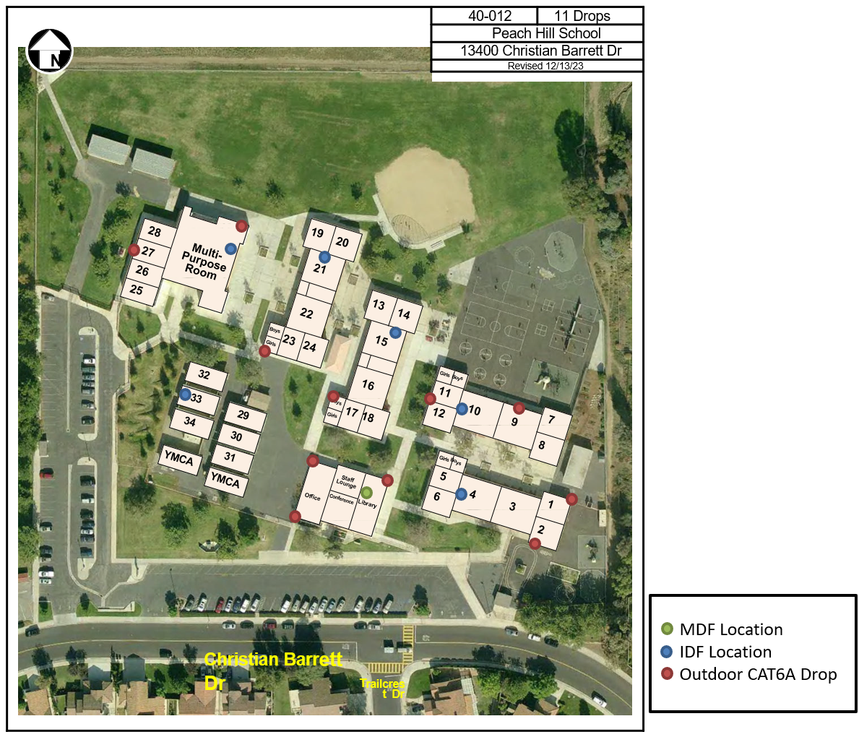

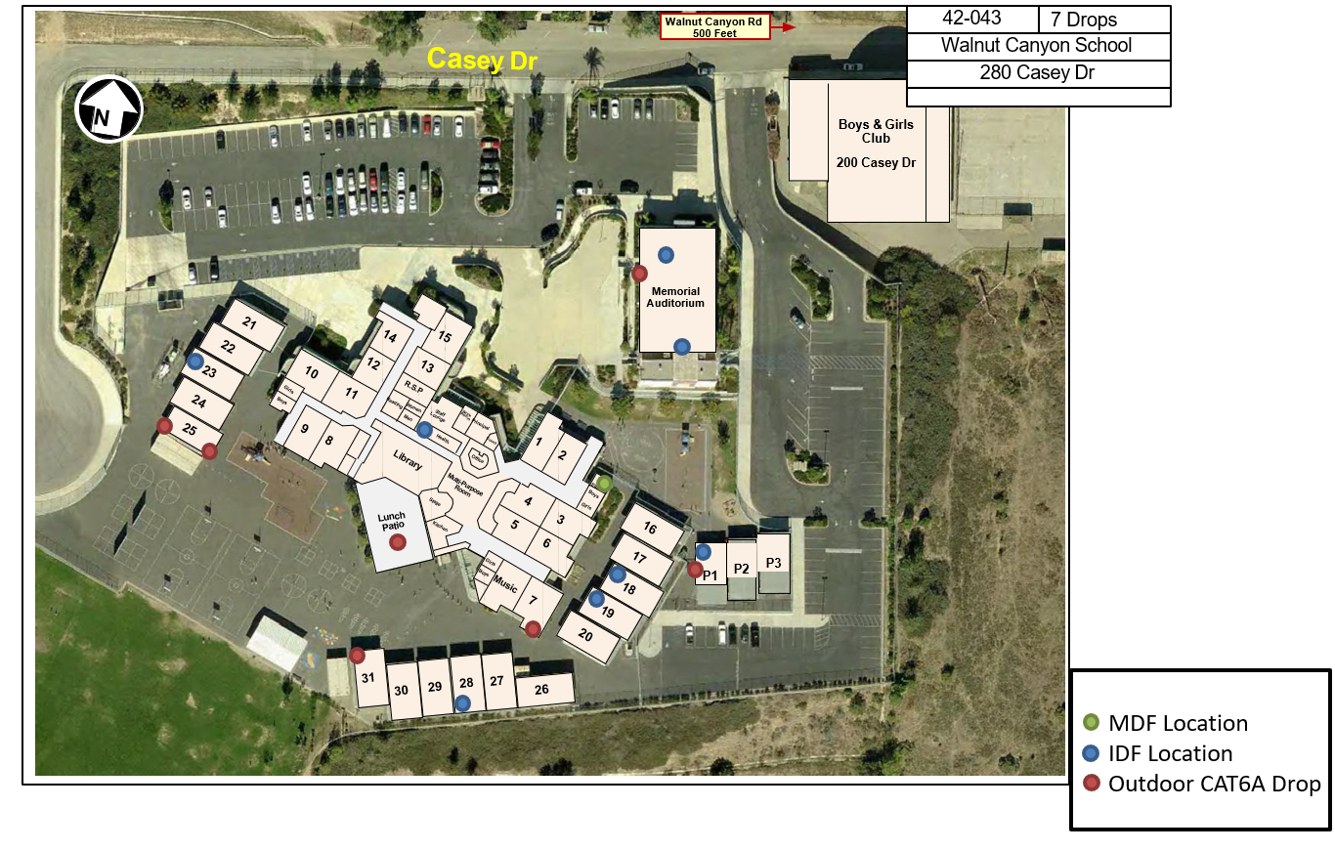

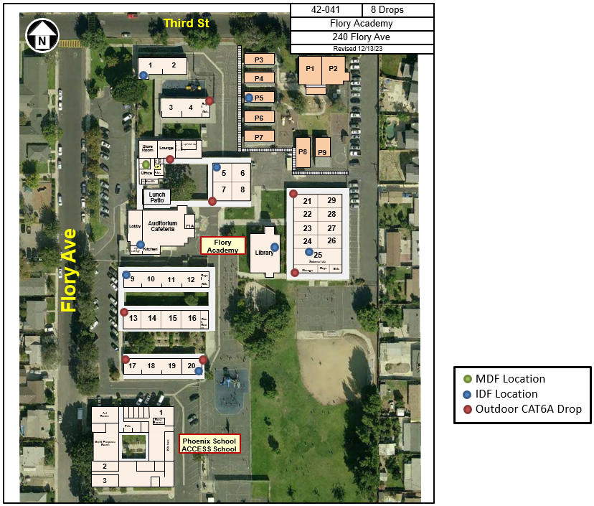
End of Appendix A – Site Map

THIS PAGE LEFT BLANK INTENTIONALLY

