LaSalle-Peru Township High School
Class of 2028
9th Grade Program of Study

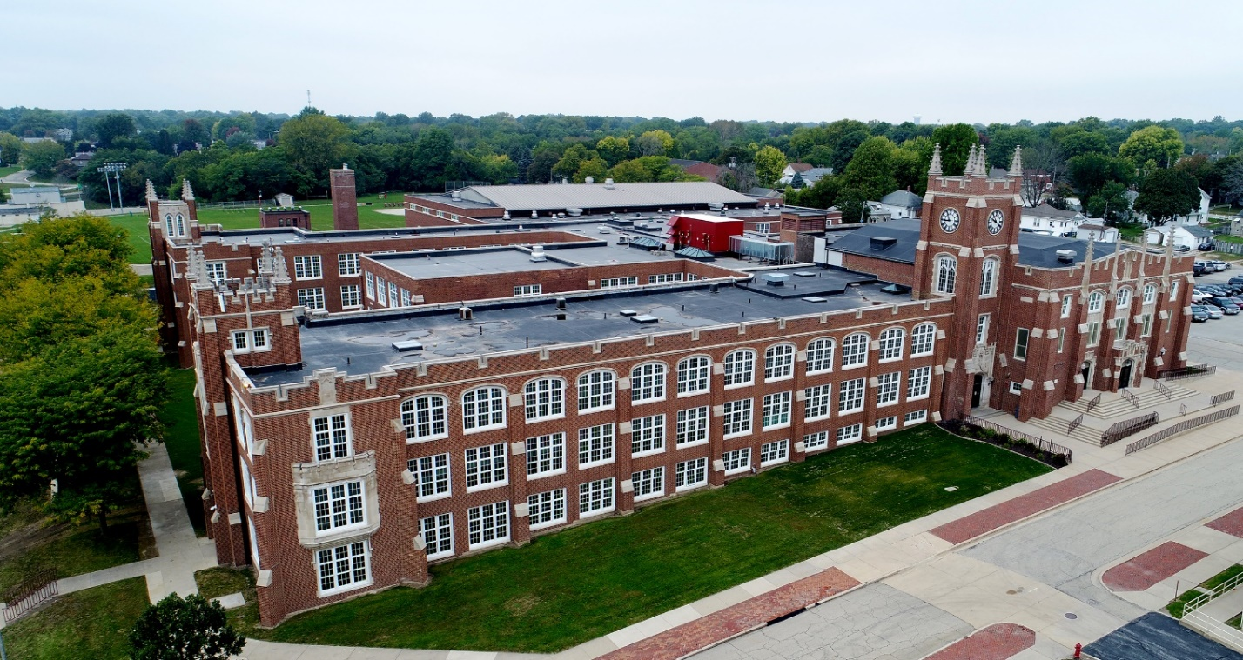

A Freshman’s Guide to Navigating High School

Welcome from the Superintendent & the Principal

Dear L-P Class of 2028:
It is our great pleasure to welcome you to LaSalle-Peru Township High School. We are very excited about you joining the Cavalier Family and have no doubt that your four years at L-P will provide you with a critical foundation – both academically and socially – that will prepare you for college, a career, and, most importantly, life.
This Freshman Guide will provide you will all the course offerings available to you in your freshman year. As you can see, L-P has a great deal to offer. We want to encourage you to continue working hard in all your 8th grade classes and learn as much as you can during the rest of this school year. The hard work you put it now will pay off when you enter L-P next year in the Fall.
We wish you success in your present academic endeavors and hope you are looking forward to entering high school next fall. We look forward to meeting you in August 2024.

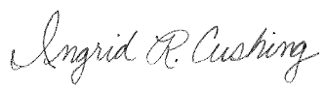
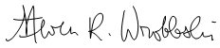
Sincerely,

Dr. Steven R. Wrobleski Mrs. Ingrid R. Cushing
Superintendent Principal

Learn…Grow…lead…Excellence is our Standard!

Important Topics Included

Key Dates
General Information
Course Selection Process
Registration Process
Student Health Information
Required Coursework and Electives
Freshman Planning Guide
Athletics and Activities
Link Crew
One-to-One Program
Technology Division
Course Descriptions
Contact Information
Key Dates
December 4-7, 2023 – Counselor Visits to Middle Schools
February 5-8, 2024 – Course Selection Meetings
Early August 2024 – Registration for Freshmen
August 2024 – Link Crew’s Freshman Kick-off Day
August 2024 – Freshman Year Classes Begin

General Information
As a comprehensive high school, L-P is proud of the great curricular and extra-curricular programs it has to offer students. Not only are the programming and faculty and staff premier, so are the facilities. The building recently underwent a $38 million renovation. The state-of-art facility includes fully renovated, climate-controlled classrooms with increased technology capabilities to best educate students in the 21st century. New and improved science labs and a STEM lab have been added. The building renovation also includes enhanced safety features, such as a secure main entrance and expansive camera system. The programs, faculty, and staff, and building work together to ensure that students are receiving an education that will best prepare them for their college, career, and life experiences.
L-P educates students in grades 9-12 with an enrollment of approximately 1300. The high school day begins at 7:45 AM and ends at 2:40 PM. The day consists of seven 50-minute periods and a 25-minute lunch. The school year consists of two 18-week semesters. As with all student schedules at L-P, the seven classes are a combination of required and elective courses. Across the academic divisions, courses are offered to meet the academic needs of all students, and include many Honors, Advanced Placement (AP), Career Tech Education, and Dual Credit opportunities. L-P, combined with the Area Career Center, offers over 170 courses and programs to students. We look forward to working with you to select the best classes to meet your goals and interests.
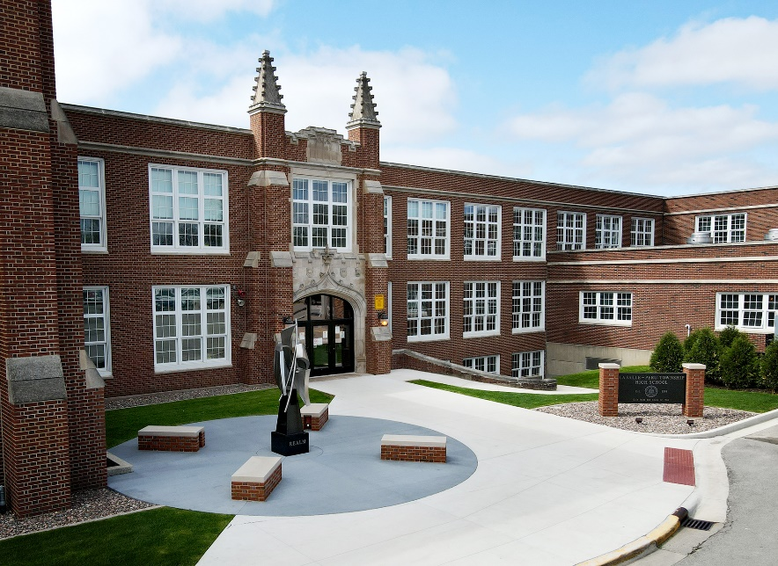

Course Selection Process
Incoming freshmen will be placed into their core classes of English, Math, Science, and Social Science based on their middle school grades and test scores, teacher recommendation, placement test scores, and student interests. Students will also determine what elective courses they would like to take. Elective courses provide students with the opportunity to pursue special interests within the academic curriculum.
We help students make course selections by having counselors visit the middle schools to share general information about the process and answer questions that students have. We also help by sharing the course options in this document as well as on our website. Course descriptions for freshmen level courses are found in this document. Students and their families are encouraged to preview these options prior to the individualized counselor meetings.
During the individualized counselor meetings, the student along with his/her family will meet with a Counselor to officially select the student’s freshman courses. These meetings typically take place at L-P during the first week of February and are scheduled in the evenings. A letter is sent home to parents/guardians in advance regarding the date and time of their meeting and is shared at the middle schools during counselor visits.

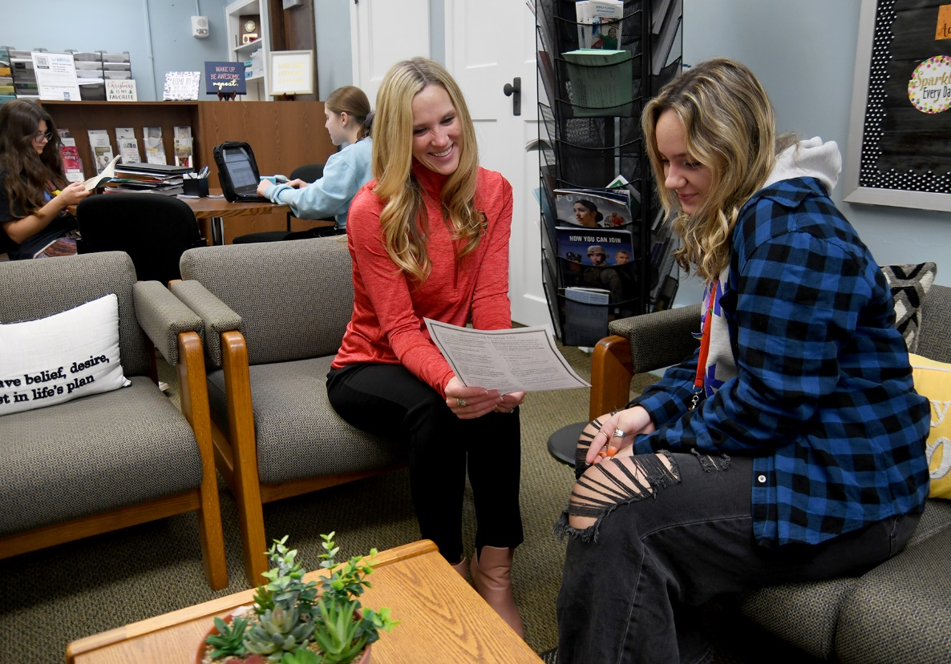

Registration Process
The final step in becoming a Cavalier is to complete the official registration process. The annual registration at L-P is divided into two parts. The first part occurs during July when letters will be mailed with instructions and login information for the online registration. Families complete this process prior to the August registration that is held at the school. The second section occurs in August when students and families come to the school on their designated day to finalize the registration process. Students will have their ID picture taken, show proof of residency, obtain locks, PE clothes, and complete any other necessary registration items at that time.
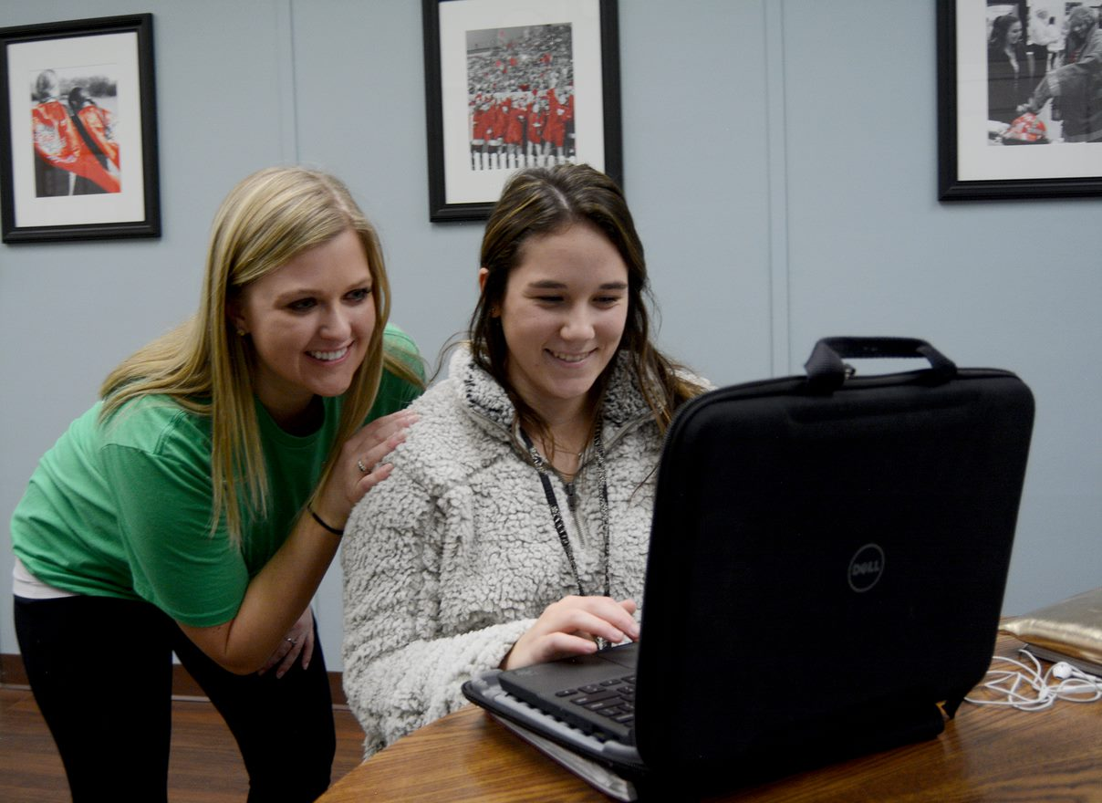

Student Health Information
Illinois School Code requires all incoming freshmen to have a valid physical examination and up-to-date immunizations. The physical exam must be documented on the official State of Illinois form, which is available either through the school’s website (https://www.lphs.net/Page/338) or at your doctor’s office. The physical exam must be completed within 12 months prior to the start of the school year. A sports physical does not count as a physical exam. However, once the physical exam is done, a student does not also need a sports physical for their freshman year. A list of the required immunizations is listed on the school’s website. Completed health information can be mailed to the school during the summer or submitted during registration.
Students requiring prescription or over-the-counter medications will need documentation from their doctor that includes specific information about storage and administration of the medication. Parents must deliver all medications in the original container to the school nurse. Asthma inhalers and epi-pens are allowed to be carried and used directly by students, however, the Parents’ Request for Medication form, which is located on the website, must be completed.
Required Coursework and Electives
The graduation requirements for L-P are based on credits (1 semester = 0.5 credits). To receive a diploma, a student must earn 23 credits and take the State’s accountability testing during their junior year. These requirements have been established to best prepare students for college, career, and life success. Within these requirements, some courses are specifically required for graduation (i.e.: American Government) while other requirements allow the student to choose between courses that meet the criteria (i.e.: Algebra 1 or Algebra 1 Honors). Elective course is the term used to describe the remaining courses that you select to meet the total number of credits needed for graduation. In the table below is a list of the graduation requirements for the Class of 2028.
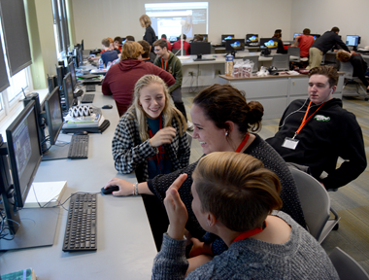
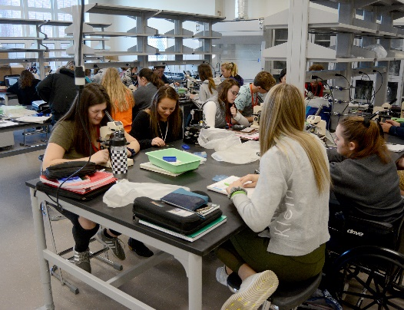
*** Physical Education
Number of credits may vary depending on PE waivers. While Driver’s Ed is an elective, it will count toward the 3.5. credits needed.
++ These classes fulfill the Illinois State Board of Education’s two-year writing-intensive requirement.
Class of 2028
English ~ 4.0 Credits ++

Mathematics ~ 3.0 Credits
Algebra 1 (1.0)
Geometry (1.0)

Science ~ 2.0 Credits
Biology (1.0)
Chemistry (1.0)

Social Science ~ 2.5 Credits
World History (1.0)
U.S. History (1.0)
US Government (0.5)

Essential Technology ~ 0.5 Credit

Consumer Education ~ 0.5 Credits
Successfully pass one of the following classes:
Personal Finance (0.5)
AP Microeconomics (0.5)

Physical Education*** ~ 3.5 Credits

Health ~ 0.5 Credits
Health is taken at the 9th grade in tandem with one semester of P.E.

One Year Chosen From ~ 1.0 Credits
Art
Music
World Languages
Career & Technical Education
Business
Family & Consumer Science

Electives ~ 5.5 Credits

TOTAL CREDITS TO GRADUATE ~ 23
Freshman Planning Guide
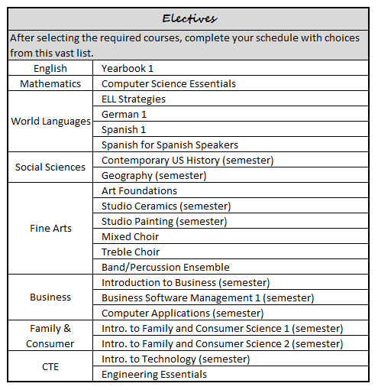
Students often ask the question: What classes should I take my freshman year? This guide will help you to make those selections. The classes that students can select from are listed in the boxes below. The specific details about each course are listed in the next section. The courses in the “Required and Recommended” box are classes that all students should take their freshman year. To complete your seven-period schedule you can also select from the courses listed in the “Elective” box. Students should create a mock schedule in this planning guide prior to meeting with their counselors.
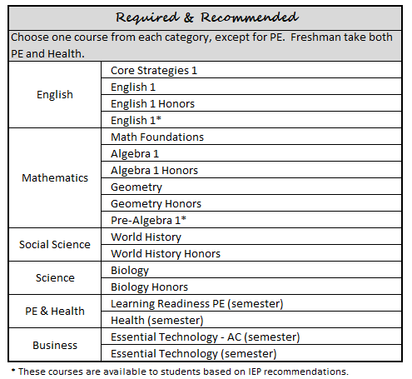

Freshman Planning Guide
Subject | 1st Semester | 2nd Semester
English
Math
Social Science
Science
PE/Health
Elective
Elective

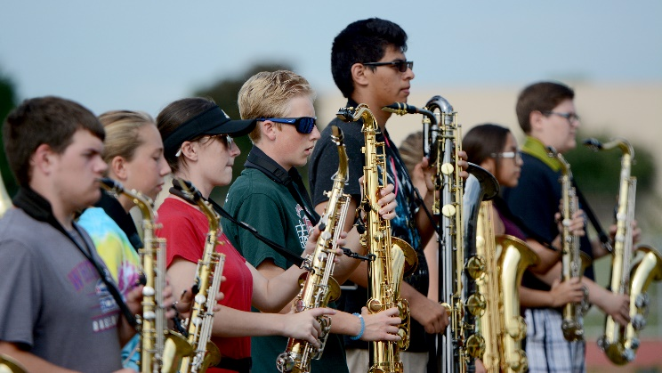

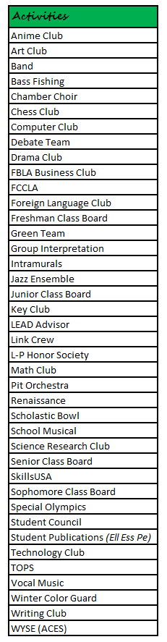

Athletics and Activities

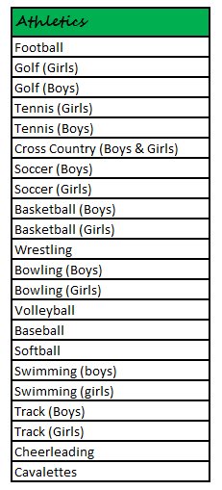
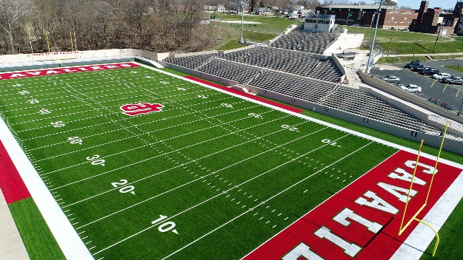
LaSalle-Peru Township High School values student involvement in athletics and activities. Students are encouraged to participate in at least one of these experiences during their high school career. These opportunities allow for enrichment and assist students in connecting to their school community. Athletic teams are organized based on the seasons of fall, winter, and spring, whereas activities have various participation times. Students are made aware of these opportunities through the Open House and announcements.

Link Crew
Link Crew is a national high school transition program that welcomes freshmen and makes them feel comfortable throughout the first year of their high school experience. Built on the belief that students can help students succeed, Link Crew trains members of the junior and senior classes to be Link Leaders. As positive role models, Link Leaders are motivators, leaders and teachers who guide the freshmen to discover what it takes to be successful during the transition to high school and help facilitate freshman success.
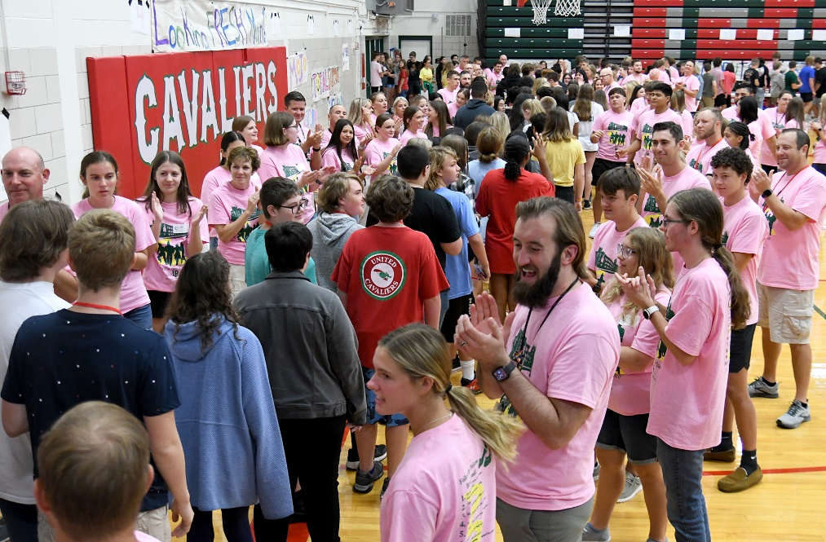

Technology Opportunities
The LaSalle-Peru High School community embraces and infuses technology into the curriculum and campus life. Teachers and Administrators use technology tools and strategies for improvement of curriculum and instruction and to assess, gather, analyze, evaluate, and communicate information. And students use technology as a tool for research, composition, creation, presentation, management, and communication that support personalized learning experiences.
LaSalle-Peru High School’s 1:1 Mobile Learning Program began in August 2015 to help ensure that every student has access to current technologies. Every student is issued a Chromebook and carrying case at the beginning of each school year and is an essential part of their learning experiences. Students learn and demonstrate the character trait of responsibility through proper device care, digital citizenship, internet safety, collaborative learning and more.
LaSalle-Peru High School’s 21st Classroom is equipped with an interactive teaching wall, which allows teachers and students to be more collaborative, whether working with curriculum software, presentations, Chromebook apps, webpages, etc.
Course Descriptions

BUSINESS EDUCATION
Introduction to Business
This is an introductory Business course for students of all grades that may be interested in a business- or business-related career. Students will be introduced to the following areas in business education, including but not limited to finance, marketing, production, social responsibility, ethics, basic economics, career planning, decision-making, technology, and management. Projects consist of economic systems design, business cycle, international business, consumer bill of rights, family budgets, financial institutions web, banking process.
Essential Technology / Articulated Credit
*This course fulfills the graduation requirement and has an articulated credit option through IVCC.
Students will learn to expand their knowledge in technology and its application in academics and the workforce. This course helps students develop the skill to type more quickly and accurately using the touch-typing method. Students learn word processing and formatting skills and then apply these by producing professionally formatted business memos, letters, formal writing styles (MLA and APA), and formal emails. Students who desire improvement in keyboarding and current software applications skills will benefit from this course and be better prepared for further study in the computer sequence.
Essential Technology
Students will learn to expand their knowledge in technology and its application in academics and the workforce. This course helps students develop the skill to type more quickly and accurately using the touch-typing method. Students learn word processing and formatting skills and then apply these by producing professionally formatted business memos, letters, formal writing styles (MLA and APA), and proper emails. Students will learn appropriate and effective communication skills for a variety of audiences. Improvement of soft skills will be a focus throughout the semester.
Computer Applications
Prerequisite: Essential Technology
This course explores the field of word processing and presentation software. The student will develop an in-depth understanding of computer related careers, advanced formatting techniques using Microsoft 2016 and Microsoft 365. Creating tables, tabs, mail merges, and wizards are emphasized through project- based learning and hands-on activities. In addition, students will research careers, plan, create, and properly present using PowerPoint 2016. It is highly recommended that students take a full year of computer applications. This class is articulated with CSP1203 through IVCC.
Business Software Management 1
Prerequisite: Essential Technology
This course provides students with the opportunity to use Microsoft Excel 2019 to create, analyze and formulate data properly in a spreadsheet format. Students learn advanced formulas (absolute cell referencing, if statements, financial functions) through many real-world applicable activities and projects. Students will learn to use these spreadsheets to create and analyze charts and graphs. This class is articulated with CSP 1203 through IVCC. To be eligible for this three-hour credit, students MUST take Computer Applications 1 and Business Software Management 1 and earn an “A” or “B” in both courses. In addition to being dual credit with IVCC, students will test for Certiport Certification.

CAREER AND TECHNICAL EDUCATION
Introduction to Technology

This semester length course is divided into nine-week sections that cover four different industrial areas— Welding, Electricity, Machining Skills, and Woods. The focus is on occupational awareness and orientation in each of the four industrial areas. Emphasis in the course is placed on the student’s ability to perform in a safe and engaged learning environment with real world problem solving. Each section is project based, with the student being able to identify and use specific tools and procedures in each area. By participating in Introduction to Technology, students will also be able to make more meaningful selections of possible career and technical education courses as a sophomore, junior, or senior at either the high school or the Area Career Center.
Engineering Essentials

The course introduces students to engineering concepts that are applicable across multiple engineering disciplines and empowers them to build technical skills using a variety of engineering tools, such as geographic information systems (GIS), 3-D solid modeling software, and prototyping equipment. Students learn and apply the engineering design process to develop mechanical, electronic, process, and logistical solutions to relevant problems across a variety of industry sectors, including health care, public service, and product development and manufacturing. Students explore the work of engineers and their role in the design and development of solutions to real-world problems. This course is the student’s first exposure to the PLTW Engineering program.
ENGLISH
Core Strategies 1
In this course, students will work on improving their reading skills to become successful in all content area classes. This course uses the program Reading Plus to target these areas of concern and differentiate instruction based on the needs and abilities of each student. In addition, students will work on the fundamentals of writing and speaking. Students will continue in Core Strategies until they have met the exit criteria.
English 1
In this course, students will analyze the author’s use of literary elements in the development of a variety of texts including short stories, novellas, poetry, dramas, and novels. Students will apply their knowledge of the writing process as well as demonstrate correct formatting to produce compositions for a variety of purposes and audiences. Students will demonstrate appropriate communication skills in a variety of situations.
English 1 Honors
This course presents some of the literary masterpieces that comprise an important part of Western civilization. Through readings selected from Greek, Renaissance, and nineteenth and twentieth-century classics, students will analyze, evaluate, and synthesize literature to make connections to personal experiences, other disciplines, and other literary works. Students will speak and write to communicate their understanding of these connections using Socratic seminars, informal presentations, note-taking, literary analysis, argumentation, narrative, and research writing. Students enrolled in this course also take World History Honors.
Yearbook 1
In this course, students will produce the school’s yearbook using research, sports reporting, interviewing, editorial writing, basic copy writing, caption writing, feature stories, straight news, and verbal communication. They will also proofread and edit their work and the work of others as well as apply graphic design using the assigned yearbook digital processing software. In preparing their final product, students will learn valuable workplace skills such as organization, time management, conflict resolution, and cooperative learning. Students will also plan and host two major fundraisers to help offset the cost of the annual’s production.

FAMILY AND CONSUMER SCIENCES
Introduction to Family and Consumer Sciences 1

This course is recommended for all students who are ready to pursue a study of the family and consumer sciences in the context of “helping” professions. The curriculum will provide students with the information and practical techniques concerning such topics as personal growth, pathways to career success, consumer skills, and clothing and fashion choices. This course is a project-based course in which students integrate higher order thinking, communication, leadership, and management processes to conduct investigations in family and community services.
Introduction to Family and Consumer Sciences 2

This course is recommended for all students who are ready to pursue a study of the family and consumer sciences in the context of “helping” professions. The curriculum will provide students with the information and practical techniques concerning such topics as parenting and caregiving skills, wellness, nutrition, and food choices, and housing and interior design. This course is a project-based course in which students integrate higher order thinking, communication, leadership, and management processes to conduct investigations in family and community services.
FINE ARTS
Art Foundations

Student enrolled in this class will be introduced to the elements and principles of art as presented by the instructor and ArtTalk, the course textbook. Writing assignments regarding vocabulary and art history are part of this curriculum. Students will be introduced to a wide variety of art media and complete hands-on studio projects as well as sketchbook assignments.

Studio Ceramics

Students enrolled in this course will learn the fundamentals of hand-built pottery. Projects will be made by using the pinch pot, coil, and slab building methods. Students will create a piece on the potter’s wheel. The history of ceramic pottery will be explored. Ceramic terminology is studied, and tests are given in this semester-long course. Participants can expect to create five or six ceramic projects.
Studio Painting
Students enrolled in this course will learn the fundamentals of painting by introduction and exploring watercolor and acrylic. The history of painting is studied, and tests are given in this semester long course. Participants can expect to create five or six paintings and study a variety of painters/artists and art periods from the past and present.
Treble Choir
Treble Choir is an introductory choir performing primarily SSA (Soprano, Soprano, Alto) music and providing early instruction for the changing voice. Students are taught fundamentals for producing tone quality and healthy breathing. Basic instruction in rhythm, melody, and harmony is given using two, three, and four-part music. Students are expected to expand their knowledge of music theory, perform quarterly vocal assessments, and attend all rehearsals and performances scheduled outside the school day. Treble Choir is a non-auditioned choir and performs four concerts throughout the year.
Mixed Choir
Mixed Choir is open to Bass Voices in freshman year. Mixed Choir emphasizes the development of the maturing voice and its place within an SAB (Soprano, Alto, Baritone) choir. Students are exposed to a broad range of rhythmic and harmonic structures through music from the Renaissance through the twentieth century. Students learn the proper stylistic approach to singing various literatures. The choir sings in foreign languages often. Mixed Choir offers instruction in the fundamental techniques of sight singing. Students are expected to expand their knowledge of music theory, perform quarterly vocal assessments, and attend all rehearsals and performances scheduled outside the school day. Mixed Choir is a non-auditioned choir and performs at four concerts throughout the year.

Band/Percussion Ensemble
All students wanting to be a part of the L-P Band program must play a band instrument (i.e. woodwind, brass or percussion). Violin, viola, cello, string bass, electric bass, guitar, and piano are not accepted instruments. String players may audition for the Illinois Valley Youth Symphony Orchestra (IVYSO) and string/electric bass, guitar and piano players may audition for the L-P jazz band. Jazz band auditions are at the end of the marching band season. Sub-areas of the band are as follows:
Marching Cavaliers: All members of the LP Band program participate in the award-winning Marching Cavaliers. The Marching Cavaliers rehearse every school day during 1st period. This ensemble performs at all home varsity football games, several parades and various field show competitions in the fall. There are Marching Cavalier rehearsals during summer break, on Wednesday nights from 6-9PM and on Saturday mornings.
Symphonic Band: All woodwind and brass musicians participate in symphonic band. Symphonic band begins after the marching band season. Symphonic band meets every school day during 1st period. This ensemble performs high school level literature at concerts throughout the school year.
Percussion Ensemble: All percussionists are enrolled in percussion ensemble. Percussion ensemble rehearses every school day during 2nd period. This ensemble performs percussion music at concerts throughout the year. All members of this ensemble will participate within the symphonic band.
Basketball Band: All members of the LP Band program participate in Basketball Band. This ensemble plays at most home boys and girls varsity basketball games.
Jazz Ensemble: Those students interested in participating in jazz ensemble will audition for this group in late October. This ensemble rehearses Tuesday nights from 6-8PM and performs at concerts throughout the year.
Spring Musical (Pit Orchestra): Using both an audition process and the selection of the director, students will have an opportunity to play in the pit orchestra for the spring musical. Instrumentation depends on the show that is being performed.
Band Lessons: All members of the LP Band program will participate in band lessons. Students will have at least 4 private or sectional lessons throughout the semester. These lessons will take place during the first or second half of 3rd and 4th period. Students’ teachers will be informed ahead of time and students are responsible for any missing class work.
WORLD LANGUAGE
English Language Learners 1
This course is for first year English language learners. Reading and writing are heavily emphasized in this class. The students can further develop their reading, writing, listening, and speaking skills. Readings from government, science, history, math, and literature are incorporated into this course to enhance academic performance in various disciplines. The curriculum is supplemented using Keystone curriculum by Pearson Longman. Daily practice is vital to success in this course
ELL Strategies

This course is most appropriate for students who have recently moved to the United States and have limited English-speaking skills. It will provide students with the basic English communication skills as well as support with the school system and technological assistance needed to be successful in all classes at LaSalle-Peru Township High School. This course can be taken concurrently with English Language Learners I and supports the overall development of the student providing strategies that can be used in all content areas.
Spanish 1
Students learn the fundamentals of pronunciation, grammar, and vocabulary by engaging in many listening, speaking, reading and writing activities. They also explore the various Latin American and Spanish cultures. Students are required to actively participate in class in group and pair work, complete daily assignments, assessments, and chapter tests. Films and instructional computer programs are part of the textbook program.

Spanish for Spanish Speakers
This course is designed to develop and/or improve the students’ reading, listening, speaking, and writing skills. It is taught in Spanish and includes an introduction of the grammar rules and the orthography of Spanish. The students will be taught rules which will enable them to write and to spell correctly in Spanish. There is an inclusion of short lower-level readings to enable the students to become fluent in reading Spanish and projects to incorporate the various cultures that make up the Hispanic community. The students will read and write, give oral presentations, and participate in classroom discussions. The first year will consist of the development on the informative essay, descriptive essay, personal narrative, and expository essay.

Este curso fue diseñado para desarrollar y mejorar las habilidades del estudiante. Se enseñará en español e incluirá una introducción a las reglas de gramática y ortografía. Se les enseñará estas reglas para continuar el desarrollamiento de la escritura.

Se incluirá historia y cuentos cortos para desarrollar la lectura y proyectos que incluirán las diferentes culturas que forman la comunidad hispana. Los estudiantes leerán, escribirán, darán presentaciones y participarán en los discursos. El énfasis del primer año será en el desarrollo del ensayo informativo, la escritura descriptiva, del ensayo personal y del ensayo expositivo.
German 1

This course begins with an introduction to the German language and culture of the German-speaking countries. Students begin to learn to understand, speak, read, and write German. Course emphasis is on building confidence and competence in communicating basic expressions, thoughts, and ideas in German. In addition, students acquire a basic vocabulary and an understanding of simple German grammar. Daily study outside of class is expected.

HEALTH AND PHYSICAL EDUCATION
Learning Readiness P.E.

This course alternates with Health during the freshman year. Learning Readiness P.E. emphasizes the following benefits of physical activity: better health, better behaviors, and better learning. Units of study include cardiovascular exercise, strength training, swimming/CPR, and fitness games. Fitness progress is recorded and monitored by each student and continues throughout high school. All units take full advantage of the effects that exercise, and movement have on learning.
Health

This one-semester class helps students understand the importance of good health habits in their present and future lives. It incorporates units of instruction in consumer health, wellness and exercise, nutrition, emotional and mental health, human sexuality, and substance use and abuse education.
MATHEMATICS
Math Foundations

This course is designed for those students who need reinforcement in their computational and problem-solving skills. The students will review fundamentals, learn problem-solving strategies, math facts, and mental math. The course will be designed with whole class instruction based on topics, such as integers, tools of Algebra, fractions, etc. along with individualized work and project-based activities to ensure mastery of skills. The course will be driven using an interactive notebook. It is intended to fully prepare students to successfully complete Algebra 1 the following year. The course will fulfill a graduation requirement. Students will be recommended for the course based on performance in their 8th grade math course, 8th grade placement exam scores, and/or teacher recommendation from the 8th grade teacher and the Mathematics Division Chair.

Algebra 1

Students will choose the appropriate method and solve linear and quadratic equations and linear inequalities. Students will graph, write, and compare linear, quadratic, and exponential functions and apply these concepts to real-world situations. In addition, students will summarize, represent, and interpret data. This course fulfills the Algebra 1 graduation requirement.

Algebra 1 Honors

Students will choose the appropriate method and justify the process of solving linear and quadratic equations and linear inequalities. Students will graph, write, compare, and analyze linear, quadratic, and exponential functions and apply these concepts to real-world situations. In addition, students will design studies and summarize, represent, and interpret the data. Students will be recommended for the coursed based on performance in their 8th grade math course, 8th grade placement exam scores, and/or teacher recommendation from the 8th grade teacher and the Mathematics Division Chair. This course fulfills the Algebra 1 graduation requirement.

Geometry

Students will construct logical arguments based on geometric concepts. Students will classify geometric figures and apply their properties between problems. Students will utilize and communicate appropriate geometric principles to solve concepts and terminology in everyday situations. This course fulfills the geometry-content graduation requirement.

Geometry Honors

Students will analyze problems to construct logical arguments based on geometric concepts. Students will examine geometric figures to apply their properties to solve problems. Students will apply the concepts of coordinate geometry to investigate geometric relationships. In addition, students will utilize and communicate appropriate geometric concepts and terminology in everyday situations. This course fulfills the geometry-content graduation requirement. The L-P Honors Geometry course is designed for those students who took Algebra 1 in 8th grade and demonstrate proficiency on the Algebra Proficiency Test administered in May.
Computer Science Essentials

This course exposes students to a diverse set of computational thinking concepts, fundamental, and tools allowing them to gain understanding and build confidence. Students use visual, block-based programming and seamlessly transition to text-based programming with languages such as Python® to create apps and develop websites and learn how to make computers work together to put their design into practice. They apply computational thinking practices, build their vocabulary, and collaborate just as computing professionals do to create products that address topics and problems important to them.
SCIENCE
Biology

Students will examine organisms to determine their characteristic structures, functions, and interdependence using scientific knowledge and methods. They will generate solutions to real-world problems through critical thinking and effective communication.
Biology Honors
Students will examine organisms to determine their characteristic structures, functions, and interdependence using scientific knowledge and methods. Students will create solutions to real-world problems through critical thinking and effective communication. Students will develop dissection skills using preserved animals.
SOCIAL SCIENCE
World History

This course examines the critical episodes of World History with an emphasis on western civilization, and the ideas studied by social scientists, as well as the methods they use. Through reading, discussions, lectures, and projects, students will develop research skills, ability to evaluate, and synthesize material. The course highlights the contributions of ancient, medieval, and modern times. The achievements of each historical period are analyzed in relation to their time and lasting impact.

World History Honors

This course examines the critical episodes of World History with an emphasis on western civilization, and the ideas studied by social scientists, as well as the methods they use. The art, architecture, and music of the historical periods are also studied. Students work on projects as individuals or groups to develop research skills, ability to evaluate, and synthesize material independently. Emphasis is placed on increasing the students’ ability to express themselves in both writing and speaking. Vocabulary building, language study, and library use are also part of the curriculum. This class coincides with Honors English 1.
Contemporary US History
This one-semester course will cover mid to late 20th century U. S. History. Through reading, discussions, lectures, and projects students will learn of events extending from WWII, Korean War, Cold War, Vietnam, and the Civil Rights Movement to the breakdown of Communism. These events will be analyzed both from a U. S. and world perspective. Students will also examine current event topics from around the world as well as issues such as environmentalism and racism.
Geography
Students will have the opportunity to exam human societies in their habitat. Learning experiences will center on the following: (1) exploration of the inter relationships between human beings and our physical environment; (2) analysis of the physical bases of geography; and (3) focus on selected regions throughout the world, examining political, historical, social, and cultural consequences of physical geography. Considerable map work, oral and written reports, and some supplemental reading is required.
SPECIAL EDUCATION
English 1*
The English sequence of courses is designed to provide strategic and intensive instruction to students who have difficulty achieving at grade level in written expression. Individualized instruction is given to each student based on an assessment of current skills, and each course continues the instruction at the student’s level from the previous course.
Pre-Algebra 1*
This course teaches essential pre-algebra content and provides students with an introduction to traditional algebra 1 content using a direct instruction approach. Individualized instruction will be given to each student based on an assessment of current skills.
Topics include basic operations with integers, decimals, fractions, problem-solving, basic algebra skills, collecting like terms, solving one- and two-step equations, and the coordinate system.

LaSalle-Peru Township High School
541 Chartres Street
LaSalle, IL 61301

815-223-1721 (Phone)
815-223-3444 (Fax)

Student Support Services
Position | Name | Extension | Email
Counselor | Mrs. Emily Carney | 745 | ecarney@lphs.net
Counselor | Mrs. Andrea Eichelkraut | 740 | aeichelkraut@lphs.net
Counselor | Mr. David Spudic | 768 | dspudic@lphs.net
Counselor | Mrs. Meg Kowalczyk | 755 | mkowalczyk@lphs.net
Counselor | Mr. Brandon Placher | 737 | bplacher@lphs.net
Nurse | Mrs. Peggy Ziel, R.N. | 738 | pziel@lphs.net
Nurse | Mrs. Shelby Knickerbocker, R.N. | 738 | sknickerbocker@lphs.net
Psychologist | Dr. Lisa Jones | 753 | ljones@lphs.net
Social Emotional Interventionist | Mrs. Nicole Kowalczyk | 707 | nkowalczyk@lphs.net
Social Worker | Mrs. Michele Pacheco | 754 | mpacheco@lphs.net
Social Worker | Mrs. Megan Mahaffey | 757 | mmahaffey@lphs.net
Attendance Advocacy Coordinator | Mrs. Susan Brooker | 708 | sbrooker@lphs.net
Division Chairpersons
Division | Name | Extension | Email
Career & Technical Education | Mrs. Tiara Bedenko-Hill | 240 | tbedenko1@lphs.net
English | Mrs. Michele Honecker-Ummel | 791 | mhonecker@lphs.net
Fine Arts & Foreign Languages | Mrs. Gladys Ramey | 729 | gramey@lphs.net
Mathematics | Mr. Nick Stevenson | 797 | nstevenson@lphs.net
Driver Education, Health, & Physical Education | Mr. Jim Cherveny | 756 | jcherveny@lphs.net
Science | Mrs. Carol Navarro | 250 | cnavarro@lphs.net
Social Science | Mr. Troy Woods | 724 | twoods1@lphs.net
Special Education | Mrs. Jennifer Plym | 793 | jplym@lphs.net
Student Support Services | Mrs. Emily Carney | 745 | ecarney@lphs.net
Administration
Position | Name | Extension | Email
Superintendent | Dr. Steven Wrobleski | 730 | swrobleski@lphs.net
Principal | Mrs. Ingrid Cushing | 782 | icushing@lphs.net
Associate Principal for Teaching & Learning | Mr. Chris Gibson | 705 | cgibson@lphs.net
Associate Principal for School Safety | Ms. Kate Lance | 735 | klance@lphs.net
Associate Principal for Student Support Services | Mrs. April Eutis | 750 | aeutis@lphs.net
Director of Athletics & Activities | Mr. Steve Hanson | 774 | shanson@lphs.net
Dean of Students | Mr. Jason Miller | 733 | jmiller@lphs.net
Director of the ACC & SRAVTE | Mr. Dwayne Mentgen | 272 | dmentgen@lphs.net

