How to access electronic books

- Step 1: Go to keller.d11.org
- Step 2: Click on the Library Media Center Tab
- Step 3: Click on Destiny
- 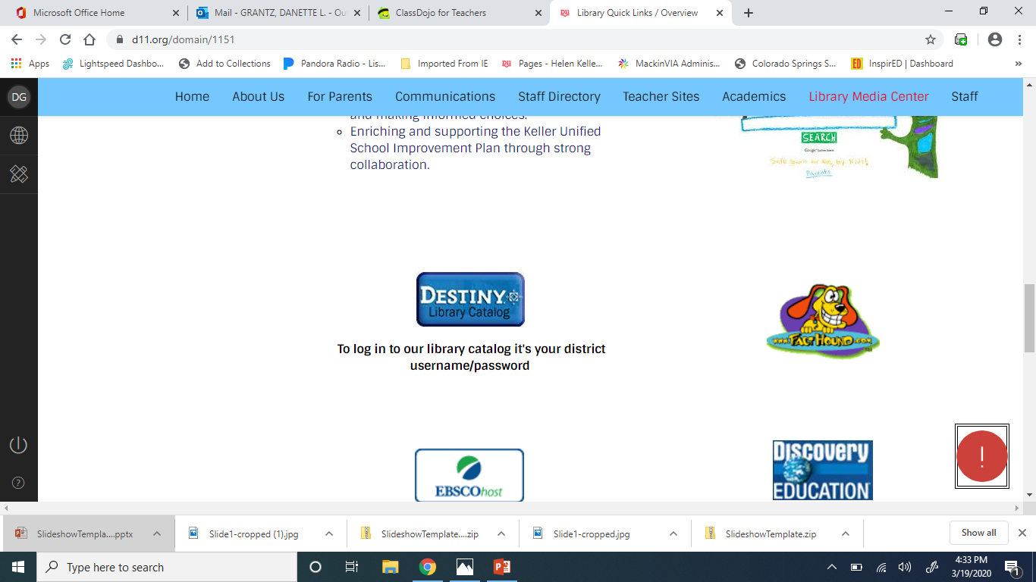

- Step 4: Log in with your username and password
- 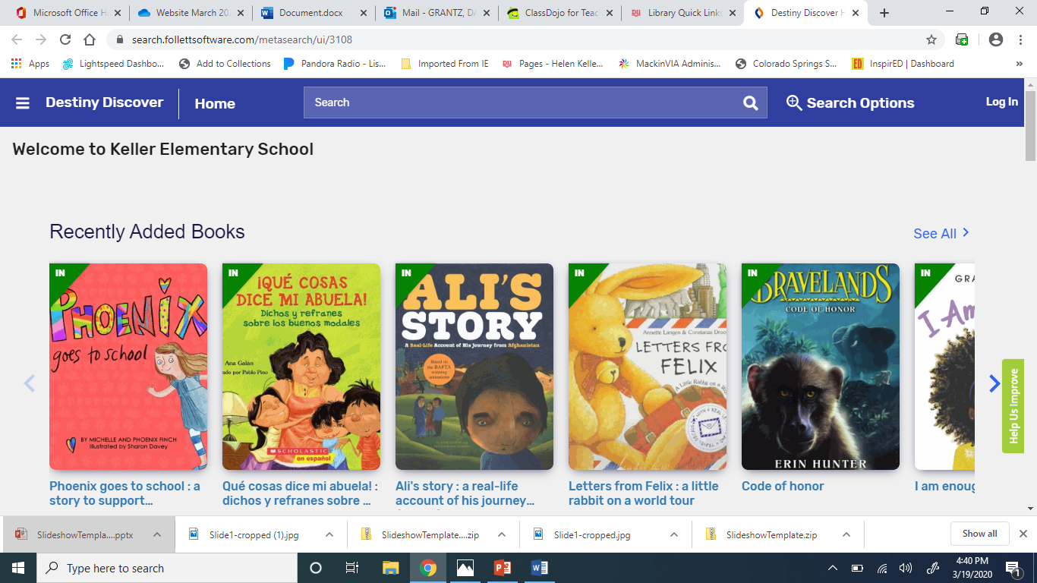

Scroll down to topics:
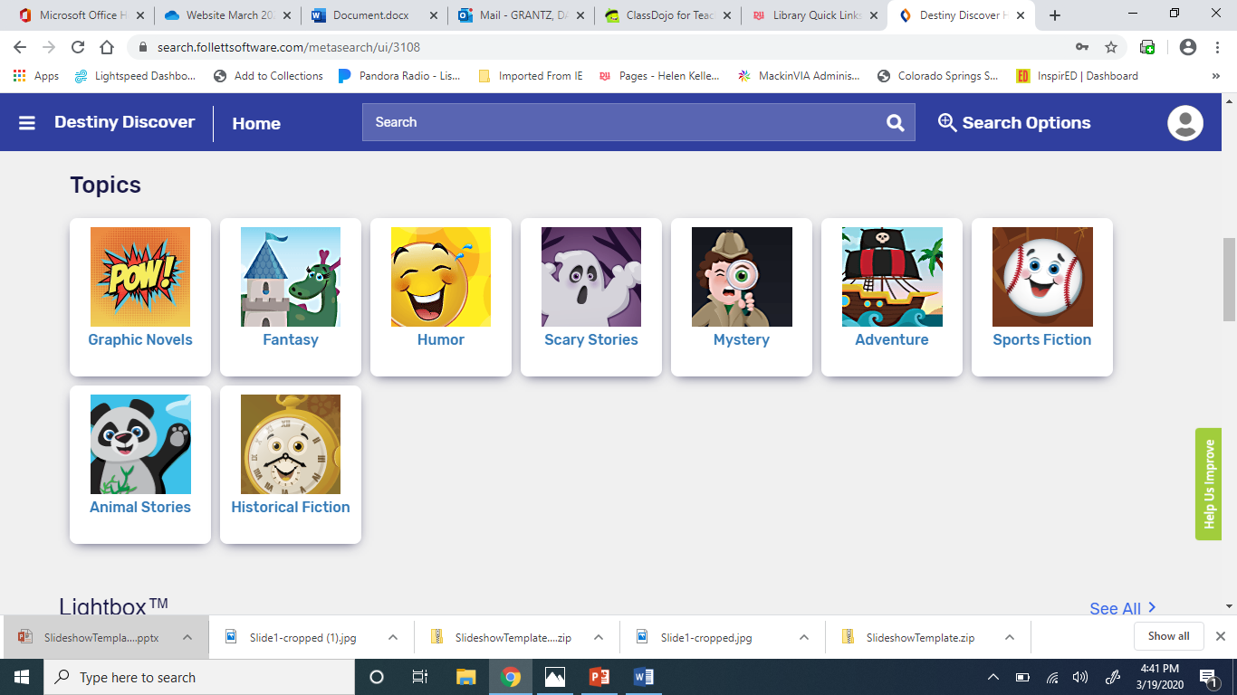
You will know it’s an electronic book because you will be able to OPEN it and CHECK IT OUT!
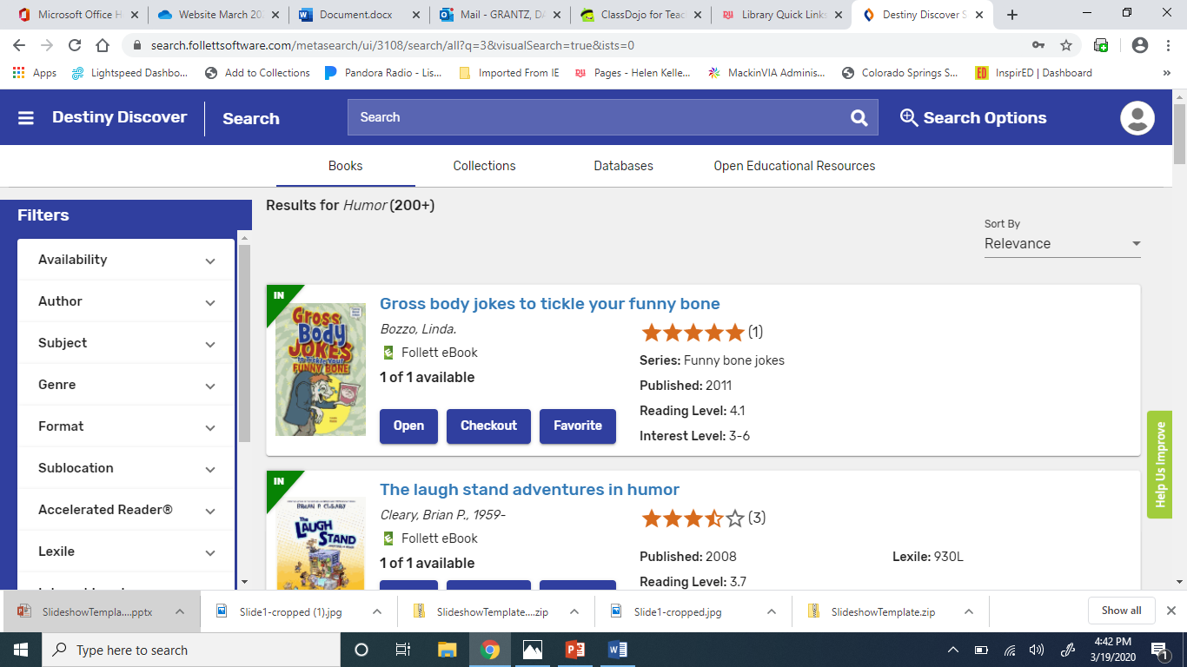

How do I find it after I log out?
Click on the menu on the left (3 solid lines) and you will see this:
Then click on CHECKOUTS.
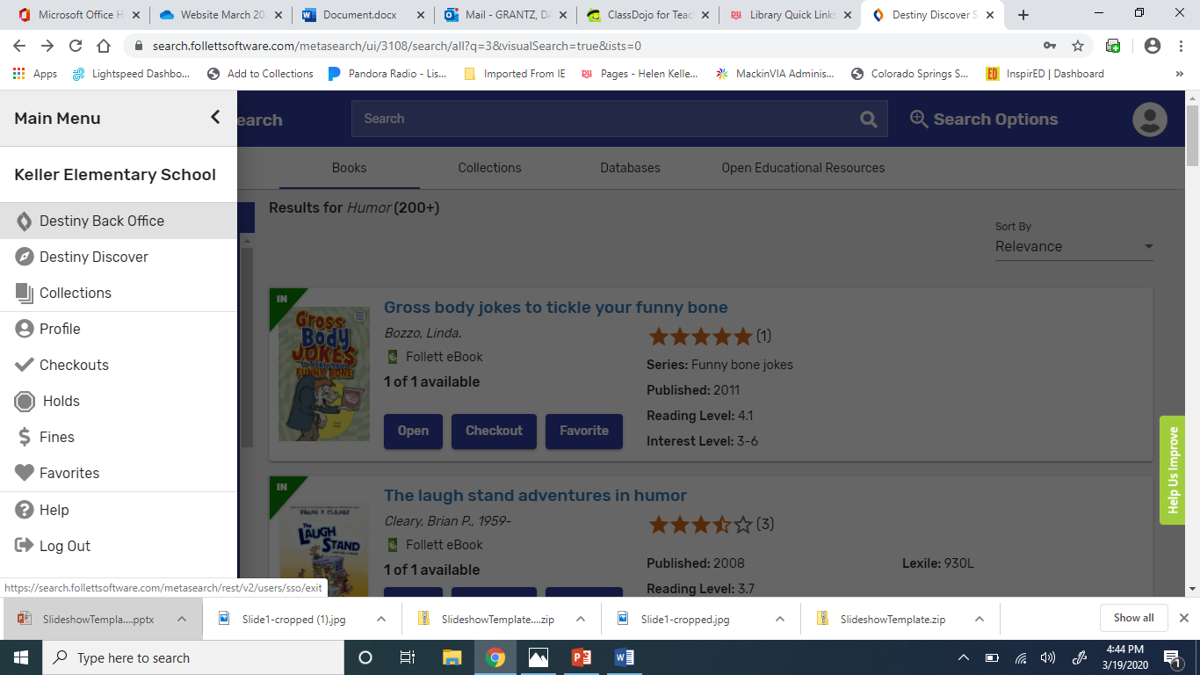

Email Mrs. Grantz if you need help:
Danette.Grantz@d11.org

