Turn Automatic Replies in Outlook
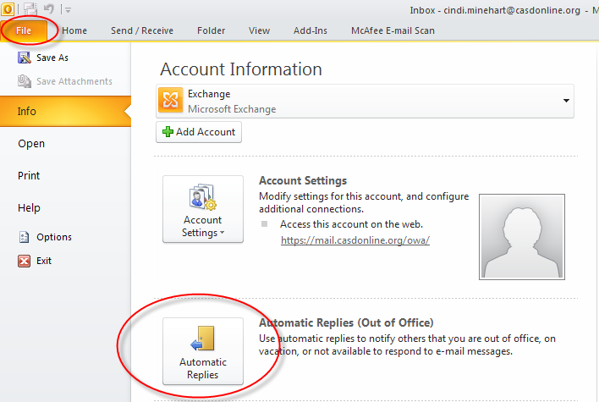
Click the File tab.
Click Automatic Replies.
Select Send automatic replies.
If you want, select the Only send during this time range check box to schedule when your out of office replies are active. If you don’t specify a start and end time, auto-replies are sent until you select the Do not send automatic replies check box.
On the Inside My Organization tab, type the response that you want to send to teammates or colleagues while you are out of the office.
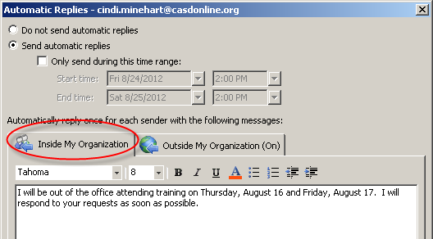
On the Outside My Organization tab, select the Auto-reply to people outside my organization check box, and then type the response that you want to send while you are out of the office. Select whether you want replies sent to My contacts only or to Anyone outside my organization who sends you messages.
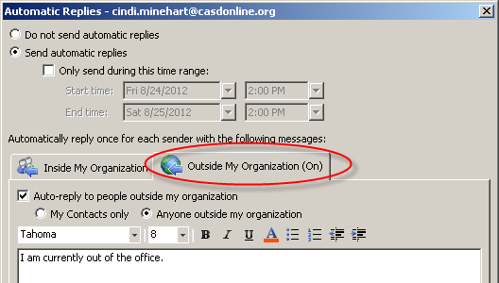
NOTES
• Organization is usually defined as your company and includes people who have an Exchange Server account on your email system.
• If you select My Contacts only, replies are sent only to contacts that exist in your Exchange Server Contacts folder. If the contact exists only in a folder that is a part of an Outlook Data File (.pst), then the auto-reply message isn’t sent.

