LS+F ~ 4 ~ Review ~ Crossword Puzzle Name: _________________________________________
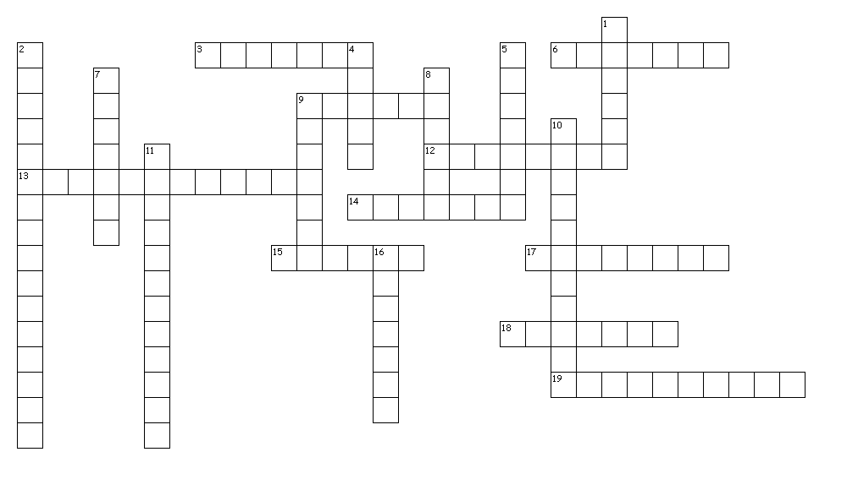

Across:
3. A type of asexual reproduction in which a new organism grows from the body of the parent.
6. The nitrogen base that gets paired up with Adenine in DNA.
9. The 23rd pair of chromosomes in humans determines the person’s _____.
12. The nitrogen base that gets paired up with Guanine in DNA.
13. The process by which organisms can re-grow body parts or reproduce asexually.
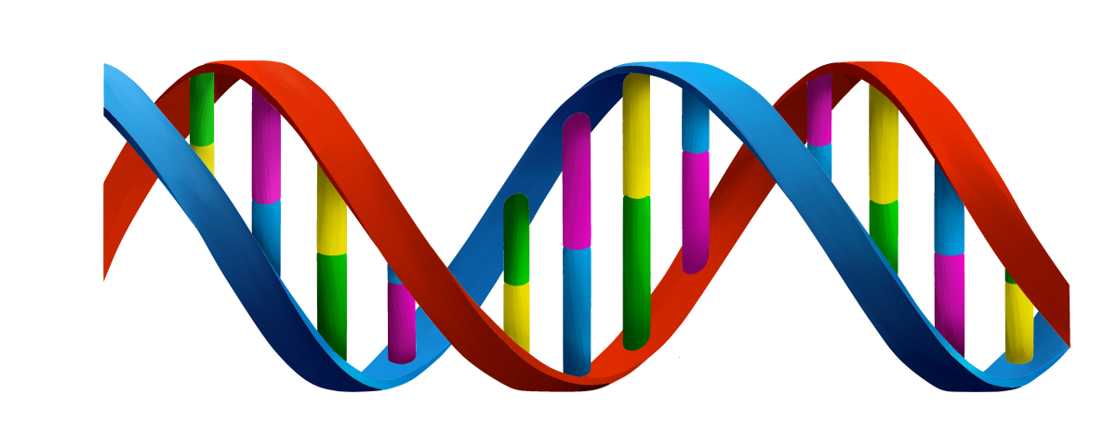
14. A cell that has half the number of chromosomes as body cells; example = sex cells.
15. A type of reproduction in which two sex cells join.
17. Any permanent change in a gene or chromosome of a cell.
18. A new organism is produced from one parent organism.
19. A structure in the nucleus that contains hereditary material.
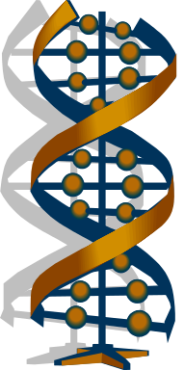
Down:
1. The cell that forms during fertilization.
2. What is the chemical code that is stored in a cell’s hereditary material? _____ acid
4. A section of DNA on a chromosome that contains instructions for making specific proteins.
5. A cell whose similar chromosomes occur in pairs; example = body cells.
7. A large organic molecule made of amino acid bases.
8. The nitrogen base that gets paired up with Adenine in RNA.
9. The nitrogen base that gets paired up with Cytosine in DNA.
10. A type of nucleic acid that carries codes for making proteins from the nucleus to ribosomes is _____ acid.
11. The process by which an organism produces others of its same kind.
16. The nitrogen base that gets paired up with Thymine in DNA.

