NAME: ______________________________ AP Language and Composition Pd. ____
JUSTICE BOOK ANALYSIS PROJECT
ASSIGNMENT GOALS:
1. Analyze and evaluate the ideas about justice by the author of your chosen fictional novel
2. Report your analysis and evaluation to the class

TASKS & POINT VALUES:
____/60 Complete mind-maps for all three sections of the book (you may choose to divide into more than 3 sections)
____/45 plot, characters, symbols/quotes, setting, theme of justice (15 points x 3)
____/15 author biography/stylistic choices (15 points)
____/20 Create a claim-evidence-reasoning paragraph about your justice book
Criteria | EXEMPLARY;  Few or No Flaws/Errors |  | MEETS STANDARD; Contains Some Flaws/Errors | NEEDS IMPROVEMENT; Many Flaws/Errors
Claim: a simple statement that asserts a main point of an argument (a side) |  | 4-5 | 3 | 1-2
Reasoning:  a) the “because” part of an argument and the explanation for why a claim is made  b) the explicit links between the evidence and the claim; the explanation for why a particular piece of evidence is important to the claim and to the argument |  | 4-5 | 3 | 1-2
Evidence: support for the reasoning in an argument; the “for example” aspect of an argument  - Best evidence is text-based, reasonable, and reliable. |  | 4-5 | 3 | 1-2
Style: concise writing (eliminates padding) with colorful language, appropriate spelling, punctuation, grammar, and in-text citations |  | 4-5 | 3 | 1-2

____/35 Discuss your book’s ideas about justice
___/5 – Provide a brief summary of your book.
____/5 – Select a quote (from the attached list) that supports your book’s ideas about justice.
____/15 – Create a visual that includes the quote and demonstrates its ideas through your book (use appropriate spelling, grammar, punctuation).
____/10 – Present your visual to the class and lead a brief discussion.

____/115 TOTAL
Note: only one student per class may read a specific novel. As such, you should identify your top three choices on the option list. Remember, the book/topic you select will become the foundation for your research project/synthesis essay.

MIND-MAPPING METHOD FOR NOTE TAKING
Mind Maps are visual diagrams with lines and pictures that represent ideas and the relationships between ideas.
Mind Maps are great, not only for taking notes, but also for brainstorming and planning. This style of note taking is effective because it is a fast and efficient way of getting down branching ideas with a few words, not lengthy explanations. The use of pictures, color, and creativity is encouraged. Mind mapping is about the process of creating the diagram as much as it is about making studying easier.
To create a Mind Map, first put the main idea in the center of the page. Then branch supporting ideas off of this main ideas. Then, further branch supporting ideas into more specific details. You can continue branching until ideas are fully illustrated.
For your justice book choice, you will create three mind maps (one for each section of the book). Your maps may be created by hand or digitally. All three maps must contain details on plot, characters, symbols/key quotes, setting and the theme of justice. One of the maps (or a separate map) must also contain author biographical details and stylistic choices in the novel.
Sample Map
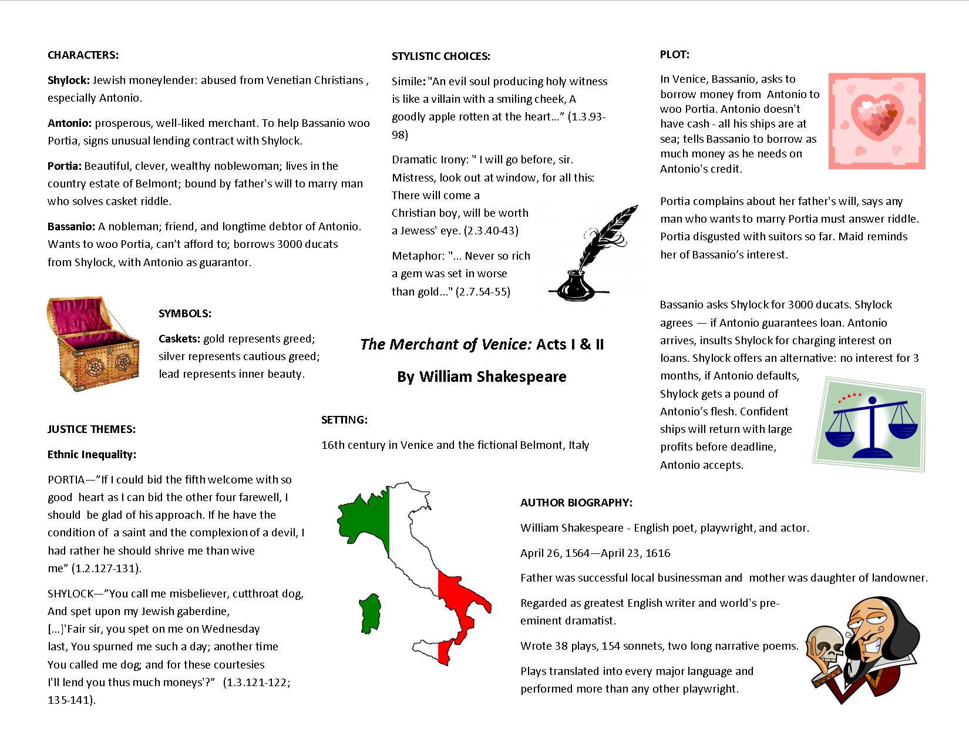

PERTAINING TO EQUAL JUSTICE
1) Select a quote that supports your book’s ideas about justice.
2) Create a visual that includes the quote and demonstrates its ideas through your book.

Overcoming poverty is not a gesture of charity. It is an act of justice. - Nelson Mandela, July 1, 2005
Like slavery and apartheid, poverty is not natural. It is man-made and it can be overcome and eradicated by the actions of human beings." - Nelson Mandela, speaking at the launch of Britain's Make Poverty History campaign.
The law should be a shield for the weak and powerless, not a club for the powerful. - Gov. Roy Barnes, 2004 Equal Justice Conference
Treat people as if they were what they should be, and you help them become what they are capable of becoming. -Goethe
It is the daily; it is the small; it is the cumulative injuries of little people that we are here to protect....If we are able to keep our democracy, there must be once commandment: THOU SHALT NOT RATION JUSTICE.
- Learned Hand, Address at the 75th anniversary celebration of the Legal Aid Society of New York, Feb. 16, 1951
Find out just what any people will quietly submit to and you have found the exact measure of injustice and wrong which will be imposed upon them, and these will continue until they are resisted with either words or blows, or with both. -Frederick Douglass, "West Indian Emancipation", August 4, 1857
"Justice is conscience, not a personal conscience but the conscience of the whole of humanity."
-Alexander Solzhenitsyn
"Equal justice under law is not merely a caption on the facade of the Supreme Court building, it is perhaps the most inspiring ideal of our society. It is one of the ends for which our entire legal system exists...it is fundamental that justice should be the same, in substance and availability, without regard to economic status." -Lewis Powell, Jr., former U.S. Supreme Court Justice
"Concepts of justice must have hands and feet...to carry out justice in every case in the shortest possible time and the lowest possible cost. This is the challenge to every lawyer and judge in America."
-Warren E. Burger, U.S. Supreme Court Justice
"Each time a man stands up for an ideal or acts to improve the lot of others or strikes out against injustice, he sends forth a tiny ripple of hope." -Robert Kennedy
"It is one of the most beautiful compensations of this life that no man can sincerely try to help another without helping himself." -Ralph Waldo Emerson
"Most of the important things in the world have been accomplished by people who have kept on trying when there seemed to be no hope at all." -Dale Carneige
"I am only one; but still I am one. I cannot do everything, but still I can do something; I will not refuse to do the something I can do." -Helen Keller
"No person was ever honored for what he received. Honor has been the reward for what he gave." -Calvin Coolidge
"Wherever a man turns he can find someone who needs him." -Albert Schweitzer
"We make a living by what we get, but we make a life by what we give." -Sir Winston Churchill
"Remember, we all stumble, every one of us. That's why it's a comfort to go hand in hand." -Emily Kimbrough
"Never doubt that a small group of thoughtful, committed citizens can change the world. Indeed, it is the only thing that ever has." -Margaret Mead
"Great things are not done by impulse, but by a series of small things brought together." -Vincent Van Gogh
"This is our special duty, that if anyone specially needs our help, we should give him such help to the utmost of our power." -Cicero
"Service is the rent you pay for room on this earth." -Shirley Chisholm
"One vote, one act or one person can change the course of history "I also thought of the lawyers who daily and tirelessly labor in the vineyards of justice - men and women who represent their clients with integrity, ethics and professionalism, and who think nothing of it as that is what lawyers do. Yet, often these individuals are the very people who change the world." -Martha W. Barnett (ABA President)
"Not everything that is faced can be changed, but nothing can be changed until it is faced." -James Baldwin
"Where justice is denied, where poverty is enforced…neither persons nor property will be safe." -Frederick Douglass
"Do not go where the path may lead; go instead where there is no path and leave a trail." -Ralph Waldo Emerson
"If we do not maintain justice, justice will not maintain us." -Francis Bacon
"Poverty is a veil that obscures the face of greatness." -Kahlil Gibran
"Justice delayed is justice denied." -William Gladstone
"You must be the change you wish to see in the world."-Mahatma Gandhi
"Our Constitution is color-blind . . . In respect of civil rights, all citizens are equal before the law. The humblest is the peer of the most powerful." -John Marshall Harlan
"The failure to invest in civil justice is directly related to the increase in criminal disorder. The more people feel there is injustice the more it becomes part of their psyche." -Wilhelm Joseph, Director, Legal Aid Bureau of Maryland , July, 2003
"It is from numberless diverse acts of courage and belief that human history is shaped. Each time a man stands up for an ideal, or acts to improve the lot of others, or strikes out against injustice, he sends forth a tiny ripple of hope." -Robert F. Kennedy, Speech, South Africa, 1966.
"The future does not belong to those who are content with today, apathetic toward common problems and their fellow man alike, timid and fearful in the face of bold projects and new ideas. Rather, it will belong to those who can blend passion, reason and courage in a personal commitment to the great enterprises and ideals of American society." -Robert F. Kennedy
"Throughout history, it has been the inaction of those who could have acted, the indifference of those who should have known better, the silence of the voice of justice when it mattered most, that has made it possible for evil to triumph. " -Haile Selassie (1892-1975), Ethiopian political leader Opening a special session of the UN General Assembly which succeeded the League of Nations and the UN, 4 Oct 1963.
"Concepts of justice must have hands and feet . . . to carry out justice in every case in the shortest possible time and the lowest possible cost. This is the challenge to every lawyer and judge in America. "
-Warren E. Burger (1907-1995), U.S. supreme court justice Address to the American Bar Association, 12 Feb 1978.
"From the very beginning, our state and national constitutions and laws have laid great emphasis on procedural and substantive safeguards designed to assure fair trials before impartial tribunals in which every defendant stands equal before the law. This noble ideal cannot be realized if the poor man charged with crime has to face his accusers without a lawyer to assist him." -JUSTICE HUGO L. BLACK, U.S. SUPREME COURT, Gideon v. Wainwright (1963)
"The only thing less popular than a poor person these days is a poor person with a lawyer." -Jon Asher, Director, Colorado Legal Services
"The first duty of society is justice." - Alexander Hamilton
"Without equal access to the law, the system not only robs the poor of their only protection, but it places it in the hands of their oppressors the most powerful and ruthless weapon ever created." - Reginald Heber Smith, Justice and the Poor, 1919
"There can be no equal justice where the kind of trial a man gets depends on the amount of money he has."
- former U.S. Supreme Court Justice Hugo Black, 1964
"How can it be, in a country as strong and rich as this one, that tens of thousands of Americans who need legal representation are turned away every year because their government won't support the very program designed to help them?" - Senator Ron Wyden (D-Oregon)
"The movement continues towards the goal of 'equal justice' and its pathway -- unfettered access." - Alex Forger, former LSC President
"But more than anything else, we have learned that legal assistance for the poor, when properly provided, is one of the most constructive ways to help them help themselves." - President Richard Nixon, 1974
"Equality before the law in a true democracy is a matter of right. It cannot be a matter of charity or of favor or of grace or of discretion." - U.S. Supreme Court Justice Wiley Rutledge, sometime in the mid-20th century
"Service is the rent we pay for living. It is not something to do in your spare time; it is the very purpose of life." - Marion Wright Edelman, Founder, Children's Defense Fund
"Equal justice under law is not merely a caption on the facade of the Supreme Court building, it is perhaps the most inspiring ideal of our society. It is one of the ends for which our entire legal system exists...it is fundamental that justice should be the same, in substance and availability, without regard to economic status." - Lewis Powell, Jr., U.S. Supreme Court Justice (ret.), During his tenure as President of the American Bar Association
"To withhold the equal protection of the laws, is to undermine the entire structure and threaten it with collapse.... To deny law or justice to any person is, in actual effect, to outlaw them by stripping them of their only protection. It is for such reasons that freedom and equality of justice are essential to a democracy and that denial of justice is the short cut to anarchy. " - Reginald Heber Smith, 1919
"We at the Bureau have the most exciting and satisfying jobs in the world. In a society that stresses individual achievement - where you pull yourself up by your bootstraps - the Legal Aid Bureau helps those without boots. By providing access to justice to tens of thousands of Marylanders each year, Legal Aid attorneys and support staff bring equity and stability to society." - Wilhelm Joseph, Director of the Legal Aid Bureau in Maryland
"No organization of lawyers can long survive which has not for its primary object the protection of the public. Laws are not made for the benefit of the few. They should be those rules of conduct prescribed by the people themselves, through their properly constituted representatives, for the equal protection of the rights of society in the aggregate. They should apply with equal force to the rich and poor alike, and to the protection of those rights the legal profession must apply itself with integrity, industry and faith." - Roberts P. Hudson, first president of the State Bar of Michigan
"Equal justice is a dream. We must make it a reality." - John Cummiskey (a Michigan hero)
"You make a living by what you get; you make a life by what you give." - Winston Churchill
"Injustice anywhere is a threat to justice everywhere." - Rev. Martin Luther King, Jr.
"These are the times for real choices and not false ones. We are at the moment when our lives must be placed on the line if our nation is to survive its own folly. Every man of humane convictions must decide on the protest that best suits his convictions, but we must all protest." - Rev. Martin Luther King, Jr. 1968
"If we are to keep our democracy, there must be one commandment: thou shalt not ration justice." - Judge Learned Hand

