APA Citations
Books:
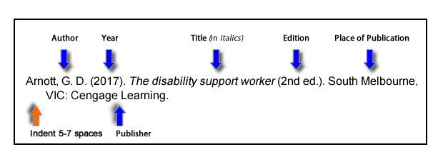
Websites:
Last, F. M. (Year, Month Date Published). Article title. Retrieved from URL
Satalkar, B. (2010, July 15). Water aerobics. Retrieved from http://www.buzzle.com
Cain, K. (2012, June 29). The Negative effects of Facebook on communication. Social Media Today RSS. Retrieved from http://socialmediatoday.com

PDF:
Author. (Year). Title of Book (edition if not first) [PDF file]. Place of Publication: Publisher. Retrieved from http://www.someaddress.com/full/url/ or doi:0000000/000000000000 or http://dx.doi.org/10.0000/0000
American Psychological Association. (2010). Publication Manual of the American Psychological Association (6th ed.) [PDF file]. Washington, DC: Author. Retrieved from https://is.muni.cz/el/1423/jaro2013/ZUR537/um/APA.pdf

Images:
Artist Last Name, First Initial. Second Initial. (Year). Title of the artwork [Format]. Retrieved from URL.

Figures:
Figure X. Descriptive phrase that serves as title and description. Reprinted [or adapted] from Title of Website, by Author First Initial. Second Initial. Last Name, Year, Retrieved from URL.

