Name: ________________________________ Period:_____
This I Believe Visualization
Directions: Review your belief statements, identify a central idea, and then create a visual on poster paper to help organize your beliefs. Your visualization must include an image, the central idea, belief statements, and the stories related to the beliefs.
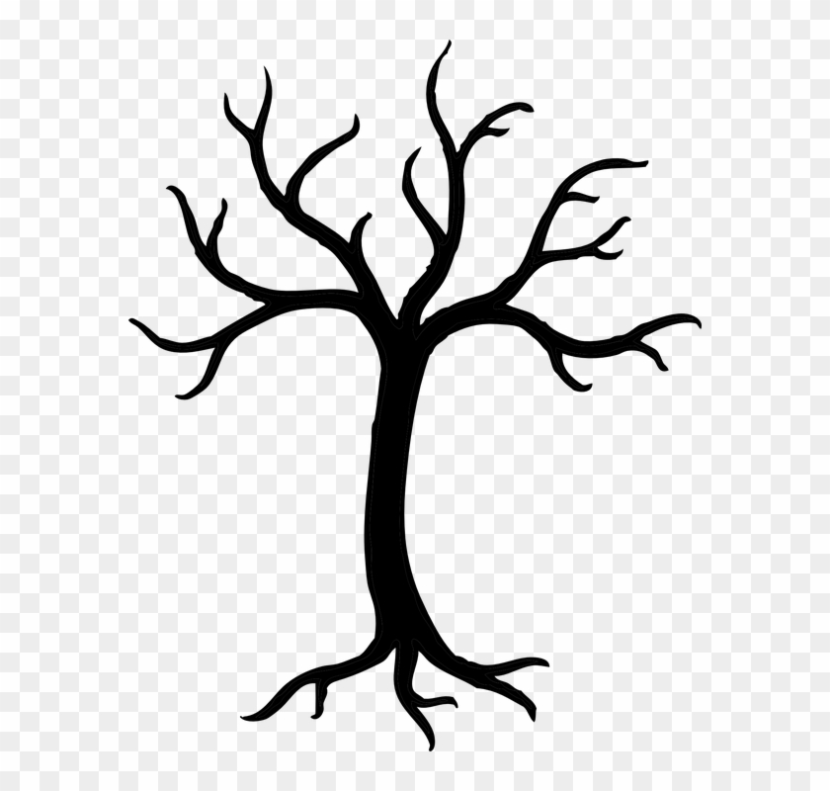
DETERMINATION
The power of education

Failure is the key to success
Hard work is a necessity
Changed my college major
Changed careers
College Scholarship
Improved job, life-style options
Corporate Job
Teaching Job

Rubric
The TIB visual includes:
____/3 An image
____/3 A central idea
____/3 The student’s belief statements
____/3 The stories that connect to the belief statements
____/3 Appropriate spelling, capitalization, punctuation

____/15 TOTAL

