English 11
Course Syllabus
General Information
Location: A304
Teacher: Mrs. Yosler
E-mail: beth.yosler@casdonline.org
Website: www.chambersburg.k12.pa.us/education/staff/staff.php?sectionid=3274&
Meeting Times: Before school (office hours -7:20-7:50 am); after school (until 3:30);
periods 4; and, activities period
Note: Please make an appointment if you need to meet with me.

Course Description
- The course is designed to improve overall writing, reading, listening, and speaking skills.
- We will explore drama, novels, short stories, poetry, and nonfiction essays and texts through extensive reading assignments, frequent writing assignments emphasizing critical analysis, lecture, small-group activities, and seminar discussion.
- Authors will be studied for structure, stylistic devices, and key themes.

Required Materials
- Textbook or novels (when needed)
- Access to a computer with a word processor and Internet capabilities (Note: All students will be expected to access the teacher’s school website and download material for assignments. Any student without home internet access will be expected to access library computers during a study hall or before/after school to properly acquire the required materials.)
- Binder/folder with notebook paper (dedicated to this course)
- 3”x5” notecards (for vocabulary)
- Pencil/pen/highlighter
- SSR book

Late Policy
Late work will not receive full credit unless extenuating circumstances exist. Late work will be penalized a 50% deduction and will only be accepted for 5 school days past the due date.

Tardiness
Class will be in session once the bell has rung, and any student who arrives after the bell will be considered tardy to class. Keep in mind that class tardiness will affect Midterm and Final Exam exemption.
- First Offense – Verbal Warning
- Second Offense – Verbal Warning, Loss of Classroom Participation Points
- Third Offense – 60 Minutes, Loss of Classroom Participation Points, Call/e-mail Home
- Fourth Offense – 90 Minutes, Loss of Classroom Participation Points, Parent/Guardian Conference
- Fifth Offense – Office Referral (Note: Severe disruptions will result in an Immediate office referral)

Absences and Make-up Work
- Absences must be excused to receive credit on missed work.
- All unexcused absences will result in a zero for work due the day of the absence, as well as work that was assigned the day of the absence (as noted in the student handbook).
- All work must be made up within the number of school days missed (i.e., if you miss two days, the make-up work is due two days after your return to school).
- If you are legitimately absent when a paper/project is due, it will be due upon the day of your return. If you are legitimately absent on a test day, you must take the test on the day of your return.
- All work must be completed from unexcused absences, regardless of the zero given on the missed work.

Grading
- Exams
- Homework
- Quizzes
- Classwork (includes assignments, participation, behavior, etc.)
- Projects
- Class Discussions

CASHS Grading Scale
- 92-100 A (excellent)
- 83-91 B (above average)
- 74-82 C (average)
- 65-73 D (below average)
- 0-64 F (failing)

Classroom Rules
- Expectations for student behavior, grades and attendance are outlined in the student handbook. These expectations will be enforced in this classroom. Additionally:
  - Take bathroom/water breaks before class begins. Only one student may leave the classroom at a time for urgent breaks and MUST sign-out/sign-in.
  - Do NOT sharpen pencils, dispose of trash, turn-in papers, leave your seat, etc. during active teaching. These tasks can be done at the beginning/end of class.
  - Remain in your seat and wait for dismissal at the end of class.
  - Do NOT talk when Mrs. Yosler is teaching or another student(s) is presenting. RAISE your hand if you have a question/comment.
- Students will be expected to come to class prepared, to respect everyone, and express themselves in an appropriate manner.
- At the start of class, students will be expected to take out homework (if any) and materials needed for class.
- At the end of class, students will be expected remain seated and focused until dismissed by the teacher.
- Most assignments can be revised for additional credit, but must be completed within one week of when the assignment is returned to the student. A revision plan must be coordinated with the teacher. Significant changes must be made for the assignment to be re-graded.
- All assignments will be considered individual assignments unless otherwise specified by the teacher.
- Plagiarism and cheating are considered a serious offense, and will be handled as outlined in the academic dishonesty agreement.

Saphire Suite
Saphire is a great tool for students and their parents/guardians to stay up to date with grades, online. It will be updated at least once a week. Students are also encouraged to keep track of grades on paper. Should you find a discrepancy, please contact the teacher for help in solving the issue.

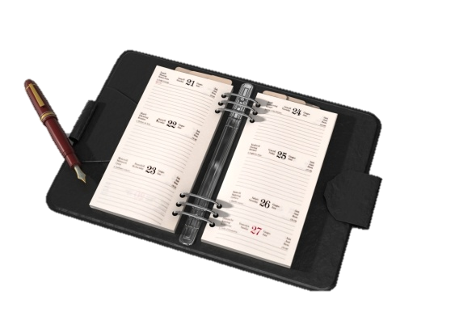
Laptop Computer and Printer Usage
Students will be utilizing computers on a regular basis; therefore, they must follow the guidelines listed below to ensure computer quality for the entire year:
- Log on to the assigned computer when and only when instructed to do so.
- Notify the teacher immediately should you notice any damage or issues with your computer.
- Use the printer only for English assignments and only with permission from the teacher.
- Any student who is utilizing the computers for activities that are in violation of the acceptable use policy, will be prohibited from using computers in this class.
- At the end of a class period, log off of computers.

English 11 Contract
By signing my full name below, I acknowledge that I have read and understand the expectations, procedures, rules, and responsibilities of English 11. I assert that I will try my best to complete my work on time and to the best of my ability. Also, I pledge that I will seek to improve my reading, writing, speaking, and listening skills during this course in order to prepare myself for the future. Should I have questions or concerns, I will seek out help immediately from Mrs. Yosler.

______________________________________________________ ________________________
Student Signature Date

_____________________________________________________________________________________________________
Student Email Address

______________________________________________________ ______________________
Parent/Guardian Signature Date

_____________________________________________________________________________________________________
Parent/Guardian Email Address

Please sign and return this page, fully completed, to Mrs. Yosler no later than August 30, 2019 for 5 homework points.

**Should you have any further information you would like to share, please either contact me using the information above or include a note below.

