Name ________________________________________ Algebra 1 Keystone Practice
1. Evaluate the following expression for m = 9.
$\sqrt{4m}+5$
A. 7
B. 11
C. 1
D. 17

2. Simplify the following expression.

$8^{4}∙8^{3}$

A. $3(12)$
B. $8^{7}$
C. $8^{12}$
D. $8(7)$

3. Simplify: $7\sqrt{54}-2\sqrt{24}$

A. 25$\sqrt{6}$
B. 9$\sqrt{6}$
C. 17$\sqrt{6}$
D. 55$\sqrt{6}$

4. The expression below should be further simplified for which value of x?

$\sqrt{85x}$

A. 185
B. 53
C. 74
D. 3

5. Factor the following polynomial completely.

$-0.9x^{2}-4.5x+12.6$

A. $-0.9\left(x+7\right)\left(x+2\right)$
B. $0.9\left(x+7\right)\left(x-2\right)$
C. $-0.9\left(x^{2}+5x-14\right)$
D. $-0.9\left(x+7\right)\left(x-2\right)$
6. Order the following from least to greatest: $\frac{2}{3}, 0.56, 14\%, 77\%, \frac{1}{2}$

A. $\frac{1}{2}, \frac{2}{3}, 0.56, 14\%, 77\%$
B. 14%, $\frac{1}{2}$, 0.56, $\frac{2}{3}$, 77%
C. 14%, $\frac{2}{3}$, $\frac{2}{3}$, 77%, 0.56
D. 77%, $\frac{2}{3}$, 0.56, $\frac{2}{3},$14%

7. The Rose Theater seats 146 people, and the theater is hosting a play for 8 nights. If the theater is at about 80% capacity for each night of the play, approximately how many people will attend the play?

A. 1168
B. 934
C. 123
D. 1176

8. Mick is participating in a cross county bike race. Every 2 hours he travels between 38 and 50 miles. Four hours ago, Mick had traveled 52 miles from the start of the race. Which is a reasonable measure of Mick’s total distance?

A. 158 miles
B. 142 miles
C. 166 miles
D. 118 miles

9. Evaluate the following expression when n = 2.

$2\left|3-6n\right|+\left|2\right|$

A. 20
B. 16
C. $-$20
D. $-$16

10. Simplify the following expression: $\frac{3x^{3}+18x^{2}-15x}{3x}$

A. $3x^{3}+18x^{2}-15x$
B. $x^{2}+6x-5$
C. $19x^{2}+5x$
D. $x^{2}+15x-12$

11. Simplify: $\left(7x^{2}+6x+3\right)-\left(2x^{2}-3x+7\right)$

A. $9x^{2}+9x-4$
B. 5x^2 +9x -4
C. $9x^{2}+9x-10$
D. $5x^{2}+3x-4$

12. Factor the following polynomial.

$16x^{2}+20x$

A. $4x\left(4x+20\right)$
B. $4x^{2}\left(4x+5\right)$
C. $4x\left(4x+5\right)$
D. $4(4x+5)$

13. Factor the following expression completely.

$x^{4}-1$

A. $\left(x-1\right)\left(x^{3}+1\right)$
B. $\left(x-1\right)\left(x+1\right)\left(x^{2}+1\right)$
C. $\left(x-1\right)\left(x+1\right)\left(x-1\right)\left(x+1\right)$
D. $\left(x^{2}-1\right)\left(x^{2}+1\right)$

14. First State Bank has a drive-thru for customers who are making withdrawals or deposits. The drive-thru is open 5 days a week for 8 hours per day. Every hour, the bank serves 4 to 8 drive-thru customers. If two-thirds of drive-thru customers make a deposit, then about how many drive-thru customers will make deposits in one work week?

A. 160 drive-thru customers
B. 80 drive-thru customers
C. 20 drive-thru customers
D. 224 drive-thru customers

15. Simplify: $4(13-\left|-9+4\right|)-{\left|9-7\right|}^{2}$

A. $-$4
B. 28
C. 43
D. 16

16. Evaluate the following expression when r = 3 and t = 2.

${\left(2∙r^{t}\right)}^{-2}$
A. $\frac{4}{81}$
B. $-36$
C. $\frac{1}{2}$
D. $\frac{1}{324}$

17. Simplify: $\left(6x^{2}-8x-1\right)\left(2x-5\right)$

A. $12x^{3}-46x^{2}+38x-5$
B. $12x^{3}-14x^{2}-42x+5$
C. $12x^{3}+14x^{2}-42x-5$
D. $12x^{3}-46x^{2}+38x+5$

18. What is the greatest common factor (GCF) of the monomials shown below?

$14x^{3}y^{3}z^{2}$ $22xy^{2}$

A. $2xy^{2}$
B. $2x^{3}y^{3}z^{2}$
C. $154x^{4}y^{5}z^{2}$
D. $154x^{3}y^{3}z^{2}$

19. Look at the two monomials below.

$6u^{2}v^{2}w^{3}$ $10u^{3}vw^{4}$

What is the least common multiple (LCM) of the monomials shown above?

A. $30u^{3}v^{2}w^{4}$
B. $30u^{5}v^{3}w^{7}$
C. $2u^{5}v^{3}w^{7}$
D. $2u^{2}vw^{3}$

20. Simplify the following expression: $\frac{2x^{2}+12x+16}{2x^{2}+4x-16}$

A. $\frac{2x+4}{x+2}$ C. $\frac{x-2}{2x-1}$
B. $\frac{x+2}{x-2}$ D. $\frac{x-2}{x+4}$

21. Alena is packing a box that has a height of one inch more than twice the width and a length of two inches less than three times the width, as shown in the diagram below.

$2x+1$

$x$
3$x-1$

A. Write a polynomial expression, in simplified form, that represents the volume of the box.

B. Alena packs another box. This box has a square base with an area of $9x^{2}-6x+1$ square inches. Write an expression to represent one side length of the base.

C. Alena has a third box whose height is the same as the first box, but whose volume is $6x^{3}+15x^{2}+6x$ cubic inches. Determine how much wider and longer this box is than the first box. Assume that the length of the box has a larger coefficient than the width. Show all of your work. Explain why you did each step.

22. Solve the inequality: $24<-2\left(x-3\right)<36$

A. $-26<x<-15$
B. $-21<x<-9$
C. $-21<x<-15$
D. $-15<x<-9$

23. Solve the inequality: $\left|3x+4\right|<8$

A. $x<\frac{4}{3}$
B. $-\frac{4}{3}<x<4$
C. $-4<x<\frac{4}{3}$
D. $-8<x<\frac{4}{3}$

24. Which of the following graphs shows the solution set for the inequality? $\left|2x+4\right|>2$

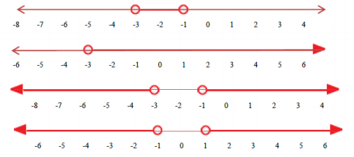
A.

B.

C.

D.

25. Tom can spend up to $40 for gasoline and a carwash at a service station. The carwash will cost $6.00, and the gasoline costs $4.50 per gallon. The inequality below can be solved for g, the number of gallons of gasoline Tom can buy.
$4.5g+6≤40$

Which of the following is a true statement?

A. Tom can buy over 10 gallons of gasoline.
B. Tom can buy at most 7 gallons of gasoline.
C. Tom can buy 6 gallons, but not 7 gallons.
D. Tom can buy 7 gallons of gasoline, but not 8 gallons.

26. Which of the following graphs shows the solution to the inequality? $-\frac{1}{2}x-4<0$

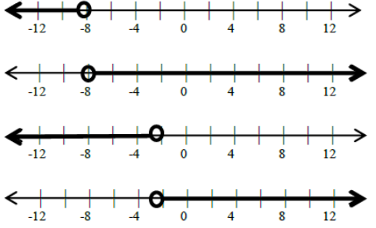
A.

B.

C.

D.

27. Which graph represents the following system of inequalities? $\left\{\begin{aligned}y>\frac{1}{3}x-2 \\ y≤-2x-1\end{aligned}\right\}$
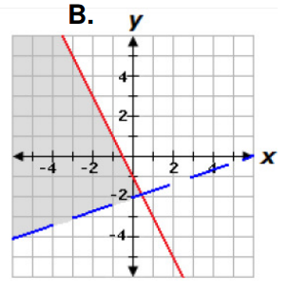
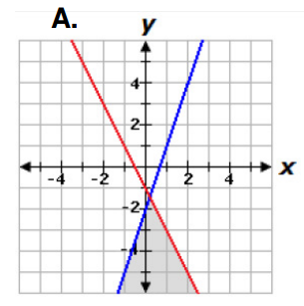

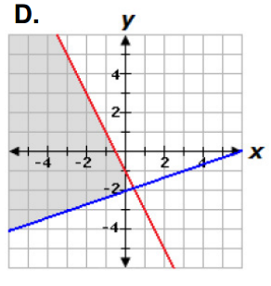
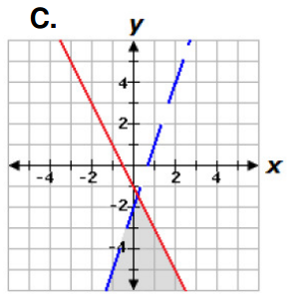

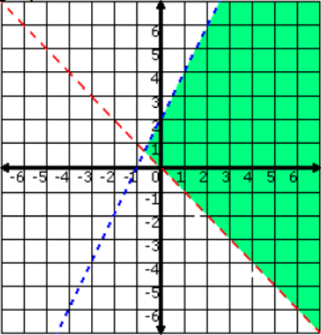
28. Choose the system of inequalities that best matches the graph below.

A. $y<2x+2$ C. $y<2x$
$y<x$ $y≤x$

B. $y≤x-2$ D. $y<2x+2$
$y>-x$ $y>-x$

29. At an ice-cream parlor, ice-cream cones cost x dollars each and sundaes cost y dollars each. The total cost of 4 cones and 3 sundaes is more than $20. The total cost of 5 cones and 1 sundae is less than 16. This situation can be represented by which of the following system of inequalities?

A. $4x+3y>20$ B. $4x+3y<20$ C. $4x+3y≥20$ D. $4x+3y≤20$
$5x+y<16$ $5x+y>16$ $5x+y≤16$ $5x+y≤16$

30. Choose the system of inequalities that best matches the graph below.

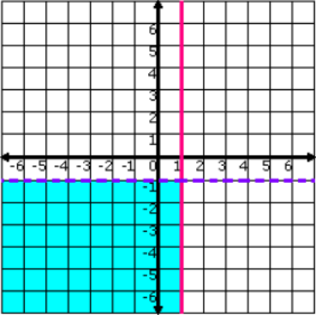
A. $y<-1$ C. $y<1$
$x≤1$ $x≤-1$

B. $y≤-1$ D. $y>-1$
$x<1$ $x≥1$

31. Blade-Z manufactures roller blades. The production facility has fixed costs of $300 a day and total production costs of $3,300 per day at an output of 100 pair of skates per day. Which of the following equations represents the daily production cost for Blade-Z based on the number of skates manufactured?

(Let $C(x)$ represent the daily production cost and $x$ represent the number of pairs of skates manufactured.)

A. $C\left(x\right)=33x+300$
B. $C\left(x\right)=30x-300$
C. $C\left(x\right)=30x+300$
D. $C\left(x\right)=33x$

32. Meghan is completing her chemistry and geometry homework. Each chemistry assignment has $x$ problems, and each geometry assignment has $y$ problems. She must complete a total of 81 problems. The equation below describes the relationship between the number of chemistry problems and the number of geometry problems.
$5x+3y=81$

The ordered pair $\left(9,12\right)$ is a solution of the equation. What does the solution $(9,12)$ represent?

A. Each chemistry assignment contains 9 problems and each geometry assignment contains 12 problems.

B. Meghan must complete 3 more geometry assignments than chemistry assignments.

C. Meghan spent 9 minutes on her chemistry homework and 12 minutes on her geometry homework.

D. Meghan must complete 9 more chemistry assignments than geometry assignments.

33. A rental car company charges a base fee of $50.47 plus $0.50 per mile driven. If $x$ represents the number of miles driven, which of the following equations could be used to find $y$, the total cost of the bill?

A. $y=\$0.80x+\$50.47$
B. $y=\$50.47x+\$0.50$
C. $y=\$50.97x$
D. $y=\$0.50x+\$50.47$

34. Solve for$x$. $9x-5=6x+9x+10$

A. $x=\frac{5}{18}$
B. $x=-\frac{5}{18}$
C. $x=\frac{5}{2}$
D. $x=-\frac{5}{2}$

35. The steps John used to solve an equation are shown below.

Solve: $0.4x+5+0.2x=17$

Step 1: $0.4x+0.2x+5=17$
Step 2: $0.6x+5=17$
Step 3: $0.6x=12$
Step 4: $x=20$

Which properties justify Step 1 and Step 3?

A. Step 1: Distributive Property
Step 3: Multiplicative Property of Equality

B. Step 1: Distributive Property
Step 3: Additive Property of Equality

C. Step 1: Commutative Property of Multiplication
Step 3: Multiplicative Property of Equality

D. Step 1: Commutative Property of Addition
Step 3: Additive Property of Equality

36. What is the solution to the linear equation? $\frac{3}{4}x-5=10$

A. $x=\frac{15}{4}$ C. $x=\frac{20}{3}$

B. $x=\frac{45}{4}$ D. $x=20$

37. Which is a correct step in solving the following equation for$x$? $-1.75+2\left(2-x\right)=0$

A. $2\left(2-x\right)=-1.75$ C. $-2x=1.75-4$

B. $4-x=1.75$ D. $x=-2.25÷2$

38. Use linear combination to find the solution to the system of equations: $5x+y=10$
$2x-3y=4$
A. $x=14, y=8$
B. $x=2, y=0$
C. $x=-4, y=4$
D. $x=-4, y=30$

39. Use substitution to solve for $x$ in the system of equations: $11x+2y=30$
$4x+y=9$
A. $x=4$
B. $x=10$
C. $x=-4$
D. $x=8$

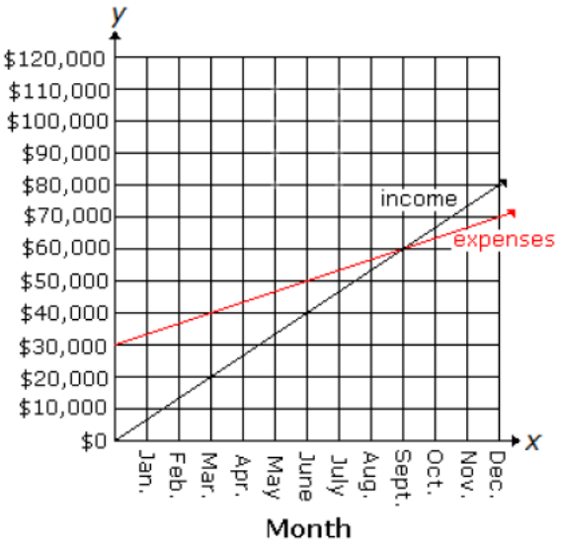
40. The equations representing income and expenses for Tom’s candy store are shown in the graph below.

Income: $20,000x-3y=0$
Expenses: $10,000x-3y+90,000=0$

Let $x$ represent the month and $y$ represent the
amount in dollars. In which month were the
store’s expenses greater than it’s income?

A. November
B. September
C. August
D. October

41. Reid and Sharon work in two different clothing stores. Reid’s store sells shirts for $14 each and pants for $39 each. Sharon’s store sells shirts for $12 each and pants for $44 each.

One day, Reid sold $145 worth of shirts and pants, and Sharon sold the same number of shirts and pants, but her sales were worth $156. When $x$ is the number of shirts sold and $y$ is the number of pants sold, the situation can be modeled by a system of linear equations.

A. Write the two equations that form the system of equations which models the information above.

B. Use the equations found in Part A to determine how many shirts and pants Reid sold.

C. On another day, Reid and Sharon each sold 5 shirts and 2 pants. Who sold the greater dollar amount of merchandise?

42. A researcher made the following graph showing the number of hours per week that people exercise versus the number of pounds that they are overweight.
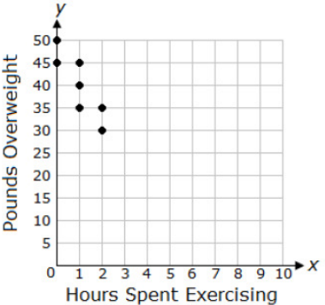

Predict the number of pounds overweight someone would be if they spend 3 hours per week exercising.

A. 30 B. 25 C. 20 D. 10

43. The table below shows how the amount remaining to pay on a bank loan is changing over time.
Time (months) | Amount Remaining (dollars)
0 | 5,000
1 | 4,800
2 | 4,600
3 | 4,400
4 | 4,200

Let $x$represent the time in months, and let $y$ represent the amount in dollars remaining to pay. Which equation describes the relationship between $x$ and $y$?

A. $y=-800x+5,000$
B. $y=-200x+5,000$
C. $y=200x-5,000$
D. $y=800x-5,000$

44. Find the domain of the radical function graphed below.
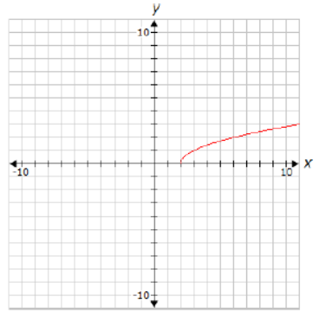

A. $x≥0$ B. All real numbers C. $x>1$ D. $x≥2$

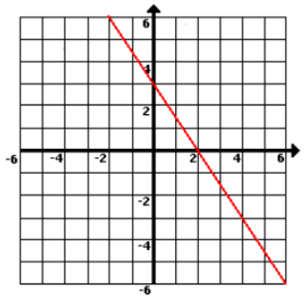
45. Which of the following functions matches the graph?

A. $f\left(x\right)=-\frac{3}{2}x+3$
B. $f\left(x\right)= -\frac{2}{3}x+2$
C. $f\left(x\right)=\frac{2}{3}x-2$
D. $f\left(x\right)=\frac{3}{2}x-3$

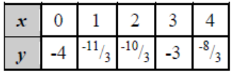
46. Which graph corresponds to the table?

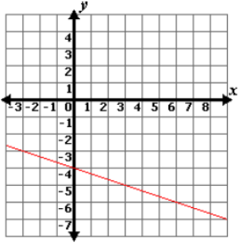
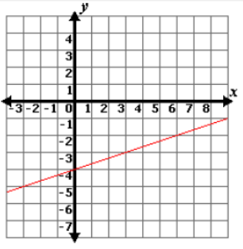
A. B.

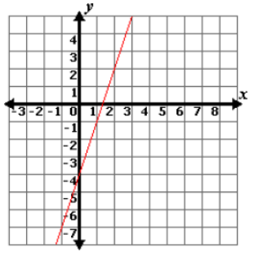
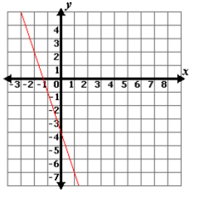
C. D.

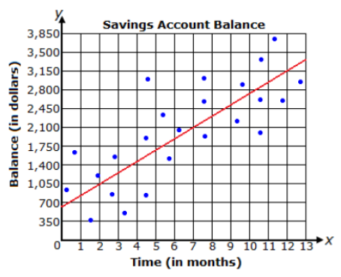
47. The graph shows a line of best fit for data collected on the savings account balances of several students in relation to the time money has been put into the accounts. What is the equation for the line of best fit?

A. $y=-\frac{3}{5}x+630$
B. $y=210x+630$
C. $y=-210x+630$
D. $y=\frac{3}{5}x+630$

48. In P.E. class, the students recorded their number of heartbeats after exercising. Below is a chart with the number of heartbeats recorded after 30, 50, and 70 seconds of exercise.

What is the rate of change of the data in heart beats per minute?
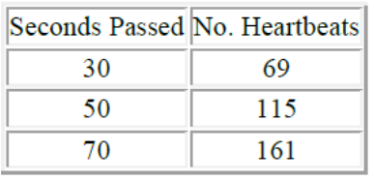
A. 138
B. 230
C. 92
D. 115

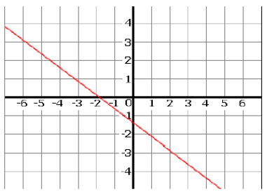
49. Which equation is graphed to the right?

A. $4x+3y=2$
B. $4x+3y=-2$
C. $3x-4y=-5$
D. $3x+4y=-5$

50. Sylvester’s Pizzeria has a party room to accommodate pizza parties. They have rectangular
tables that can be placed together end-to-end to sit large groups of people together. Some sample seating arrangements are shown below.

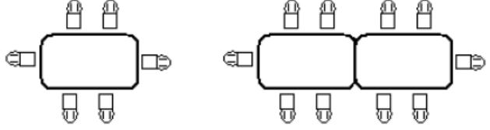

Which of the following expressions can be used to determine the number of people who can sit as a group if $t$tables are joined together?

A. $4\left(t+1\right)$
B. $3\left(t+1\right)$
C. $2\left(2t-1\right)$
D. $2(2t+1)$

51. Which scatterplot most likely has a line of best fit represented by: $y=2x+1$?
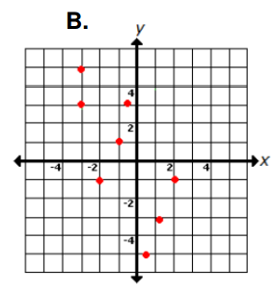
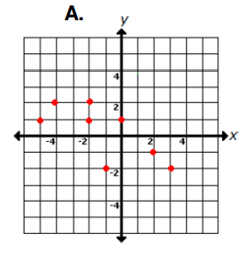

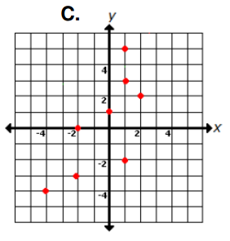
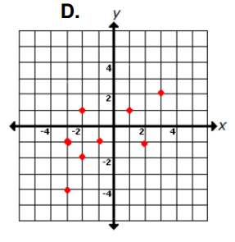

52. Which of the following relations is a function?

A. $\left(1, 4\right), \left(-4, 6\right), \left(1, 3\right), \left(-8, 2\right)$
B. $\left(1, 4\right), \left(-4, 2\right), \left(6, 1\right), \left(-8, 2\right)$
C. $\left(1, 0\right), \left(-4, 3\right), \left(6, 1\right), \left(-4, 5\right)$
D. $\left(6, 1\right), \left(-4, 4\right), \left(1, 1\right), \left(6, 2\right)$

53. What is the equation of the line that passes through $\left(-4, 5\right)$and has a slope of $\frac{1}{3}$ ?

A. $x+3y=11$
B. $y=\frac{1}{3}\left(x+4\right)$
C. $x+3y=9$
D. $y=\frac{1}{3}x-\frac{11}{3}$

54. A university completed a study to determine what effect drinking coffee had on hours of sleep. After studying 1000 people, they concluded that, for ever three cups of coffee, a person sleeps two hours less.

Which of the following graphs shows this linear relationship?
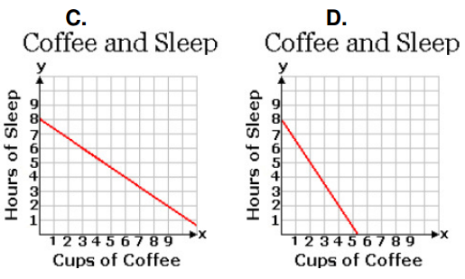
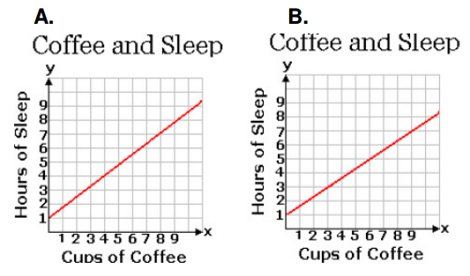

55. What is the domain of the relation plotted on the graph below?
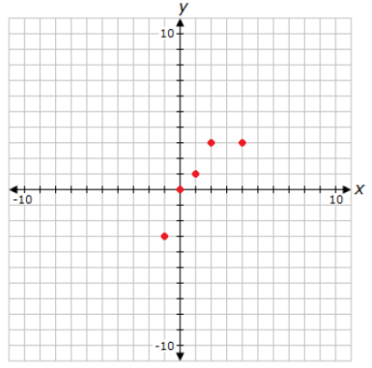

A. $\left\{-3, 0, 1, 3\right\}$
B. $\left\{-1≤x≤4\right\}$
C. $\left\{-3≤x≤3\right\}$
D. $\{-1, 0, 1, 2, 4\}$

56. A company noticed a linear relationship between the price of a luggage set and the number of luggage sets sold. At $100, the company sold 1,000 sets. When the company raised the price to $120, they sold 800 sets. Which equation relates the price of the luggage sets to the total number of luggage sets sold?

A. $y-100=10\left(x-100\right)$
B. $y-1000=10\left(x-100\right)$
C. $y-100=-10\left(x-1000\right)$
D. $y-1000=-10\left(x-100\right)$

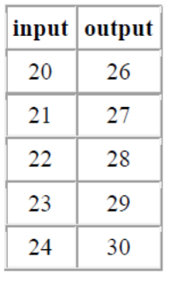
57. According to the table, what is the range of the data?

A. 27, 29, 31, 33, 35
B. 20, 21, 22, 23, 24
C. 26, 27, 28, 29, 30
D. 20, 19, 18, 17, 16

58. The first five terms of a sequence are given below.

15, 24, 33, 42, 51, …

Determine which of the following formulas gives the $n^{th}$ term of this sequence.

A. $7+8n$
B. $24-9n$
C. $23-8n$
D. $6+9n$

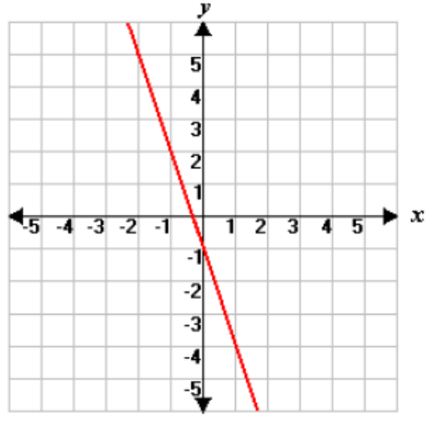
59. Which of the following equations matches the graph?

A. $y= -\frac{1}{3}x-1$
B. $y=-3x-1$
C. $y=3x+1$
D. $y=\frac{1}{3}x+1$

60. Megan is going on a long distance road trip. She drives for 19 miles before being able to travel at a constant speed using cruise control. The equation $y=68x+19$ can be used to find her total distance traveled. If $y$ is the total number of miles driven, and $x$ is the number of hours driven after reaching 19 miles, which statement best describes the rate of change in the distance traveled?

A. For every hour, she will drive 87 miles.
B. For every hour, she will drive 68 miles.
C. For every two hours, she will drive 68 miles.
D. For every 19 hours, she will drive 87 miles.

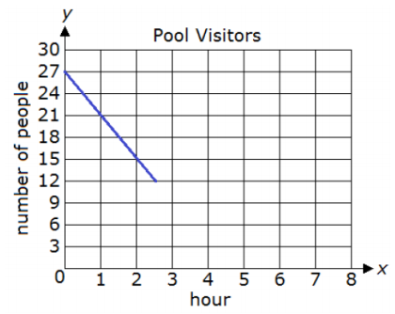
61. Tom recorded how many people were at the community pool over a few hours and displayed some of the data on the graph below. Assume the pattern continues.

A. Write an equation to find how many people were at the pool $(y)$ based on the hour $(x)$.

B. Use the equation found in Part A to determine after how many hours there will be zero people at the pool. Show all your work. Explain why you did each step.

C. Explain what the slope of the graph means in the situation.

62. Maria is completing a survey to use for a project in her statistics class. She went to two local stores and asked 10 randomly selected patrons to give their ages. The data she collected is shown below.
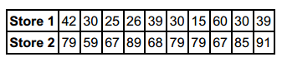

How does the mode of Maria’s data at Store 1 differ from the mode at Store 2?

A. The mode of Maria’s data at Store 1 is less than the mode at Store 2 by 28.
B. The mode of Maria’s data at Store 1 is greater than the mode at Store 2 by 28.
C. The mode of Maria’s data at Store 1 is less than the mode at Store 2 by 49.
D. The mode of Maria’s data at Store 1 is greater than the mode at Store 2 by 49.

63. Michael and Stanley both work for the same company in sales. Their supervisor announced that the salesperson with the highest cumulative sales numbers over the last six months will receive a bonus. Below is a table showing the worth of the goods sold by Michael and Stanley for each of the last six months.

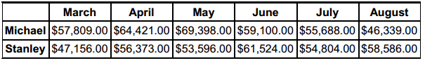

How does the range of Michael’s sales numbers compare to the range of Stanley’s sales numbers?

A. The range of Michael’s sales numbers is greater than the range of Stanley’s sales numbers by $5,677.00.
B. The range of Michael’s sales numbers is greater than the range of Stanley’s sales numbers by $8,691.00.
C. The range of Michael’s sales numbers is less than the range of Stanley’s sales numbers by $8,691.00.
D. The range of Michael’s sales numbers is less than the range of Stanley’s sales numbers by $8,883.00.

64. A company conducted a survey with 6,225 people to find out the fastest speed they have driven in certain cities. Based on the table below, what is the difference between the sample’s interquartile range and the population’s interquartile range?

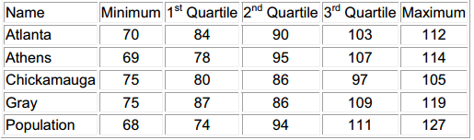

A. There is a difference of 19.6.
B. There is a difference of 12.25.
C. There is a difference of 15.25.
D. There is a difference of 18.25.

65. Mr. and Mrs. Nelson have decided they are going to send their son, Christopher, to a private high school. They will make their decision based on a rating system where 1 point is the lowest score a school can receive and 20 points is the highest. Below are the ratings received by the schools over a five-year period.

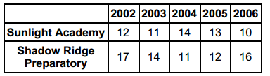

Based on the mean of the ratings, which school should the Nelson’s choose and why?

A. Sunlight Academy, because it’s mean rating is 2 points higher.
B. Shadow Ridge Academy, because it’s mean rating is 3 points higher.
C. Shadow Ridge Preparatory, because it’s mean rating is 2 points higher.
D. Sunlight Academy, because it’s mean rating is 3 points higher.

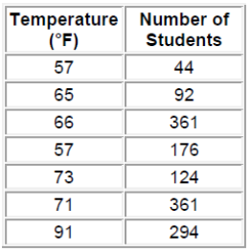
66. The school is conducting a survey to determine the relationship between the outside temperature and the number of students who eat lunch in the outside commons. The information is in the chart below.

What is the approximate mean of the temperatures?

A. $69.00℉$
B. $70.50℉$
C. $80.00℉$
D. 68.57$℉$

67. Which of the box-and-whisker plots below represents the data set below?

46, 51, 54, 58, 64, 70, 74, 74, 69, 60, 52, 46

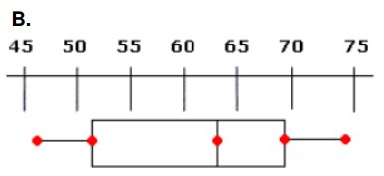
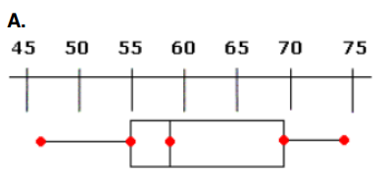

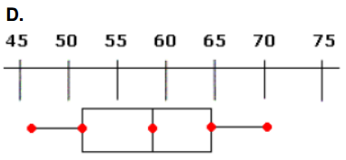
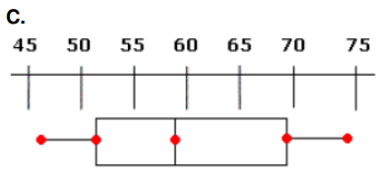

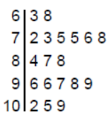
68. The following stem-and-leaf plot shows the number of people that attended the preseason basketball games.

What is the mean of the data?

A. 87
B. 96.37
C. 91.17
D. 86.37

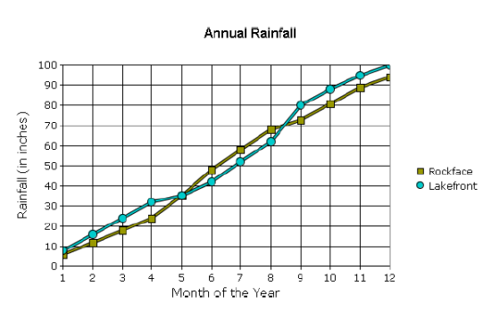
69. The towns of Rockface and Lakefront have been tracking their annual rainfall. The average monthly rainfall for both towns over the previous year is shown in the following line graph.

Using the graph, predict during which of the following months Lakefront will have the greater cumulative rainfall for the year.

A. October
B. July
C. June
D. August

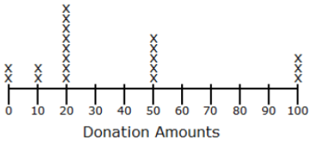
70. The following line plot shows the number of donations received during a charity drive. What is the median of the data in the graph?

A. $20.00
B. $35.00
C. $25.00
D. $50.00

71. A company made a bar graph showing the amount of sales for each month in thousands of dollars. Which of the following is closest to the range of sales for the four-month period?
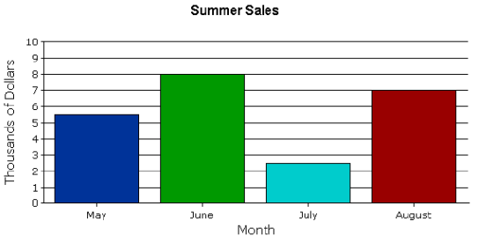

A. $2,500
B. $1,500
C. $5,500
D. $3,000

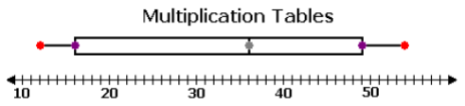
72. When helping her little sister with her homework, Monique picked some products randomly from the multiplication chart. The products are represented by the box plot below.

What percent of the data is below 36?

A. 25%
B. 50%
C. 75%
D. 36%

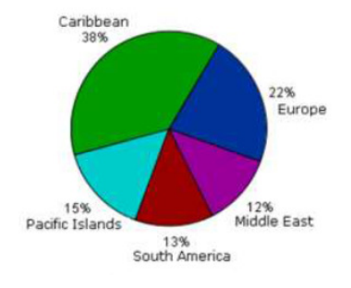
73. A travel agent made the given circle graph. The graph divides up the destinations that clients chose for the previous year into 5 categories. The agency is expecting to service 800 clients this year. Using the circle graph, predict the number of those clients who will choose the Caribbean as their vacation destination.

A. 304
B. 104
C. 176
D. 120

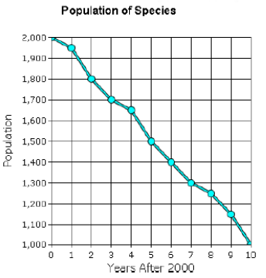
74. The population of a certain species is declining rapidly. Use the graph to predict the population in 2015.

A. 500
B. 750
C. 875
D. 625

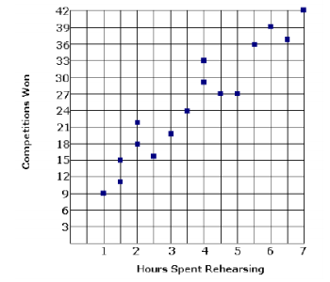
75. A group of band instructors answered a survey about hours of rehearsal per week and number of competitions won. The graph shows the results of this survey. Based on these results, if a band practices 5 hours per week next season, which is the best estimate of the number of competitions the band can expect to win?

A. 27
B. 24
C. 38
D. 31

76. Kayla has a standard deck of 52 cards and a six-sided die. What is the probability that she will pull a diamond from the deck of cards and roll a 2?

A. $\frac{3}{26}$
B. $\frac{1}{4}$
C. $\frac{1}{24}$
D. $\frac{1}{6}$

77. Marli has one bag of different colored, same-size chips. There are 4 blue chips, 5 red chips, and 3 black chips. What is the probability that she will pull a blue chip and without replacement pull another blue chip?

A. $\frac{1}{3}$
B. $\frac{3}{11}$
C. $\frac{1}{11}$
D. $\frac{1}{4}$

78. Katie is trick or treating. The man answering the door holds out two bags. In one bag, there are 3 bars of dark chocolate and 1 bar of white chocolate. In the other bag, there are 3 pieces of strawberry licorice, 1 piece of cherry licorice, and 1 piece of orange licorice. If Katie gets to randomly draw one piece of candy from each bag, what is the probability that she will get a bar of dark chocolate and a piece of cherry licorice?
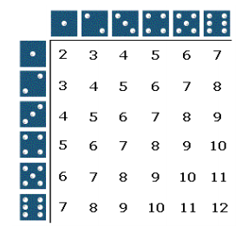

A. $\frac{1}{4}$
B. $\frac{2}{9}$
C. $\frac{1}{9}$
D. $\frac{1}{6}$

79. The following balls are placed in an urn: 5 red, 6 yellow, 3 blue, and 3 green. One ball is randomly drawn from the urn. What is the probability that the ball is either yellow or green?

A. $\frac{9}{8}$
B. $\frac{2}{17}$
C. $\frac{1}{17}$
D. $\frac{9}{17}$

80. Bobby is taking a multiple-choice history test. He has decided to randomly guess on the first two questions. On each question there are 4 answer choices. What is the probability that he answers the first question correctly and the second question correctly?

A. $\frac{1}{16}$
B. $\frac{3}{16}$
C. $\frac{9}{16}$
D. $\frac{1}{4}$

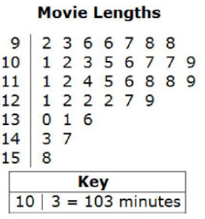
81. The lengths, in minutes, of the movies in Rob’s DVD collection are shown in the following stem and leaf plot.

A. What is the interquartile range of the movie lengths?

B. Raul wants to know the mean length of the shortest
25% of his movies. What is the mean length of the
shortest 25% of the movies?

C. Raul bought 4 new movies with lengths of 126, 116, 104, and 134 minutes. Find the new interquartile range and the new mean length of the shortest 25% of the movies.

