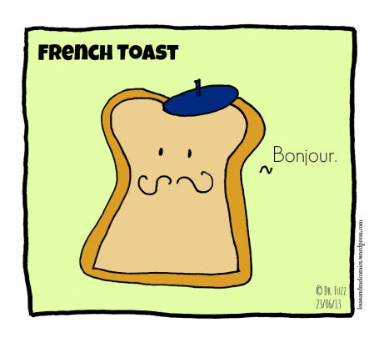
Name: Period: Date: Score: _______/20
All About French Toast Web Quest
Soon you will be making French toast. In preparation for your lab, you will be learning about this centuries- old dish by completing the steps below.
Web Quest Steps
- Save this document to your files. Alternatively, you can print out this document now and write directly on it.
- Put your name, period, and date at the top of this document.
- Read the information here about French Toast: http://www.todayifoundout.com/index.php/2010/11/french-toast-was-not-invented-in-france/. (Click on the link and press the CTRL key at the same time to open the link.)
- Answer these questions directly on this chart in the boxes to the right.
- NOTE: You have to read the entire article to get the questions correct. A lot of students in the past have lost points due to not reading the entire article and mistaking the myths in this article for facts.

- Explain why French toast was probably created. | 1.
- What is the translation for pain perdue? Explain. | 2.
- If French toast did not come from France, why is it called French toast? (Warning: Do not get confused by the myths described in the article. You have to read the ENTIRE article to be able to arrive at the correct answer!) | 3.
- The article mentions that only recently did humans waste large amounts of food. French toast is a way to use up old bread. Think of another way to not waste food. Maybe it is another dish or recipe that comes to mind or a way of conserving in general. Whatever it is, describe it here. | 4.
- What is one fact you found interesting or surprising? Describe it here. | 5.
- Do you eat French toast? Write a little about your French toast experiences. Where have you had it? Do you make it, or does a family member make it? Do you eat it in a restaurant? Do you eat it with any special ingredients or toppings, etc.? | 6.
- Do a Google search for “variations of French toast” and search for different ways to make French toast. Put the link to the recipe and the name of the recipe in the box to the right.  - Explain how the recipe you chose is similar to and different from the traditional recipe. | 7.  8.
- Why did you pick this recipe and why does it appeal to you? Explain. | 9.
- Go here and watch the video about how to make French toast: https://www.youtube.com/watch?v=vPrtNzvDS5M  Write down two tips from the video that you learned. | 10.
- Take out your recipe for French Toast, read it, and highlight it according to the chart in the front of the room. Answer the questions on the recipe. If you do not have the recipe, go here to print one out: http://www.casdonline.org/education/components/docmgr/default.php?sectiondetailid=31347&fileitem=49603&catfilter=8593 | You don’t have to write anything in this box. Just follow the directions on the left.

Save this document again, print it out, and hand in. Staple the two pages together before handing in.

