Name: ____________________ Period: ________ Date: ____________

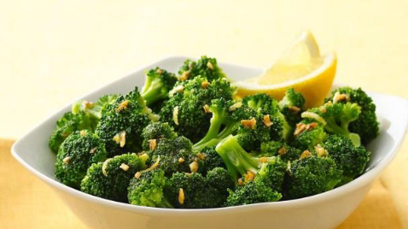
Cooking Methods Lab Follow-up

Complete the following as you sample and taste test each version of the Lemon Garlic Broccoli recipe.

Kitchens 1 & 2: Cooking Method: _______________________
Describe the taste, color, & texture of the product.

Kitchens 3 & 4: Cooking Method: _______________________
Describe the taste, color, & texture of the product.

Kitchens 5 & 6: Cooking Method: _______________________
Describe the taste, color, & texture of the product.

Describe the similarities & differences between the three methods.

Which method did you like best and why?

