Moving your Personal Google Documents to CASD Google Apps for Education

Google does NOT allow you to share ownership of documents with Google accounts in other domains (@gmail.com documents cannot be owned by @casdonline.org). If you would like to move your Google Documents from your personal Google account (@gmail.com or another account) to your Google Apps for Education account (@casdonline.org), you will need to download the items to your computer, and then upload the same documents to your Chambersburg School District Google Drive.

Downloading your Google Drive documents to your computer:
1. Log into your personal Google Drive account (www.drive.google.com) with your personal Google username and password
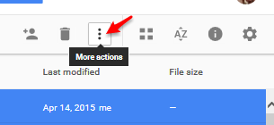
2. In your list of documents or folders, highlight the documents or folders you want to download (You can highlight multiple files or folders at one time if desired).

3. Once you have selected your documents, click more actions at the top right of your documents list and choose Download from the drop-down menu. There is a 2 GB file size limit. If you have difficulties, split your download in to multiple ones.

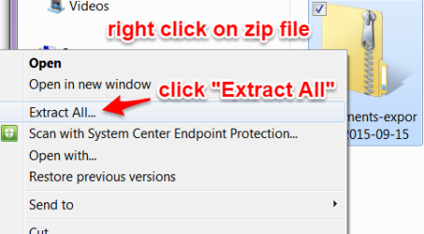
4. Google will compress your files into a .zip file and your browser will automatically download the .zip folder. I would go to Save As and place my .zip file somewhere easy to find. After you have the .zip file you will want to unzip the contents into a folder. This will make it easy to upload later. To unzip a file, just right click and choose “Extract All”.
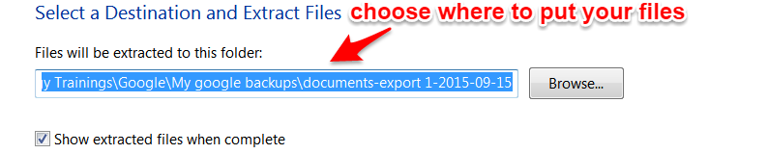
You will get a popup to ask what destination you want to place that folder. It should default to the file where your .zip file is located. This is a great location to leave it in.

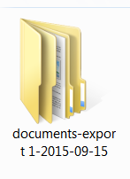

Your unzipped document folder should look something like this. All your files will be inside and unzipped.

Uploading Documents into your CASD Google Drive:

1. After downloading your documents from your personal Google Drive, you can upload the same files into your CASD Google Apps for Education account. Uploading or dragging your folders/files is easiest using Chrome

2. Log into your CASD Google Apps for Education account using your full district email and password

3. Choose Drive from the gray navigation bar at the side of your window to open Google Drive
4. Click New and then File or Folder upload 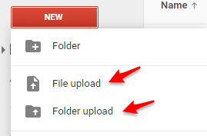

a. Choosing Files... will allow you to upload individual files
b. Choosing Folder... will allow you to upload a folder with multiple files in Chrome

5. To upload the folders or files that were downloaded in the previous section, in Drive, click Folder upload or File upload (or you can open two screens and drag your folders from your my documents across to your open Google Drive).

6. Browse your computer for the folder that you downloaded

7. Once you have located the folder you want to upload, click OK

8. Your folder will begin uploading automatically and you will see the following window appear
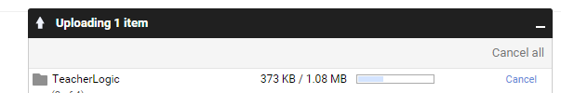
9. Your Google Apps for Education account (@casdonline.org) is now listed as the owner for the documents you just uploaded from your personal Google Drive. Happy day!
Shared documents and folders – things to consider when moving content

- If you have documents that have been shared with you in your personal account and you want to delete the documents out of your personal account.
  - You can share the document from your personal account to your new @casdonline.org account. You can then delete the shared doc in your personal account.

- But I own the document that is being shared.
  - If you share the document from your personal account to your @casdonline.org you will keep all the sharing. If you delete the doc from your personal account, you will lose all the sharing since you are the owner of that shared doc.

